Informal Survey of Birdston Core Path for Milton of Campsie Community Council – May 2021
The Core path runs for a short distance from B757 just prior to entering Birdston (traveling from Kirkintilloch) along the top of an old railway embankment and joins the Strathkelvin Railway Walkway. This short path forms part of the Kelvin Valley Walkway which continues in a westerly direction towards Torrance from the other side of the B757. Note the section of the Kelvin Valley way westward towards Torrance from the B757 is not classed as a Core Path. The route can be walked in reverse. Note Great care is required crossing the B757 due to bends in both directions and traffic speeds.
The path commences on the “non-footpath “ side of the B757 and rises up a short incline to the top of the old railway embankment continuing for a short distance before descending and joining the Strahkelvin Railway walkway (Thomas Muir Trail) also a Core Path.
The path consists of compacted earth, is subject to some ponding after heavy rain and is not suitable for wheelchair users or persons with prams or baby buggies. Walking boots are not essential.
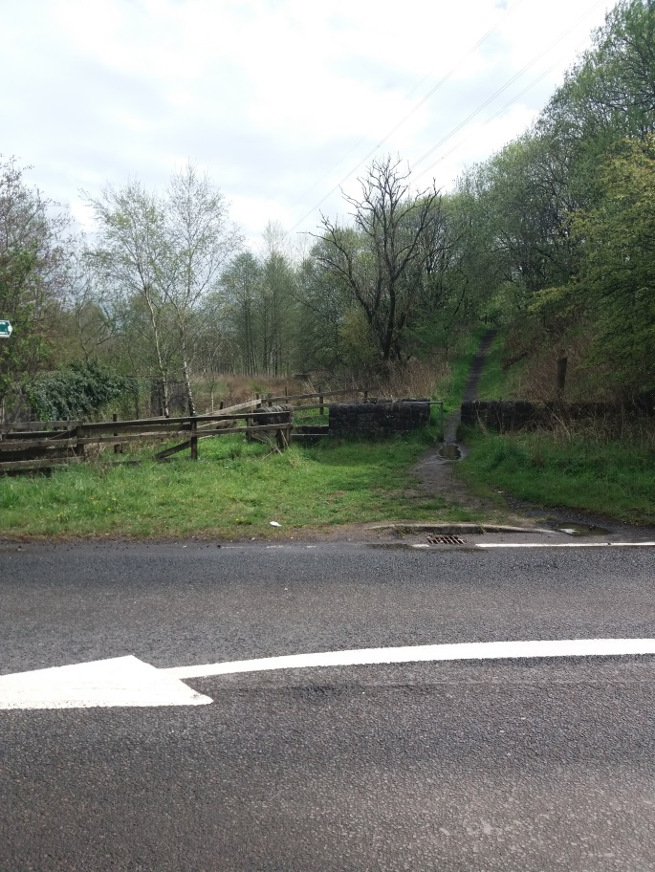
- View looking across from footpath on B757 to start of Birdston Core path. Access to bath is through gap in barrier wall.
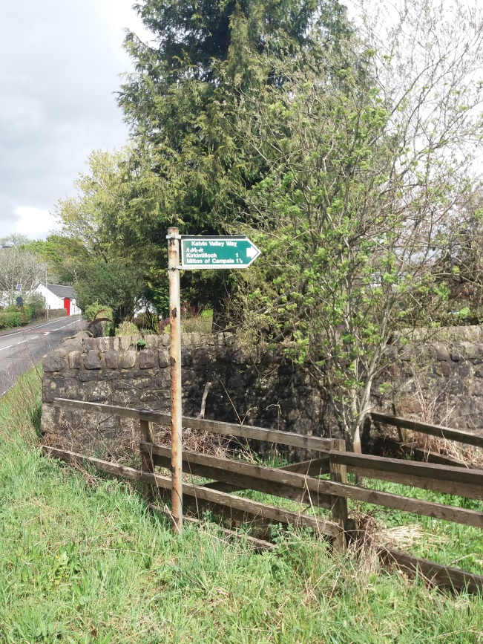
- Directional sign at start of Core path. Note no directional sign for Kelvin Valley Way is available on opposite side of B757 for information in Torrance direction.
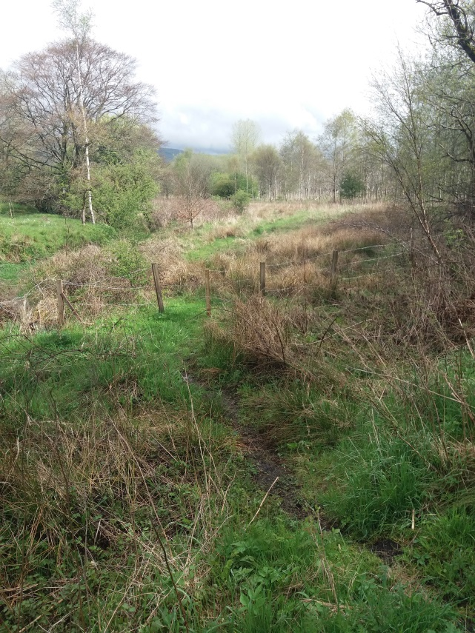
- Little used path to LHS of start of Birdston Core Path with recent barbed wire fence blocking access to “Community Woodland” between Birdston and Strathkelvin Railway Walkway and Milton of Campsie. (Issue previously reported to MoCCC)
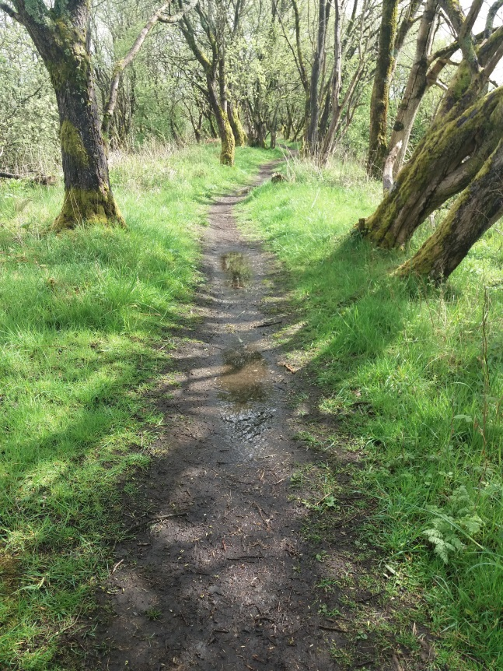
- Path on top of old railway embankment showing slight ponding.
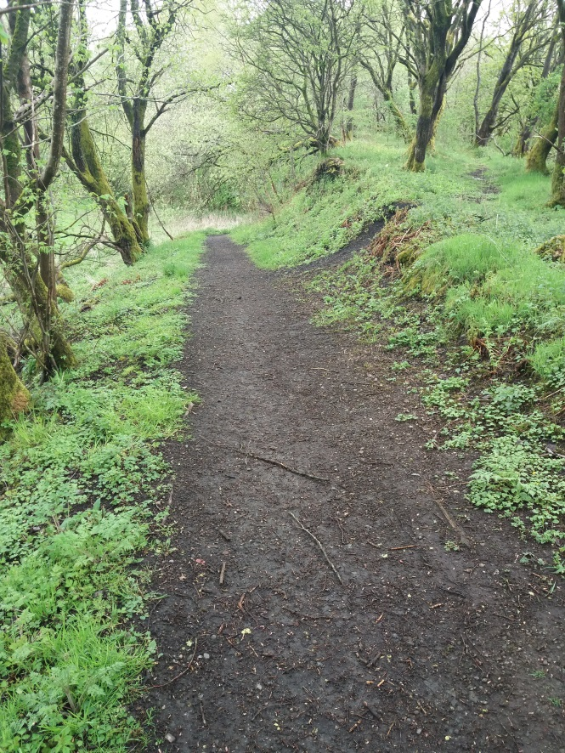
- Path descending towards Strathkelvin Railway Walkway. Path off to right goes to edge of viaduct parapet. Railway viaduct goes over Strathkelvin Railway Walkway and River Glazert, however section over Walkway has been removed with dangerous drop and no guardrail.
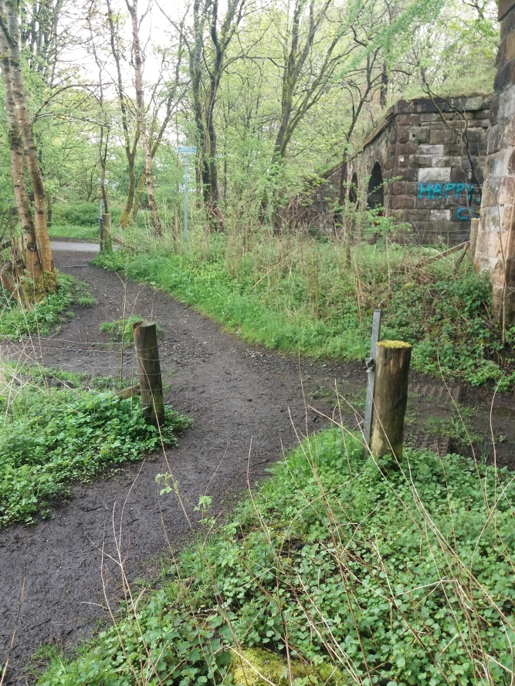
- View showing path crossing over field access track and joining Strathkelvin Railway Walkway. Old railway viaduct visible showing “missing” link over walkway.
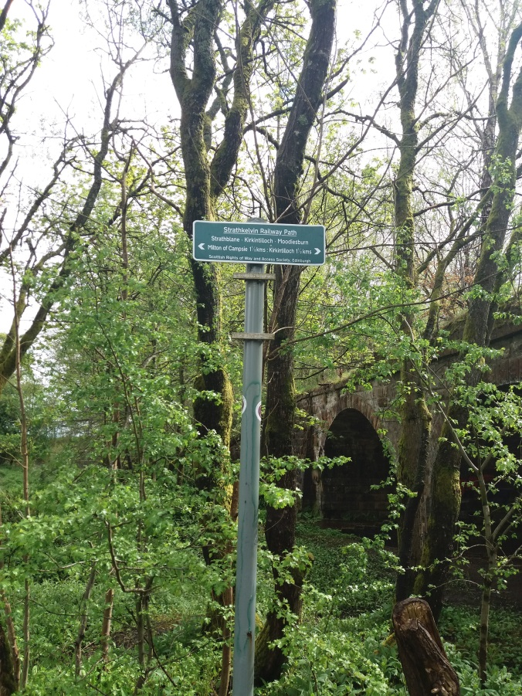
- Directional sign on Strathkelvin Railway walkway opposite point of Kelvin Valley Way (Birdston Core path)/ Strathkelvin Railway Walkway junction.

