Informal Survey of Kelvin Valley Way Core Path (Birdston – Campsie Road) for Milton of Campsie Community Council
This route is the extension f the path from Strathkelvin railway walkway to Birdston Road and accessed by crossing the B757 at Birdston and following the path adjacent to the Birdston Coup haul road. Alternately one can miss out the section parallel to the “haul road” and take the road/track at the side of the white barn of Birdston Farm which the path joins approximately 1 Km further along as one travels west. Note this route is not classed as a Core path in the original online map provided by the Access Officer of EDC but is classed as a Core Path in the map available on line as part of the current Active Travel consultation.
The path consists of mixture of compacted earth, farm track and short sections of maintained hard-core. The path is not suitable for wheelchair use of those with prams or buggies. The route ends with a climb up steps at the road bridge of Campsie Road where it crosses the old railway track bed. From here one has to turn left and follow the road to Kirkintilloch, or right towards the B822 (Lennoxtown/Torrance Road and hence to Torrance, Lennoxtown or Milton of Campsie. Note neither of these roads have footpaths or suitable grass verges for walking and have a number of blind bends. However there are a number of access points to the Redmoss Core Path and other informal paths to the Redmoss Area along part of the way as well as access to walks across the Kirkintilloch Golf Course with access to Kirkintilloch.
While walking boots are not essential waterproof walking shoes/footwear is advisable after periods of heavy rain as there may be sections of ponding water and muddy ground.
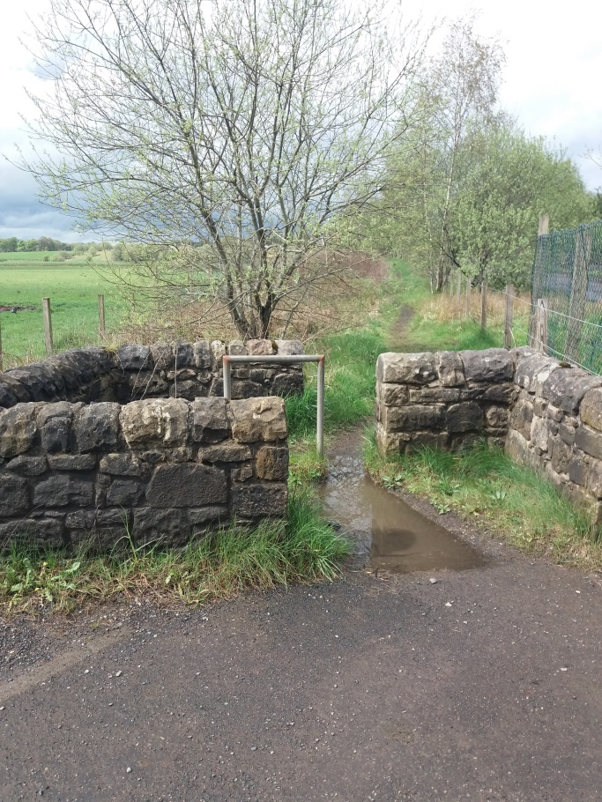
- View of entrance to Kelvin Valley Walk from Birdston Road (opposite entrance to walk towards Strathkelvin Railway Walkway), path runs parallel to Birdston Coup haul road.
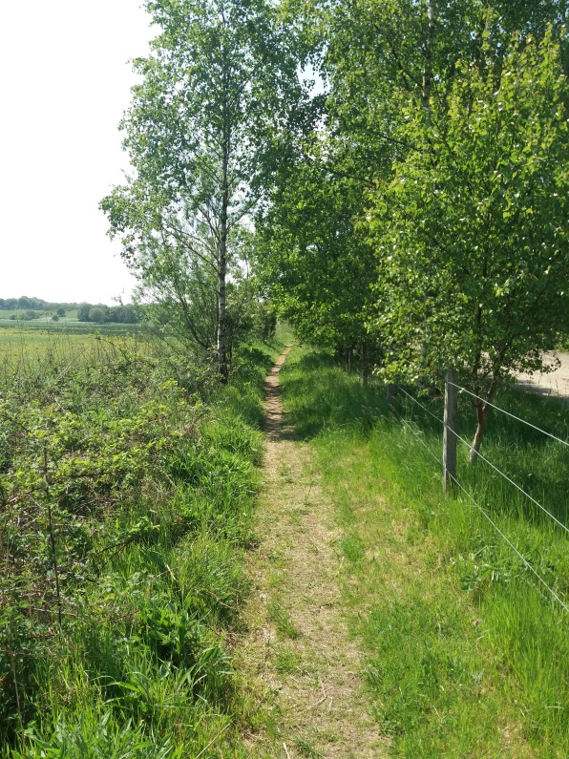
- Path running parallel to Birdston Road Coup haul road.
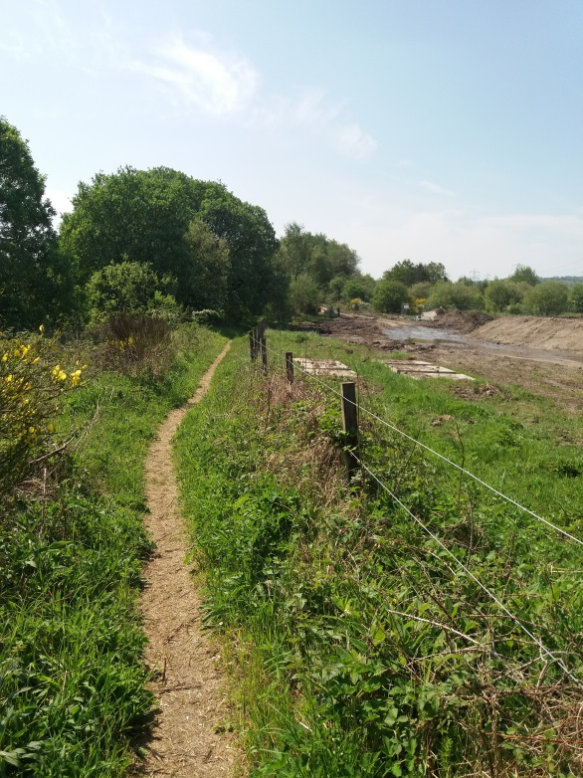
- View approaching flooded area of Birdston Coup haul road, visible in the distance.
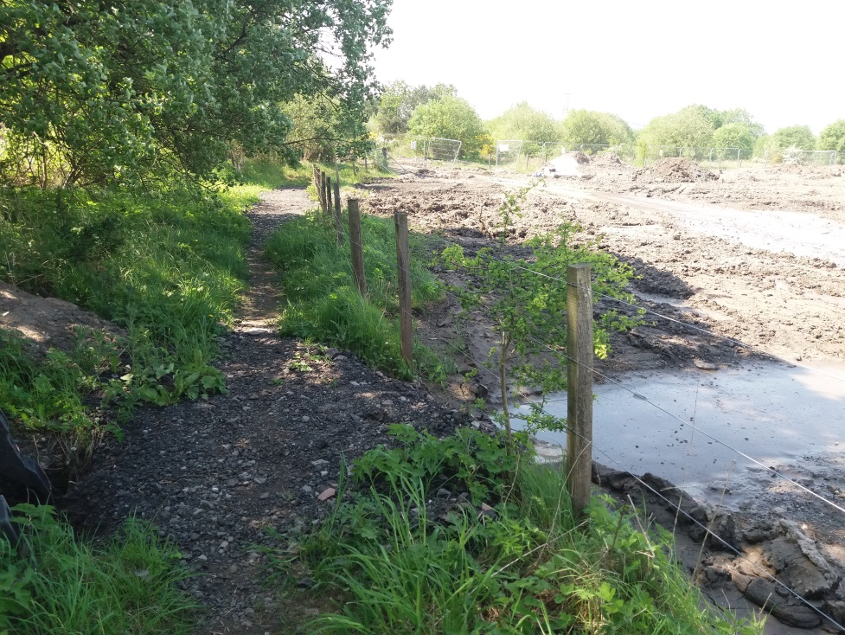
- Section of path that has been culverted and refilled to allow flooding from haul road to drain without flooding path. Note this work is recent as previously this section of path flooded after periods of rain, section of haul road to right of path still flooded after period of dry weather.
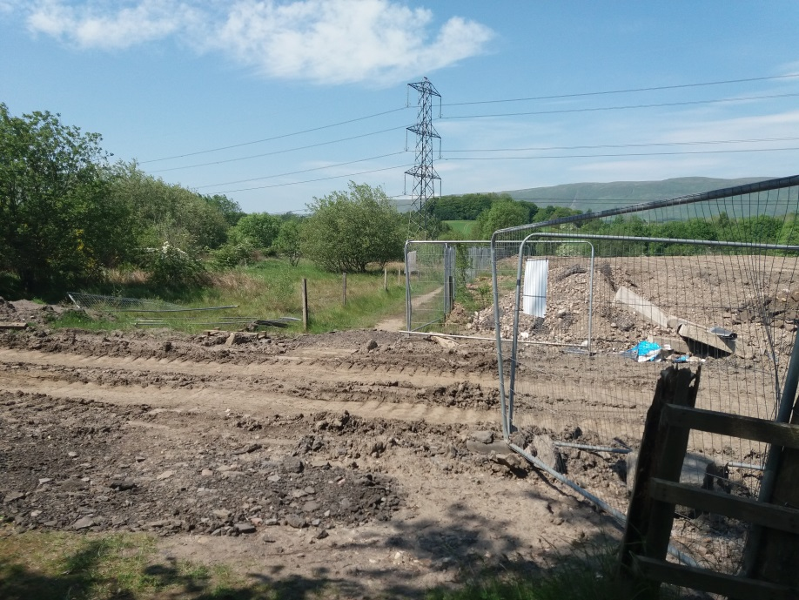
- Point where path changes from west/east to south/north and crosses haul road. Note large area on north side of haul road that has been “regraded” and covered with what is thought to be clay type material over soft ground. It is thought that this is contributing to significant run off and interfered with the natural drainage of the area.
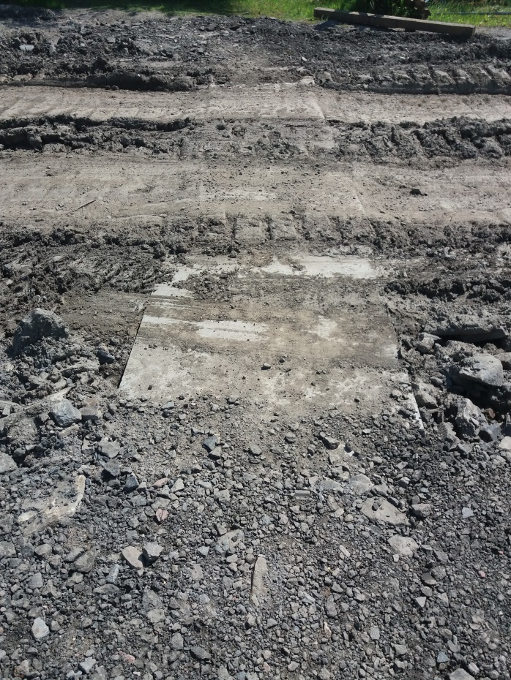
- Close up picture showing where “metal road plates” and additional hard-core have been placed on the haul road to reduce the impact of soft ground and “improve” the path for walkers. Again this work s recent with previously this section being ankle deep in mud following periods of heavy rain.
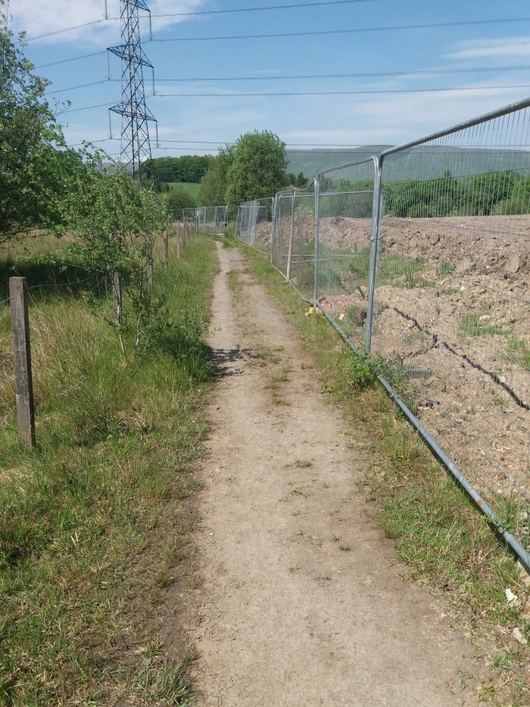
- View of path after crossing the haul road looking north in the direction of its junction with track leading from Birdston farm towards Wetshod farm.
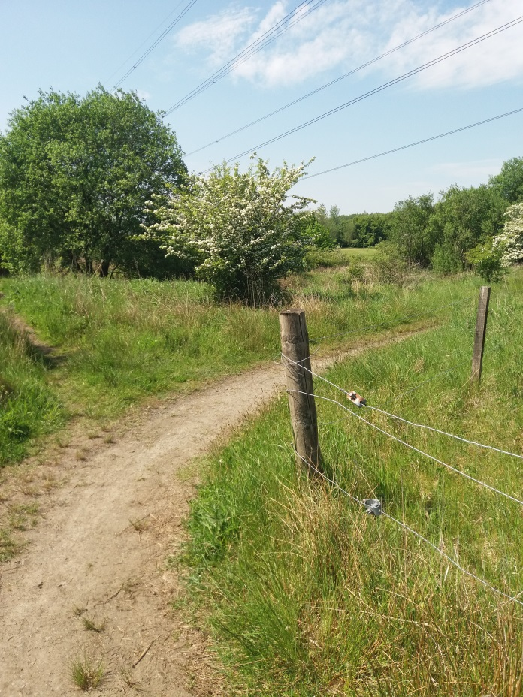
- View where path alters direction, still leading to junction with track from Birsdston farm.
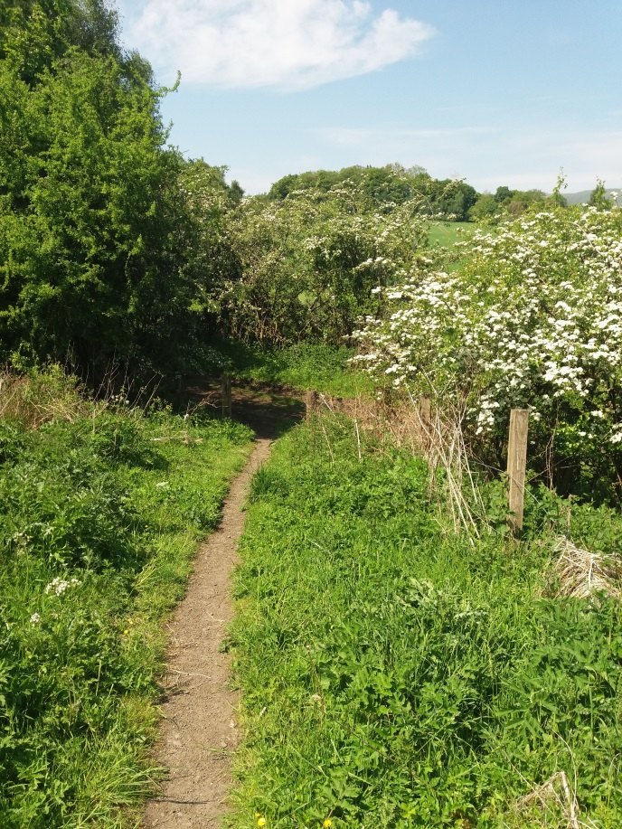
- View of the junction of the “single file” width path with its junction (centre of picture) with track from Birdston Farm to right and Wetshod farm on left.
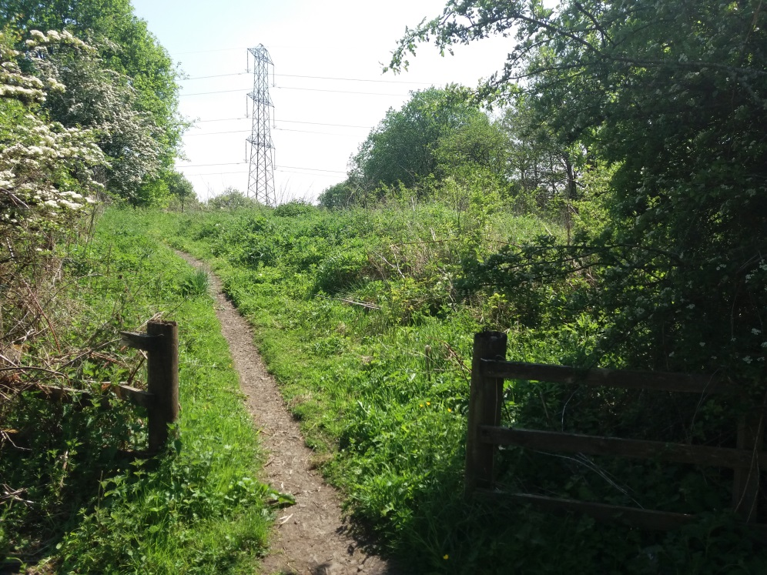
- View taken from “Birsdston/Wetshod farm trach looking back at section of path shown in picture 8.

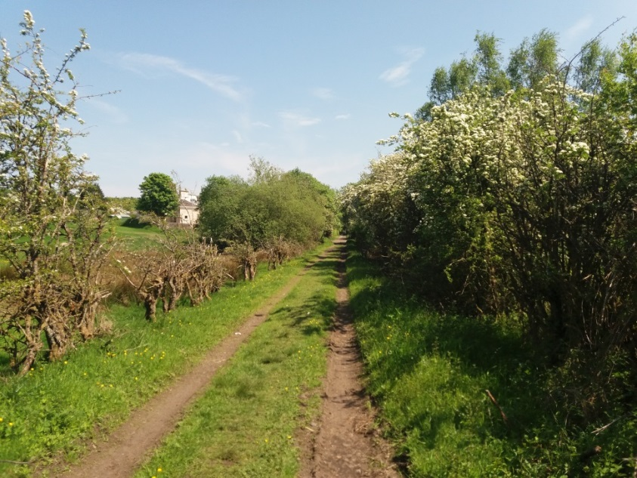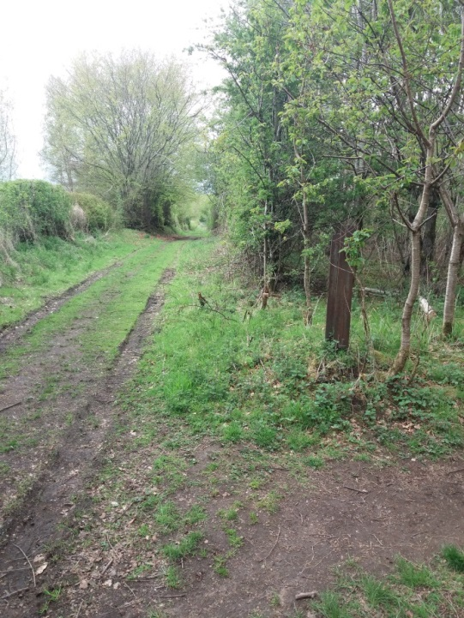
- Two views looking Wetshod farm direction of track. LH picture taken on bright Sunny day from junction with path from Birdston Road after a few days of sunshine, LH view taken further along trach with its junction with Redmoss Core path on first dry day after period of rain.
Note this track from Birsdton Road to the B822 ( Lennoxtown/Torrance Road) is shown as an “other minor road, narrow, good” on OS maps of 1925 and as “other road drive or track” (presumably driveable) on OS maps of 1984.
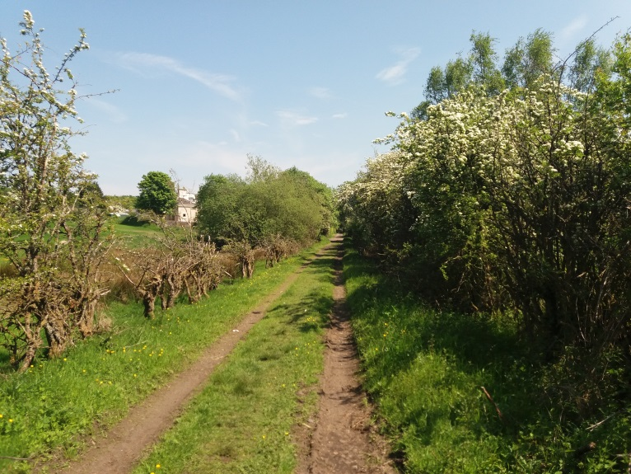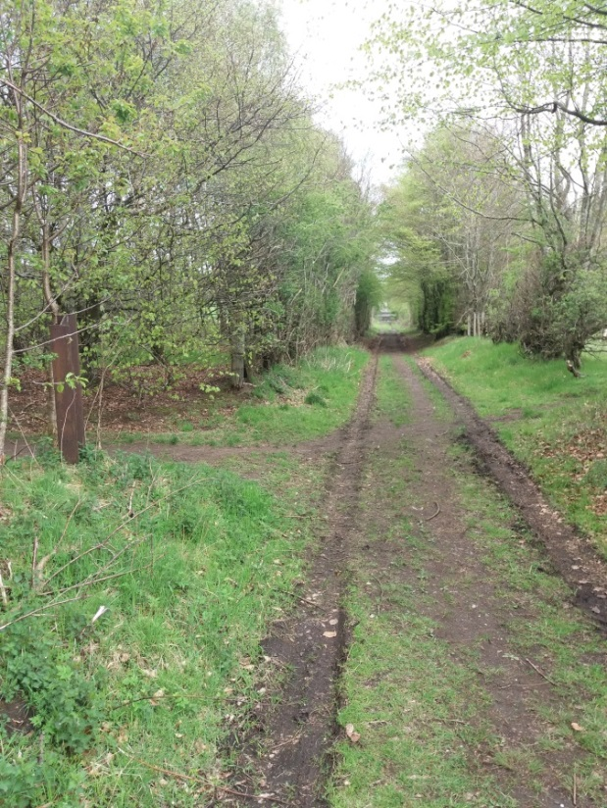
- View taken from same point as picture 12 looking back towards Birdston Farm. LH picture taken on bright Sunny day from junction with path from Birdston Road (last property on trach from Birdston Road visible as white in centre left of picture) after a few days of sunshine, LH view taken further along trach with its junction with Redmoss Core path on first dry day after period of rain.

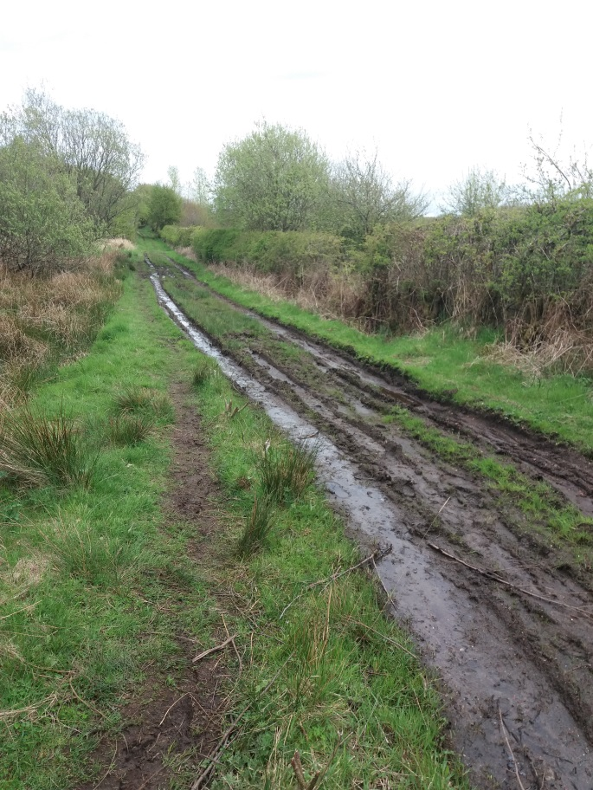
- View take of track looking west towards change in direction from east/west to south/north. Note this picture was taken after short period of heavy rain and should be compared to LH pictures 11 and 12 taken after a few days of sunshine to see change in surface condition.
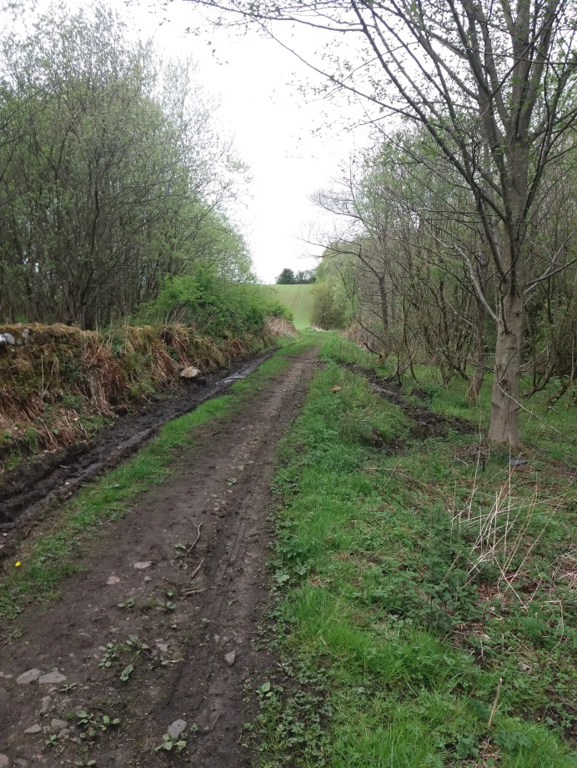
- View looking north where track direction again changes from east/west to north south. Wooded are to left is the wooded extreme edge of Redmoss Grasslands. Again picture take after period of rain.
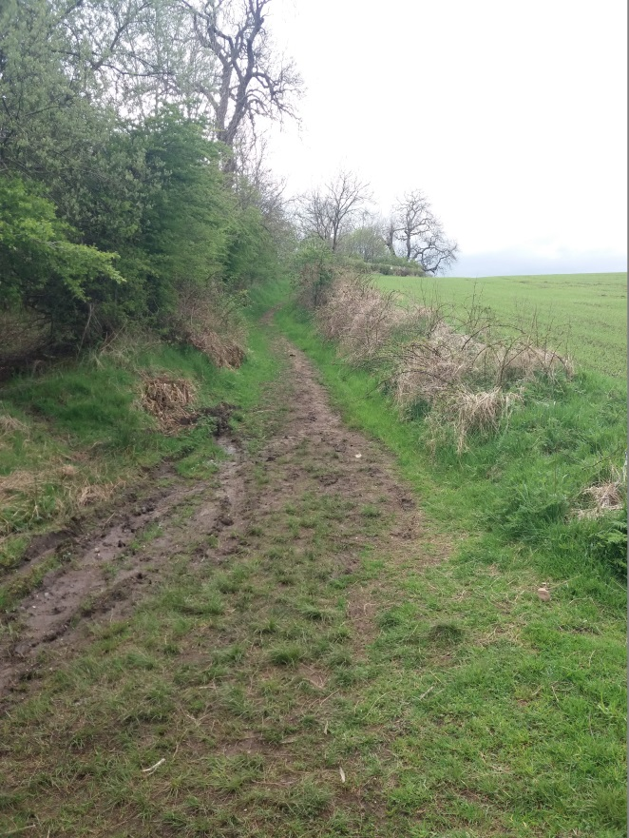
- After a few 100 m of point from which picture 14 was taken track/path again changes direction to east/west and trach narrows to a single file path. Behind from this view point there is an access to the wooded area and informal path network of Redmoss grasslands. The path will lead to the grass bank at the rear of Juniper Drive.
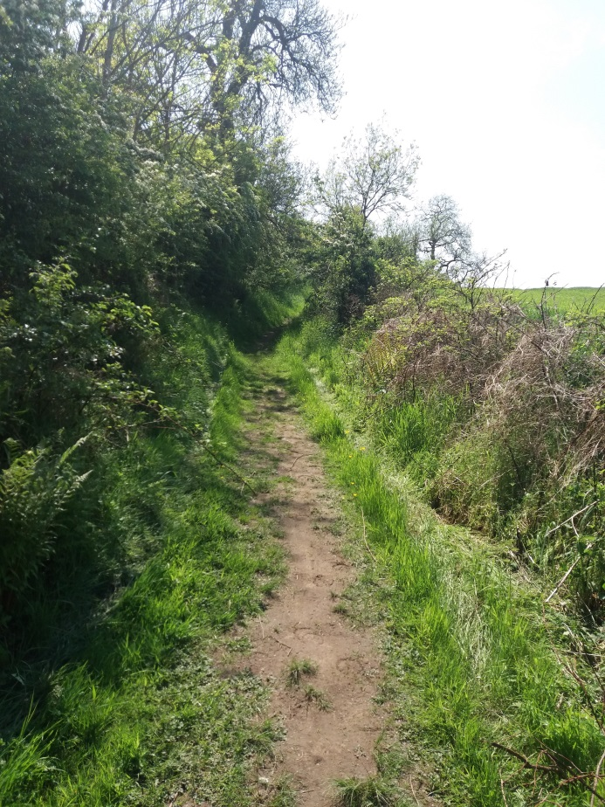
- View of path take from the distant point visible in picture 15, this time taken on a dry day, note difference in condition of path surface i.e. compacted dry earth as opposed to soft muddy surface,

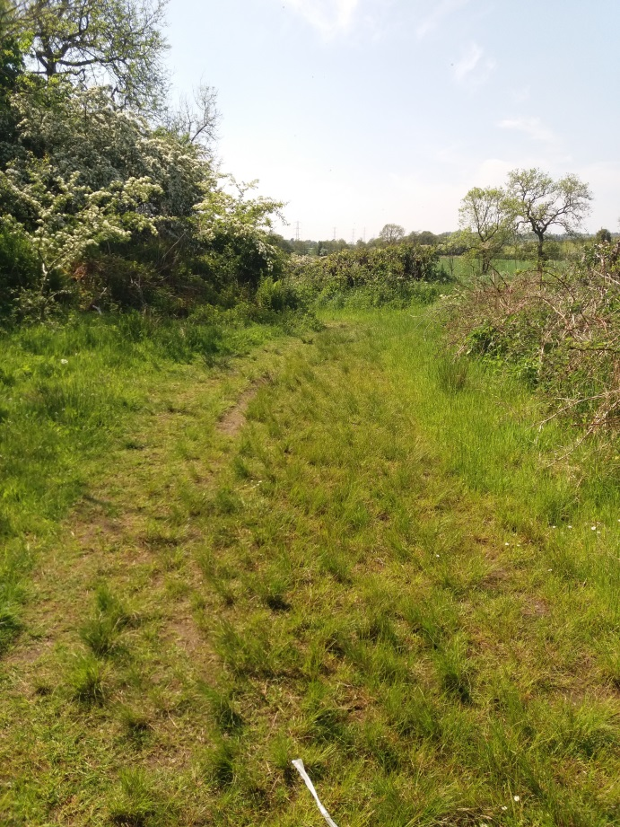
- At points the path surface changes from bare compacted earth to have a slight covering of rough grass, indicating that sections of the route may not be used of often or that the drainage to either side of the walked section is better.
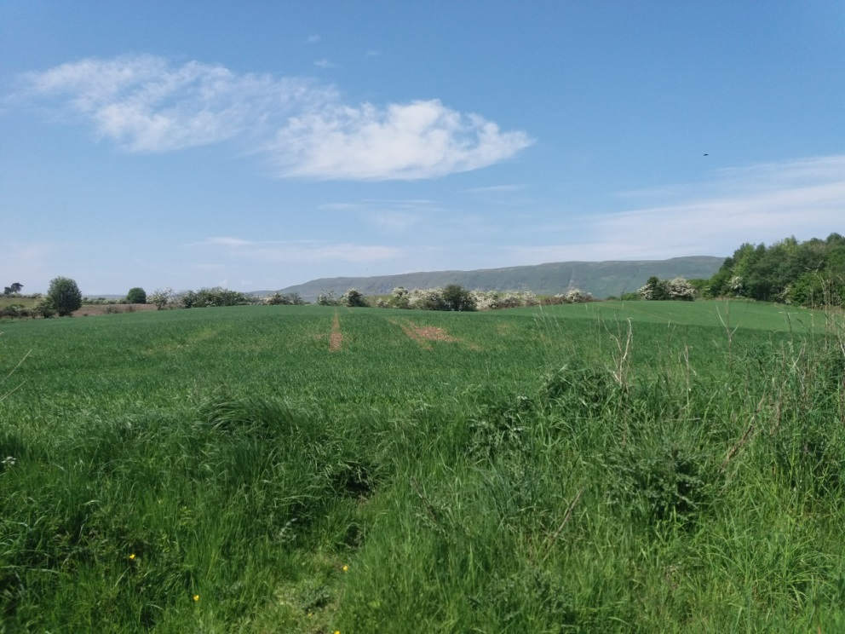
- Scenic view taken from the path showing open countryside and Campsie Fells to the north. i.e. what the walkers enjoy. The woods on the left and the row of flowering hawthorn trees in the distance are the edges of land correctly in ownership of developers and subject to objections by them to being classed as Greenbelt in EDC current LDP2.
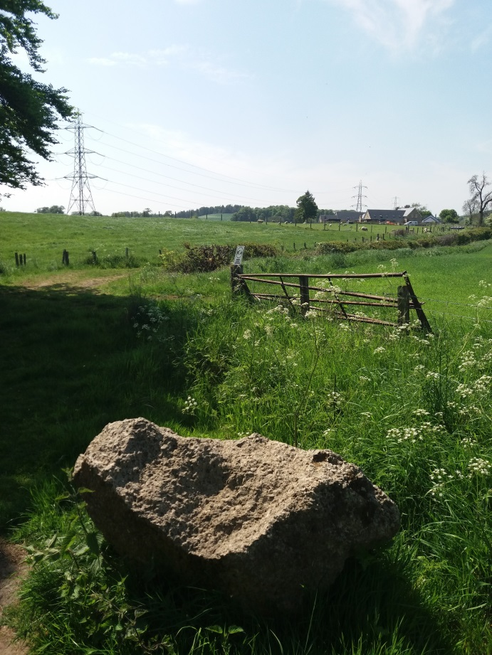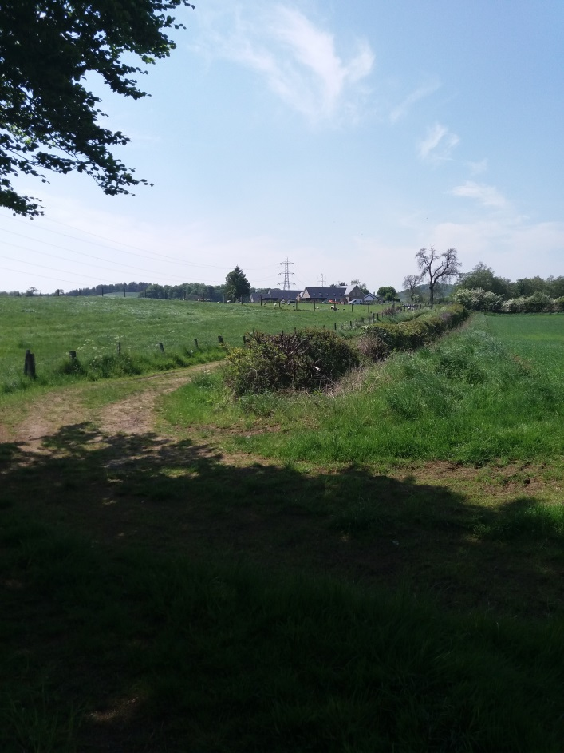
- Views looking east towards Wetshod farm where path changes direction from east/west to north /south. The original track as shown in OS maps (see comment picture 11) can be seen running diagonally L/R towards Wetshod Farm on skyline in centre of picture.
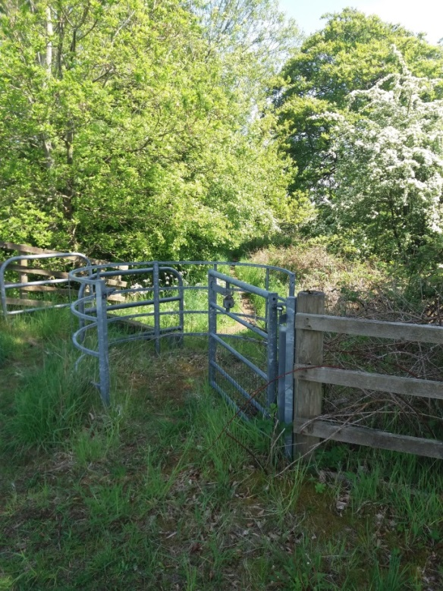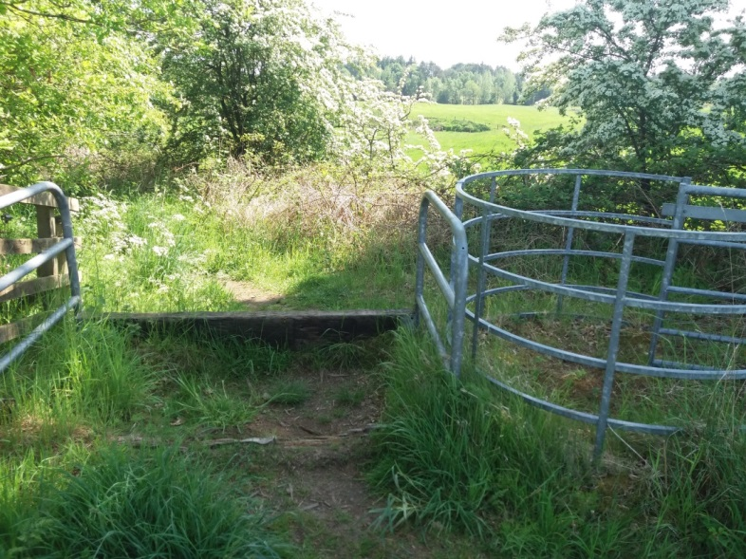
- View taken of “Kissing” gate and vehicle barrier looking south taken from same point as picture 19.
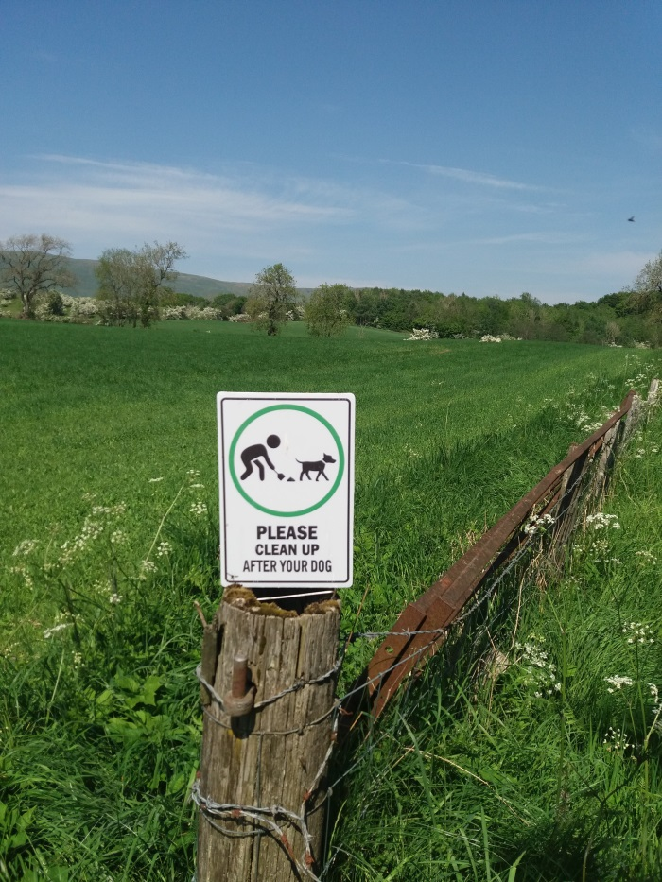
- Sign in connection with dog fouling on fence post at side of path looking back towards MoC. Picture taken from same point as picture 19 & 20. Trees in distance mid picture are extreme edge of Redmoss Grassland area.
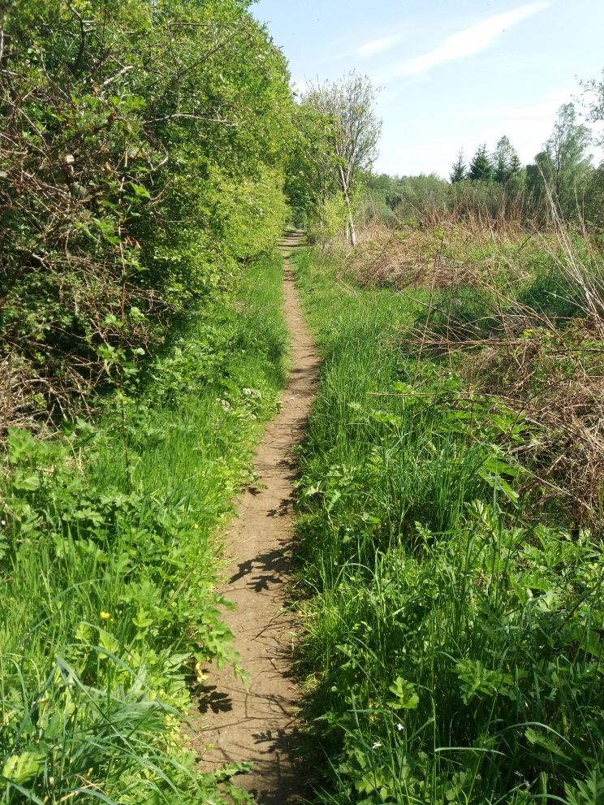
- View of path looking south taken from other side of gate shown in picture 20.
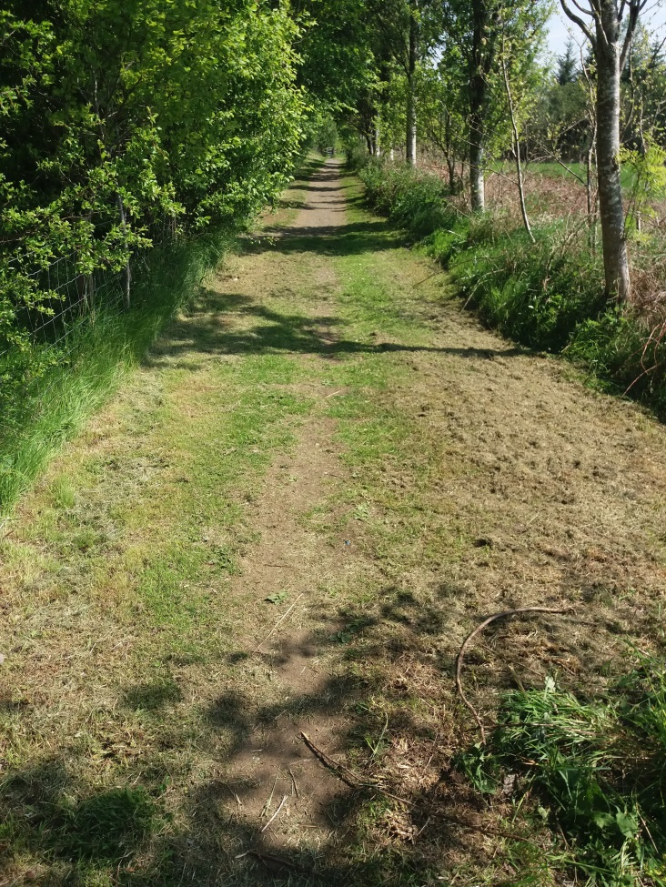
- After a short walk along the path the path grass on either side is well maintained, and the single file worn path widens (centre of picture) where it is maintained by Kirkintilloch Golf Club as it provides access points between fairways.
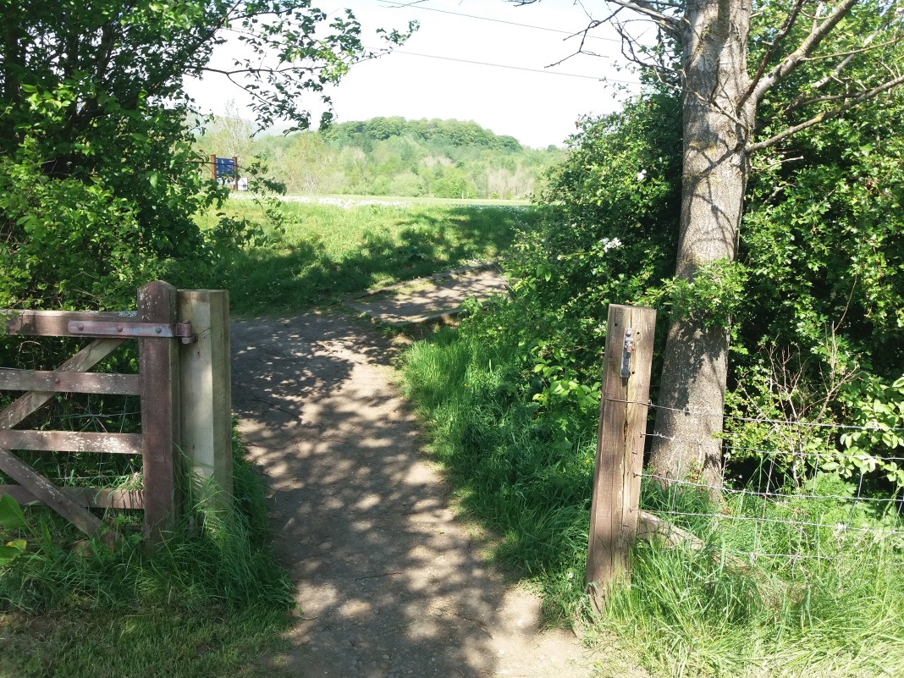
- View of access point to tee of one of Kirkintilloch Golf Course fairways.
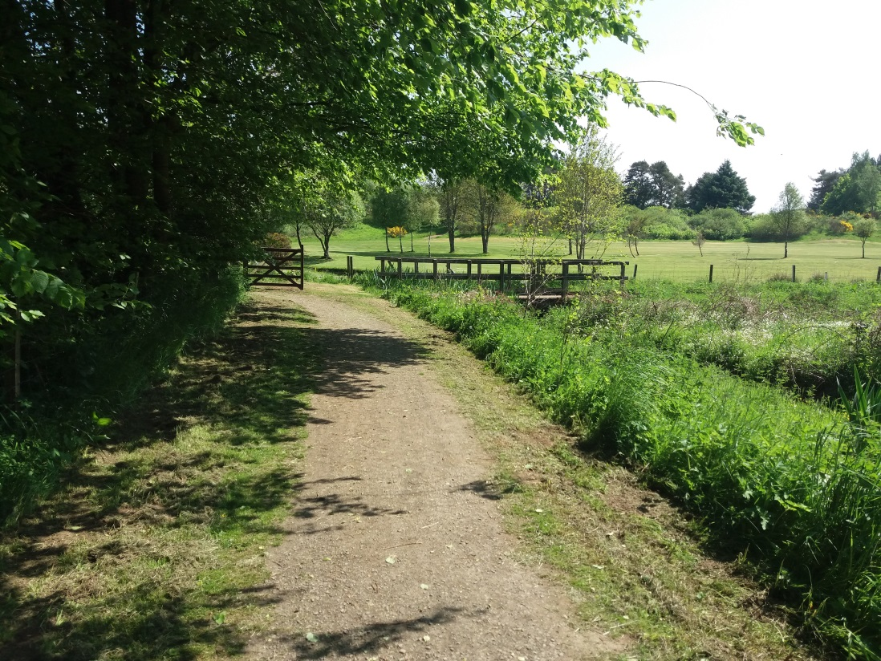
- View of maintained section of path by Kirkintilloch Golf Course towards point where path again changes direction from north/south to east/west.
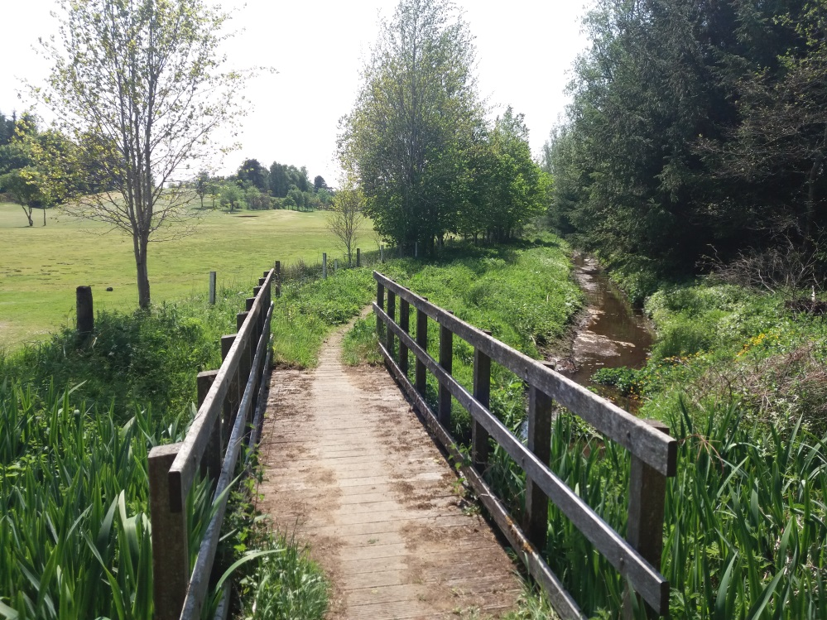
- Crossing point of burn running alongside of path, visible in middle of picture 25
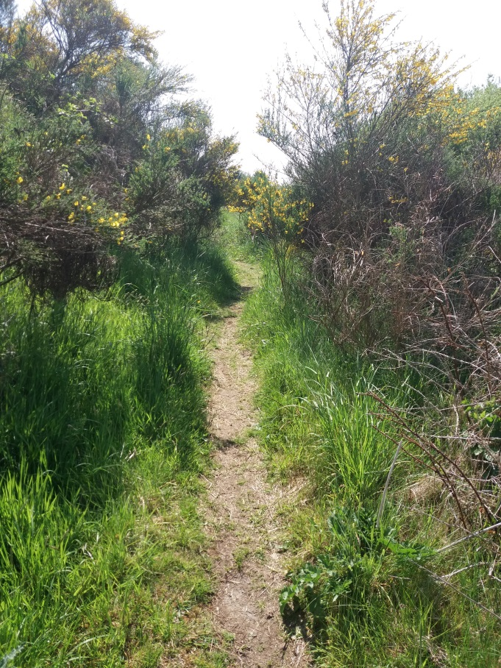
- Path continues to run westwards alongside burn shown in picture 62, then after passing through a section of gorse and scrub joins the course of the old railway line from which the haul road to Birsdston Coup is formed.
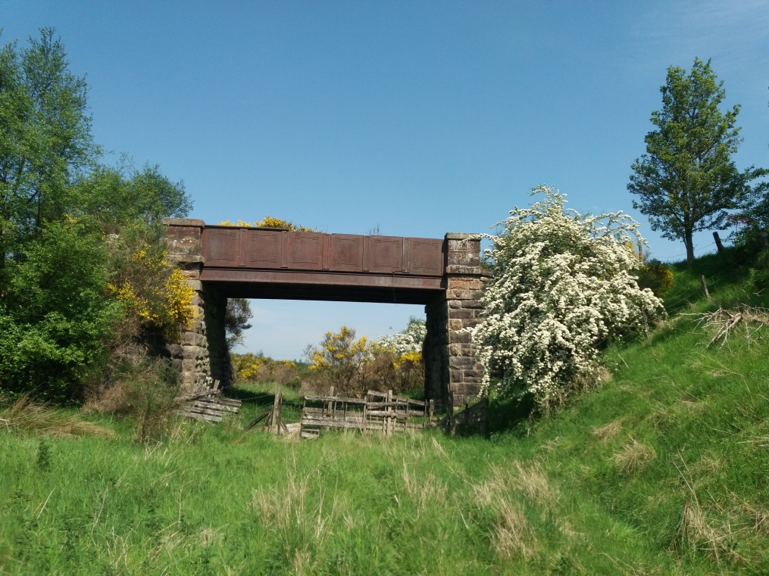
- View looking back east from where path joins the course of the railway. If retracing steps back towards Birdston the path runs to the left of the picture and through the shrub area to the left of picture.
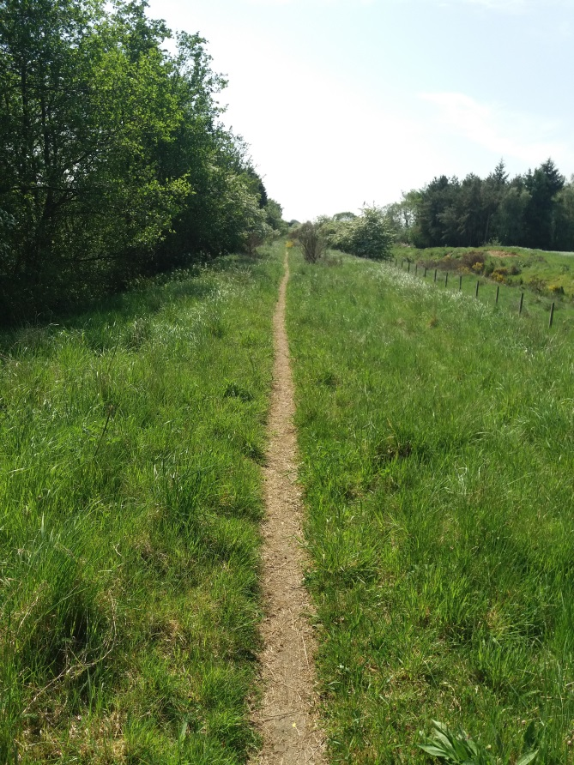
- View of path running along embanked section of course of railway looking west.
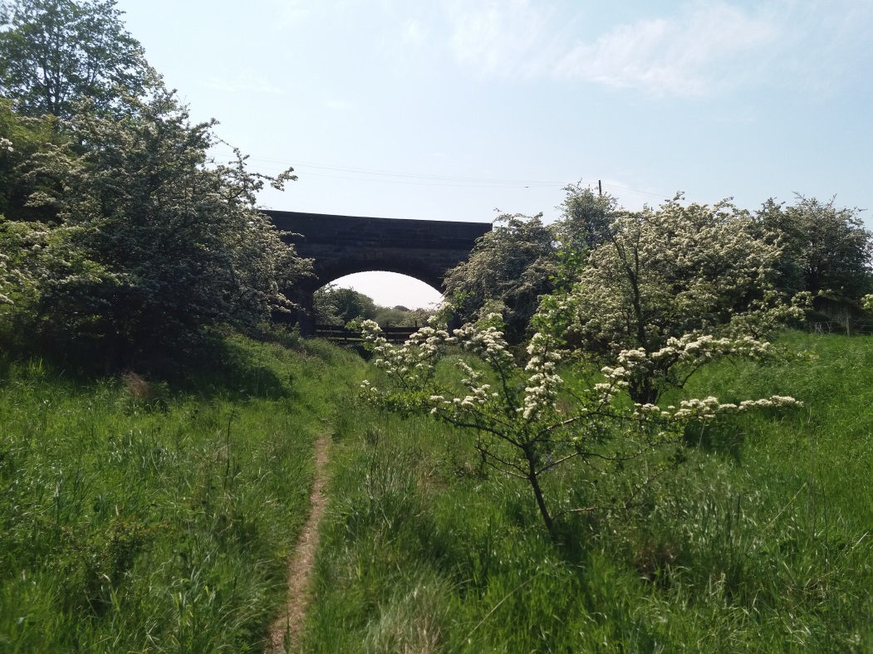
- View looking towards end of this section of the kelvin Valley Way with bridge carrying Campsie Road in centre of picture.
Although not very clear in this picture it can be noted that there is a barrier fence under the bridge preventing further access to the track bed leading towards Torrance, nor is there path/step access from Campsie Road down from the western side of the bridge to the track bed.

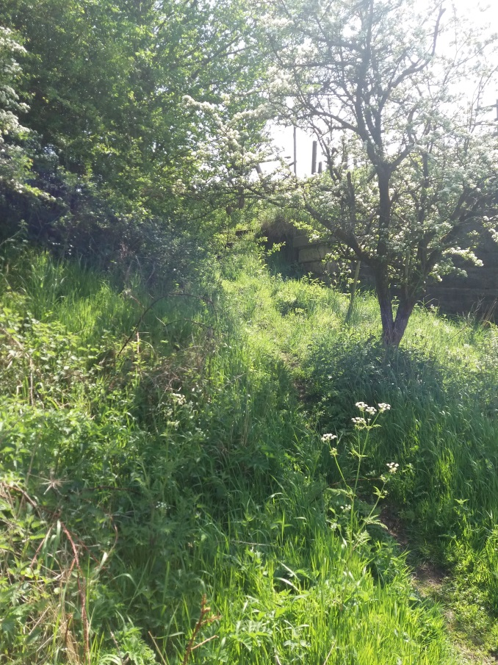
- View of overgrown path and steps from old track bed up to LH side of bridge in picture 30 towards Campsie Road. Posts of fence at roadside just visible through trees in centre of picture.
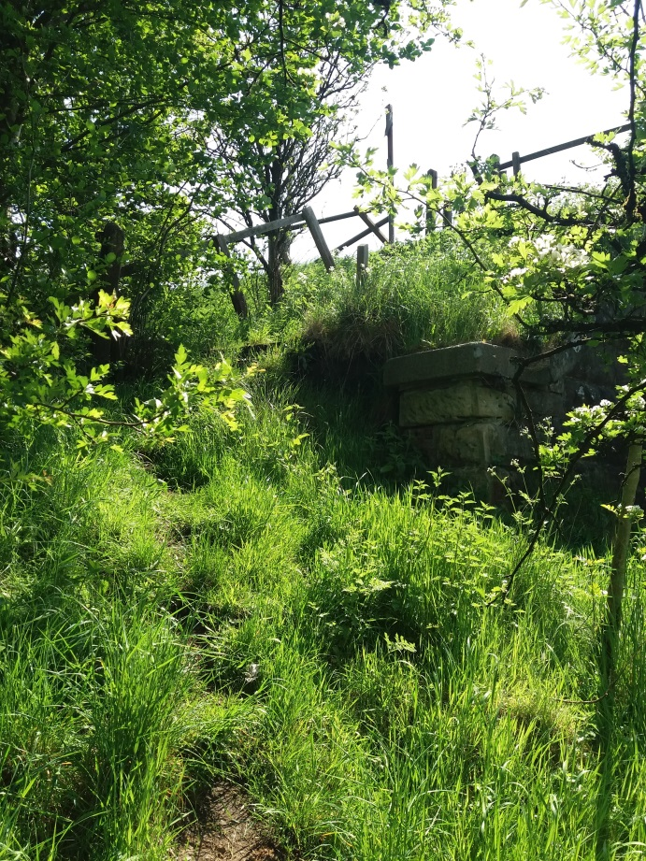
- Closer view of lower section of overgrown steps to Campsie Road, with bridge abutment in centre of picture.
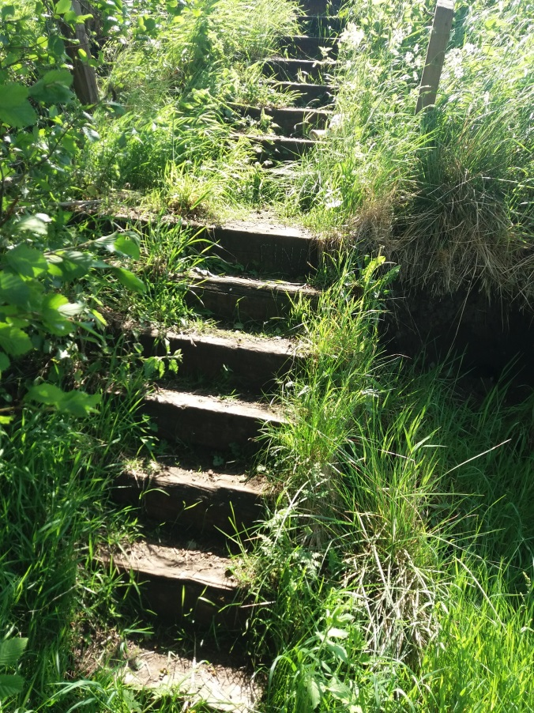
- Vie of top section of overgrown steps, although not as badly overgrown as bottom section.
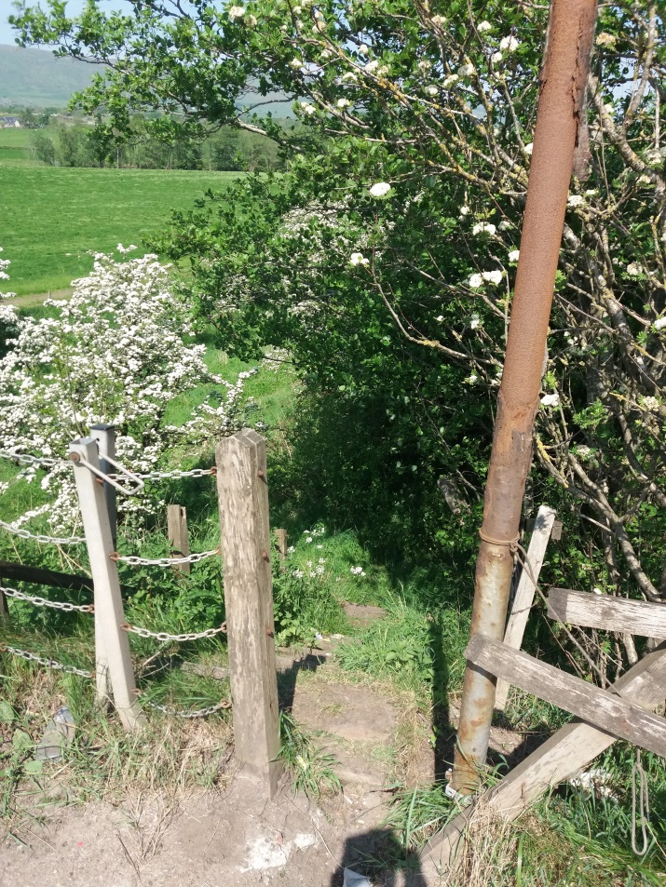
- View from road of entrance point top steps shown I picture 32 & 33. Note the actual entrance is a “self-closing” metal post and chain gate to left of picture i.e. the foot of the metal posts are hinged with the tops being pushed left and right towards the wooden posts to allow access. The wooden fence has been broken to create an alternative access to the steps which are centred to align with the “self-closing gate”. The rusting pole is thought to originally had a directional sign affixed to it.
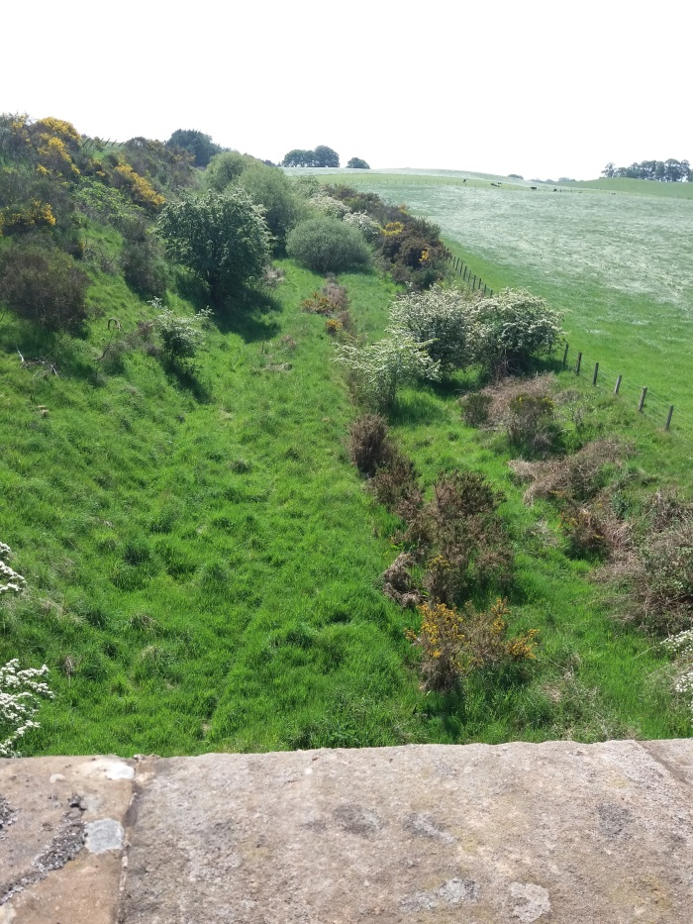
- View from the parapet of Campsie Road bridge looking east (towards Torrance) along old track bed. This point would be the edge of the MoCCC catchment however there is no indication of a footpath continuing in this direction although it is shown on EDC maps.
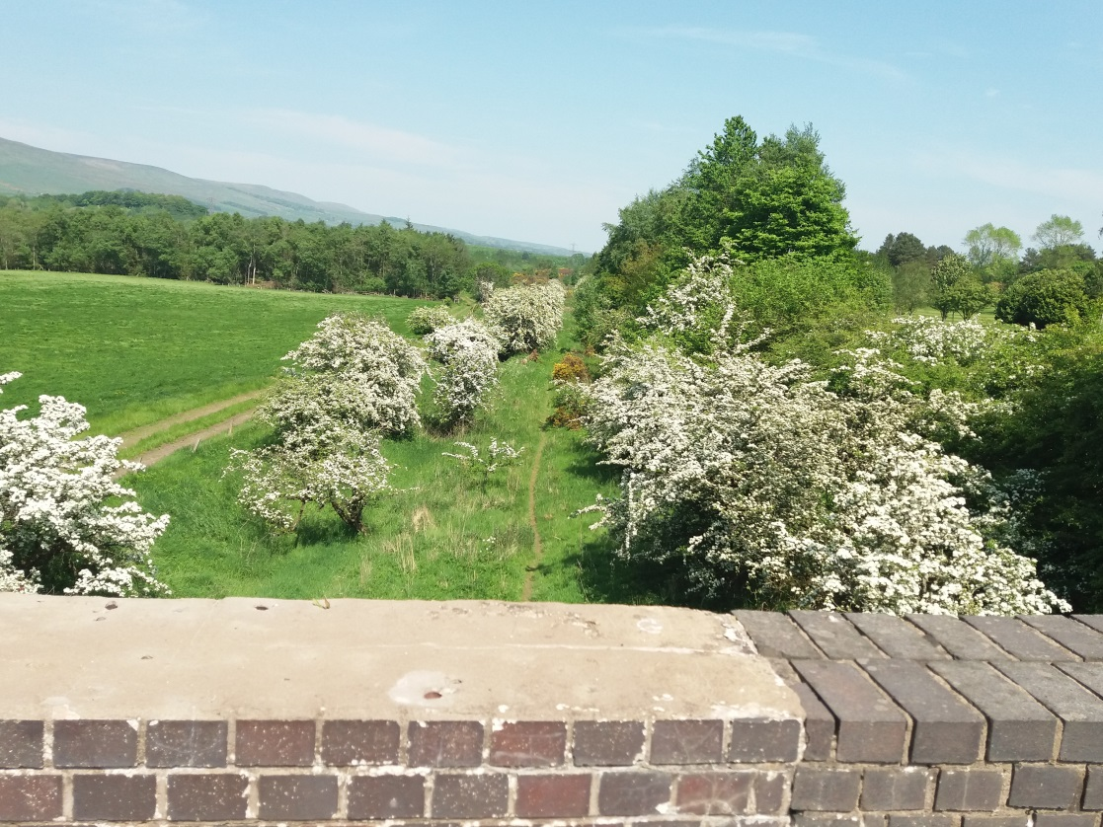
- View from the parapet of the Campsie Road bridge looking east (Direction of Kirkintilloch/Birdston/Milton of Campsie), with footpath clearly visible in centre of picture.

