Informal Survey of “Kincaid” Core path for MoCCC
The route for this section of Core Path runs from a point along the entrance drive to the Kincaid House Hotel and can be accessed either from Birdston Road or from the footpath leading to the rear of the Hotel from Alder Road, Redmoss Road etc. As with all the other Core Paths (except Strathkelvin Railway Walkway) the route is of compacted earth with areas of soft ground or areas liable to ponding after heavy rain and from adjacent poorly drained soils. The surface in places as some trip hazards due to the unevenness of the paths, tree roots and changes in elevation. At the start of the path from the Hotel Drive there is a dilapidated section of boardwalk and bridge over a stream that required attention.
The route can also be used as part of a more circular walk with access paths (not all Core Paths) to other Core paths e.g. link from Birdston to the Strathkelvin Railway Walkway) or the kelvin velley way etc.
The route is considered suitable for most walkers, however only the section through the Woods on Skimmers Hill (Hazel Wood, Fairy Woods) from the Foot of Alder Road to Hazel Bank are possibly suitable for wheelchair users – with assistance, or those with prams or buggies.
While walking boots are not necessary it is recommended that stout shoes or walking trainers are worn particularly after periods of heavy rain

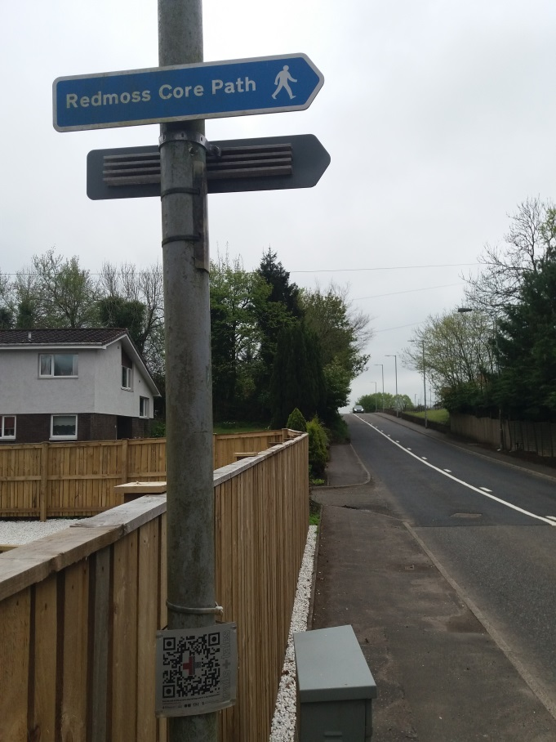
- Directional signpost for Redmoss Core path opposite entrance to Kincaid Hotel on Birdston Road. Note no further signage in place along drive to Hotel or at footpath from rear of Hotel.
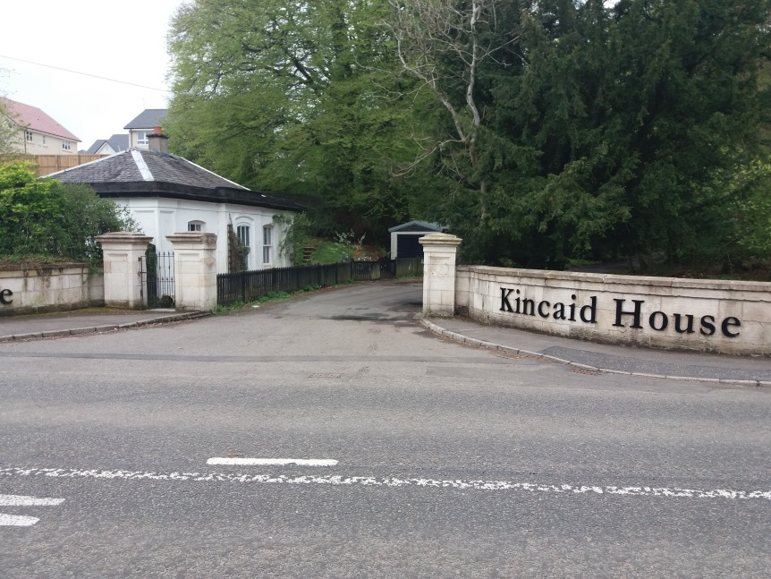
- Driveway entrance to Kincaid Hotel from Birdston Road and start of Core Path Route
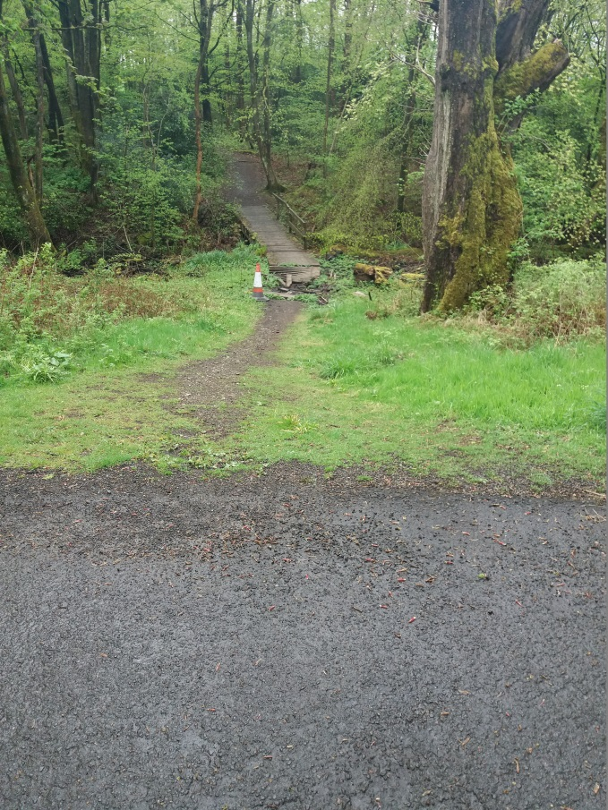
- Part way along drive to hotel start of Core Path through woods on left. No signage visible.
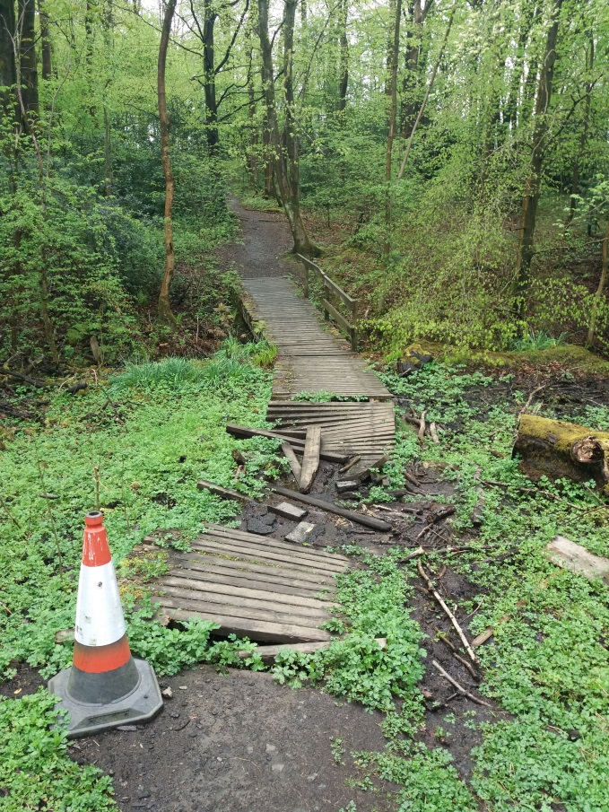
- View of dilapidated section of Duck Boards over soft ground and bridge over burn over which path crosses.
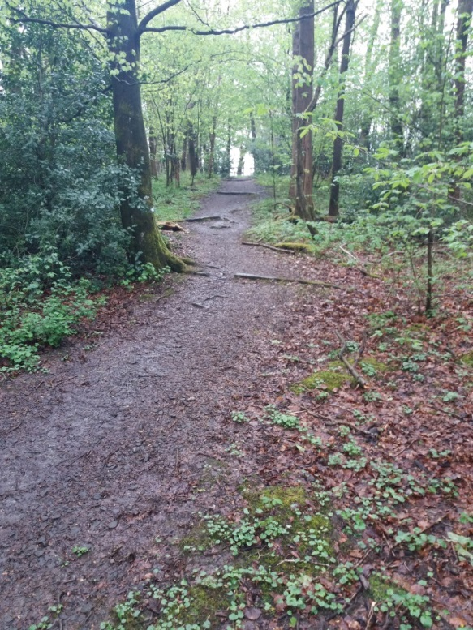
- View up rise at far side of bridge in Picture 4 towards grassed area behind recent Cala Development. Note kerbing installed part way across path to divert rainwater and path erosion. Width of path now extends beyond “kerbing”
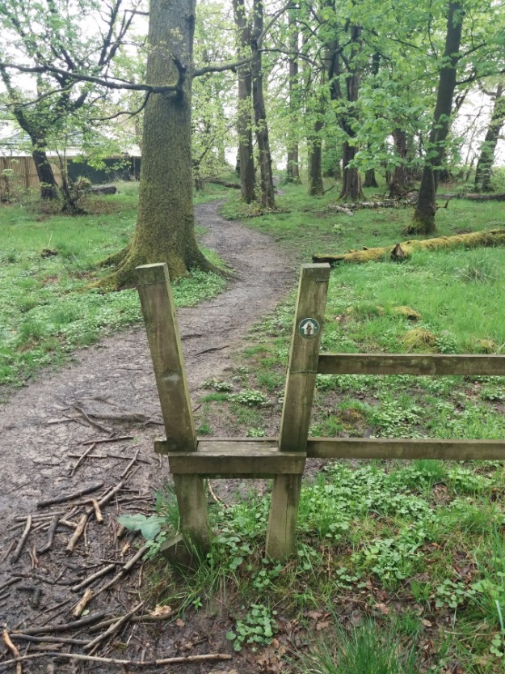
  - View of original “keyhole” type style on fence delineating change in property ownership. Note gap in fence to left negates use of “Style”. Way marker on LH post, no other similar way markers were noted along this or any other Core paths nor is there any indication on map boards etc. or other documents of existence of such. Sections littered with small branched to cover areas of soft ground.
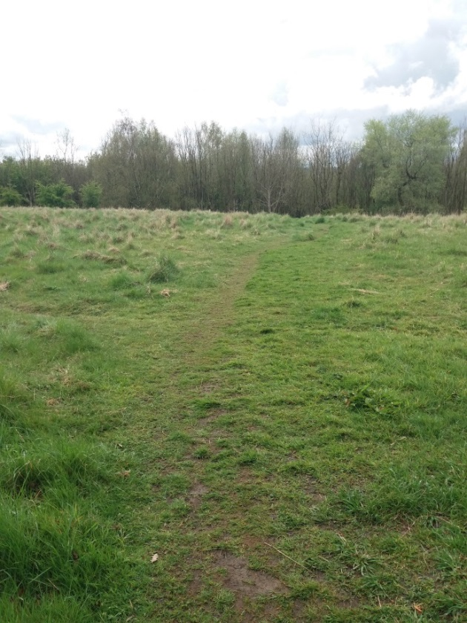
- On reaching top of rise the area opens up to open grassland (behind recent Cala Development). Path can be seen continuing across grass towards the edge of the “Community Woodland” in the far ground of picture.
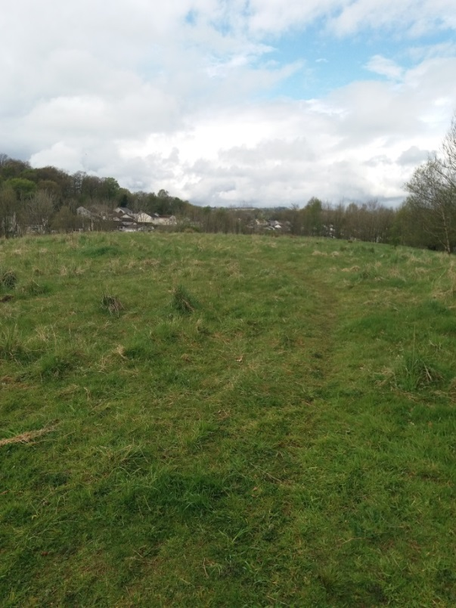
- Taken from the same point as picture 6, looking towards West towards Alder Road other paths are noted (Not Core paths)
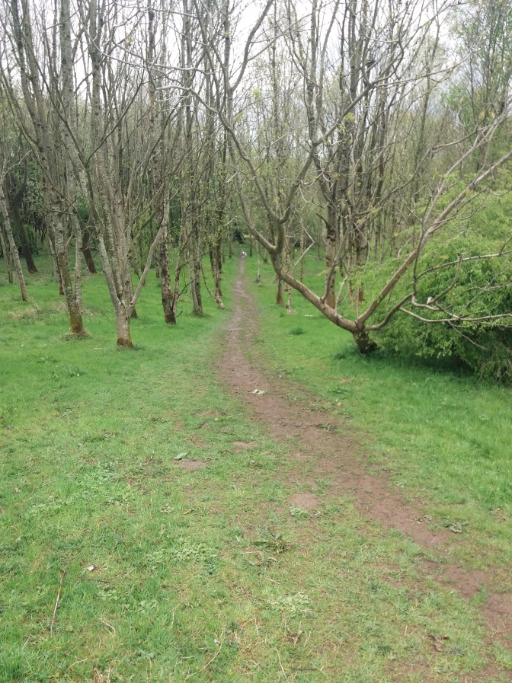
- Core Path continues into edge of Community Woodland which extends left (East) towards Birdston Road and right (West) towards grass panel at foot of Alder Road.
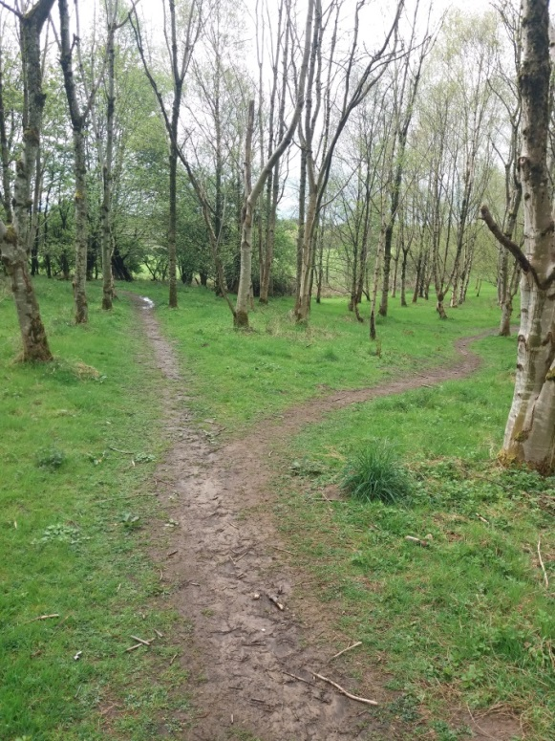
- Continuing on the Core Path into “Community Woodland” the path splits, with the Core Path continuing to the right toward the grass panel at the end of Alder Road. The left hand fork continues through the “Community Woodland” and is not classed as a Core Path. The following two pictures are taken along this section.
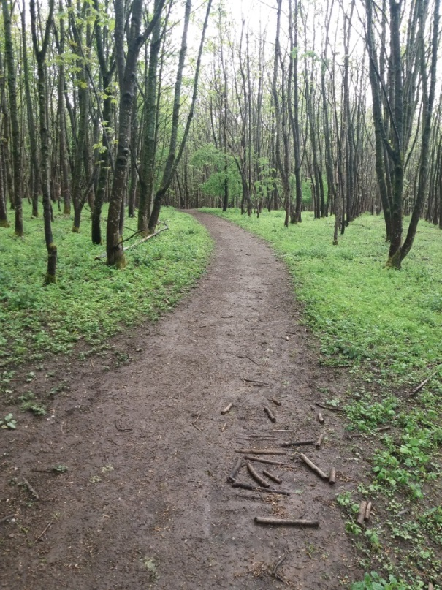
- Following the left hand (Non-Core Path) through the “Community Woodland” the path is in good condition of compacted earth and well drained.
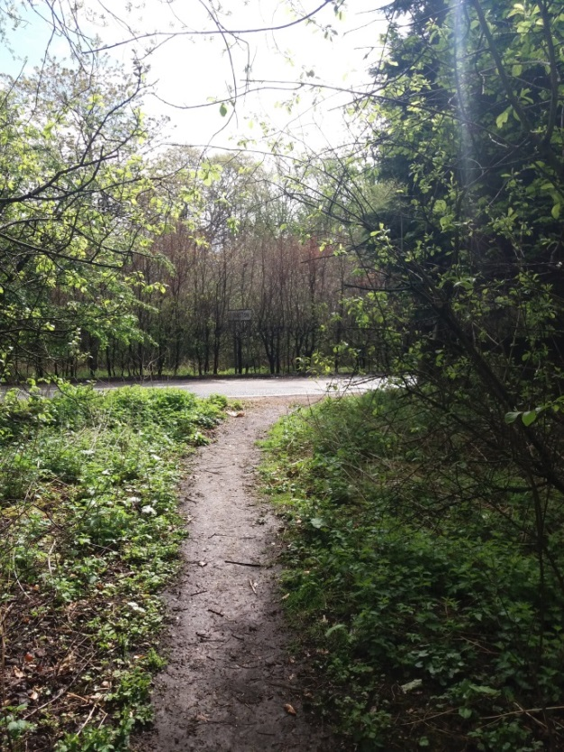
- The path exits the wood and joins the footpath on Birdston Road, just north of the Bus Stop near Birdston House and opposite the Birdston name Sign I.e. the name sign facing Milton of Campsie. This sign can just be seen in the picture opposite the exit, however as previously brought to the attention of the CC is not visible to Road users to tree/hedge encroachment.
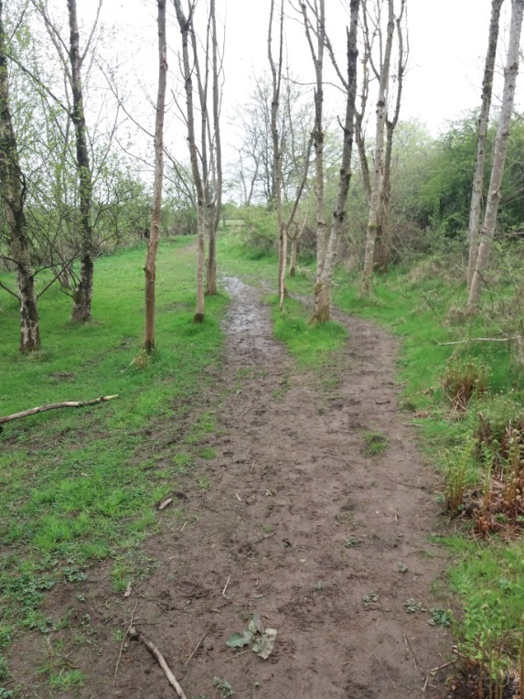
- Returning back to the Core Path by following the RH fork shown in picture 9 the path continues over soft ground through the woodland towards a partial fence line with a “keyhole” type style. The fence line delineates the boundary between the Woodland and the grass panel at the foot of Alder Road. Fence line just visible in distance of Photograph.
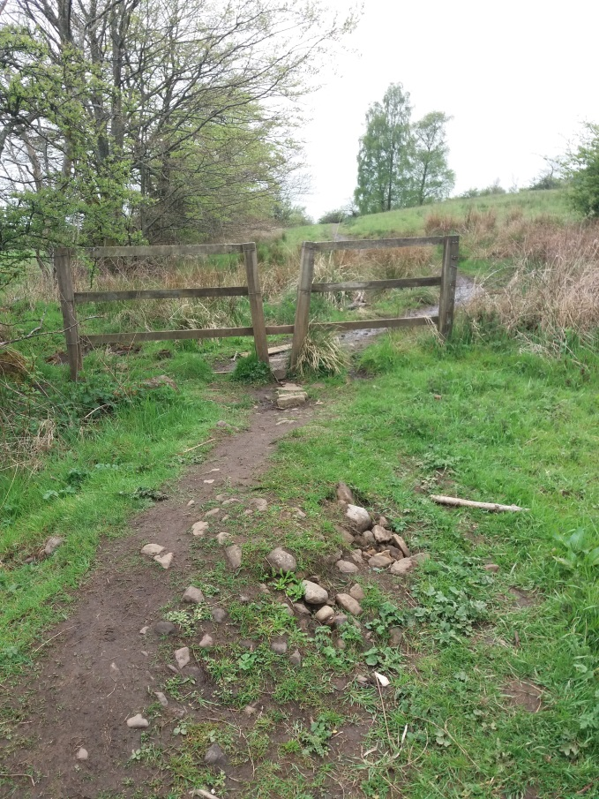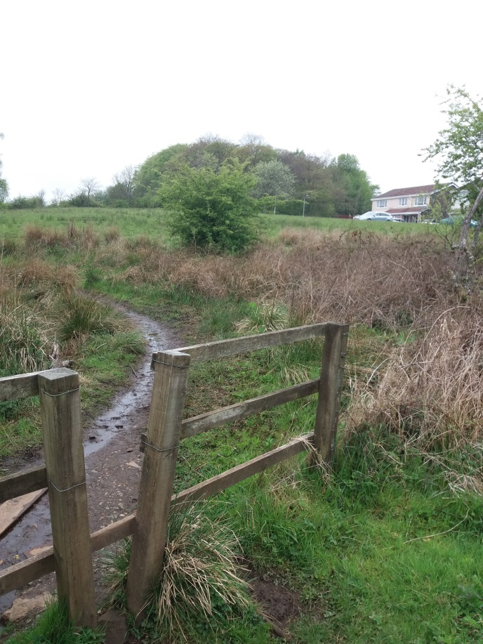
- View of “keyhole” style gate described in picture 12. LH photo shows houses at end of Alder Road. Path on opposite of gate shows some ponding along length of path.
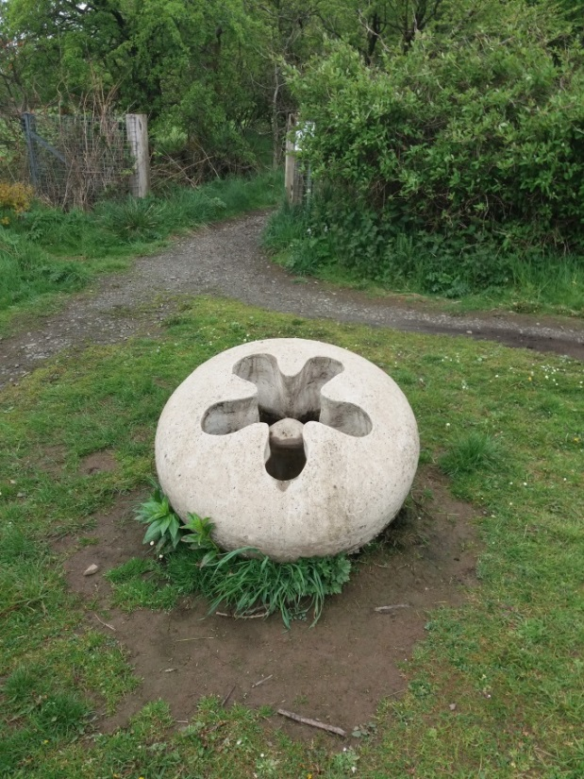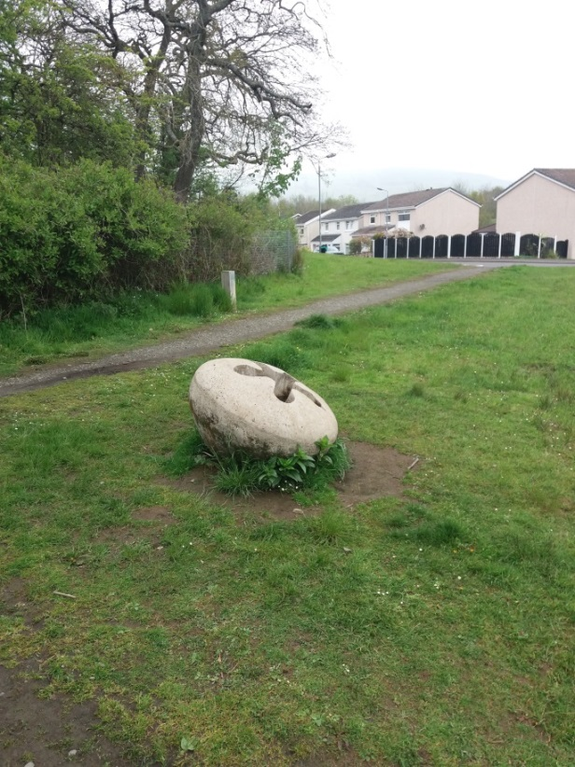
- Following the path round the edge of the grass panel toward the corner of the woods on Skimmers Hill (also known locally as Hazel Woods or fairy Woods) the above two pictures show the installation of the Gumnut Community Art piece. The LH picture shows the path followed from Picture 13, with the entrance to the woods and the path running R – L is access from the end of Alder Road
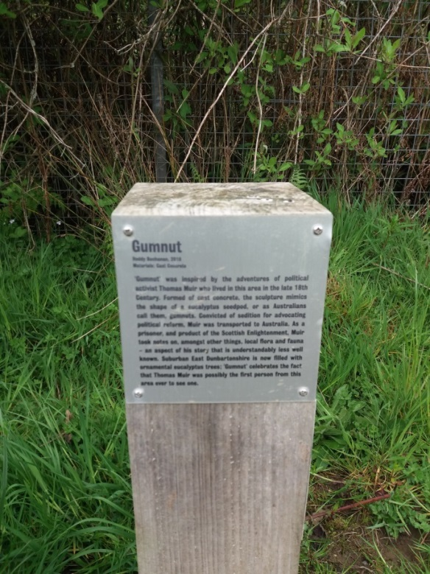
- The post above (also seen in centre of RH picture 14) gives detail of the Gumnut art piece.
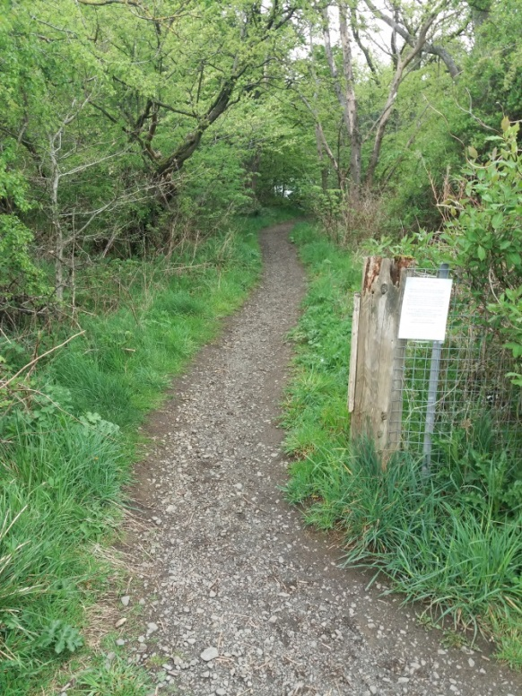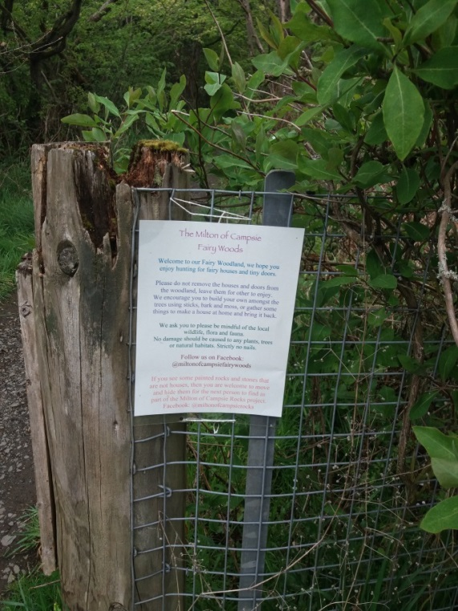
- Picture showing entrance to woods on Skimmers Hill, also nown as Hazel Woods or Fairy Woods showing descriptive piece erected concerning the “Fairy Trail” in the woods. It is understood that this was installed by a local resident to entertain young children.
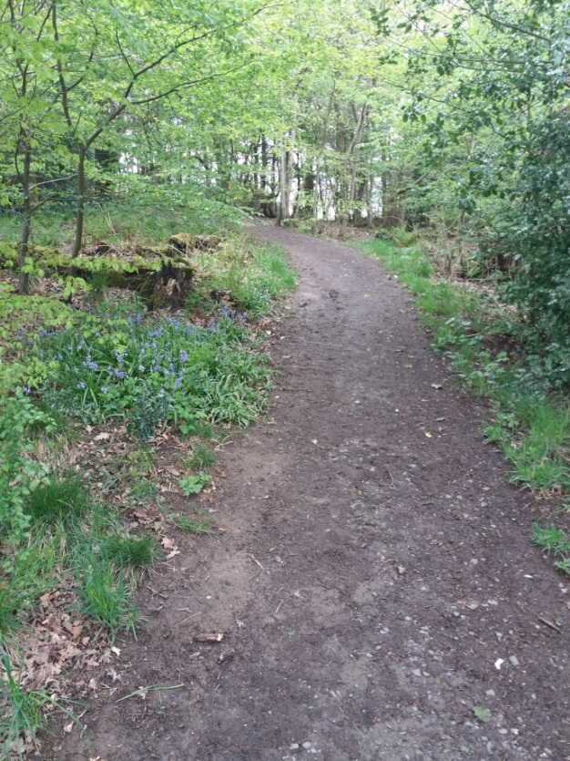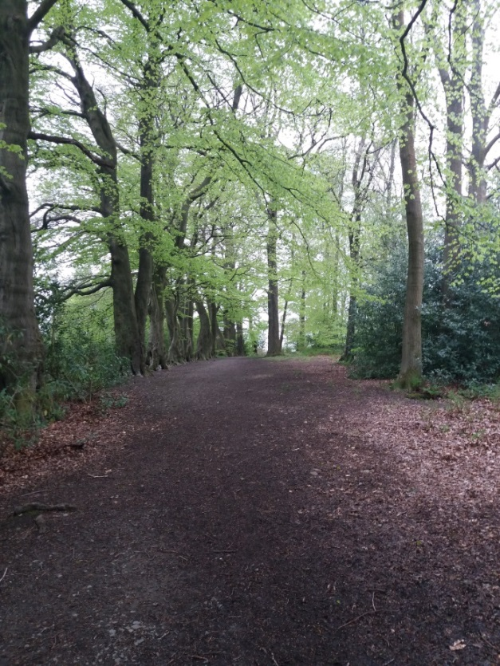
- The Core Path continues through the wooded area and provides a tranquil short walk round to the foot of Hazel Bank. This section of the path appears to have been constructed with compacted hard-core and is in good condition all the way to its exit at Hazel Bank (see picture25. It could possibly be considered with the exception of the Strathkelvin Railway Walkway the only section of the Core Paths that is suitable for Wheelchair users (with assistance) and persons with prams or buggies.
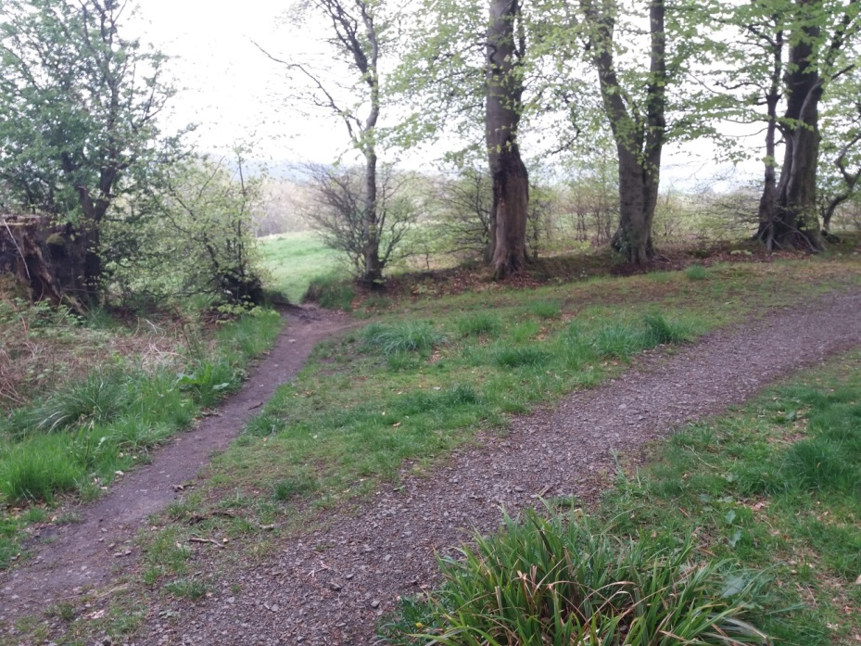
- Path divergence at the highest point of Skimmers Hill. The LH path continuing into the grassed area behind Juniper Drive is the Core Path while the more structured path off to the right continuing down towards the rear of Juniper Drive and access to Hazel Bank (entirely within the woods) is not classed as a Core Path with the Core bath following a parallel route to the RH fork across the grass area (out with the woods) towards the rear gardens of Juniper Drive.
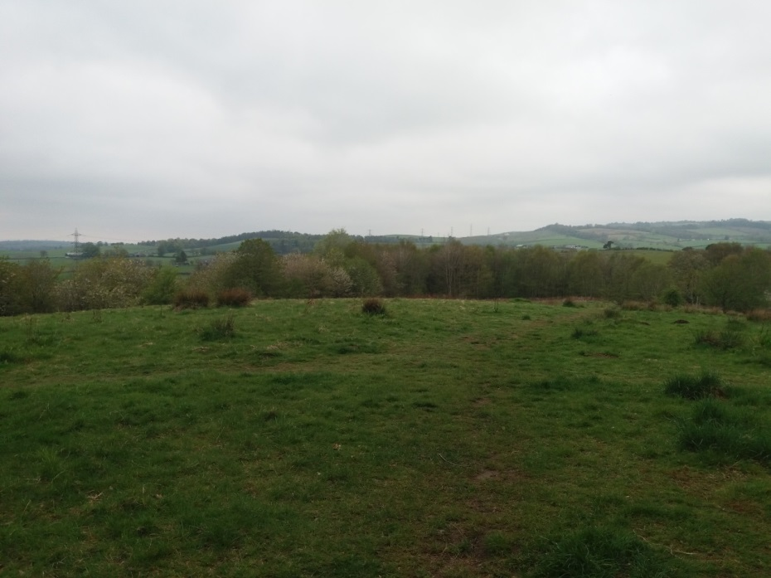
- View taken from LH path shown in picture 18 just out of the woods. This is where this section of core path (originating from the Kincaid House Hotel Drive meets with the Core Path across the wider area of Redmoss Grassland. The path continues to the right down to the rear gardens of Juniper Drive then runs north behind the gardens of Cherry Place and onto the end of Redmoss Road. To the left the path runs down to meet with the Kelvin Valley Way i.e. the continuation of the Track that runs from Birdston Farm. See separate survey report for both these sections.
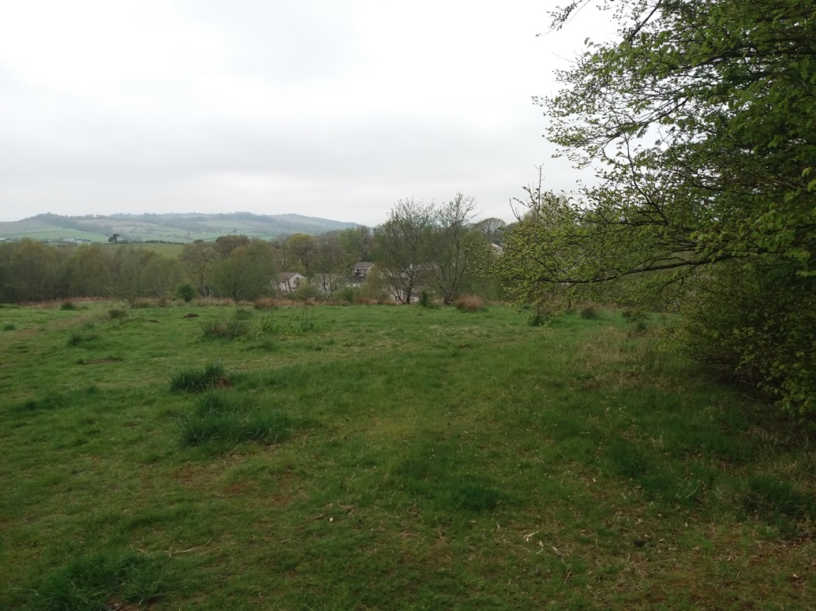
- View from exit point of woods with view towards Juniper Drive. The Core Path runs down towards Juniper Drive and along past the rear gardens out with the woods, while the more walked and visible route cuts diagonally access the grassed area of the corner of the rear garden of the last house in Juniper Drive.
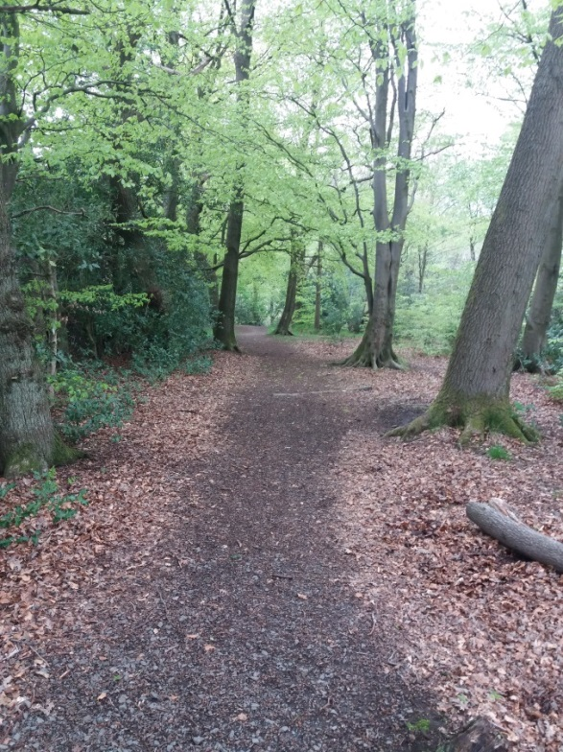
- Returning back to the path within the woods on Skimmers Hill the path continued down towards the rear of properties on Juniper Drive
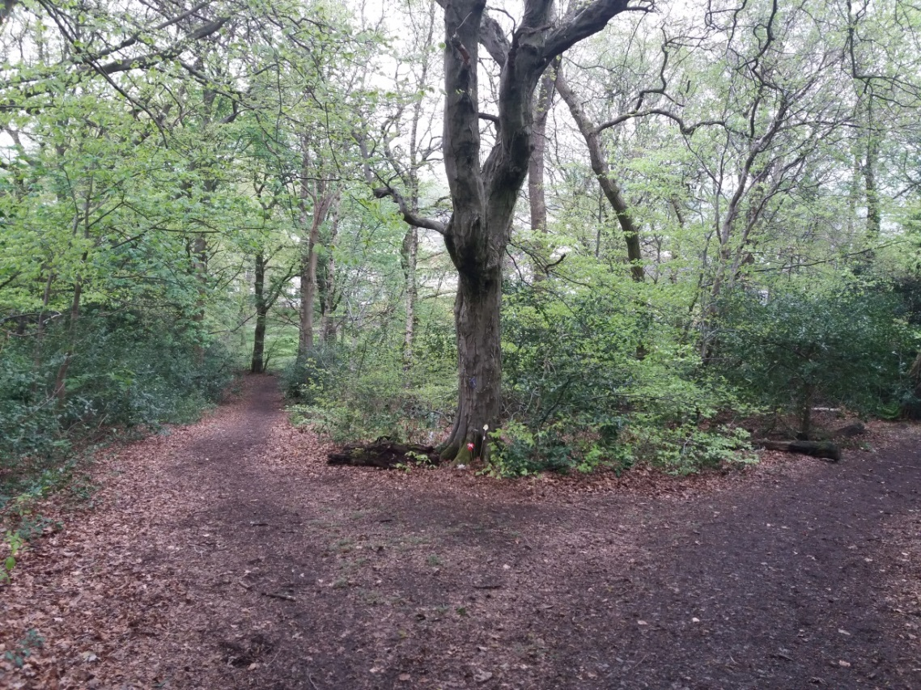
- As one approaches the rear of the properties on Juniper Drive with the path following the rear of the gardens of the properties on the “hill” section of Hazel Bank the path splits. The RH fork proceeds to its exit at the end of Hazel Bank with the LH fork continuing towards the Rear of Juniper Drive.
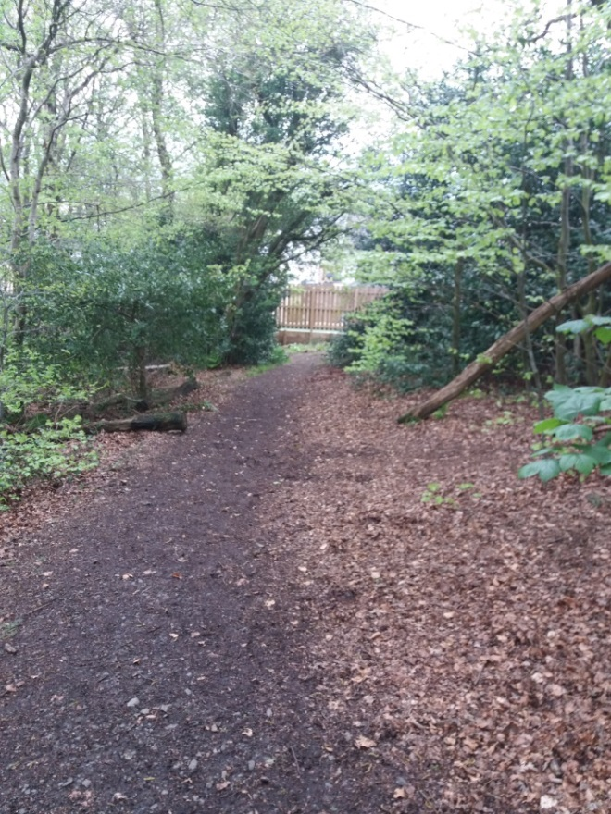
- View along RH fork of path in picture 22 showing rear fence of property in Hazel Bank.
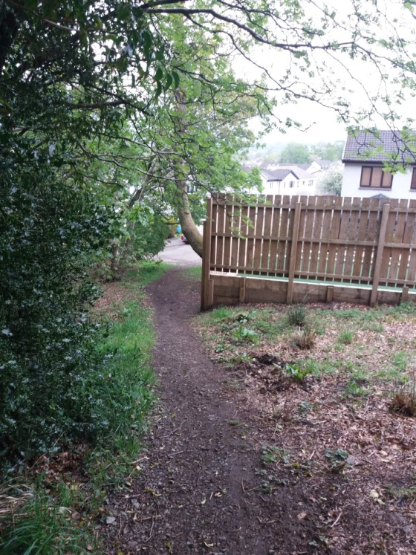
- View showing end of RH fork from picture 29 passing rear fence onward to Hazel Bank
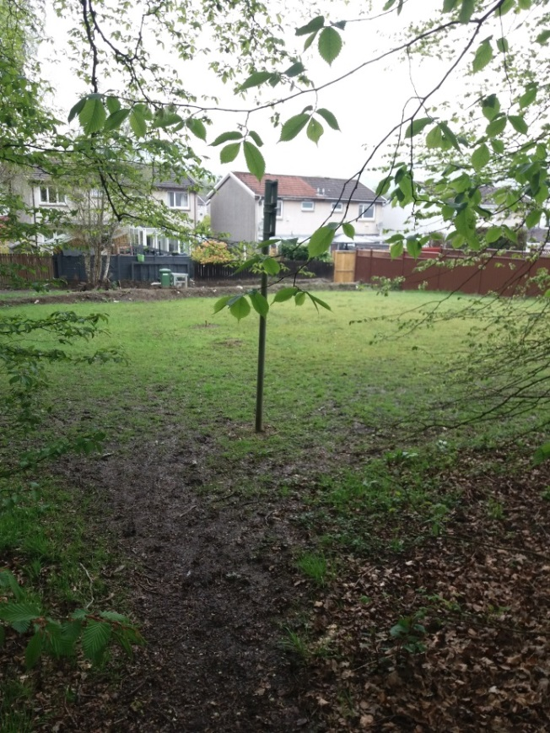
- View showing end of LH fork in picture 29 ending in grassed play area behind Juniper Drive. This area is very badly drained.
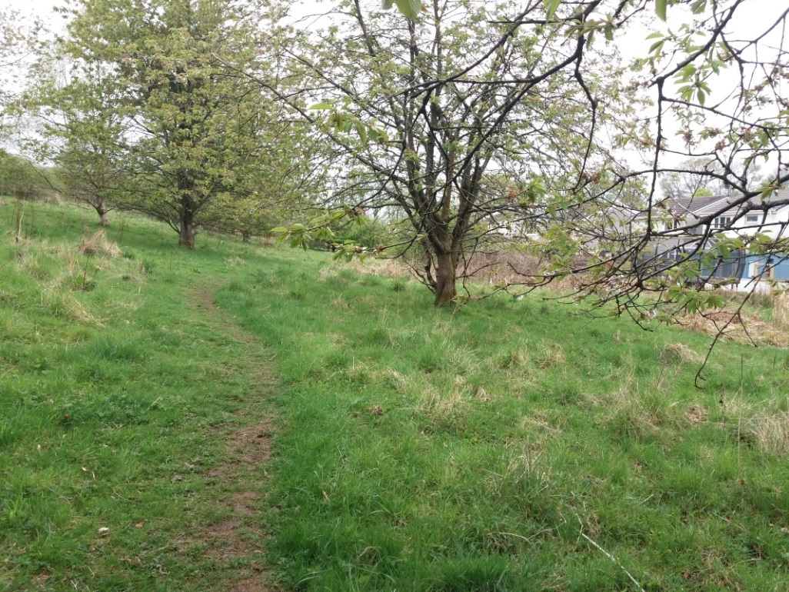
- View of Core path running parallel to the rear gardens of Juniper Drive. Picture taken from just outside the woods at edge of Grass Play Area shown in picture 25.
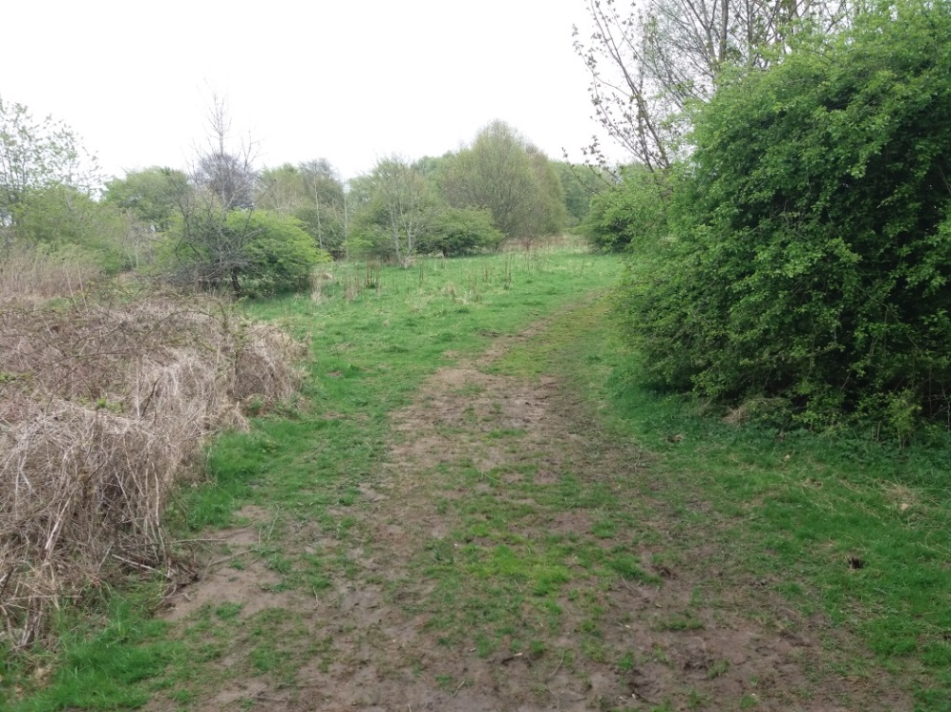
- View of the more walked route from the rear corner of last house in Juniper Drive to highest point of Grassed hill adjacent to woods on Skimmers Hill. The core path in effect runs round the edges of a rectangle formed by the grassed hill while the more walked route cuts diagonally across it.
It is also noted that if the grassed are is considered as the rectangle with the woods on Skimmers Hill, known locally both as hazel Woods and Fair Woods the core path runs entirely within the rectangle i.e. the well-made and walked path shown in pictures 28 – 31 is not classed as a Core Path.
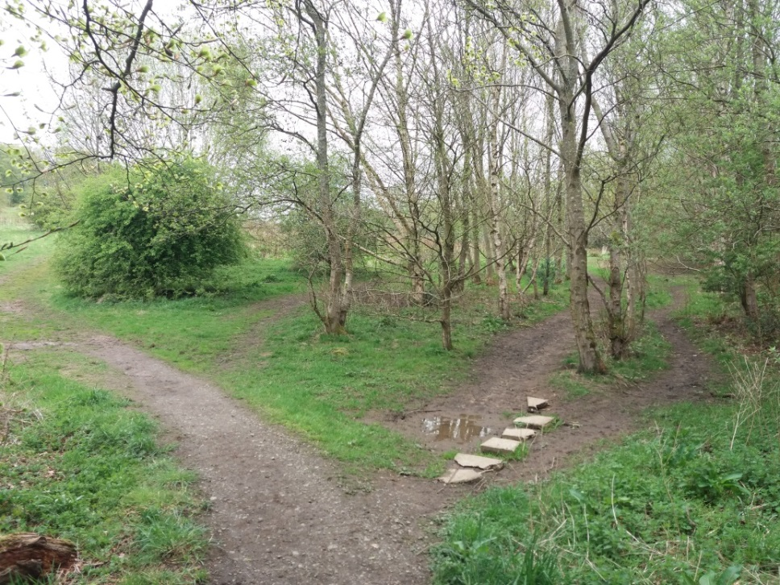
- View from taken from path at rear corner of last property on Juniper Drive. View appears to show Core Path, however Core Path is just seen mid left edge of picture edge. The path running towards top left of picture while not Core Path does end at the same point of the grass hill, while the paths identified with the broken slabs , again not the Core Path continues and eventually meets with the Core Path as the Track commencing at Birdston Farm
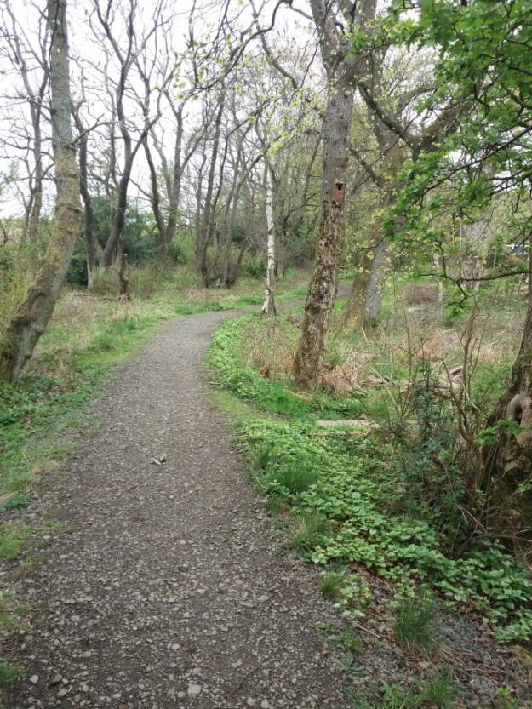
- View up Core Path (north) running behind Cherry Place. Access to end of Juniper Drive is just visible from path – mid picture right.

