MILTON OF CAMPSIE GREENBELT PRESERVATION

MEMBERS REPORT

FEBRUARY 2021

Proposed Development Adjacent to Alder Road Off Birdston Road

On 17 February I was delighted to be able to tell you that Avant Homes (Scotland) Ltd and Ashfield Land (Glasgow) Limited had decided not to proceed with the proposed development adjacent to Alder Road off Birdston Road.

I am in no doubt whatsoever that this decision was a direct result of the overwhelming number of negative responses the developers received from MOCGP members during the consultation period, particularly over the ludicrous construction and ongoing access arrangements.

As you know the site was rejected as unsuitable for development by EDC and therefore not included in the LDP2. However, I have asked EDC to confirm that the Application has been formally withdrawn and that it is not in fact going forward to the Scottish Government as an “unresolved issue”.

This is the third time in the last 10 years that we have defeated proposals to build on this site which is recognised by Scottish Natural Heritage as possessing important green network qualities and has therefore twice been rejected by SG Reporters in 2011 and 2016.  The land remains designated as protected open space and green belt in the current and proposed local development plan.

Provided that the developers withdraw any submissions that they have made to the LDP2 or the Reporter upholds the Council’s decision then it is highly unlikely that any Planning Application would succeed.

Other Proposed Development Sites

I have asked EDC to confirm whether or not the following sites will be going forward to the Scottish Government as "unresolved issues":

* Redmoss North
* Redmoss South
* Kincaidfield
* Derrywood
* Any other site in Milton of Campsie

and I have requested sight of the developer's submissions during the consultation period. These requests have been “logged as a freedom of information request and therefore the Council has 20 days to response from the date of your correspondence. You will therefore receive a response by 12 April 2021.” I have challenged the basis of this delay.

Local Garden & Designated Landscapes Designation Review Report

Baldoran & Mount Dam

(Contributed by Dr Morag Campbell)

East Dunbartonshire Council's Proposed Local Development Plan 2 (LDP2) was published for a public representation period, from 19 October 2020 to 15 January 2021 and is now the “settled view” of the Council. The LDP2 includes Policy 19 Historic Environment which states:

"The special qualities and boundaries of the Conservation Areas and Townscape Protection Areas" and "The historic environment value and boundaries of the Locally Important Gardens and Designed Landscapes are part of a review of Local Historic Environment Designations. The Plan will be updated in line with the findings of this review."

The historic environment review is of local Council designations, in the Adopted Local Development Plan 2017, including:

* Conservation Areas, defined in planning legislation as: “Areas of special architectural or historic interest, the character or appearance of which it is desirable to preserve or enhance”
* Townscape Protection Areas, defined as “localities with distinctive architectural and historic qualities”, in the existing Townscape Area Appraisals.
* **Locally Important Gardens and Designed Landscapes** (LGDL), defined as: “Grounds consciously laid out for artistic effect”, in particular sites with artistic, historical and other values.

In Milton of Campsie the only area which is protected at the moment is Baldoran and Mount Dam which is designated as “Local Gardens and Designed Landscapes”. The consultants employed by the Council are proposing de-designating this area thereby removing its protection. The area lies to the north of the road to Lennoxtown (A891). I believe that the area has been poorly represented in the consultant’s survey and their account does not demonstrate understanding of the ‘right of way’ behind the dam, the local paths and the rich history of the area.

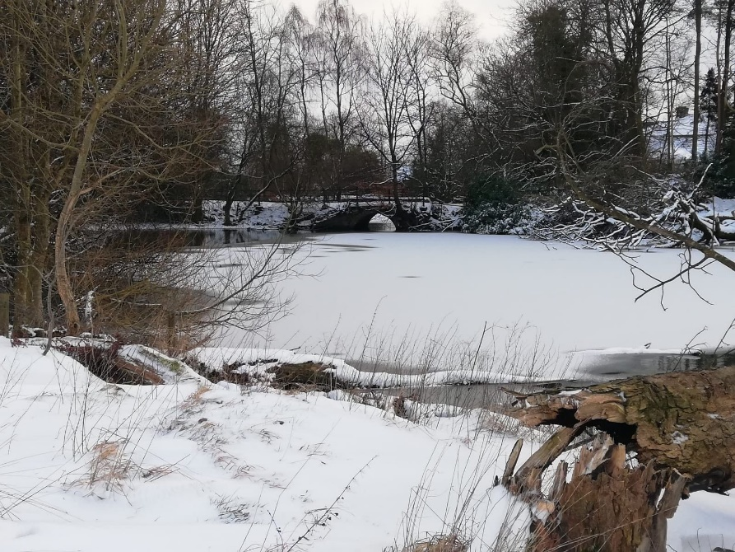

(Photograph by Jim Campbell)

You can find the Report here:

<https://www.eastdunbarton.gov.uk/proposed-local-development-plan-2-%E2%80%93-historic-environment-designations-review>

Scroll down to the bottom left to click on the [Local Garden & Designed Landscapes Designation Review Report.pdf](https://www.eastdunbarton.gov.uk/filedepot_download/279366/3401) . The section about Baldoran and the Mount Dam is on page 37.

I intend to challenge the Council’s position and recommend a change of boundary instead. The area of Baldoran has been developed with housing and I accept its de-designation. However, I believe that using the assessment applied in the process that Mount Dam should be assessed separately and retain its designation. I also will be proposing that the Alloch Dam is added to the area and should be designated “Local Garden and Designed Landscapes”. This designation provides additional protection to the area from housing development. On its own it will not prevent development but will support any future fight against development.

Many of you will know the area as a local beauty spot, and as an important part of our industrial heritage which was dependant on water supply.

It is important to protect the boundaries of the village from development and I am asking that anyone who agrees completes the consultation document which can be found half way down the left-hand side of the page here:

<https://www.eastdunbarton.gov.uk/proposed-local-development-plan-2-%E2%80%93-historic-environment-designations-review>

before the **deadline of the 31st of May**. You can also email or write to the Planning Department.

[development.plan@eastdunbarton.gov.uk](mailto:development.plan@eastdunbarton.gov.uk)

Land Planning Policy Team  
East Dunbartonshire Council,  
12 Strathkelvin Place,  
Kirkintilloch  
G66 1TJ

Please remember to **include your name and address** and make your subject or heading:

Local Gardens and Designed Landscapes - Baldoran and Mount Dam.

THIS SPACE IS INTENTIONALLY BLANK

Birdston Community Woodland Car Park

Alleged Breach of Planning Control at Land South of Gas Governor, Birdston Road, Milton Of Campsie

Our Chair, Dr Morag Campbell wrote to the EDC Planning Enforcement Officer about the fact that the car park has been closed and turned into an untidy dumping ground/builder’s yard. Morag questioned whether any change of use has been granted for this car park. The area has become an eyesore and there is a security light that is distracting to drivers on the road at night as it shines in driver’s eyes.

This reply was received on 8 March 2021.

“I have recently spoken with the new owners of the woodland area who have  
advised that they are carrying out maintenance works to the land. The works  
comprise of the thinning out of trees, the planting of additional trees and  
the dredging of the existing boundary ditches. I am awaiting the submission  
of written details of this.

I understand that the gates have been erected as a security measure to curb  
illegal fly-tipping. However, this is only one of a number of identified  
breaches of planning control at this particular site which is the subject of an ongoing investigation.  
  
I have added your name to the Case File under reference ED2020/0127/ENF”.

* **Any member who wishes to pursue this matter directly with the Council should email the planning Enforcement Officer** [**Jim.Jamieson@eastdunbarton.gov.uk**](mailto:Jim.Jamieson@eastdunbarton.gov.uk) **quoting the above reference in the subject line.**

Birdston Coup

We are indebted to one of our members who has expressed serious concern about the tipping on Birdston Coup. Our member attempted to walk the footpath from Birdston Road and link up with the path at the cats walk. The first problem she encountered was the footpath on the main road at the entrance to the coup; as many of us know, currently you have to go into the road to get past the mud and puddles. The path from there alongside the track up to the coup is very muddy and almost impassable because of the mud and water thrown up by the heavy lorries which go up and down all day. Our member tried to follow the path as it turns right around the back of the golf course but it was impossible to proceed further as the liquid mud was over the top of her walking boots.

At my suggestion our member raised this matter with the Council Planning Enforcement Officer and also pursued it directly with the Scottish Environmental Protection Agency (SEPA). She very quickly received a phone call from one of their Officers. The additional capping on the coup has been authorised by SEPA in order to bring the land back for agricultural use. Apparently, the land owner has employed a company from Northern Ireland to carry out this work. It should be finished in about a year but they could apply for an extension if the work is not completed. Our member pointed out damage to the environment by very muddy sludge escaping into water courses but was told their inspectors cannot come to the site to monitor it because of the pandemic.

On the subject of the state of the road from the site traffic our member was told that this was a matter for the local council. The footpath possibly may need to be closed on occasion to allow work to be carried out.

Members who wish to follow up on this issue can find SEPA’s contact details on their web site <https://www.sepa.org.uk/contact/> or contact the EDC Planning Enforcement Officer (in respect of the condition if the road and footpath) [Jim.Jamieson@eastdunbarton.gov.uk](mailto:Jim.Jamieson@eastdunbarton.gov.uk)

Parking Outside ScotMid Coop

I have continued to follow up on members’ concerns about this issue which has been ongoing for many years.

The most recent update I have received via Cllr Hendry was on 15 February when he passed on an email from the Executive Officer Roads and Environment:

“In relation to the further comments made by your constituent in regards to the current restriction and also the Transport (Scotland) Act 2019 the Community Safety Team do agree that the restriction currently in place only allows for 'the continuous movement of heavy or bulky goods to and from a vehicle' but this restriction also requires a reasonable time to be given to observe whether this loading and/or unloading is taking place. The agreed observation period allowed within East Dunbartonshire Council (and I believe in many other Local Authority areas) is 10 minutes. Therefore, until a vehicle has been observed parking on this type of restriction for a period of 10 minutes and no loading and/or unloading has been observed then no enforcement action can be taken. We will continue to monitor the area as much as possible and where we observe an offence taking place, we will ensure that the appropriate action is taken.

In regards to the Transport (Scotland) Act 2019 and in particular the

pavement parking - I can confirm that this legislation came into being

in November 2019, but the associated guidelines have yet to be published

which means that the Service is unable to undertake enforceable action

at this time. The Service estimate that it will be circa 2022 before the

Community Safety Team will have the ability to take any enforcement

action for offences being committed under this legislation. In the

meantime, pavement parking where a vehicle is parked in such a manner

that it is believed to be parked dangerously or causing an obstruction.

For the time being this would remain a matter for Police Scotland to

investigate and take any action if the vehicle was causing an

obstruction or parked dangerously. I would advise that Police Scotland

should be contacted on 101 at the time of the alleged offence taking

place to allow them to attend to investigate. The Service will also

raise the issue of pavement parking at this location at the regular

Police Scotland liaison meeting to ensure that the concerns have been

highlighted.

The Service recognises the concerns raised and think that a review of

the wider area may be of benefit going forward. This would require a

revised traffic survey which would inform the potential actions related

to parking and crossing points in the local area. In general, it is

accepted that traffic volumes are down during the ongoing public health

situation so the Service plans to initiate a new survey once the ongoing

lock-down measures are scaled back and the information collected is an

accurate reflection of traffic flow and volumes.

Upon completion of the survey the service would use this information to

decide on the best course of action. Upon completion the Service would

be happy to share this information and any proposed actions.”

To be perfectly honest this is just passing the buck, so I have responded as follows:

“It is disappointing to note that despite the fact that the new Act came into force in November 2019 "The Service estimate that it will be circa 2022 before the Community Safety Team will have the ability to take any enforcement action for offences being committed under this legislation"; so, I am copying this to our MP because I think that Mrs Mackay will find this information quite surprising.

(I submitted additional pictures showing that passing vehicles are forced on to the opposite side of the road.)

This situation has been going on for many years, indeed the late Cllr Kennedy tried in vain to find a resolution.  It is clear to us that if shoppers will not use the nearby car parks and the Council can't or won't enforce the regulations then realistically there are only two options:

1. place bollards all along the pavement outside the shop forcing delivery vehicles to park elsewhere (unless the bollards were removeable, which might be impractical) and private cars may simply park on the road; OR
2. create a two-car parking bay outside the shop, which would permanently reduce the width of the pavement.”

Alan S Harris

Secretary

Milton of Campsie Greenbelt Preservation

14 March 2021.