Informal survey of Redmoss Core path for Milton of Campsie Community Council
Section: Redmoss Road – Strathkelvin Railway Walkway
Throughout its length the path consists of compacted earth and as a result of its constant use in places is below the grass level of the ground on either side. The path crosses areas of poorly drained soil and changes in elevation accordingly and is subject to water flowing along its length and subject to ponding water during and after periods of heavy rain. There are areas where residents have spread red path gravel or placed broken slabs to either fill in depressions or combat soft ground conditions.
While walking boots are not essential in periods of dry weather, wellington of waterproof boots are recommended after periods of heavy rain. The path is not suitable for wheelchair users of person with prams or buggies and is subject to changes in elevation and some trip hazards due to the unevenness of the ground.
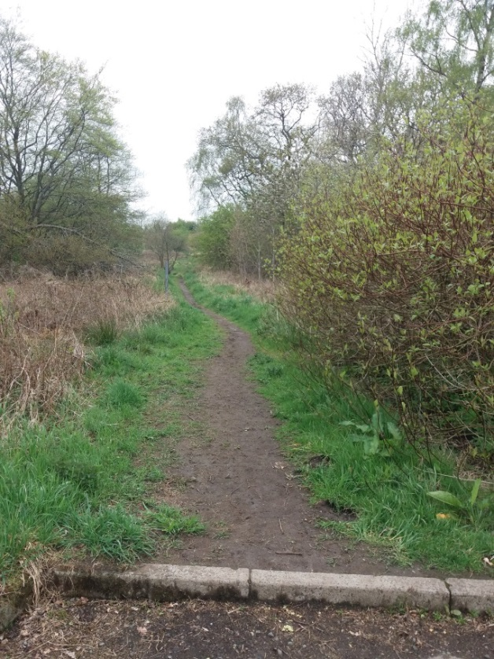
- View from end of Redmoss Road (foreground shows kerb line) looking into access point for Redmoss Core Path (looking west)

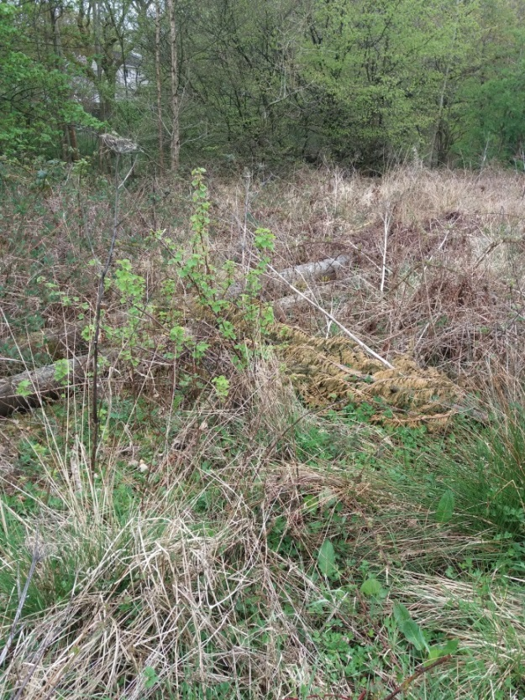
- View of old telegraph poles adjacent to access point to Redmoss Core path from end of Redmoss Road. Poles left by BT contractors after installing new poles in Redmoss Area within last two years.
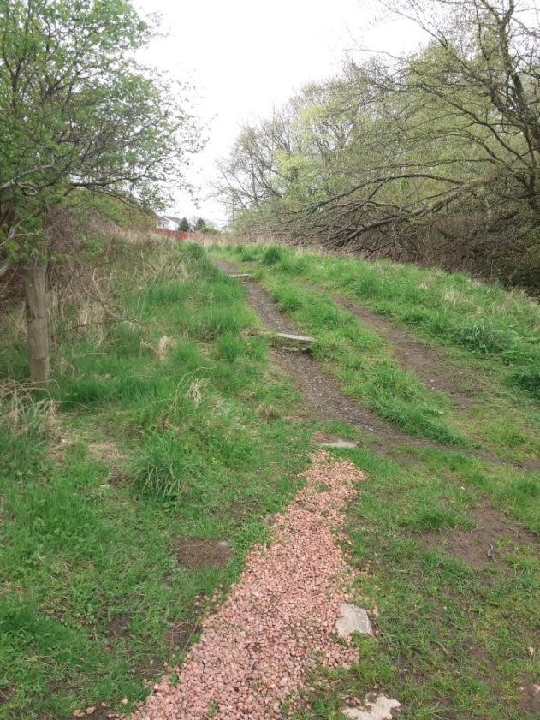
- View looking east from Redmoss Core path towards entry point from end of Redmoss Road. Note area of “red Chips” placed by residents in area liable to ponding or soft ground. Two entrance paths have been created, RH has two kerbstones making two steps while LH is sloped
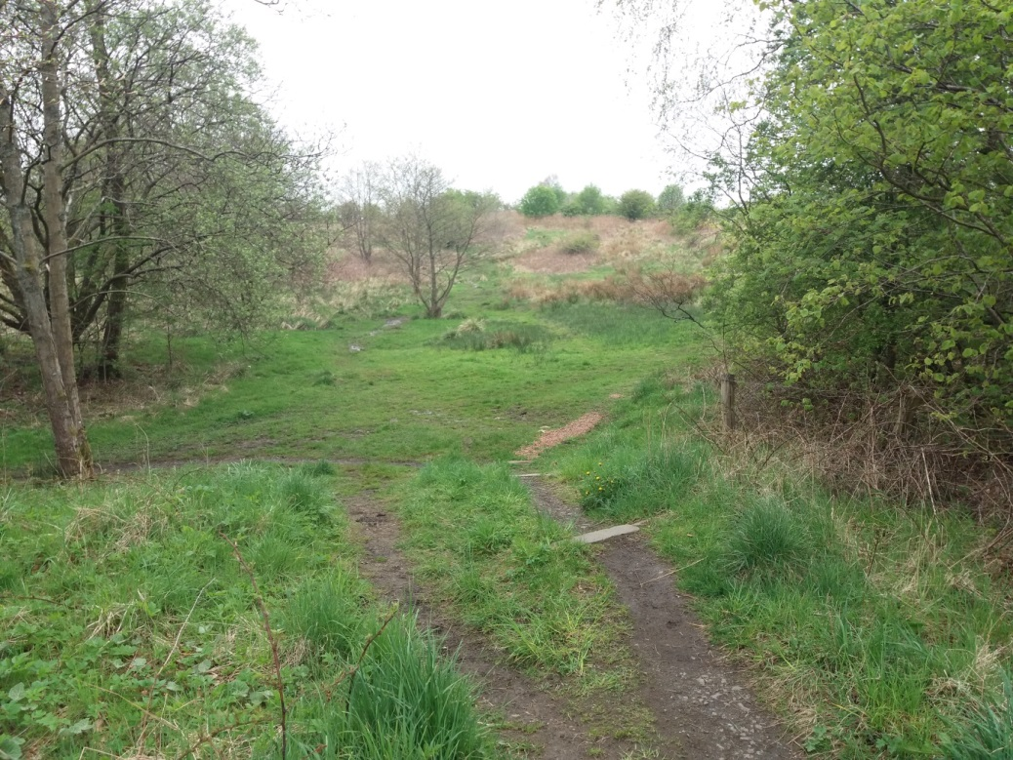
- Similar view to Picture 3, this time looking west into Redmoss from end of Redmoss Road.
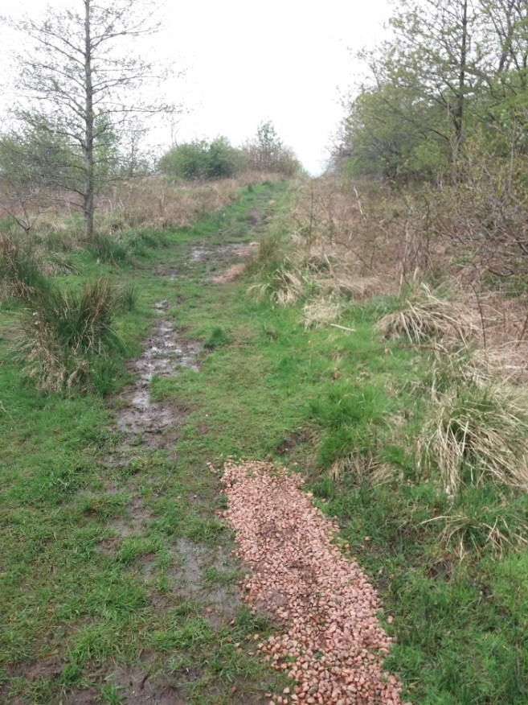
- Having accessed the Redmoss Core path from the end of Redmoss road the path turns right and runs behind the houses on Laburnum Drive. This view shows the path running up hill behind these houses. Path is of soft ground and liable to ponding in areas of soft ground or where subject to erosion. Sections have been filed with “red Chips” by residents.
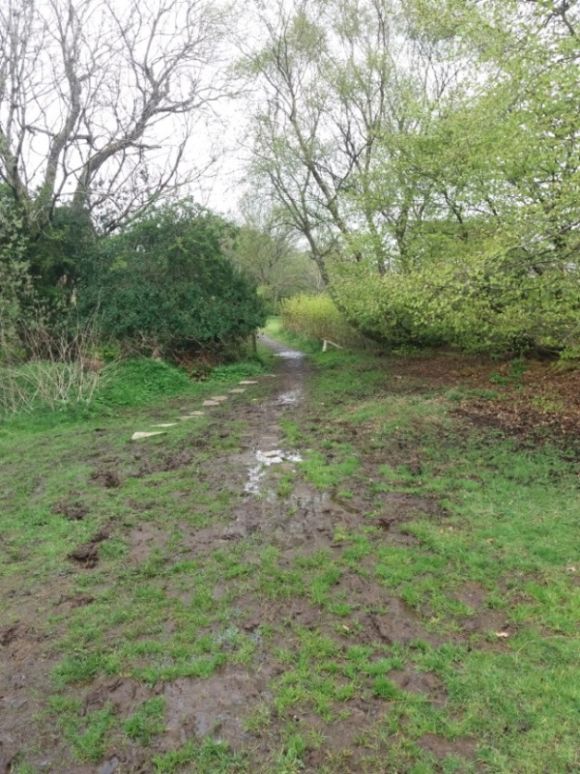
- View from Redmoss Core path looking west towards access point from Laburnum Avenue. Area heavily waterlogged with evidence of stepping stones (broken slabs) being placed by residents.
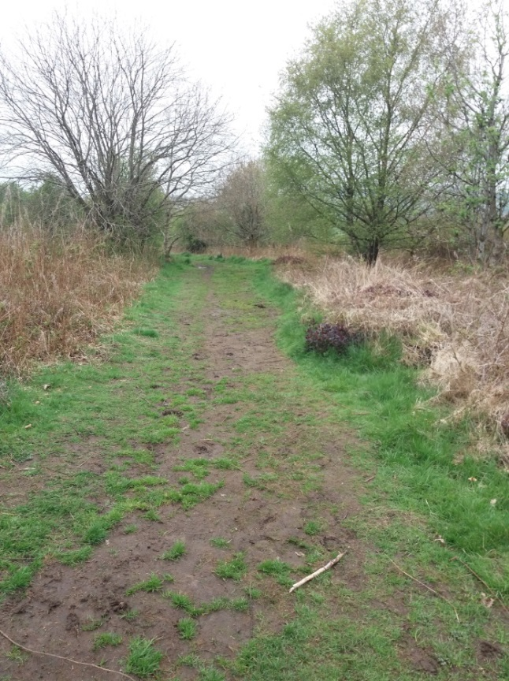
- View looking east along Core path from same vantage point as picture 6.
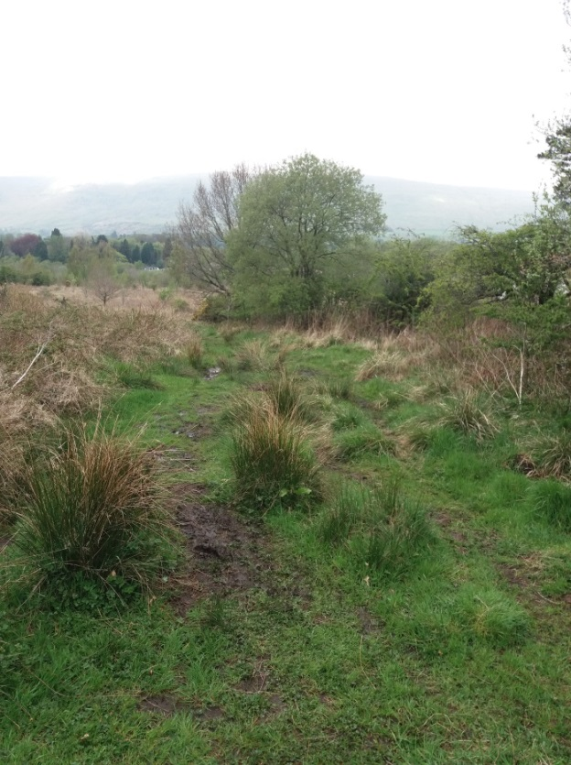
- View looking north if one continues strait on following the rear of houses on laburnum drive, at access point from laburnum Drive. Access point is to RHS of photograph, with Core Path continuing to LHS of Photograph.
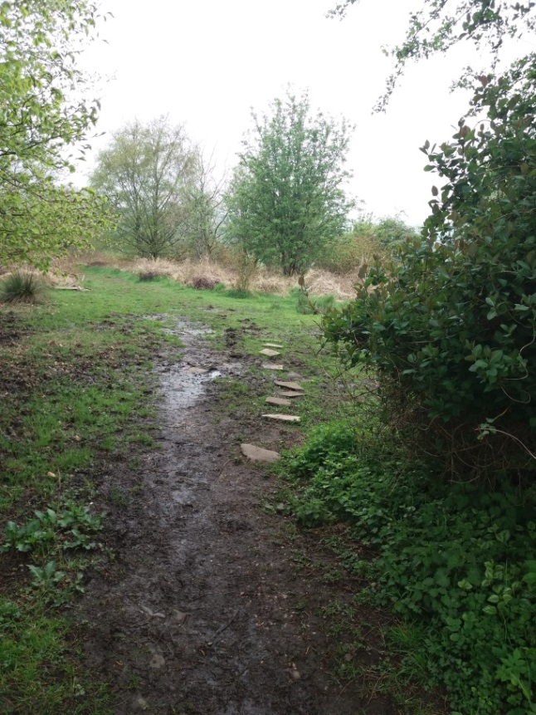
- View of access point to Redmoss Core Path from shrub /fence line shown mid picture in picture 13. Path heavily waterlogged/ponded with ad hoc stepping stones placed by residents
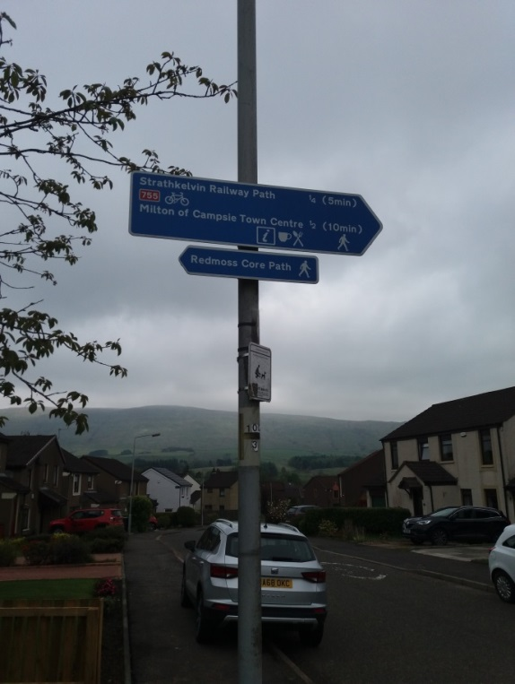
- Directional signs on lamp post on laburnum Drive at access point to Redmoss Core Path – see also picture 12.
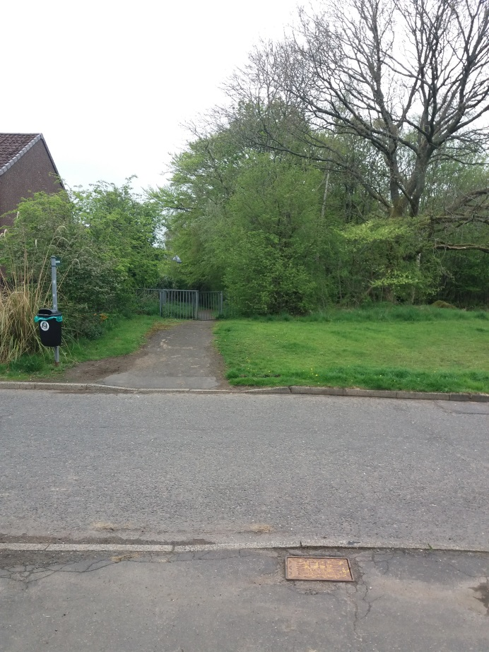
- View of end of Nappie Loan Path which runs from Cairnview Road to Laburnum Drive. Picture taken from access point to Redmoss Core path on opposite of laburnum Drive.
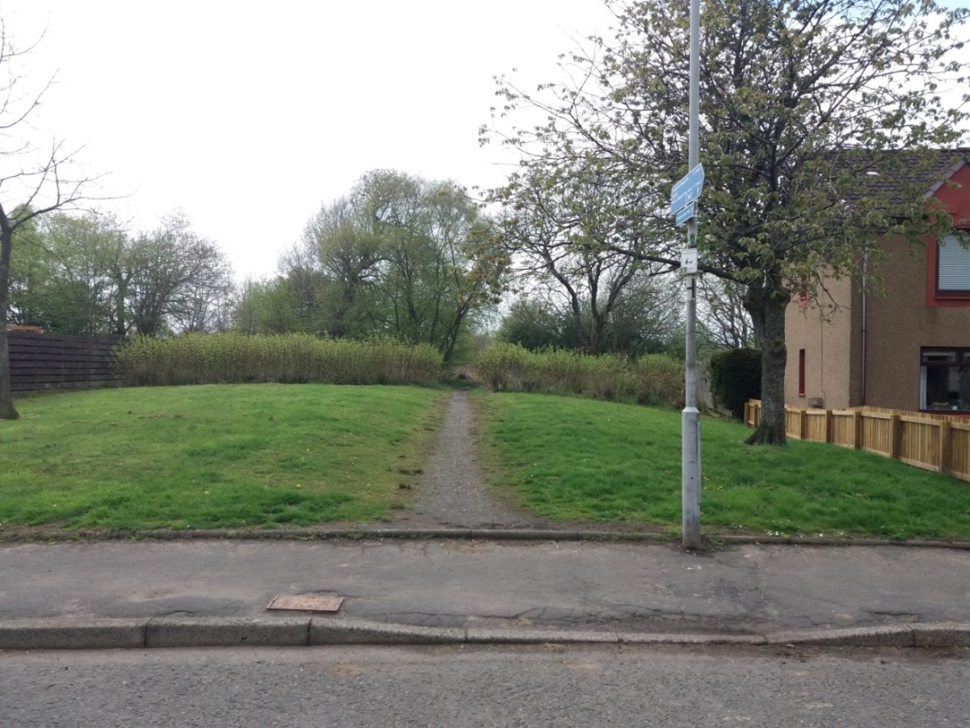
- Entrance to Redmoss Core path from landscaped gap between houses on Laburnum Drive. Access is opposite exit from the path (Nappie Loan) running between Cairnview Road and Laburnum Drive - see picture 12. For details of signs on lamppost see picture 11.
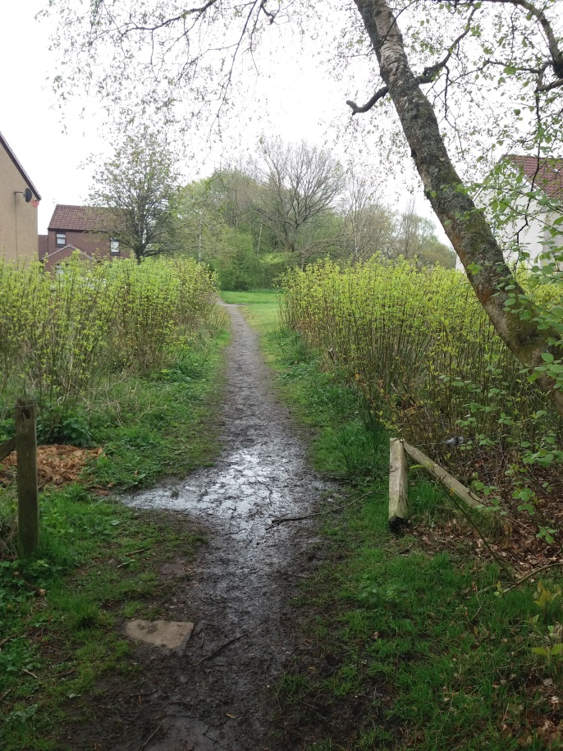
- Similar view to picture 1, this time looking out from Redmoss Core path towards landscaped area between houses on laburnum Drive.
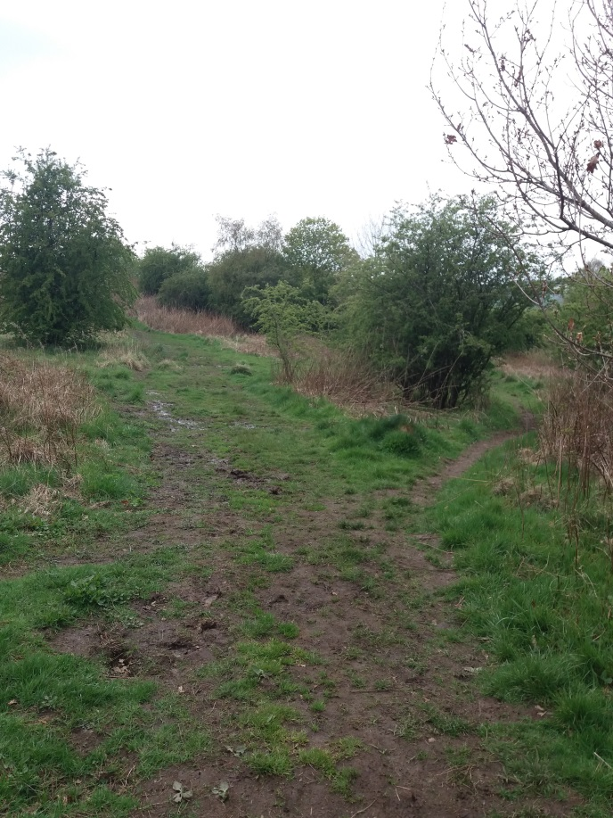
- Approximately 100m from access point from Laburnum drive it appears that Core Path follows fork to left, however the Core path is well trodden narrow fork to right, visible at RH edge of picture.
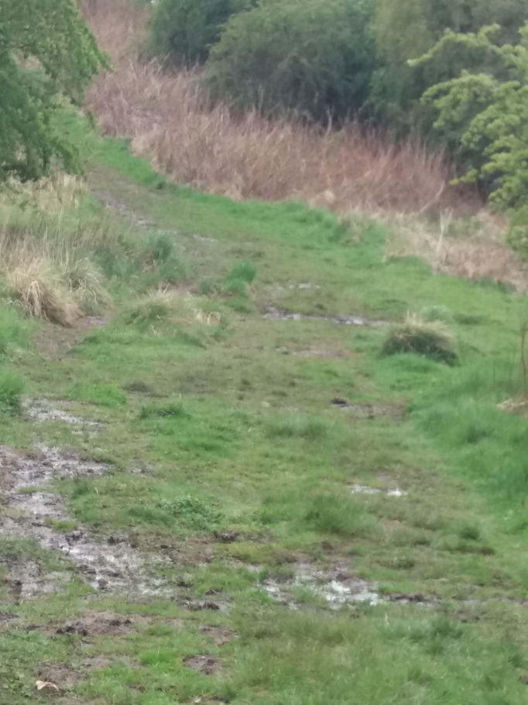
- View showing wider path formed by following LH fork shown in picture 14.
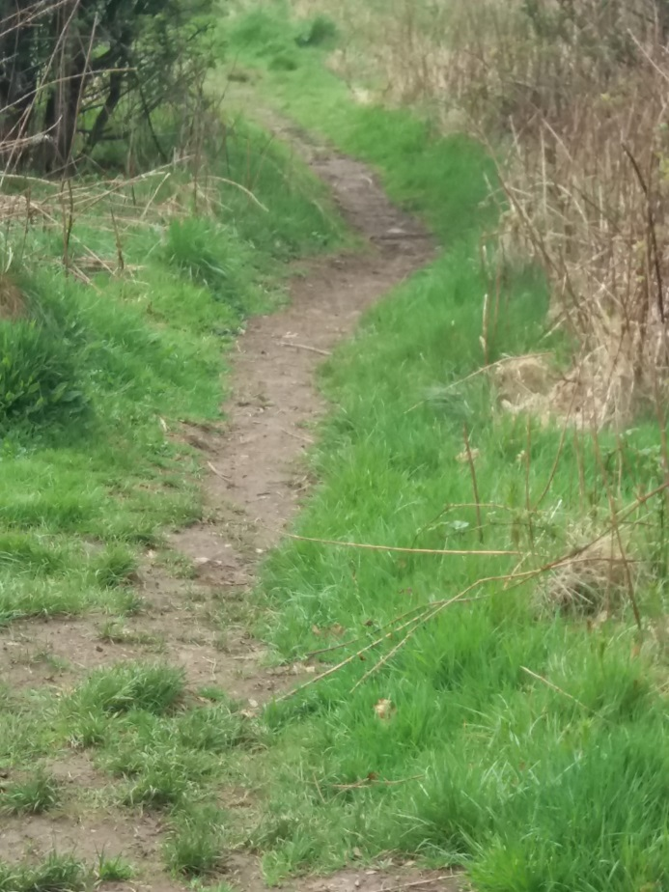
- Continuing in an approximately NW direction the Core path runs round the edge of the “Redmoss North” proposed development site, (as previously proposed by Bellway)
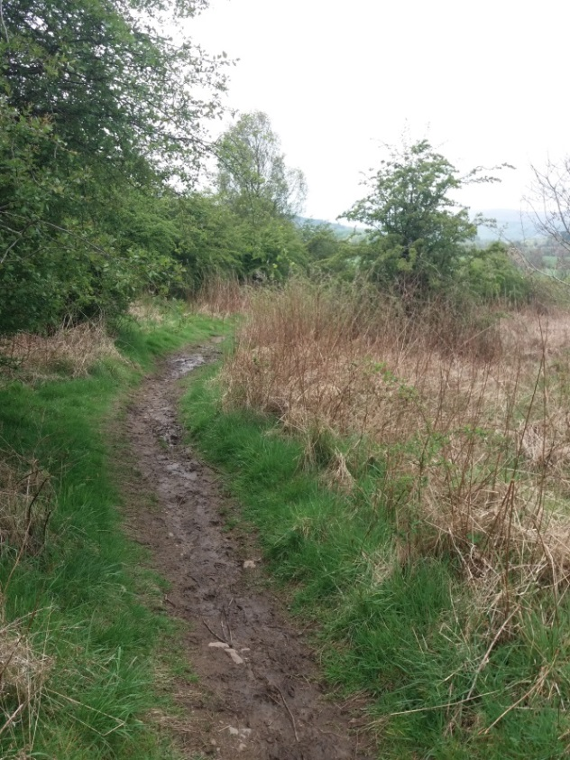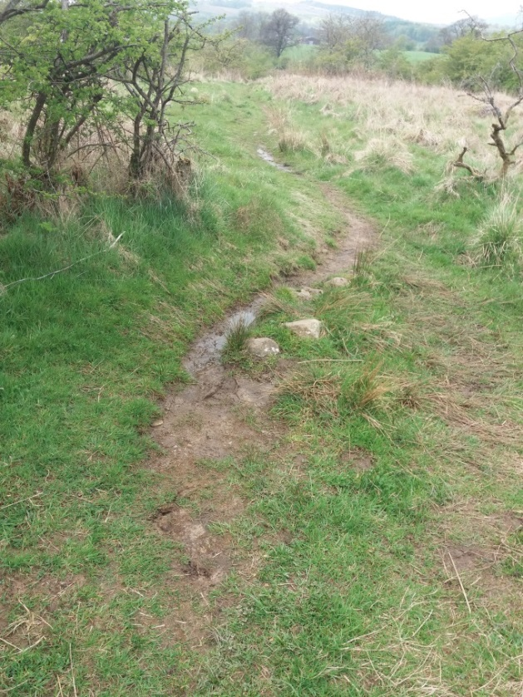
- Core path continues with ground being very soft with evidence of water streaming along rutted path in a downhill direction.

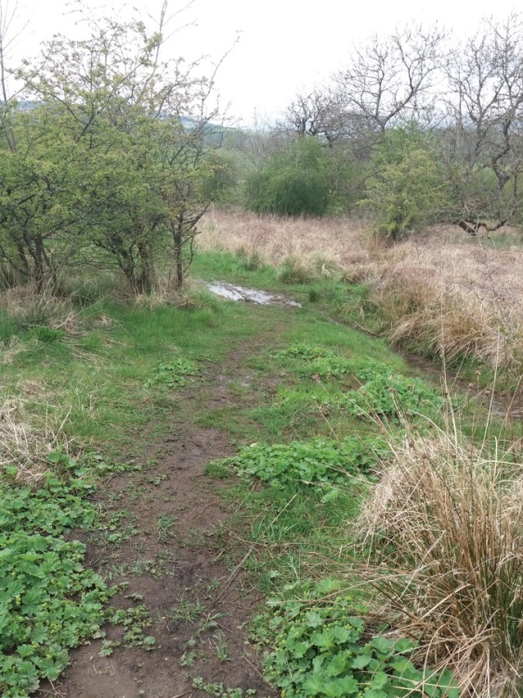
- Path has significant areas of ponding and soft ground along its length.
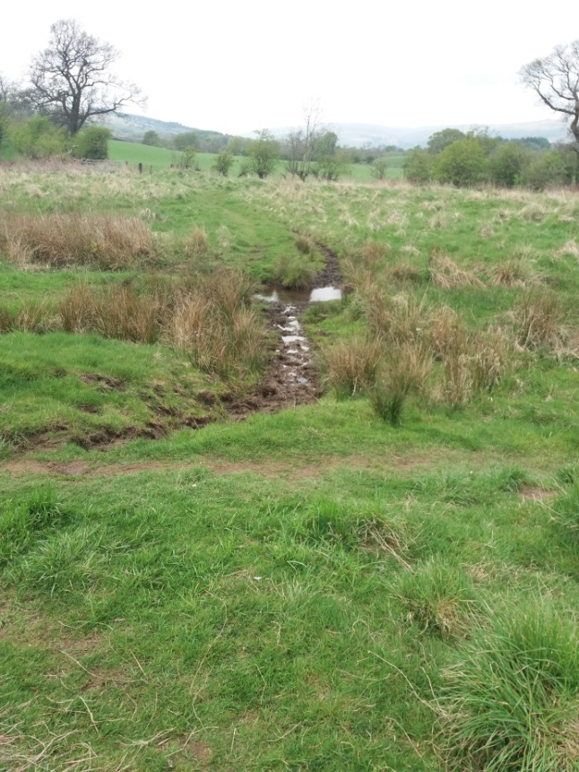
- Path continues downhill till it reaches stream running north/south
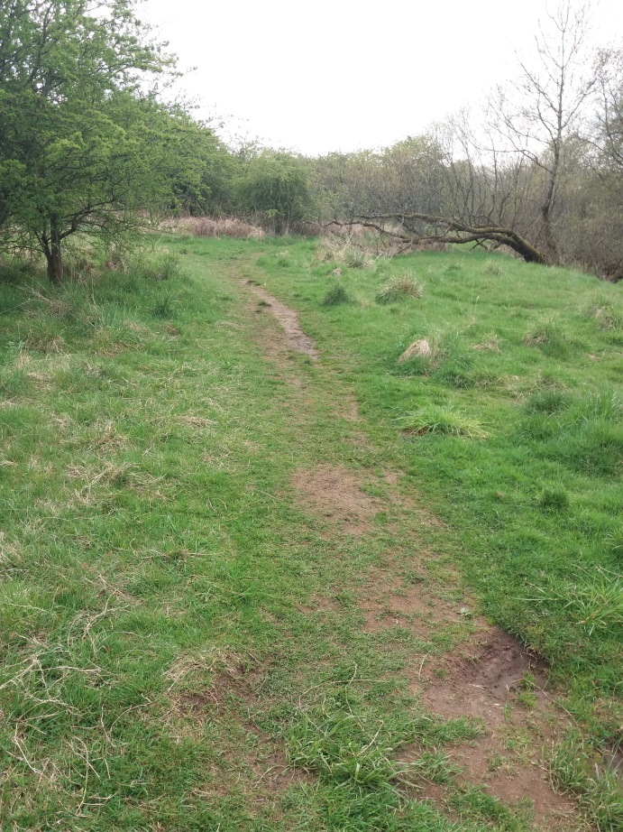
- Rather than crossing the stream one can follow the “non Core Path” in a southerly direction.
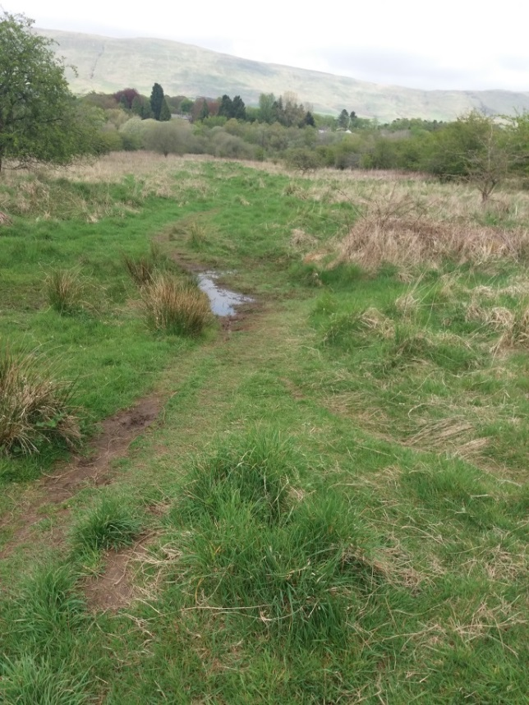
- View along alternative route to the Core Path towards the Strathkelvin Railway Walkway.
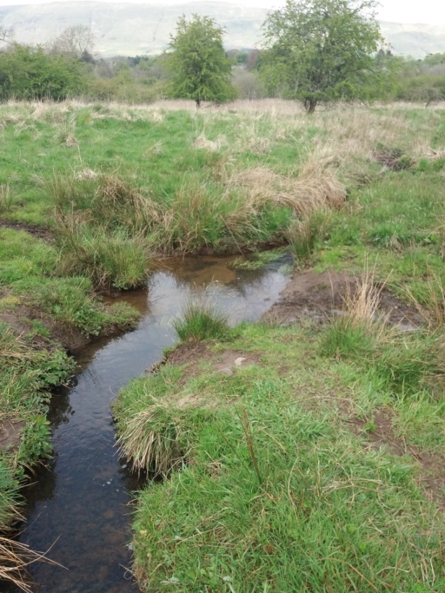
- Prior to changing direction from approximately east/west to south/north Core path crosses stream running north/south. No bridge in place. Note while Core path crosses the stream, there is a parallel path on the east side of the stream that can be followed to the soma point where the Core Path joins the Strathkelvin Railway Walkway
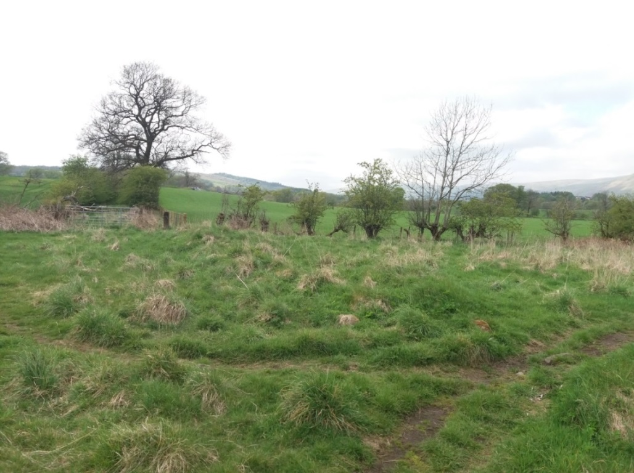
- View from “far” side of stream looking west Core path turns right in a more northerly direction towards the Strathkelvin Railway Walkway. Alternately one can turn left and follow the “Non Core path” in a southerly direction and eventually end up at the kelvin Valley Walkway
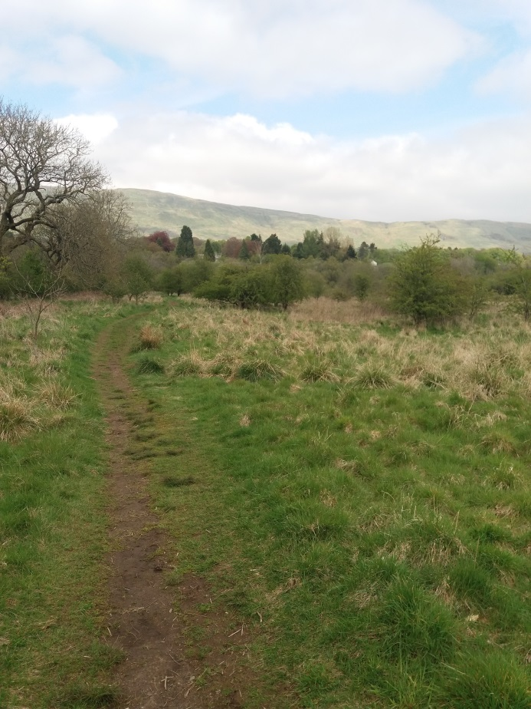
- Well-trodden path on route to Strathkelvin Railway walkway – looking north.
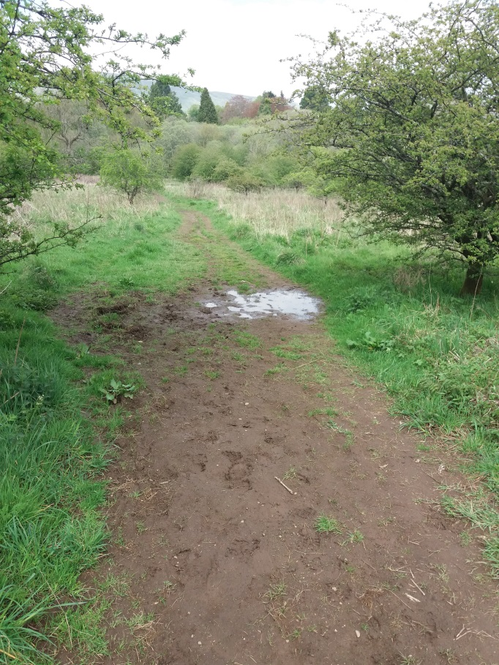
- Area of ponding and soft ground on path walking towards Strathkelvin Railway Walkway – looking north.
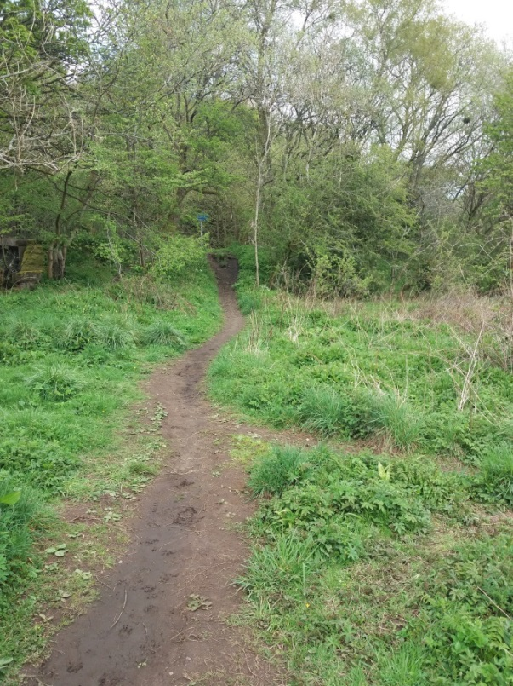
- View looking north as Core path rises to join the Strathkelvin Railway walkway. Path seen to left of picture is continuation of alternative path from where Core path crosses the stream in Picture 22. The core path along its length from the stream crossing is subject to ponding and resultant soft ground and lies within the area identified in SEPA maps as part of t Glazert flood plain.
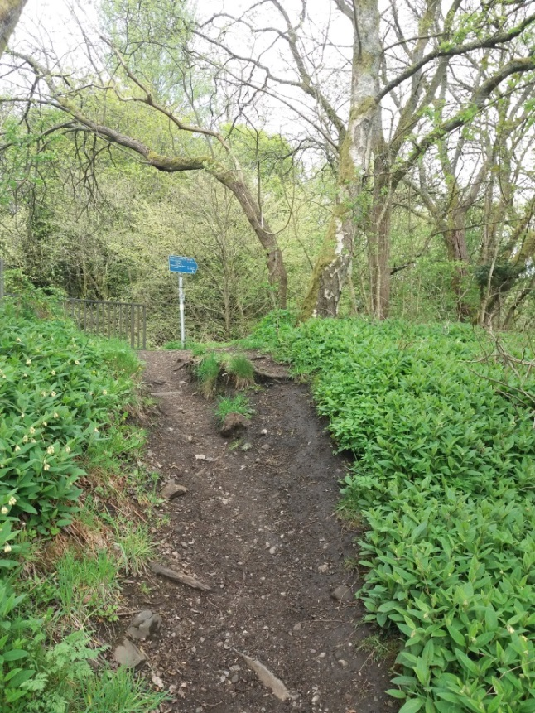
- Access slope from Redmoss Core Path to Strathkelvin Railway Walkway beside bridge over Rover Glazert. Note considerable erosion of path at junction.

