Informal Survey of Redmoss Core Path (South), for Milton of Campsie Community Council
This path runs from its entry point at the end of Redmoss Road and on turning left follows the rear of properties on Glazert Place before turning south behind properties on Munro Drive and Cherry Place and on to the end of Juniper Drive. The Core Path follows the rear of properties on Juniper Drive and long the estern edge of the woods on Skimmers Hill, at the high point of Skimmers Hill it joins with the path from the Kincaid House Hotel Drive and continues south to join with the Kelvin Valley Way. From this junction it is possible to turn right and continue on towards Torrance of left and either meet Birsdton Road at the side of the Barn at Birdston Farm of mid-way along turn right and follow the Kelvin Valley way Core Path round the edge of Kirkintilloch Golf Course, ross the access road to the Old Birdston Coup and turning left follow the path parallel to this access road and then cross Birdston Road and onwards to The Strathkelvin Railway Walkway via the ”High” level Birdston Core path.
The path consists mainly of compacted earth with large areas subject to ponding, particularly after heavy rain due to surface runoff and poor drainage of adjacent land. There are changes in elevation and numerous access/exit points from streets at the edges of the Bellway Estate. The ground is uneven in places and waterproof shoes/boots are recommended again after periods of heavy rain. Due to the unevenness of the path and the nature of its surface it is not suitable for wheelchair users of those with prams of buggies.
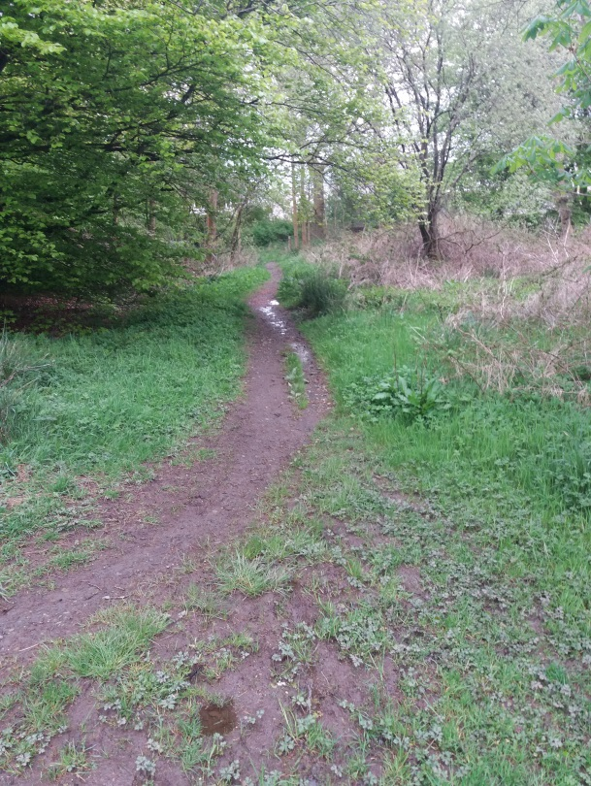
- View from start of path looking towards rear of properties in Glazert Place showing ponding water at start of path as it enters wooded area.
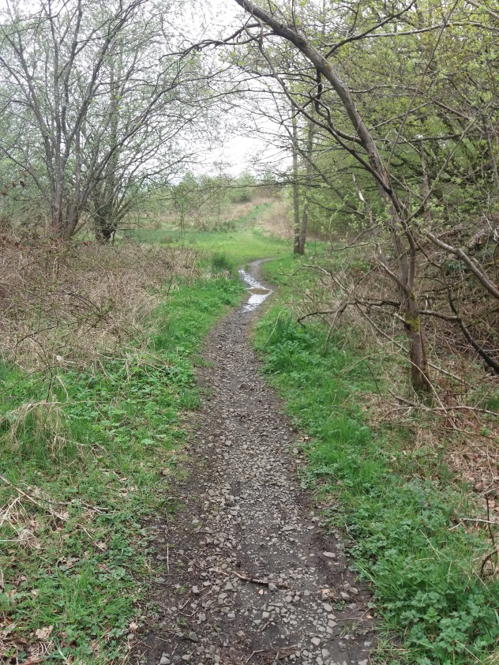
- View looking back towards entry point to Redmoss Core path (south) from Redmoss Road showing ponding water at start of path as it enters wooded area.
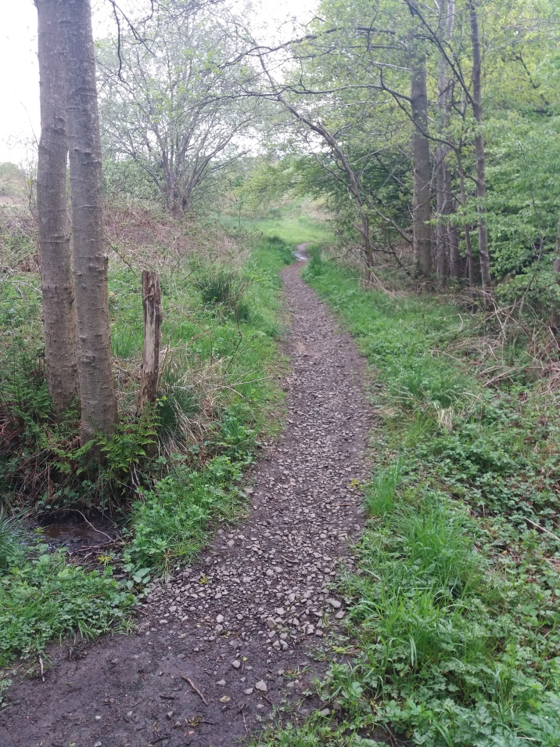
- View looking back towards entry point to Redmoss Core path (south) from Redmoss Road where path changes direction to follow rear of properties in Glazert Place.
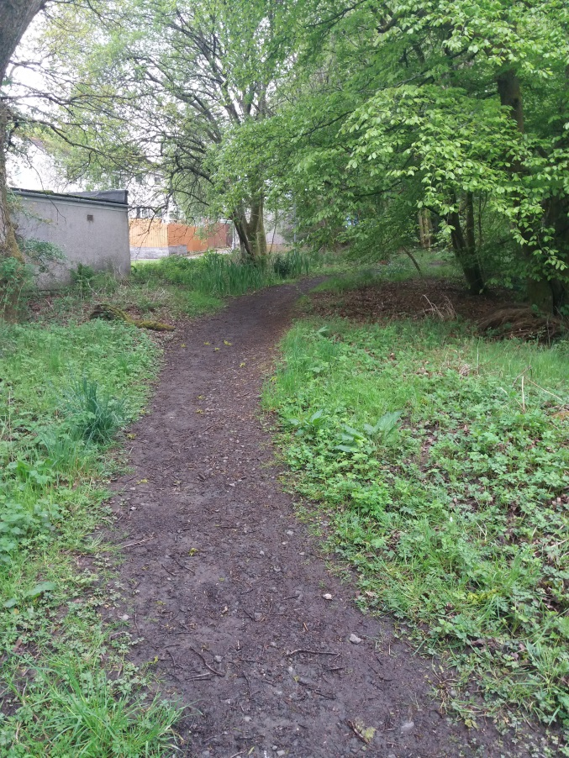
- View looking west at path rises to run along rear of properties in Glazert Place.
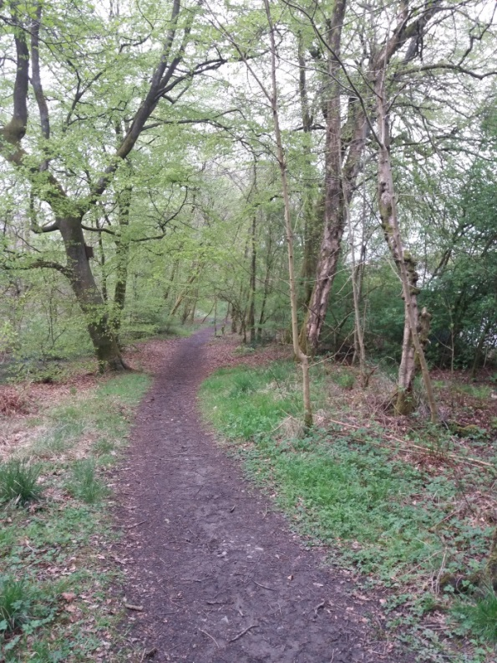
- View looking back down path being Glazert Place.
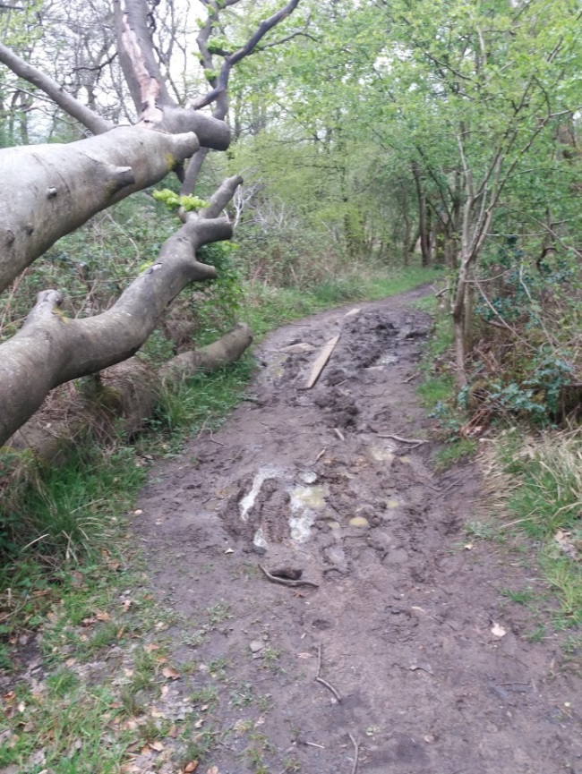
- View of area of soft material with evidence of wooden plans placed by residents to ross muddy areas. Location top corner of Glazert Place where path direction changes from east/west to north south.
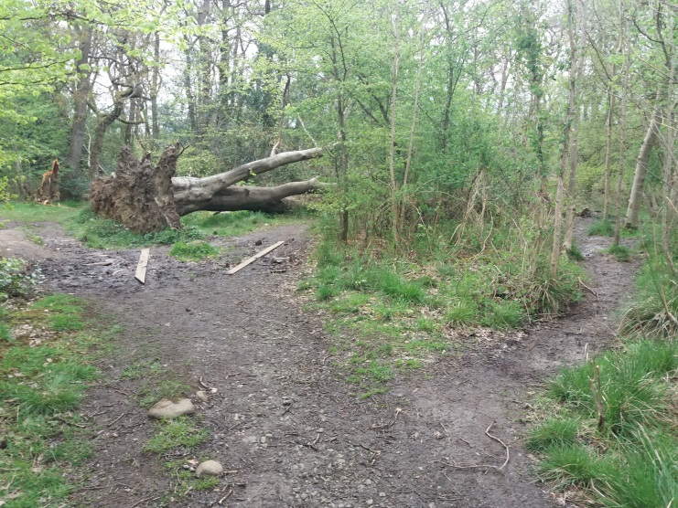
- View of same location as picture 6, taken looking north. Path on left and middle turn right and follow rear of properties on Glazert Plane, while path on left (non Core Path) continues into Redmoss Grasslands.
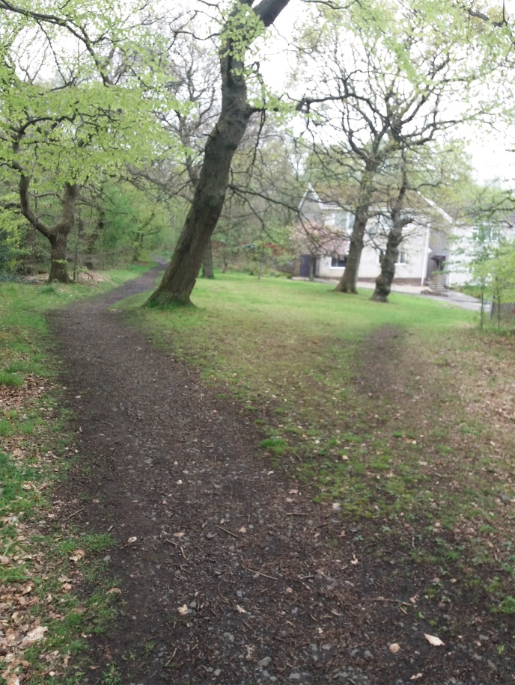
- View looking north at top of Glazert Place.
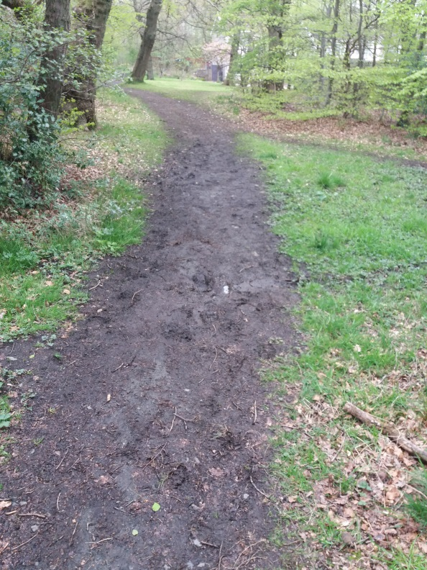
- View looking north at top of Munro Drive
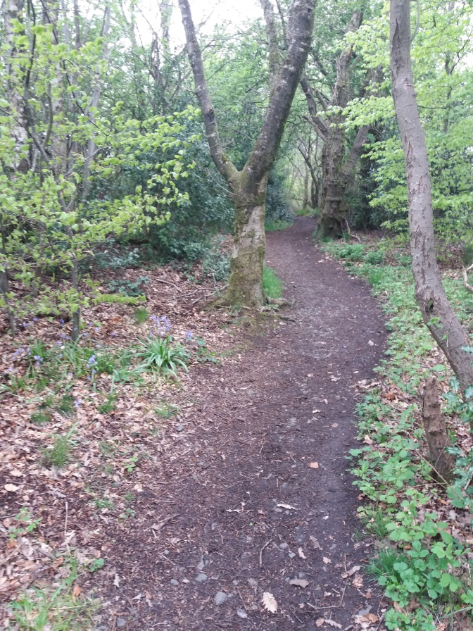
- View looking south as path enterds wooded area behind properties in Cherry Place.
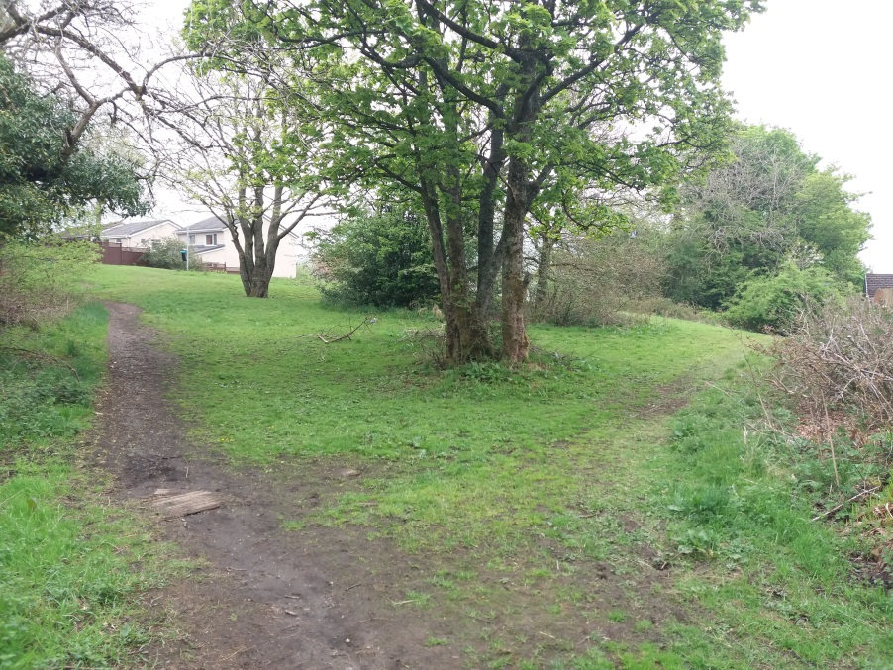
- View looking north of grassed area between Munro Drive and Cherry Place.
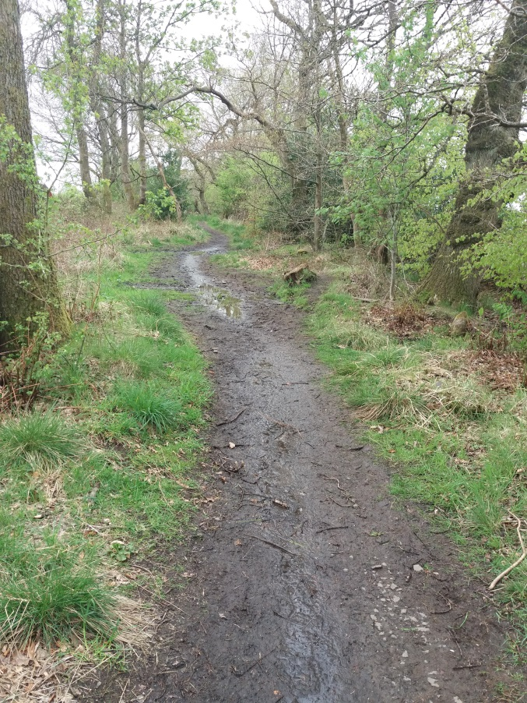
- Path at rear of Cherry Place. Path along this location is subject to large sections of ponding water and soft ground. Attempts have been made by residents to board over some sections by placing wooden boards and slabs. Area also has large sections of tree roots crossing the path.
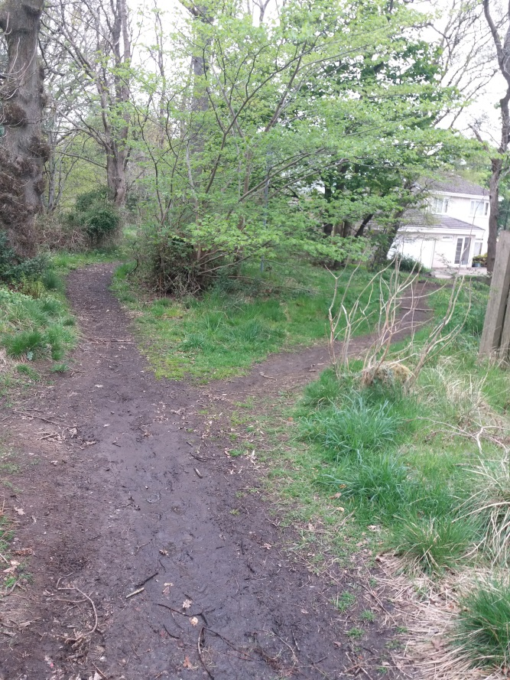
- Access to top of path at top of Cherry Place
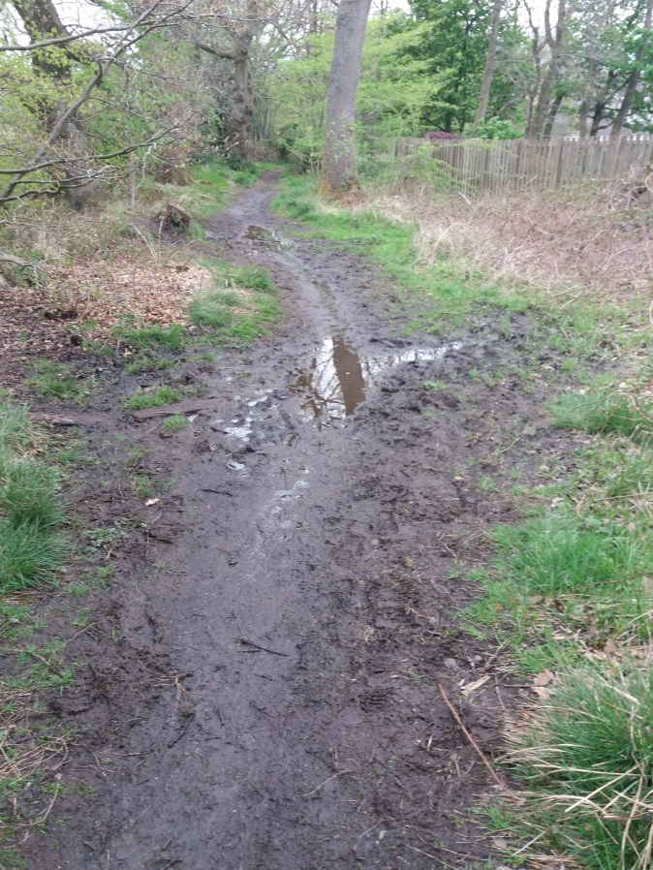
- Arae of significant ponding and soft ground behind properties on Cherry Place
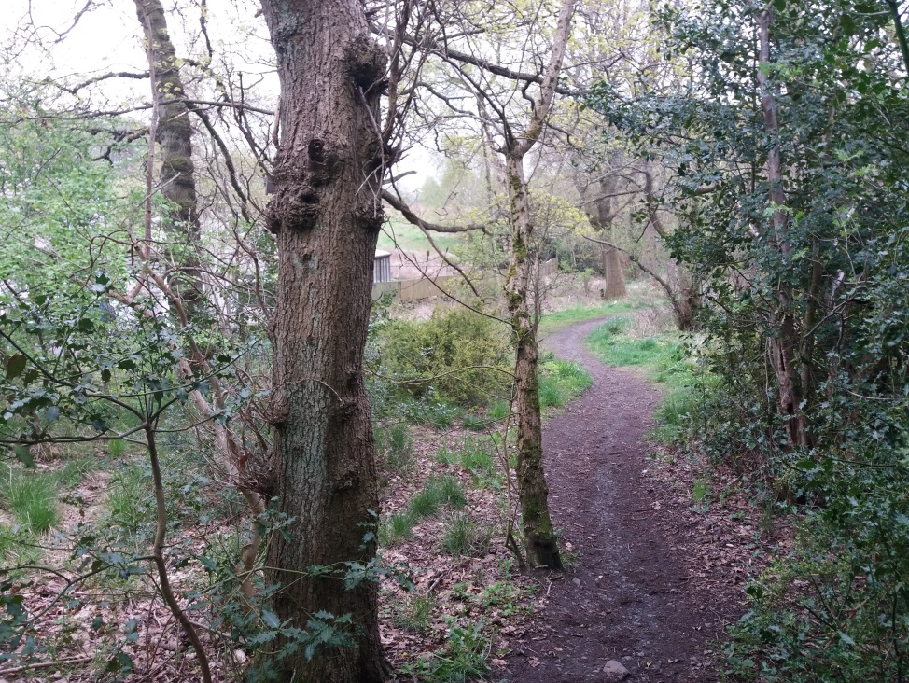
- Path continuing don towards Juniper Drive
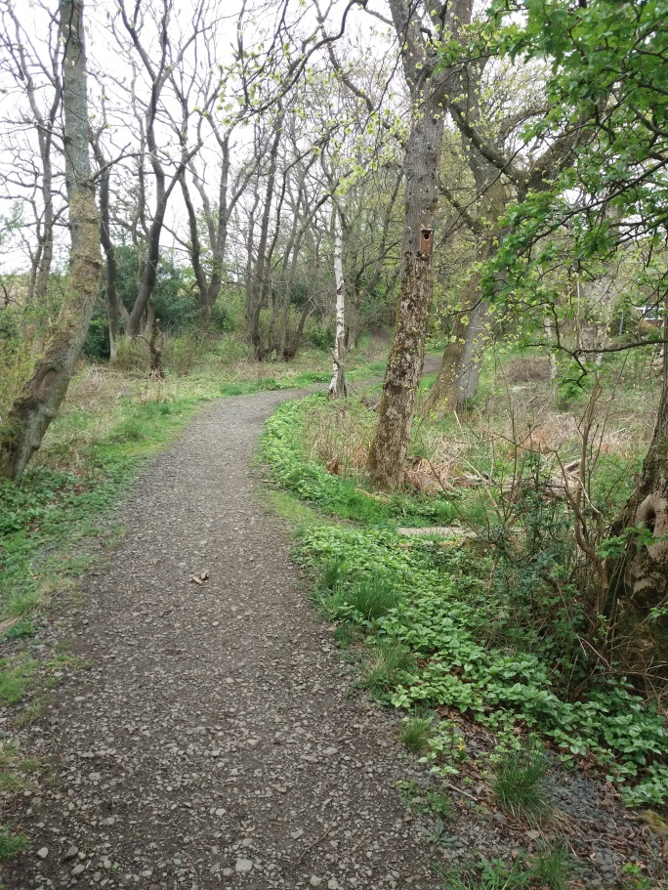
- View looking north from side of property on Juniper Drive. Path access to Juniper Drive visible centre right of picture.
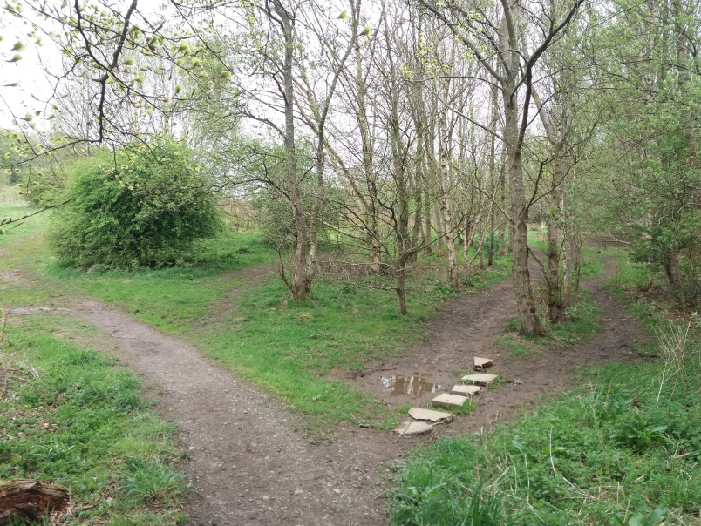
- View from rear corner of last property in Juniper Drive showing placements ofbroken slabs placed to combat area of soft ground. Note path to Right is non Core Path with core path shown veering to left
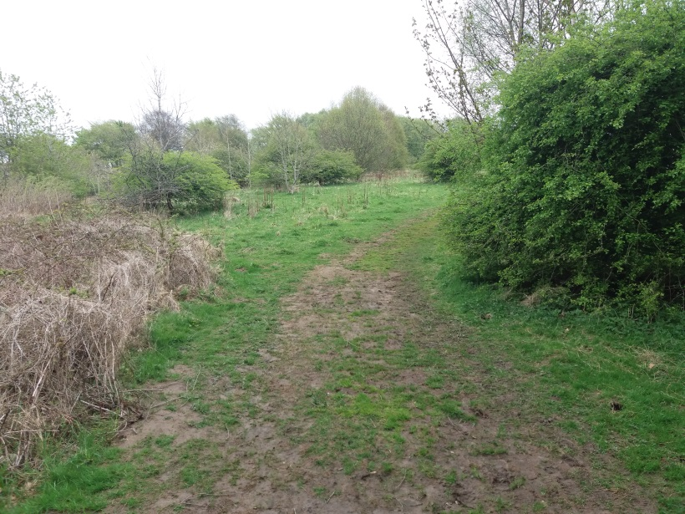
- View of Core Path as it enters grassed are behind properties in Juniper Drive with wooded area at top of Skimmers hill (Hazel Woods/Fairy Woods) in distance
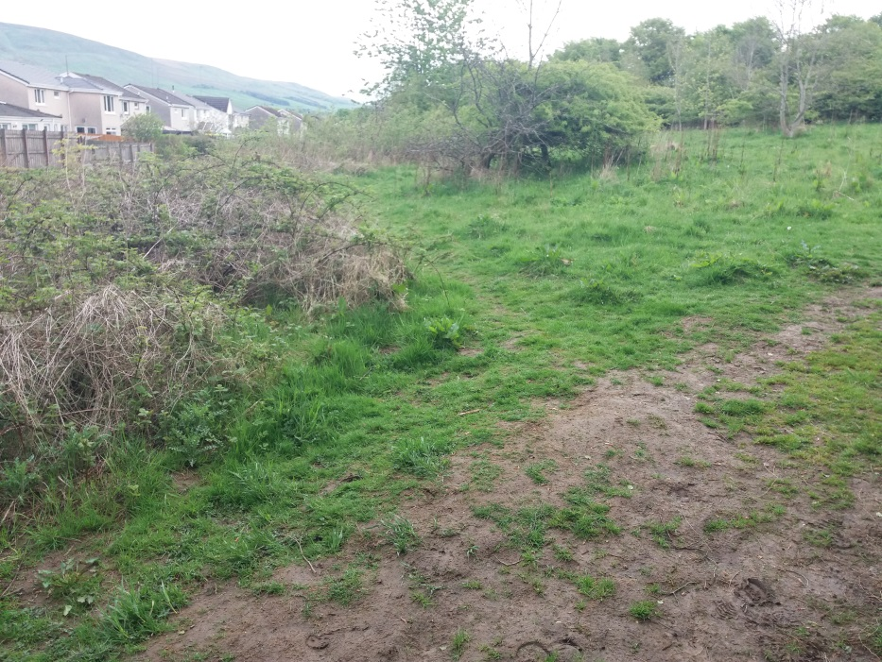
- View taken from mid-point of picture 18. Note Core Path continues to run parallel with rear of properties on Juniper Drive, while more well used path runs diagonally uphill across grassed area to highest point of woods on Skimmers Hill (Woods visible in distance) picture 17
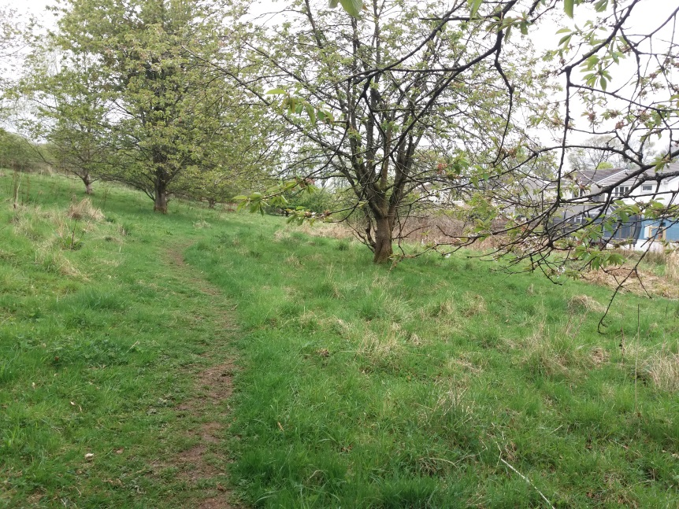
- View looking back along Core Path (running parallel to properties on Juniper Drive) towards
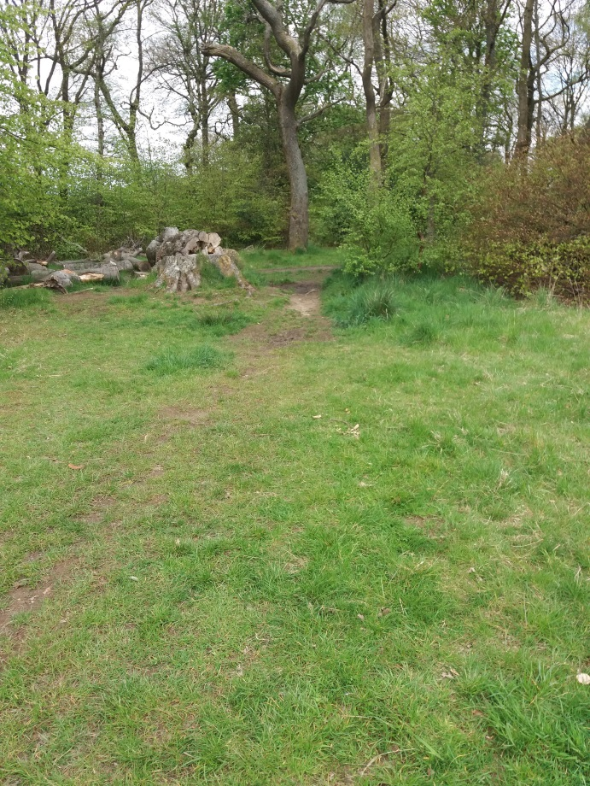
- View of point where Redmoss Core path (South) joins Core Path from Kincaid Hotel Drive at top of Skimmers Hill.
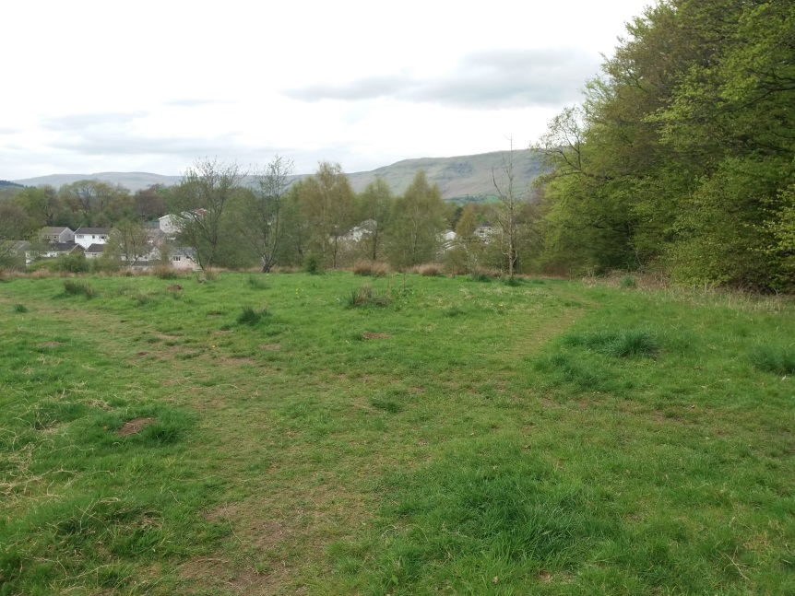
- View from point described in picture 21 looking towards location of picture 17, with rear of properties on Juniper Drive visible
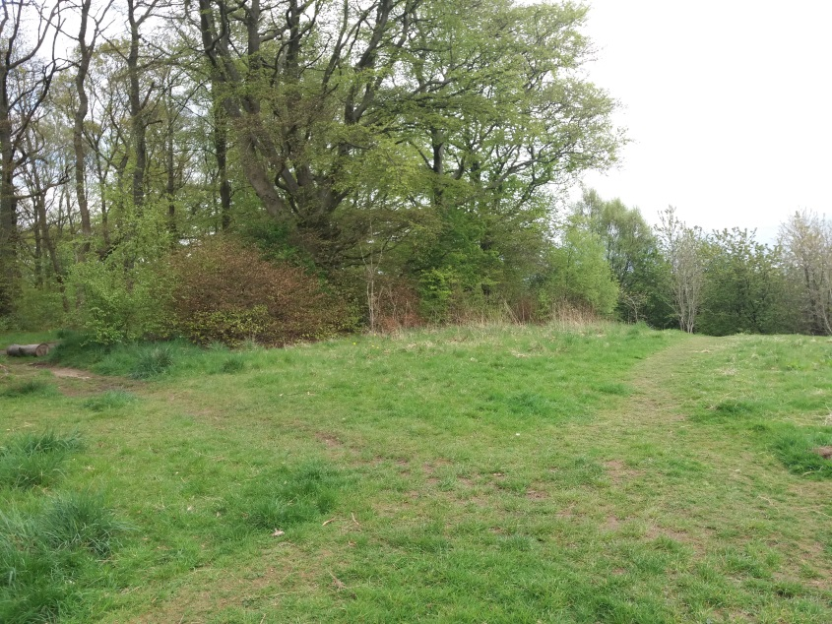
- View showing informal path network cris crossing grass bank bening properties behind Juniper Drive.
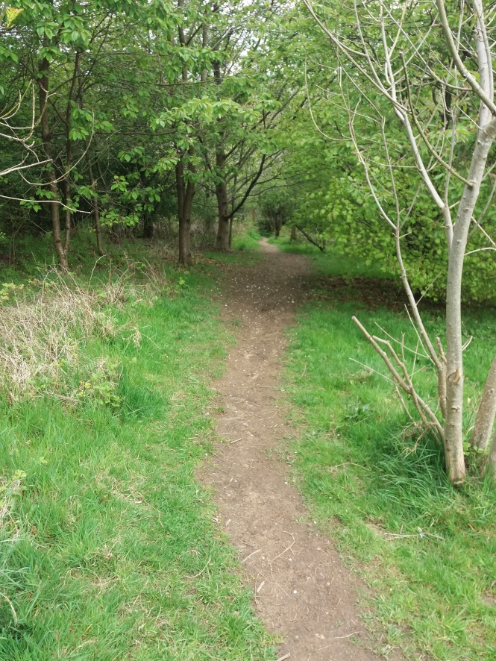
- Vie of Redmoss Core Path (South) as it enters wooded area leading towards Kelvin Valley Way.
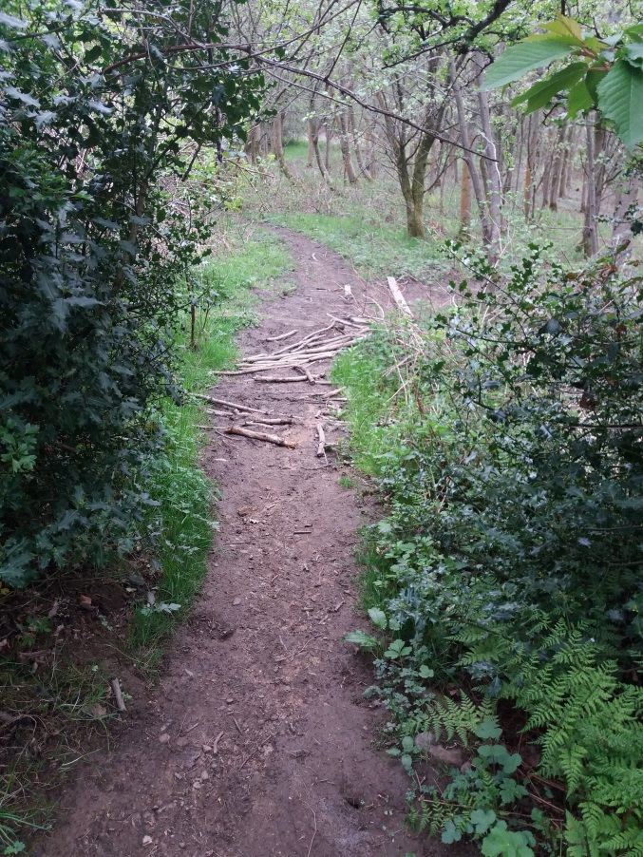
- View of path through wooded area showing build-up of branches to cover area of soft ground.
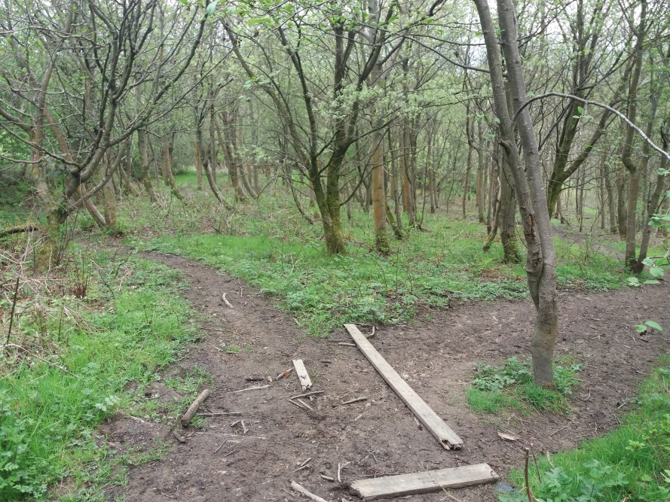
- AS path continues through the wooded area it splits with Core path being the RH fork. Both forks continue through the wooded area and meet up again just prior to joining the kelvin Valley Way.
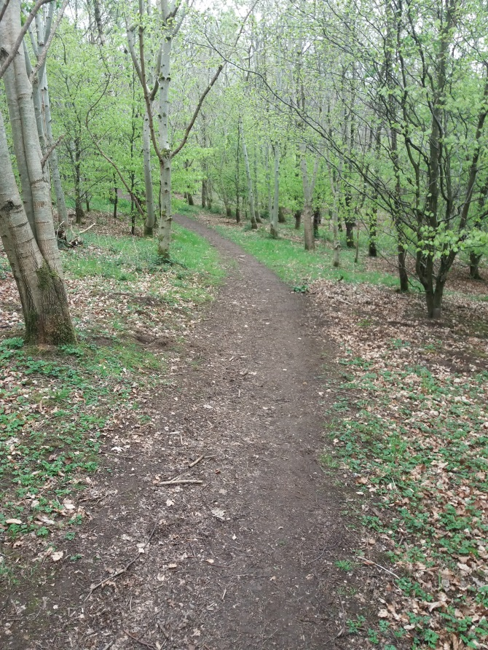
- Path continuing through wooded area.
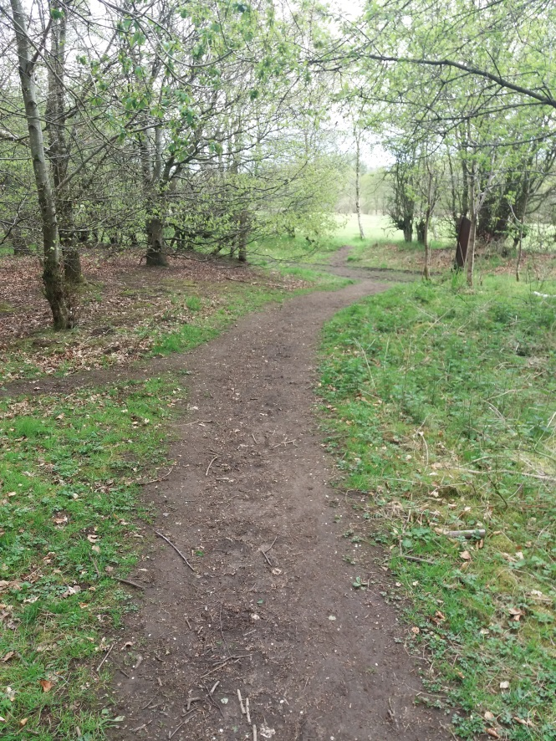
- Path just prior to joining the kelvin Valley Way. Note path seen joining on left is the path previously seen on left of picture 26.
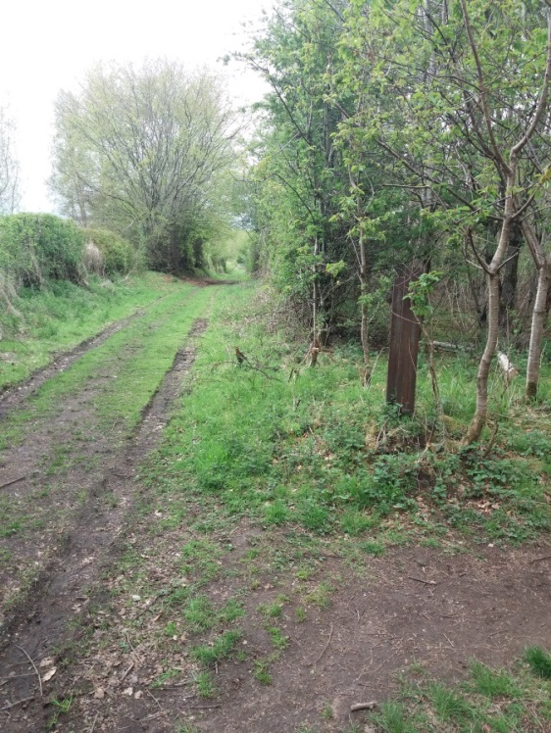
- View looking west (towards Wetshod Farm/Campsie Road/Torrance) along Kelvin Valley Way from its junction with Redmoss Core path (South). Note this track is the continuation of the Road access to properties beyond Birdston Farm and Birdston House. See separate document in connection with Kelvin Valley Way.
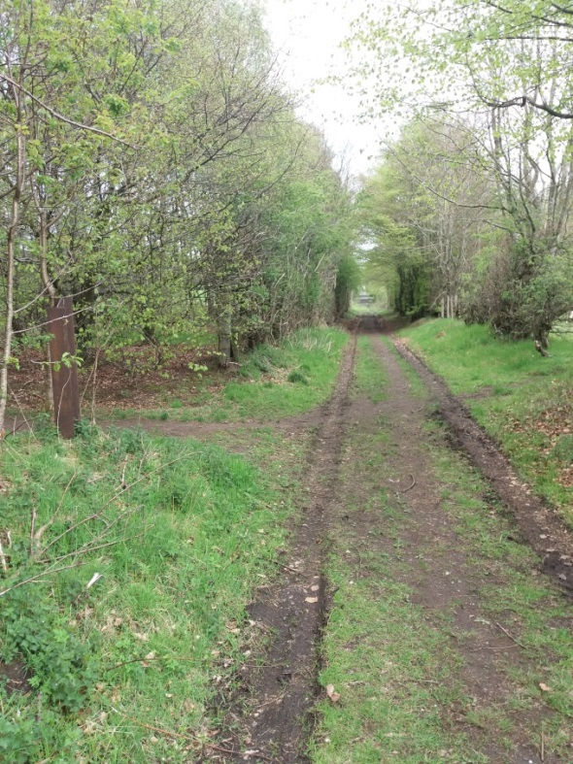
- View looking east (Towards Birdston) along Kelvin Valley Way from its junction with Redmoss Core path (South). Note this track is the continuation of the Road access to properties beyond Birdston Farm and Birdston House. See separate document in connection with kelvin Valley Way.

