Informal Survey of Strathkelvin Railway Walkway for Milton of Campsie Community Council - Part 1
The section covered is from the access point from the Lennoxtown/Torrance Road (B822) to the Strathkelvin Railway Walkway (Thomas Muir Trail) along its length to where ends in Kirkintiloch (A803). The path is macadamised and in the main is in sound condition and suitable for all users, however access for Wheelchair users and those with buggies or prams is limited to a few places. The walk can be undertaken without the requirement for walking shoes or boots in all weathers although these may be required if accessing the Walkway from some of the connecting paths.
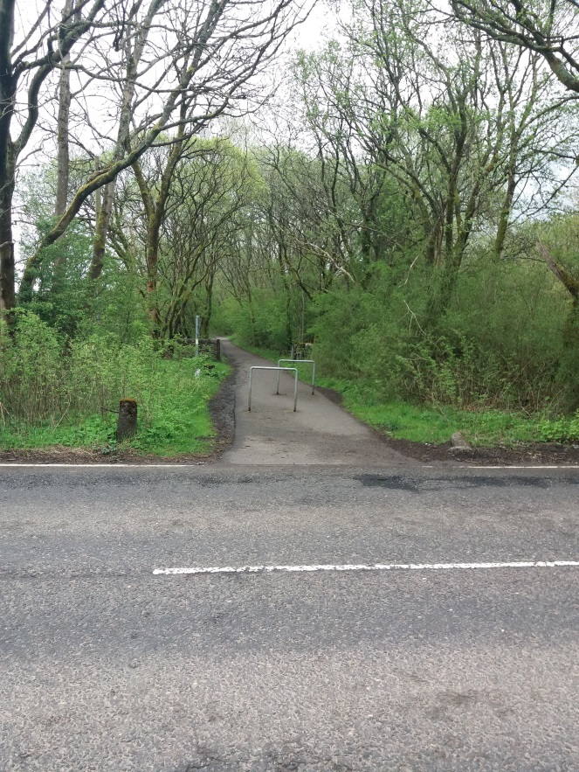
- View of access point to Strathkelvin Railway Walkway from Lennoxtown/Torrance road (B822)
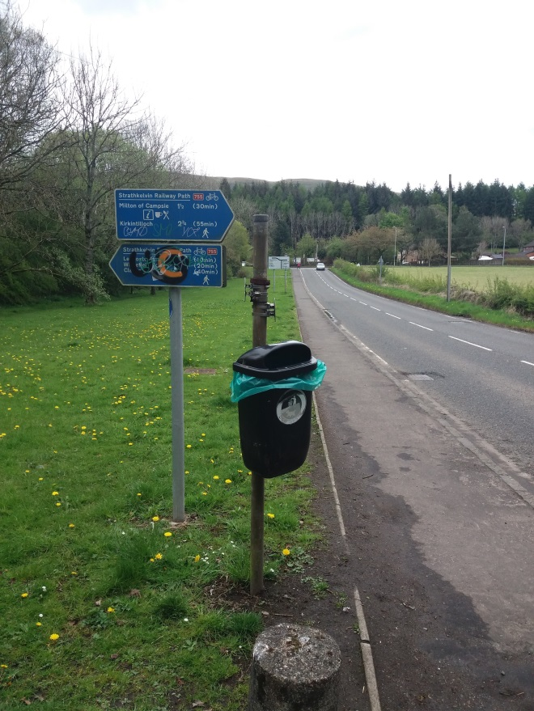
- Directional signs at access point to Strathkelvin Railway Walkway on B822. View looking north towards junction of B822 and A891 (Lennoxtown/Milton of Campsie Road)
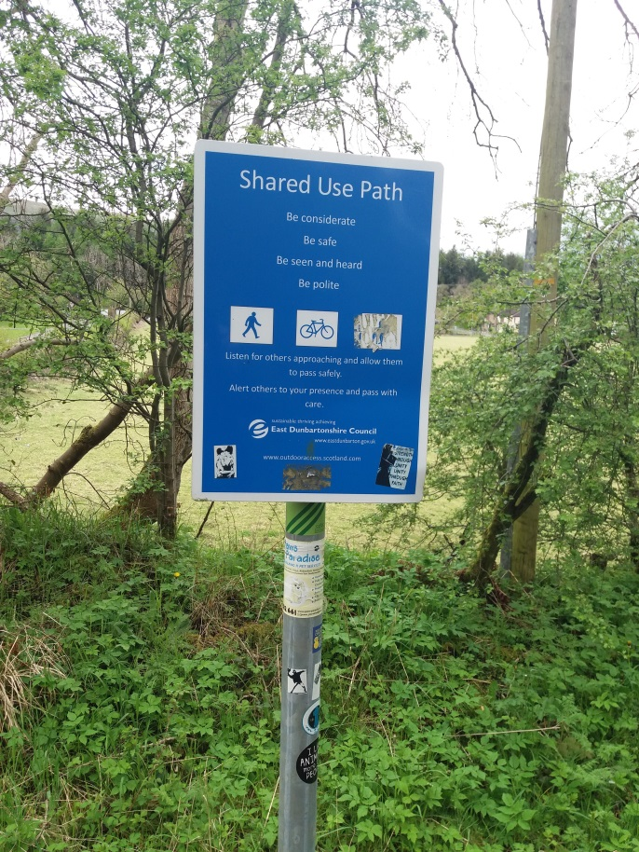
- “Shared Use” notice at access point shown in picture 1.
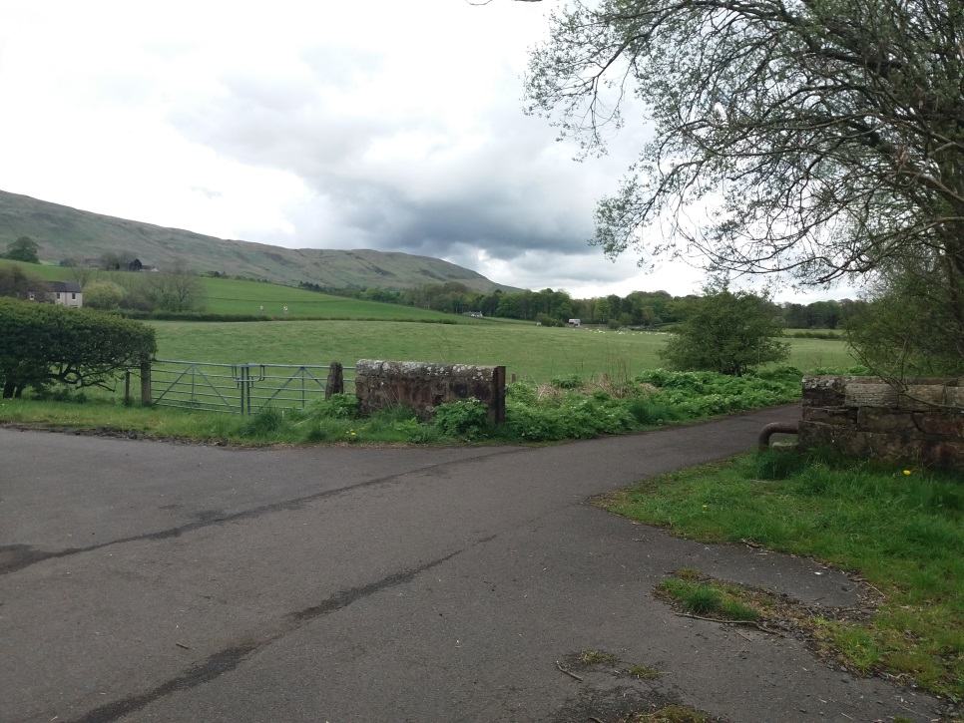
- Junction of Strathkelvin Railway Walkway (running diagonally across picture) and access track to Cherry cottage? from A891 (Lennoxtown/Milton of Campsie Road) Note there is no formal footpath on A891 from this point to start of Milton of Campsie.
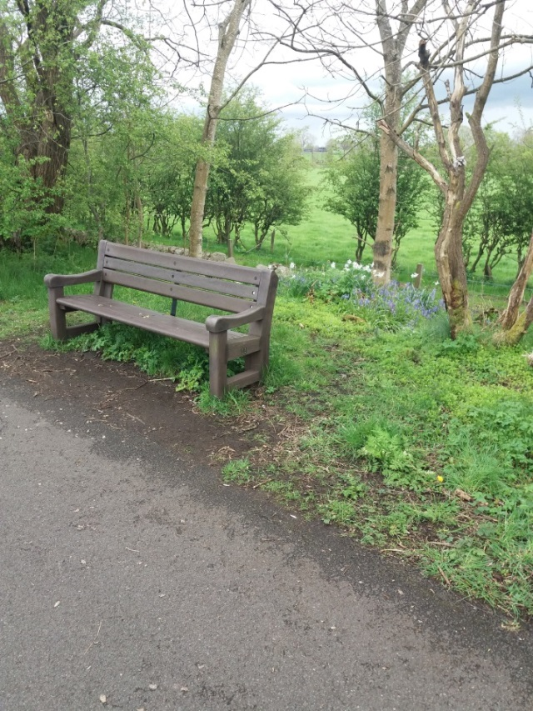
- Rest bench, looking north, overlooking fields and Campsie Fells, situated between Picture 4 and 6.
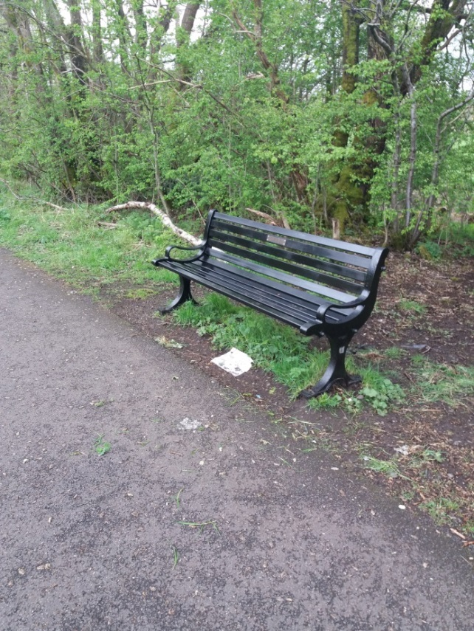
- Beth Wren memorial bench, looking north, overlooking fields and Campsie Fells, situated between picture 6 and 7. Beth was paid for by MoCCC and installed by EDC.
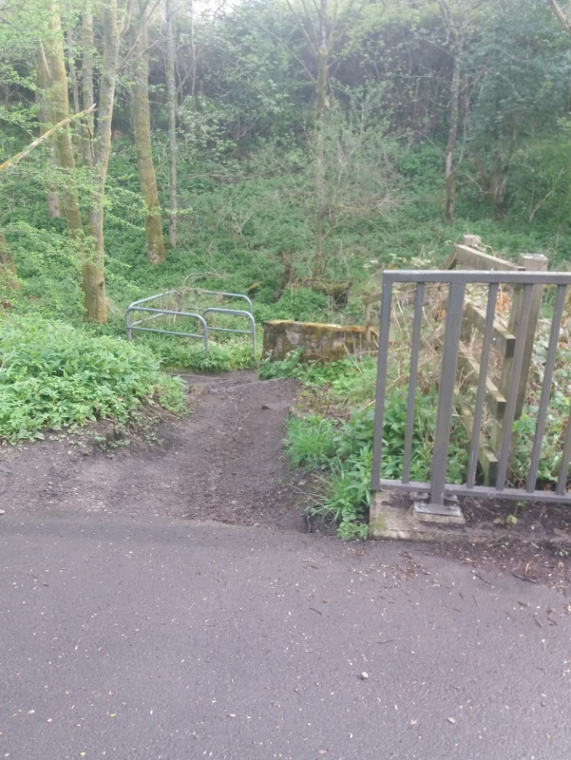
- Access path to Vallyfield (not a Core Path) on Lennoxtown side of bridge over the River Glazert.
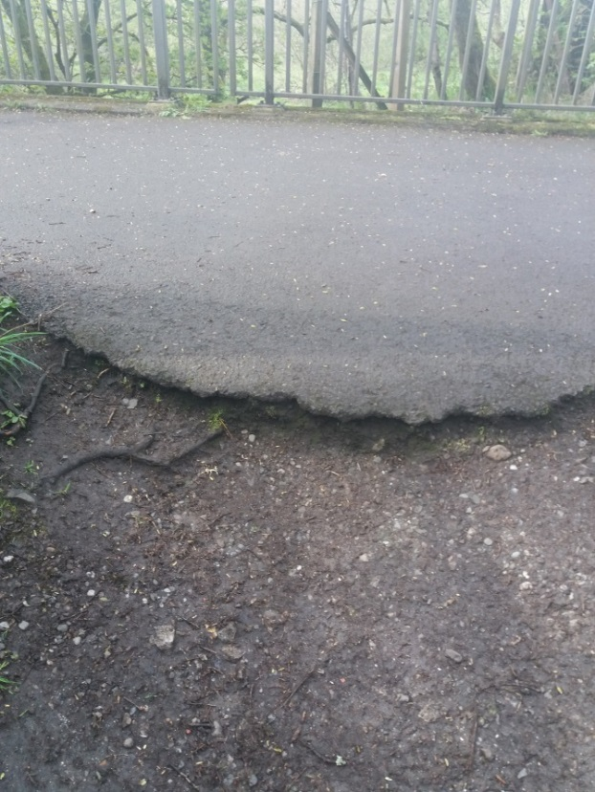
- View of path junction and Strathkelvin Railway Walkway showing erosion, drop and change of surface as path drops down towards river bank.
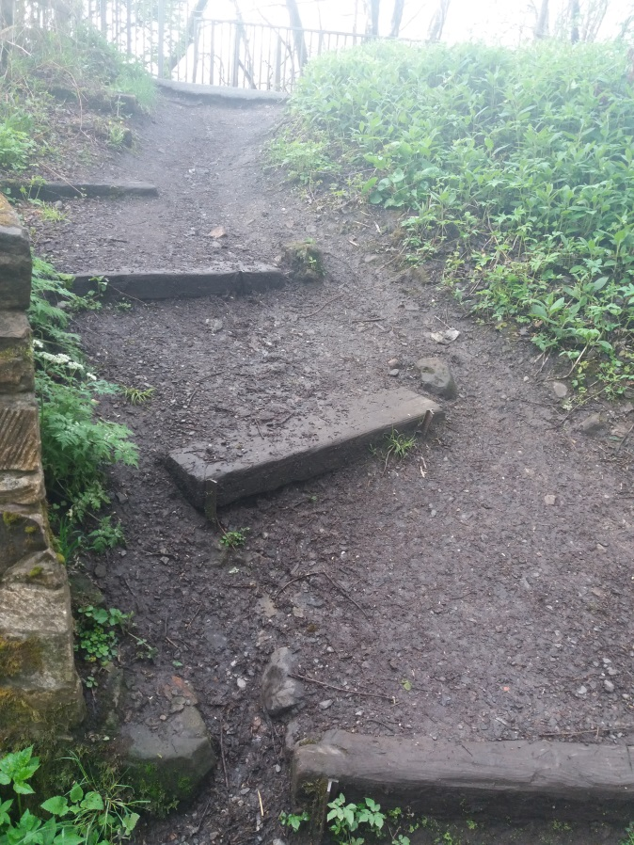
- View looking up the slope of path to Valleyfield looking towards Strathkelvin Railway Walkway. Note erosion to LH of path and around retaining steps. Also note that originally path appears to have joined the SRW lightly further left to existing access.
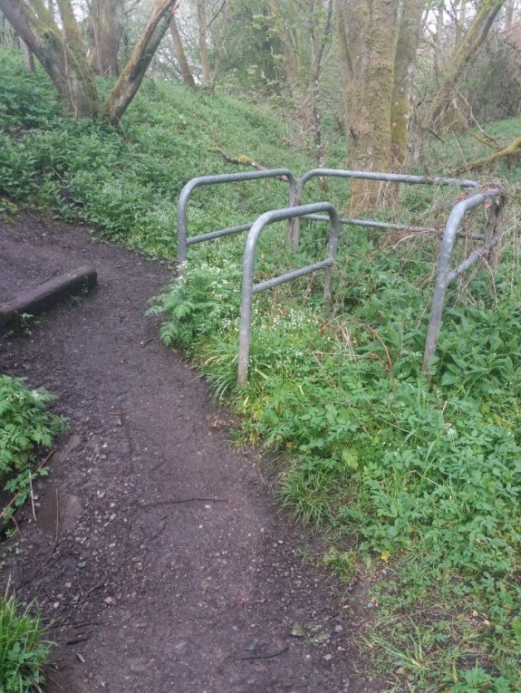
- View of “chicane” gate at foot of slope shown in picture 9. Note this “gate” is overgrown with new path being formed to LHS (in picture). This new path is nearer the river bank edge which is also showing signs of erosion.
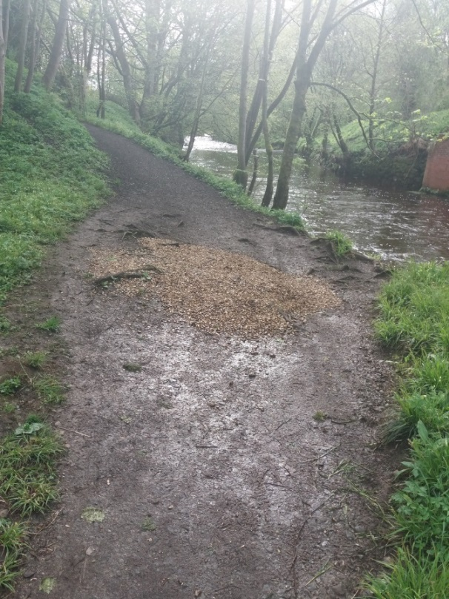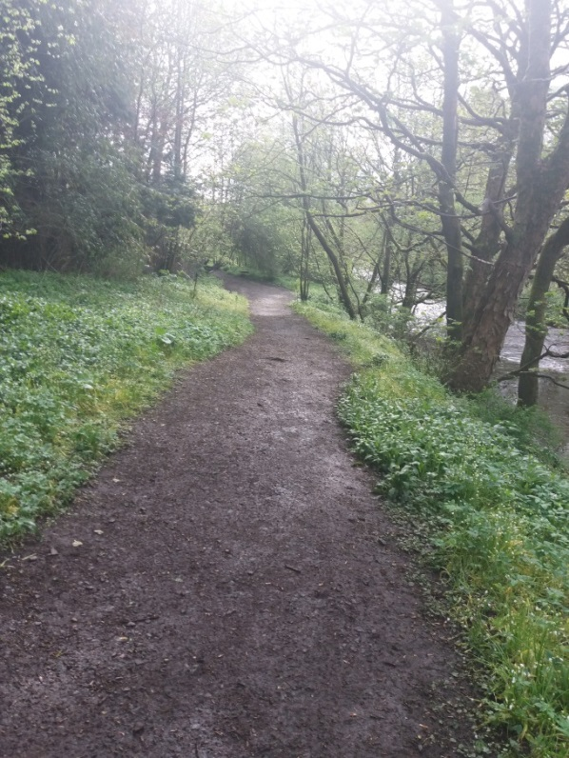
- View of path running parallel with river bank from picture 10towards grassed area behind Valleyfield properties. Note area in LHS picture where residents have deposited gravel/stones to cover area of ponding/soft material
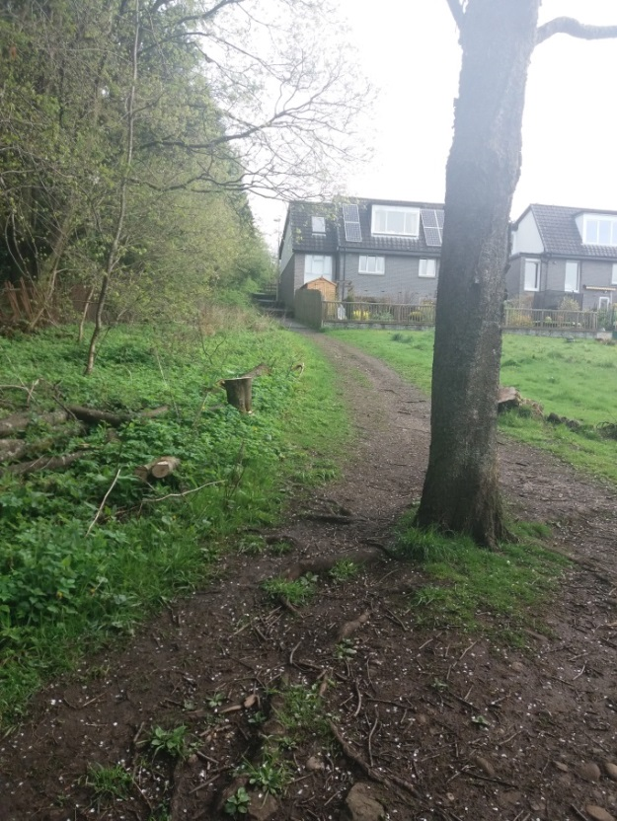
- View looking north towards Valleyfield where path changes direction from west/east to south/north at edge of grass panel between rear of Vallefield properties and River Glazert. It is understood that this area is held within the title deeds of the Valleyfield properties.
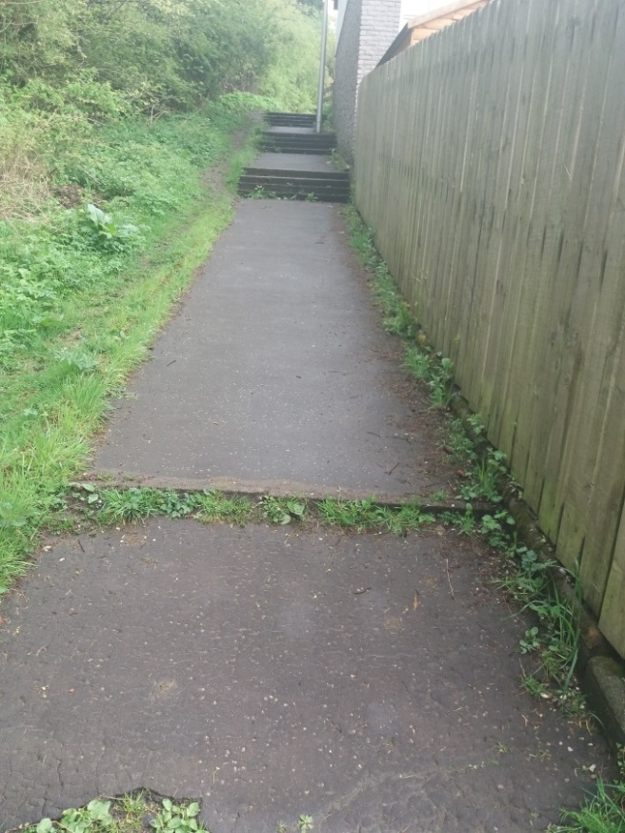
- View looking north at side of last property in Valleyfield where path surface changes from compacted earth to a macadamised footpath with shallow steps. Indication of build-up of detritus and weeds at footpath edges and step treads.
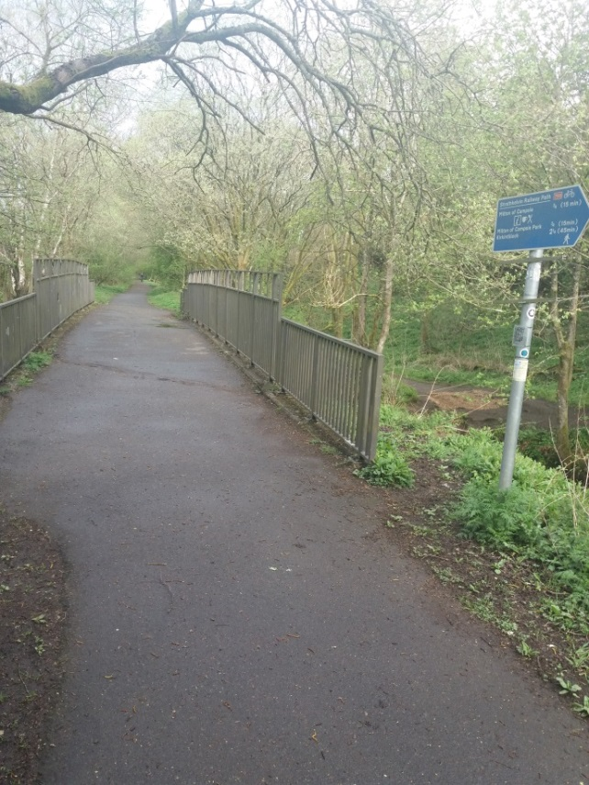
- Returning back to the Strathkelvin Riverside Walkway, view looking west across bridge over the River Glazert. Path to Valleyfield (Pictures 7 – 13) is assed at far side of bridge on left.
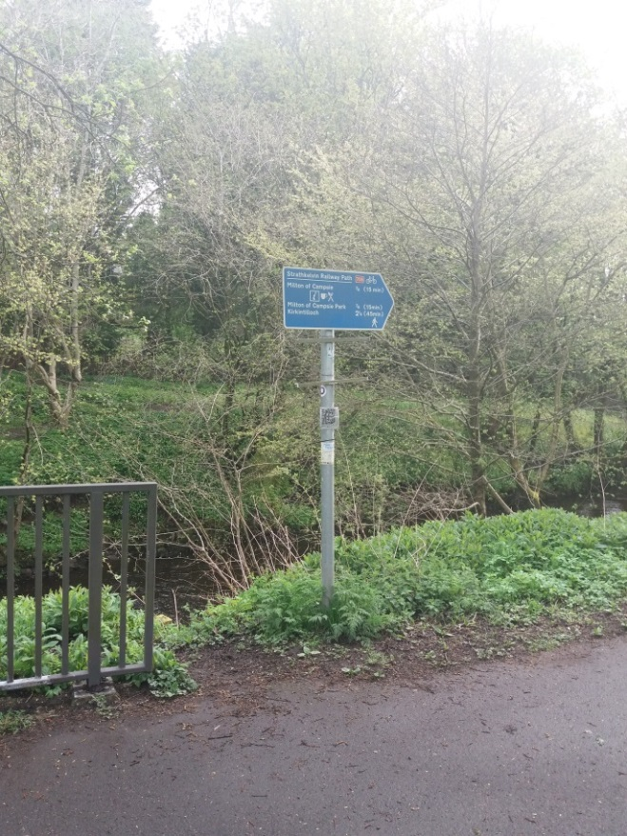
- View of Directional signpost opposite junction of Redmoss Core Path and Strathkelvin Railway Walkway, also visible in picture 14.
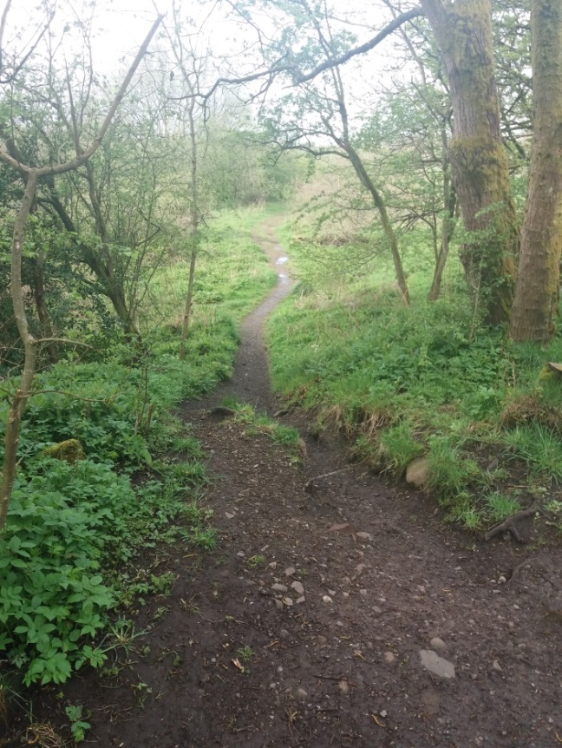
- View looking south at start of Redmoss Core path at its junction with Strathkelvin Railway Walkway. Path drops down in level with significant signs of erosion.
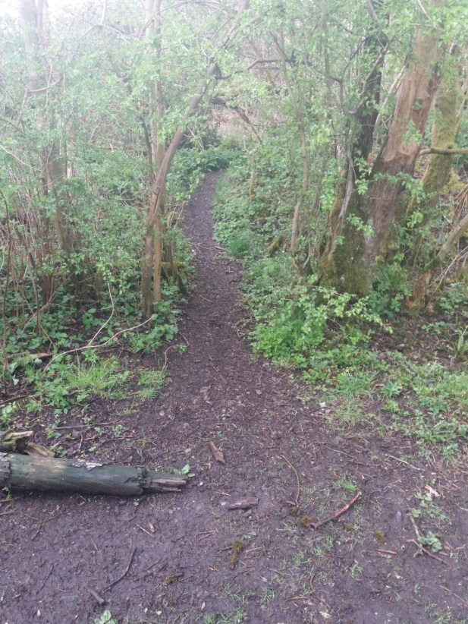
- Informal path i.e. not classed as a Core Path, leading into Redmoss Grassland from Strathkelvin Railway Walkway. This path access the Grassland Area previously named as Redmoss North Development site by potential developer (Bellway)
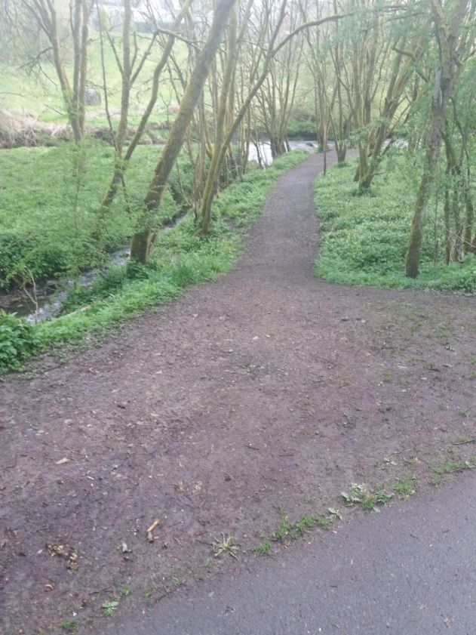
- Junction of Access to Riverside Walkway with Strathkelvin Railway Walkway. Note this path is not classed as a Core Path

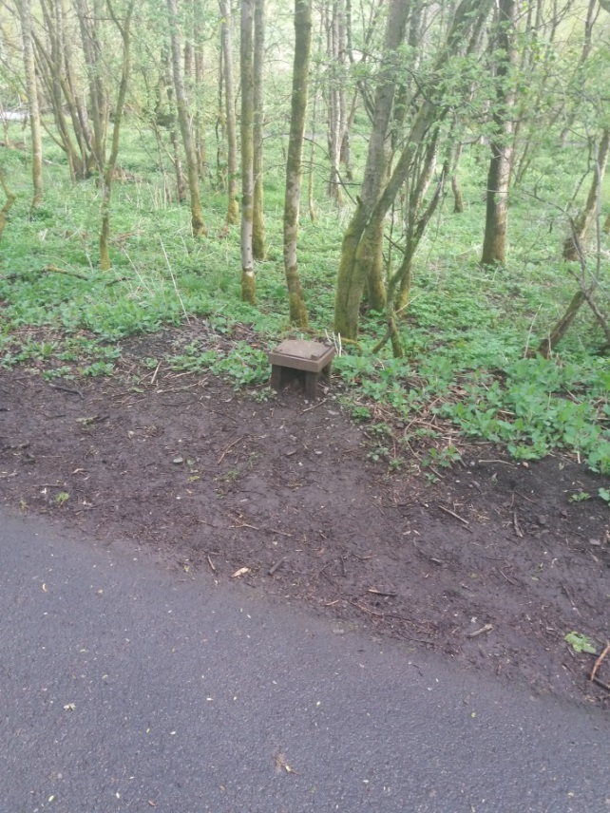
- Evidence of old Railway infrastructure, possible signal post. Opposite informal path shown in picture 20.
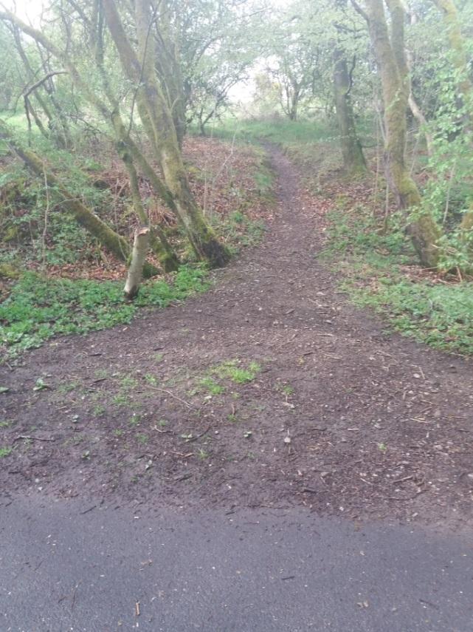
- Informal path i.e. not classed as a Core Path, leading into Redmoss Grassland from Strathkelvin Railway Walkway. This path access the Grassland Area previously named as Redmoss North Development site by potential developer (Bellway)

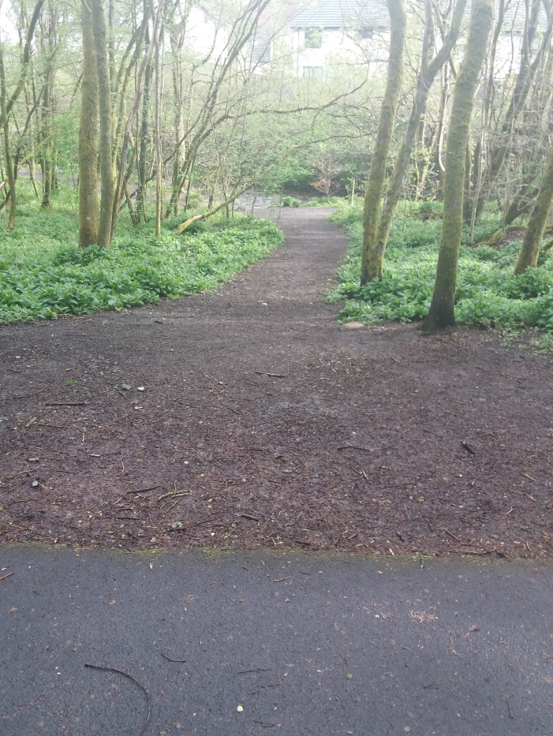
- Junction of another access to Riverside Walkway with Strathkelvin Railway Walkway. Note this path is not classed as a Core Path
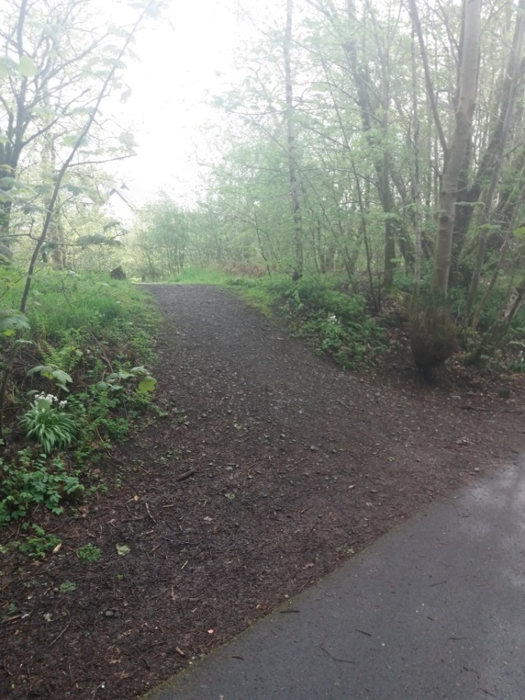
- Junction of another access to Riverside Walkway with Strathkelvin Railway Walkway opposite stairs from housing estate path between Laburnum Drive and Marguerite Place. Note this path is not classed as a Core Path
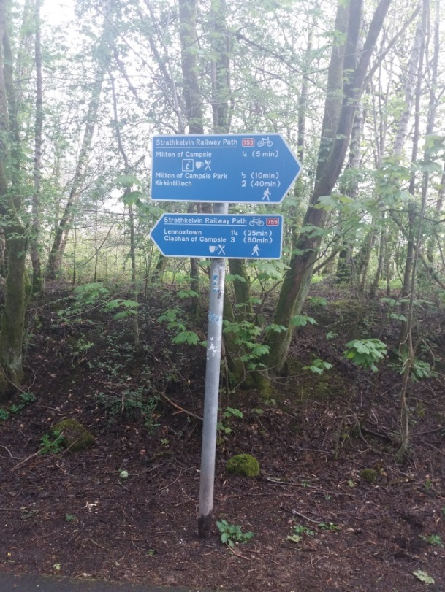
- Directional signpost opposite stairs from housing estate path between Laburnum Drive and Marguerite Place.
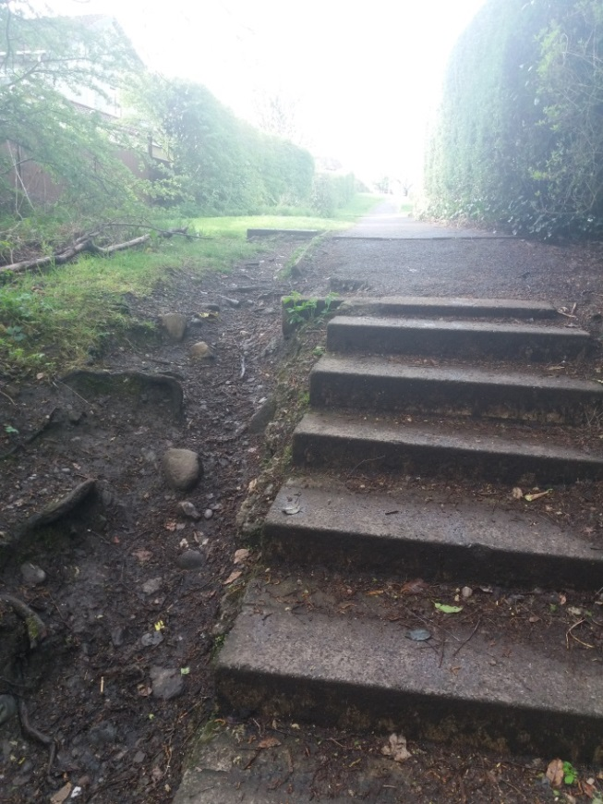
- View of top of stairs leading from estate path between Laburnum Drive and Marguerite Place showing erosion of site of steps and build of detritus on stair treads.
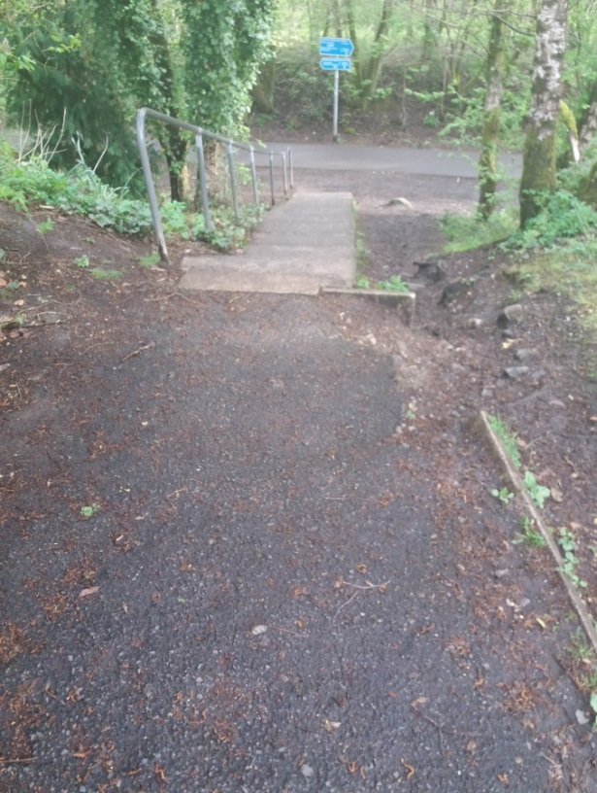
- View from top of stairs to Strathkelvin Railway Walkway from path between Laburnum Drive and Marguerite Place, showing erosion to LHS of steps and deterioration to footpath surface and LHS of path.
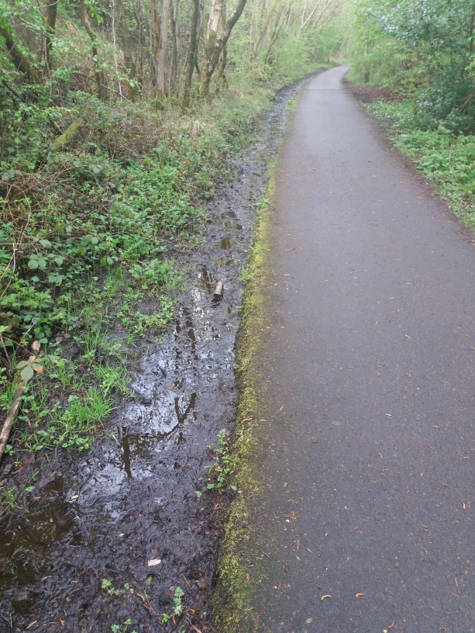
- Drainage channel alongside Strathkelvin Railway Walkway (opposite of path to Glazert) leading to culvert in pictures 27 & 28. Chanel is silted up and causes ponding on side of walkway after periods of heavy rain.
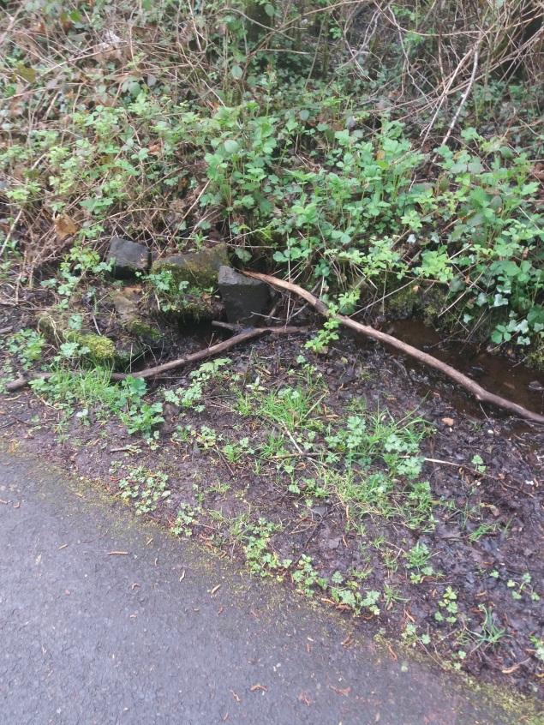
- Partially blocked entrance to culvert under Strathkelvin Riverside Walkway.
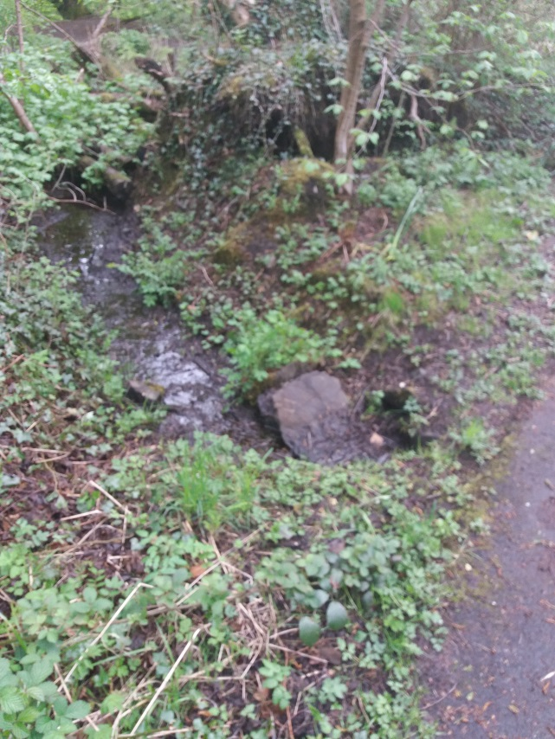
- Partially blocked exit point of culvert under Strathkelvin Railway Walkway (Glazert River side). Note the discharge from this culvert is not directed towards the Glazert but flows onwards over the Riverside Walkway.
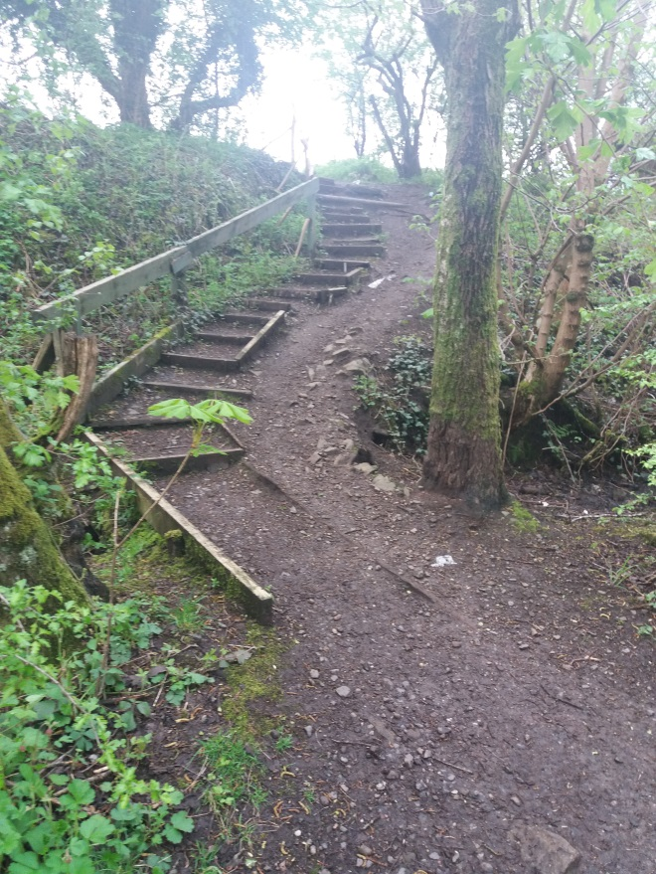
- Access path/steps to informal kickabout area accessed from James Boyle Square. Note erosion of path at step treads/retainer bars and use and erosion of area to LHS of path/steps and partial handrail.
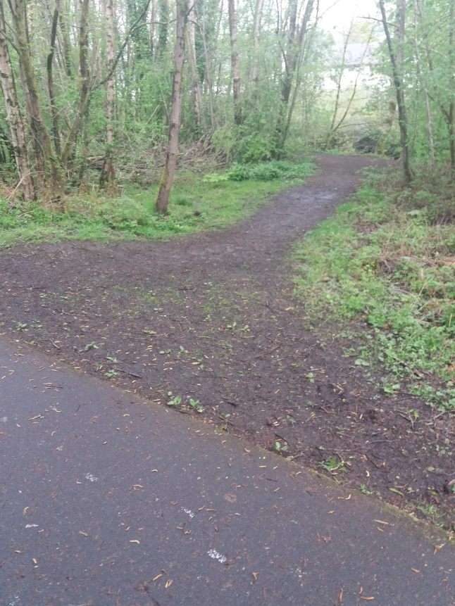
- Junction of access point to Glazert Riverside Walkway. Note this path is not classed as a Core Path.

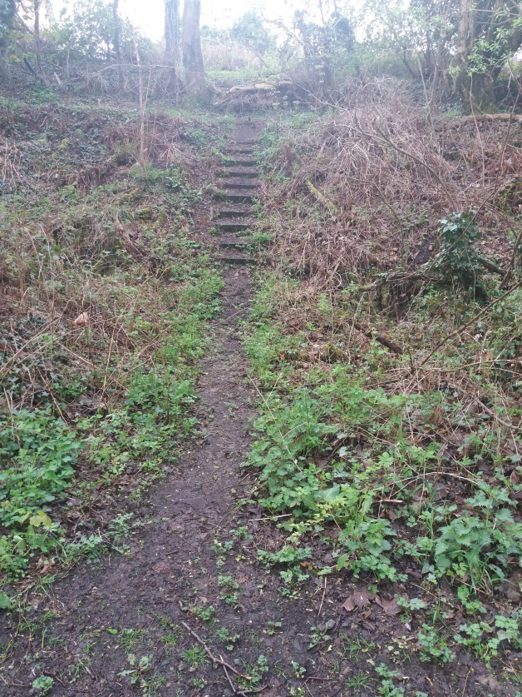
- View from Strathkelvin Railway Walkway of steps leading to informal kickabout area accessed from James Boyle Square. Fallen tree shown in picture 34 is just visible on middle far background.
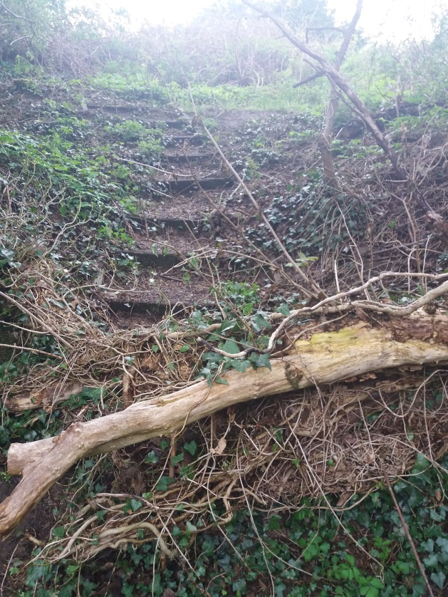
- View of top section of steps showing fallen tree and blocked access to steps.

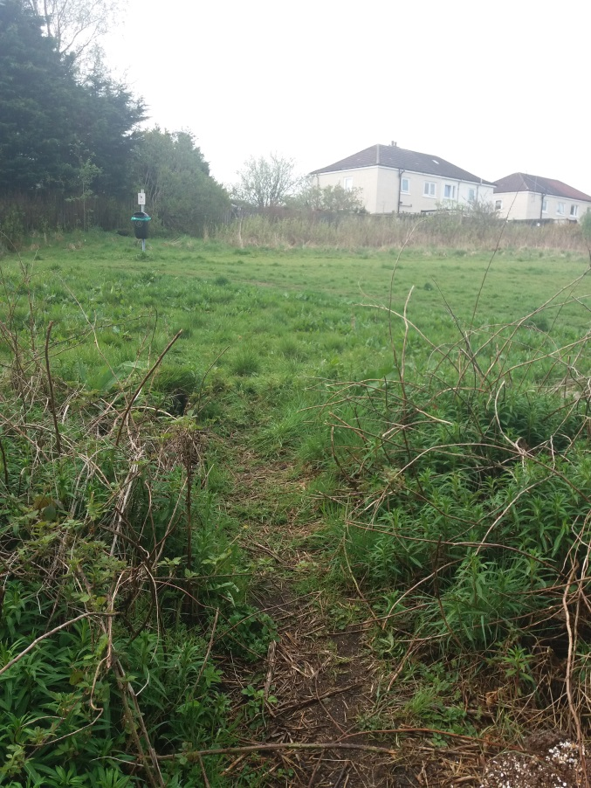
- View from top of steps shown in pictures 31 & 32 of informal kickabout area accessed from James Boyle square.
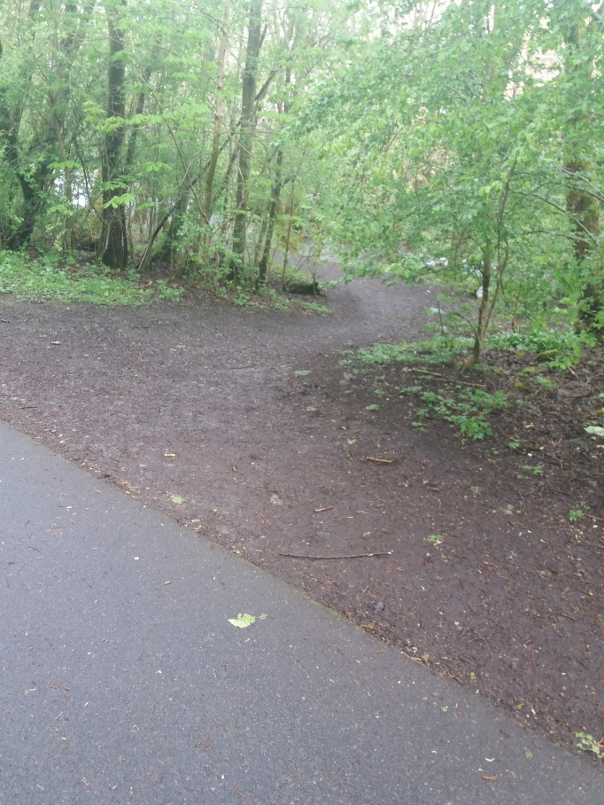
- Junction of start/access path to Glazert Riverside Walkway. Note this path is not classed as a Core Path.
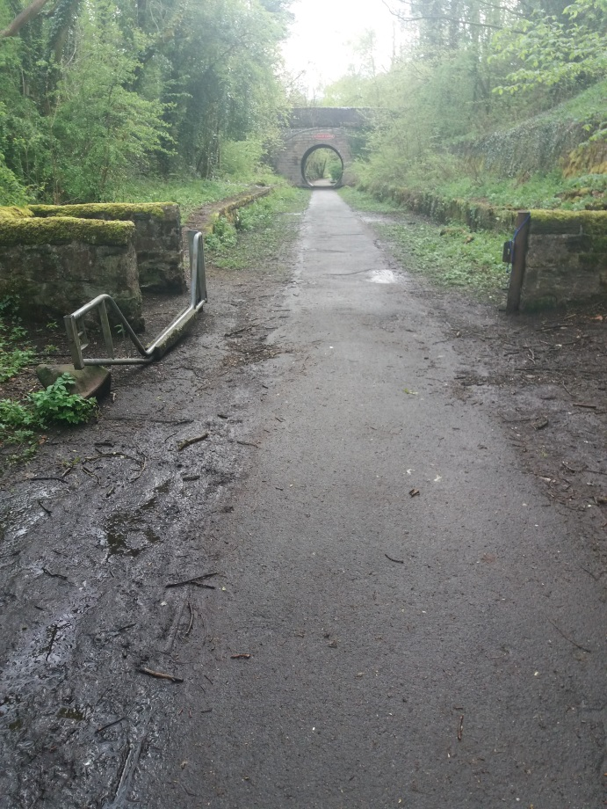
- View looking east towards eastern platform section with horse gate (constantly open). Note this section has large areas of top surface breakup.

