Informal Survey of Wells Core Path for Milton of Campsie Community Council – May 2021
The walk starts at the top of the steps between Criaghead Road and Locheil Drive, proceeds up Spouthead Farm Road to second cattle grid, then along path on LHS towards Ashenwell Dams and Alloch Dam then left on to farm track down to Campsie Road (A891) at side of Millgate Cottage. The route can also be walked in reverse.
Spouthead Farm Road is in poor condition with significant breakup of road edges and numerous potholes. On leaving Spouthead Farm Road paths are of compacted earth with numerous areas of significant ponding, flooding and soft ground, particularly after periods of heavy rain. Some attempts have been made in places to reduce the nature of the soft ground by the placement of bricks and board. There are areas of trip hazard caused my uneven surfaces and exposed tree roots in wooded areas.
Walking boots or stout footwear is highly recommended, while the route is not suitable for wheelchair users or persons with prams or baby buggies.
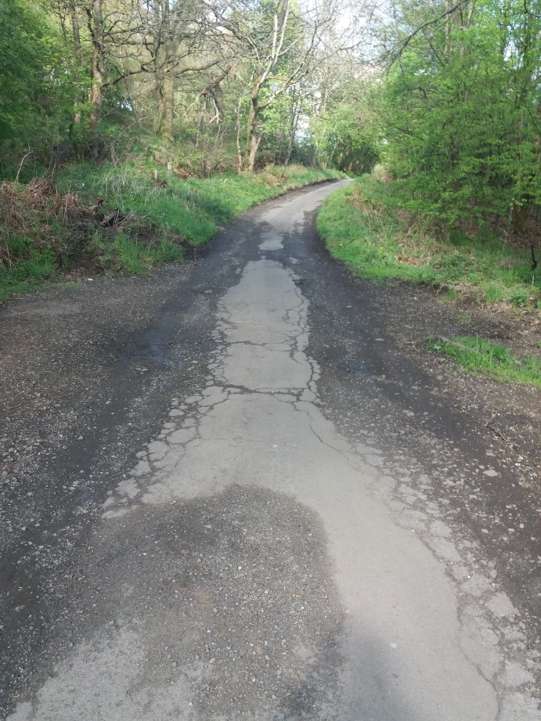
- Farm access road – Spouthead Farm Road (continuation of Craighead Road) just past rear of last of Barret Houses on Lochiel Drice
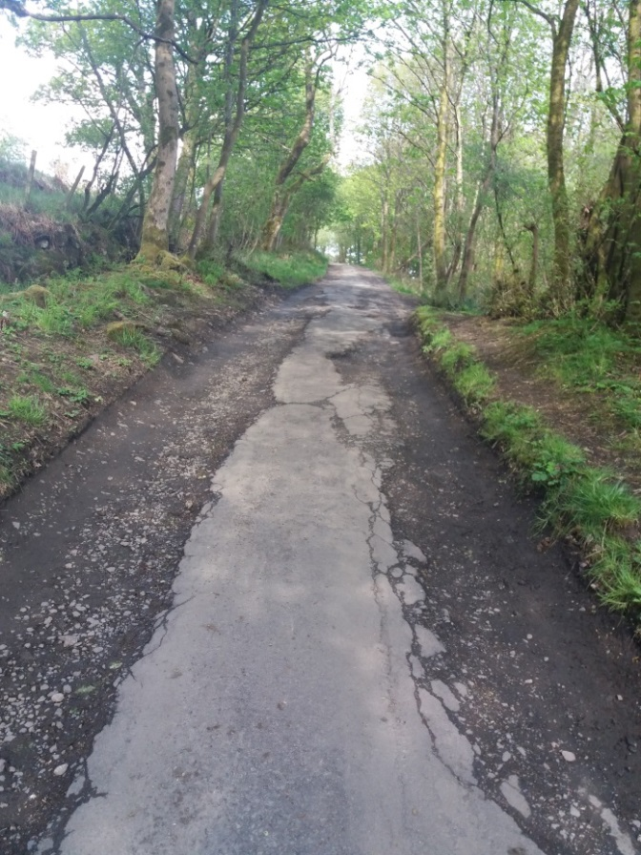
- Spouthead Farm Road from continuation of Craighead Road looking east (uphill) showing poor condition of road. Road direction changes in distance from West/East to South/North.
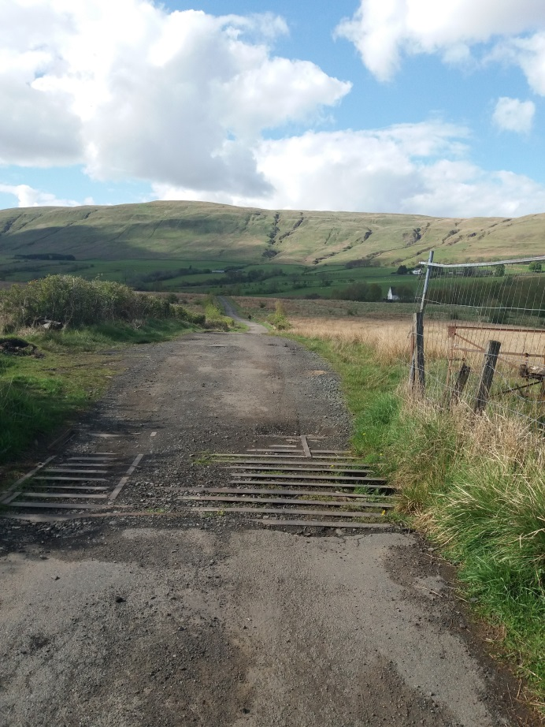
- “filled in” first cattle grid on farm access road just after directional change in road from West/East to South/ North.
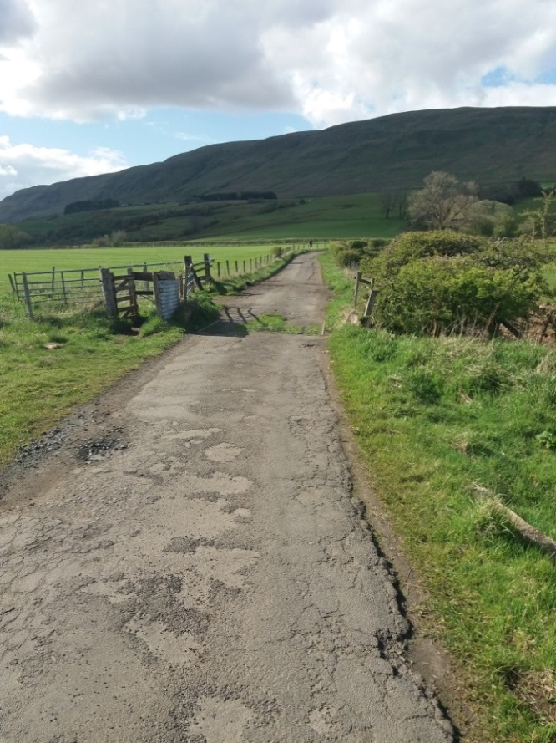
- Junction of path access and field access track with Spouthead Farm Road, showing grassed over second cattle grid and “kissing gate” shown in picture 5.
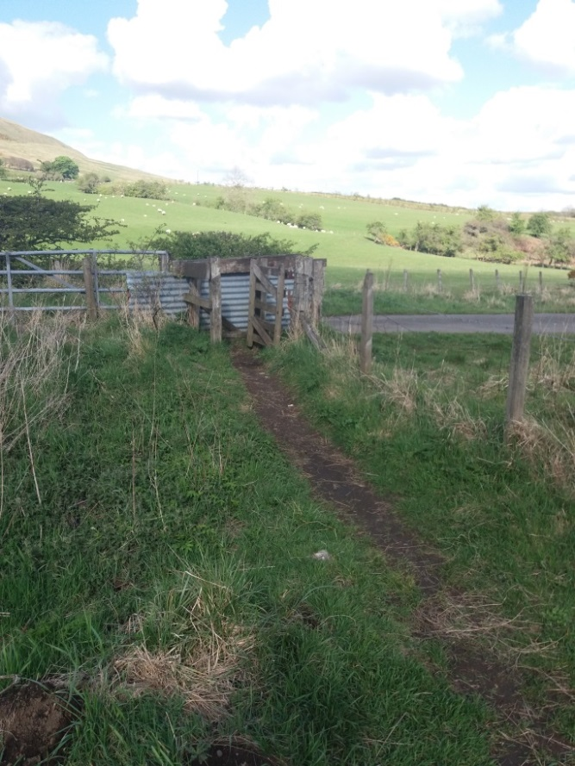
- Kissing style gate at start of path at junction of Spouthead Farm Road (picture taken looking East). Path becomes field access track shown in picture 6, 7 & 8. Junction of track and farm road is to RHS of metal gate in picture with cattle grid in road also to left of gate i.e. North
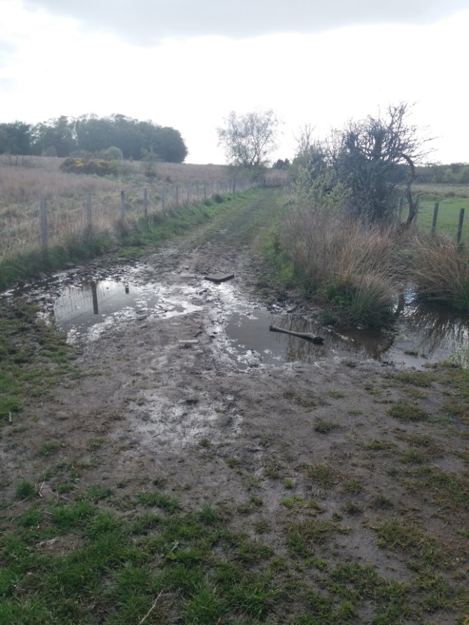
- Area of poor drainage at start of field access track from field access road looking west in direction of Ashenwell Dams
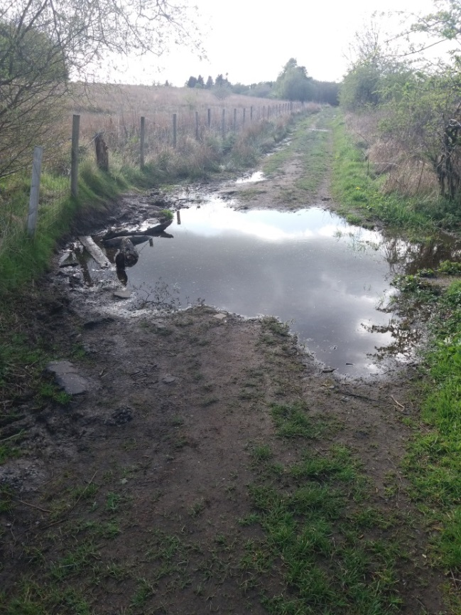
- Field access track running from access Spouthead Farm Road towards Ashenwell Dams and Alloch Dam, showing significant area of poor drainage across full with of track. Gates shown in pictures 8 & 9 are at start of tree line in distance.
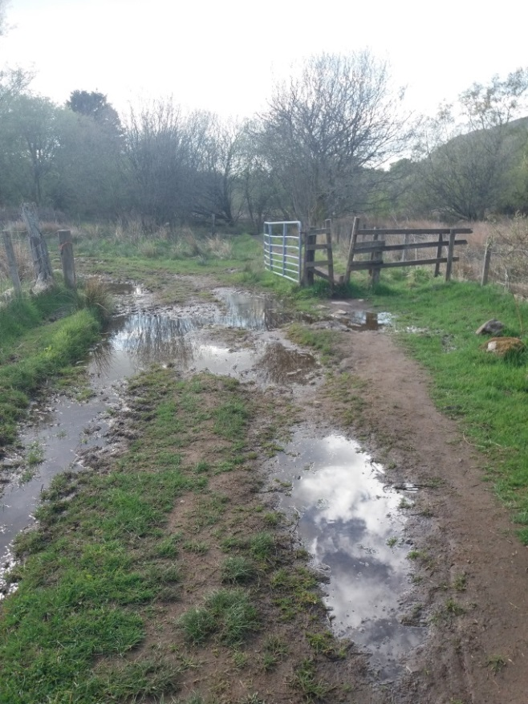
- First access gate, with “keyhole “type pedestrian gap, at end of field access track. Slightly raise path shown in Picture 9 starts on West side of gate. Track is heavily rutted with large areas of ponding in places.
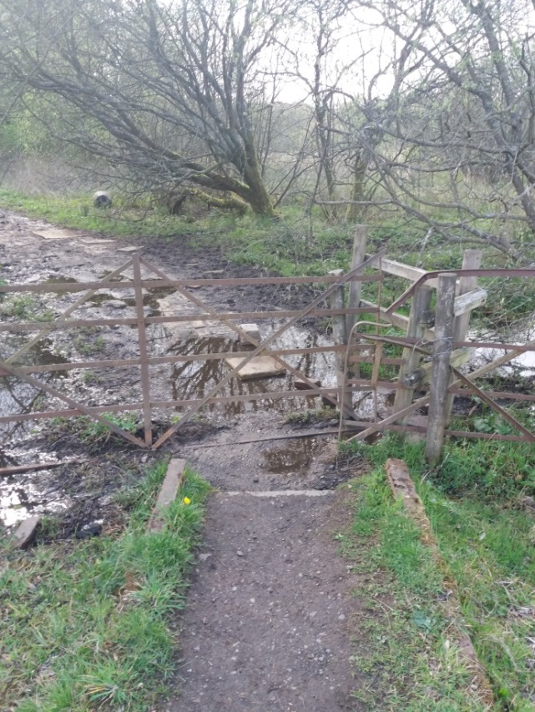
- Second access gate (dilapidated “Kissing” Type gate) at end of short slightly raised path with “kerb” edging from first access gate at end of field access track. Area on west side of gate very badly drained with significant flooding after periods of heavy rain. (See also picture 10)
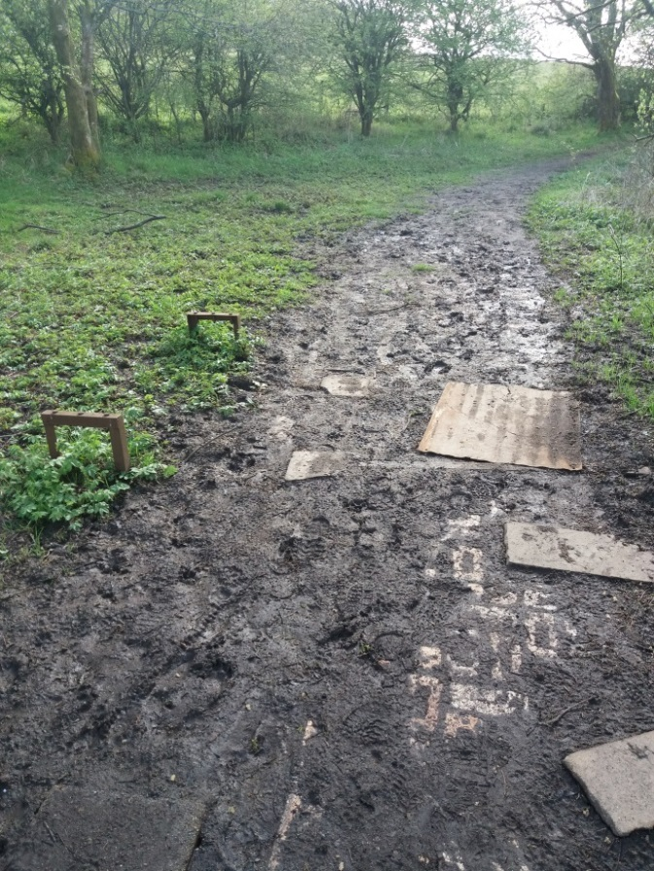
- “Start” of path after second access gate (Picture 9) after end of field access track. Path running East/West. Area very muddy with indication of path previously laid with brick and other boards to combat poor drainage. Ashenwell Dams are to RHS of path.
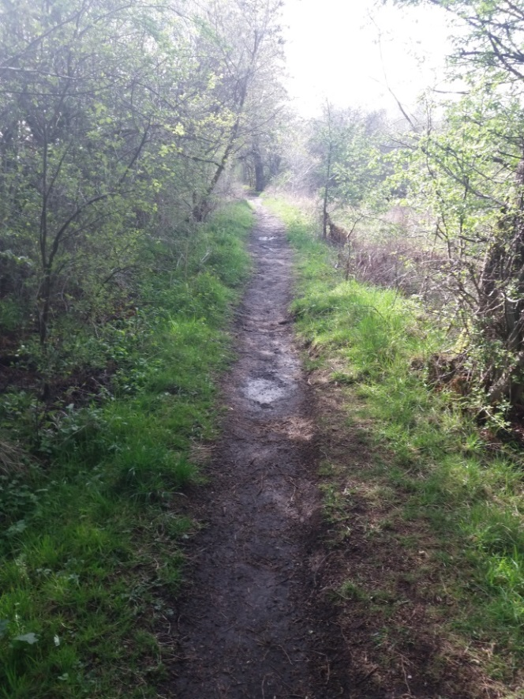
- Well rutted path continuing East/West to south of large pond. Path shows indication of significant ponding in places with path up to 6 -8 cm below grass level on either side.
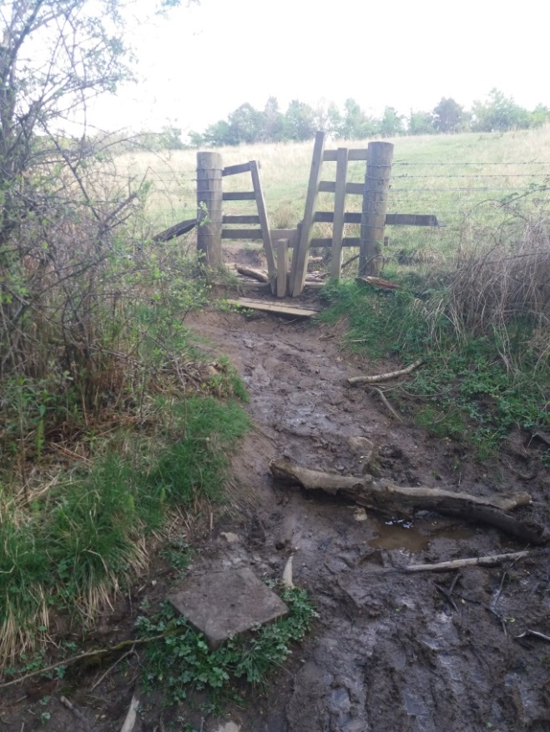
- Keyhole gate and short path from field on LHS of path, this access to field is opposite path shown in Picture 13.
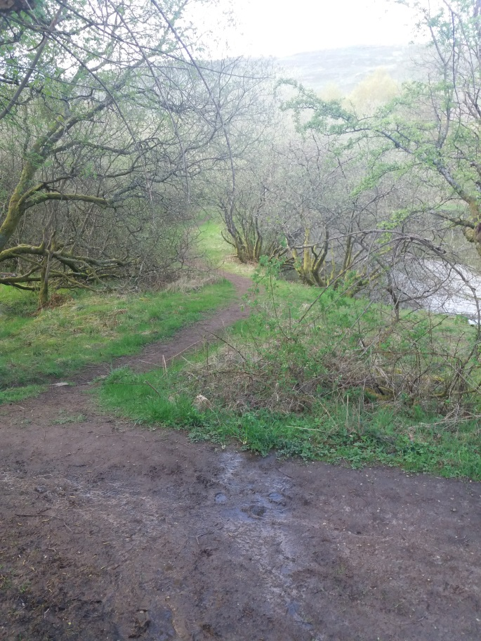
- Path off to left of main Core path at end of Ashenwell Dams (Visible RHS mid picture) running North. This path is opposite path and keyhole gate to South of Core Path shown in picture 12.
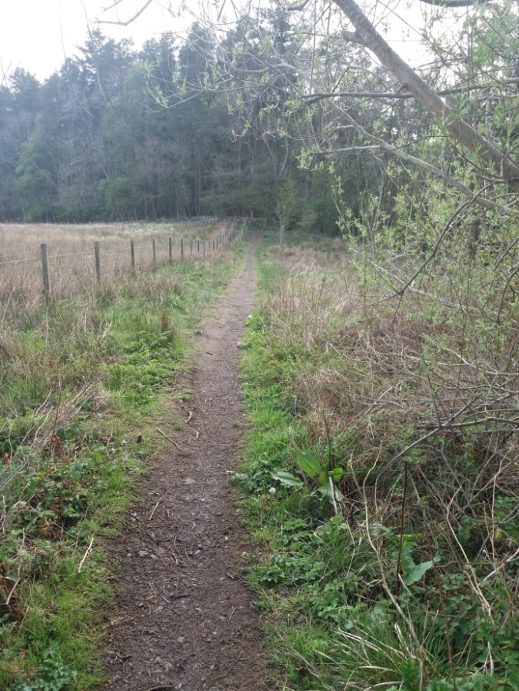
- View near end of East/West path from Spouthead Farm Road to woodland boundary wall and change of path direction to North /South. Boundary wall shown in pictures 15 & 16 just visible in distance.
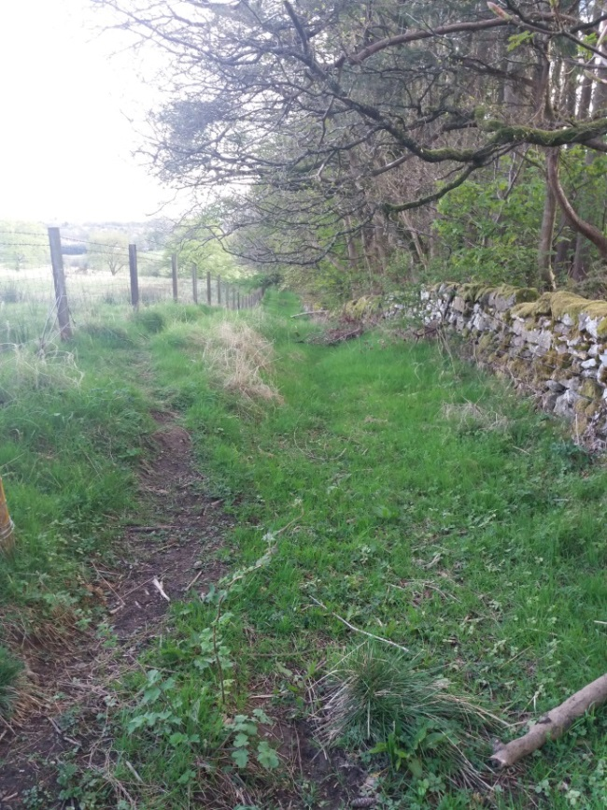
- Probable original core path running North South between Woodland boundary wall and fence. Path heavily overgrown
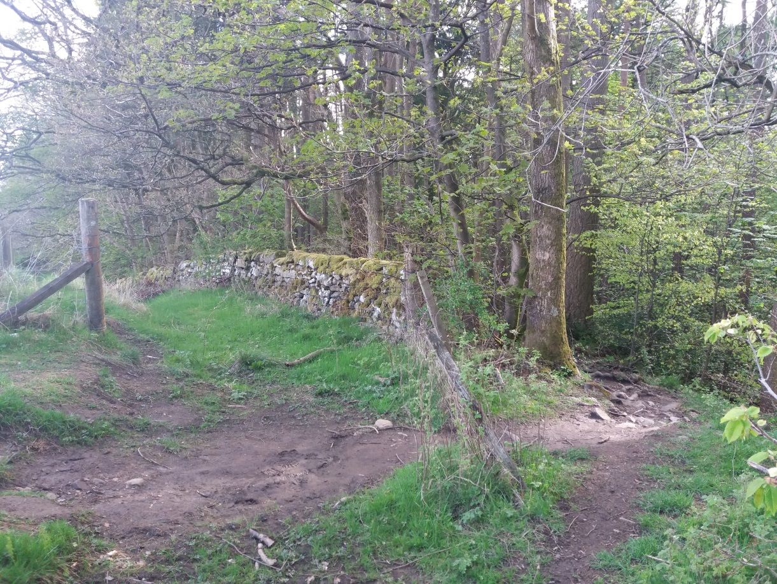
- Path at end of field showing directional change from East West to North South. Path between wall and fence (3m gap) appears to be original core path while path through woodland accessed by “climbing over” broken wall and fence is now the more used route. (see picture 15)
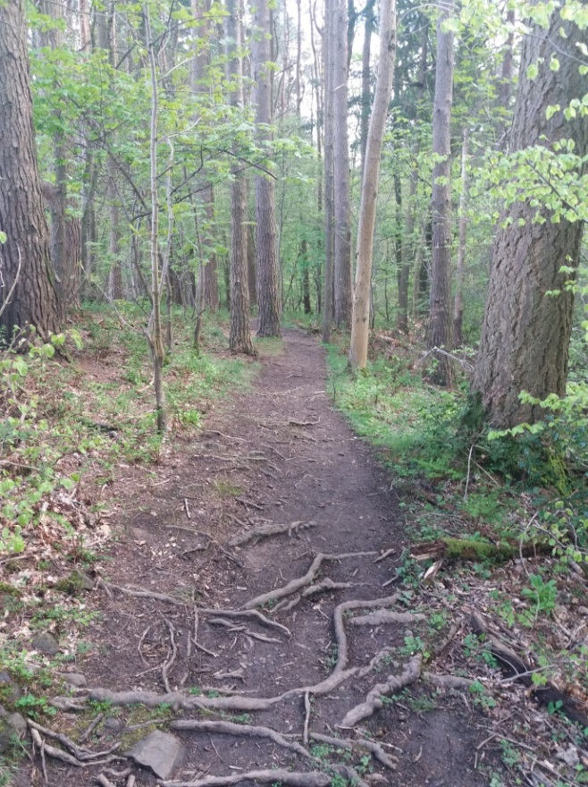
- Exposed tree roots visible along woodland path.
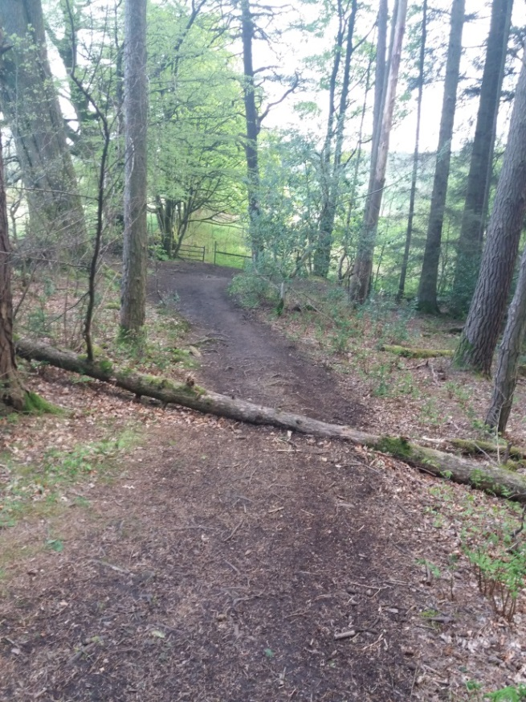
- Fallen tree over path through woods. Path running North South. Fence in distance is also shown in picture 19.
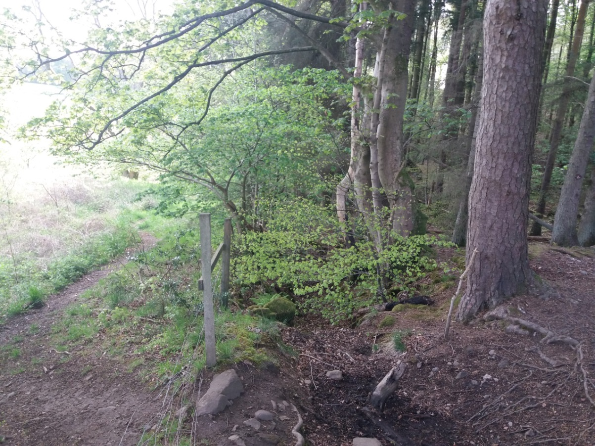
- Edge of woodland where path changes direction from North South to East West. Path on LHS of fence line appears to be original core path, while path on RHS through woods is now the more used route.
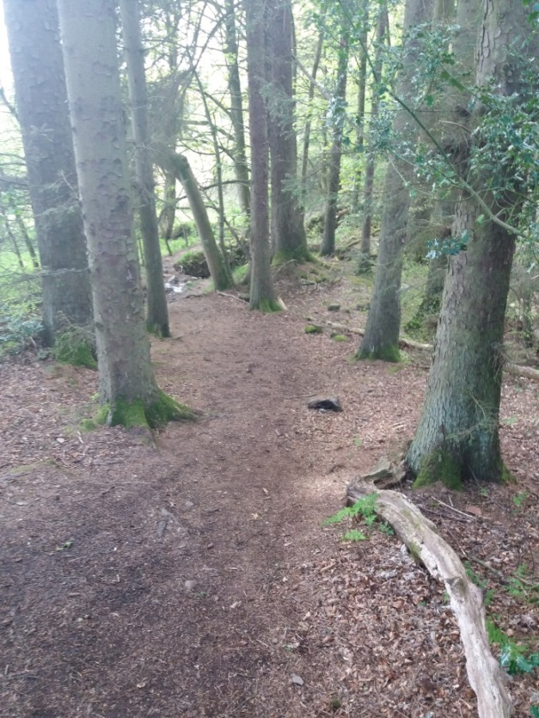
- Path through woodland running west from change in direction towards “telegraph Pole “ bridge over Brash Burn.
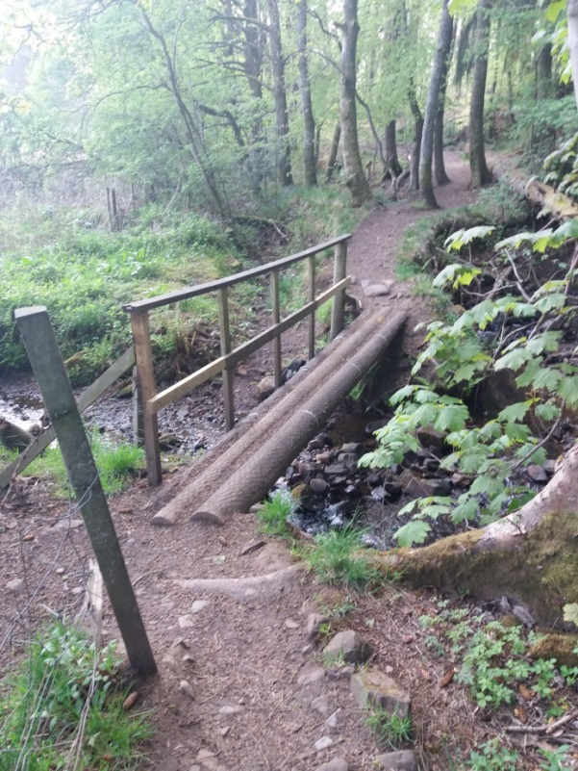
- View of “Telegraph Pole” bridge over Brash Burn looking west towards path to Alloch Dam. Fencepost in foreground marks end of fence delineating edge of woodland. Possible original Core Path is to LHS (Southside) of fence while existing well-trodden path is to RHS. Stream (Brash Burn) running under bridge appears to originally have been supply source to feeder race to Alloch Dam via open sluice gate now 1.5m higher than existing water level, it’s possible that in extremely heavy rain some water will be diverted through sluice.
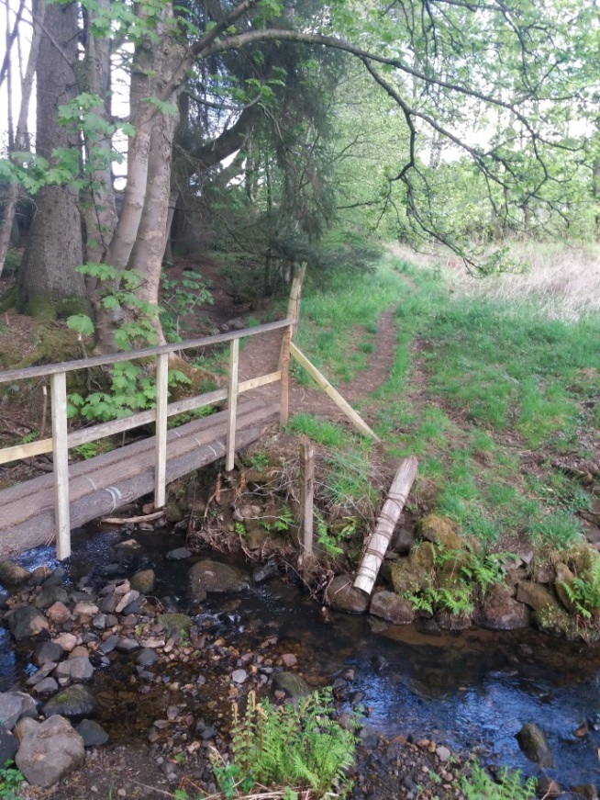
- View looking east across “telegraph pole” bridge over Brash Burn. Note Path on right is possibly little used original Core Path on RHS (South side) of fence delineating woodland edge and field. Path visible on LHS is existing well-trodden route.
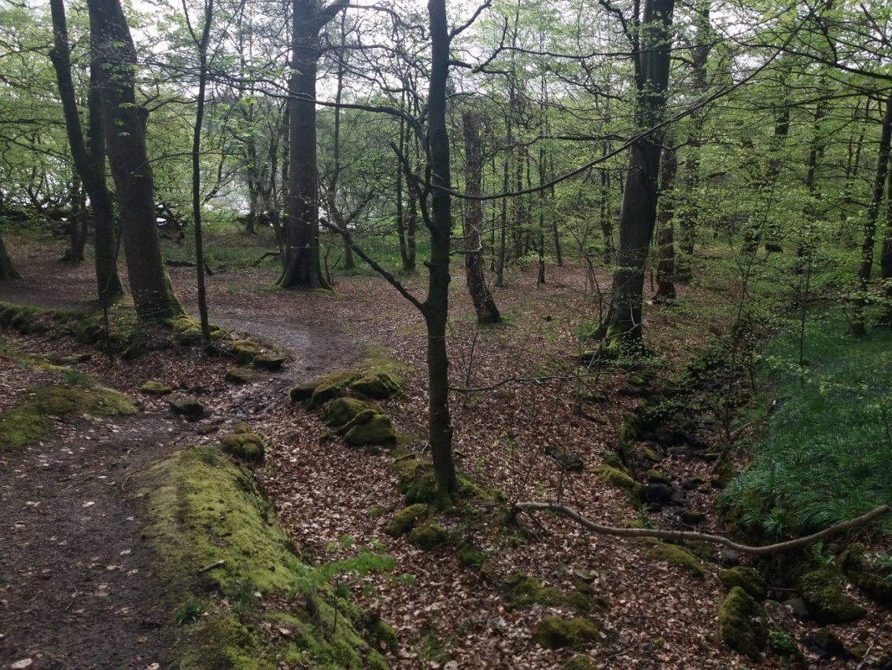
- Path through wooded area from “telegraph pole” bridge with Alloch Dam in distance through trees and dry feed race to Alloch Dam on RHS
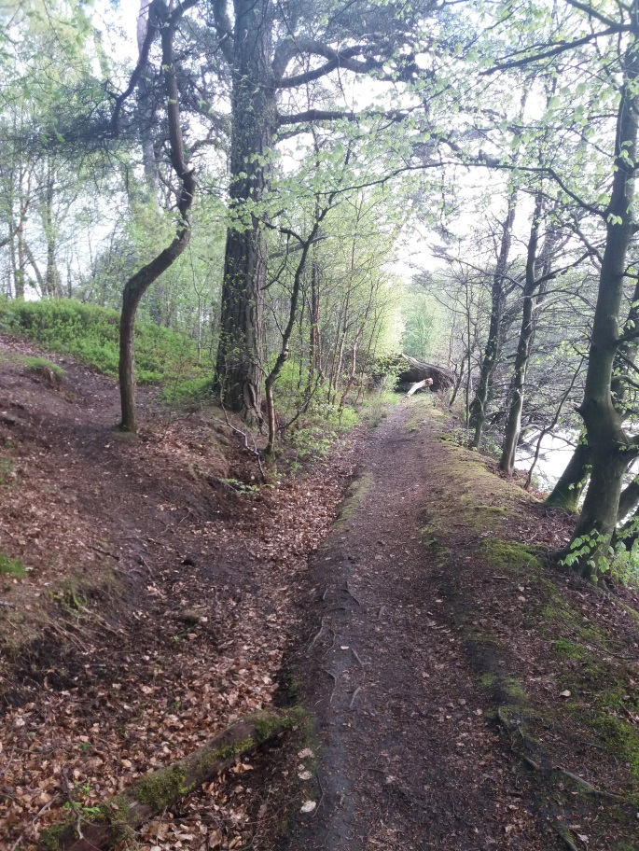
- Path blocked in distance by old fallen tree, alternative route by-passing three visible up bank to LHS of main path.
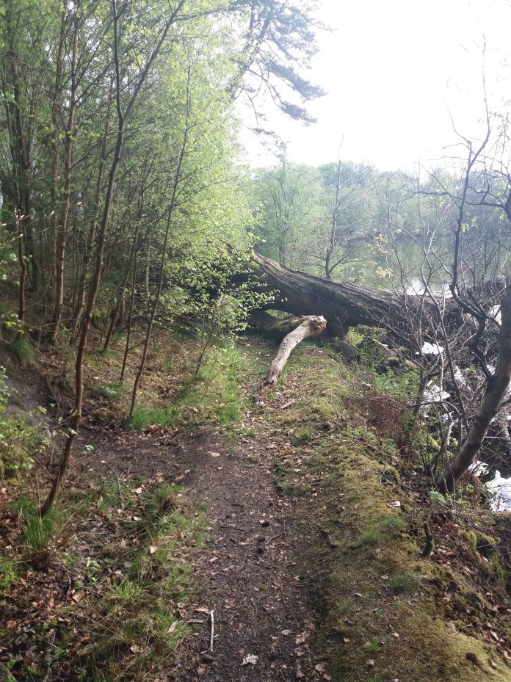
- Large “old” fallen tree blocking path to side of Alloch Dam. Steep short bank climb required to by-pass, visible LHS of path. (see also picture 24)
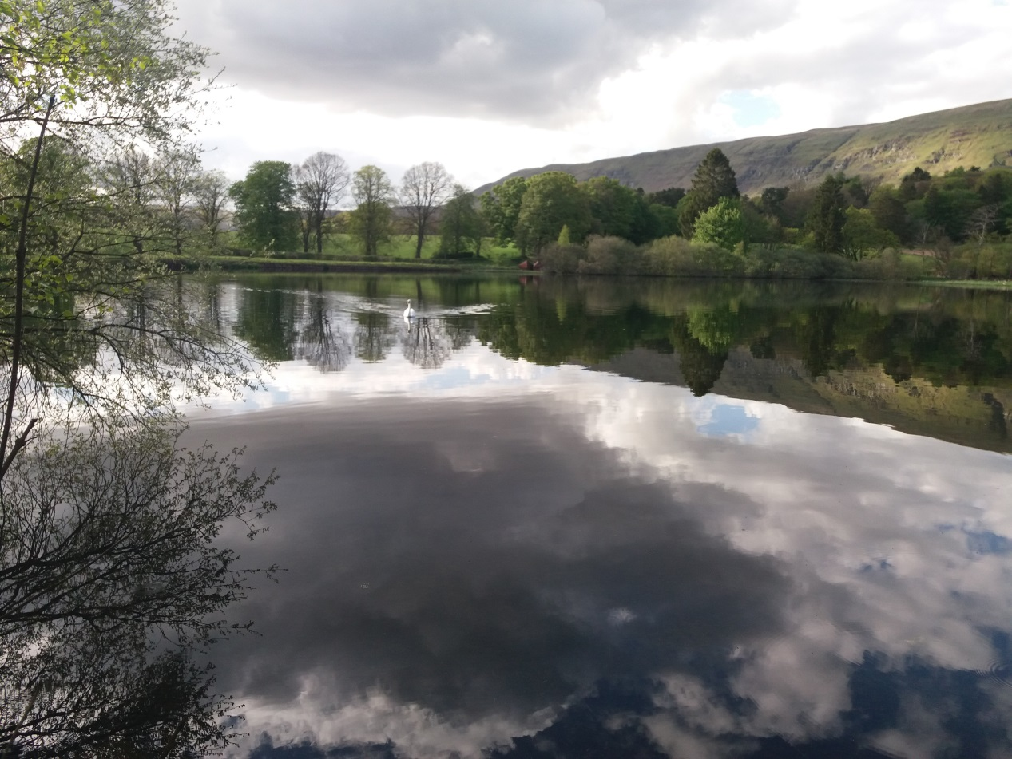
- Views that make the walk worthwhile.
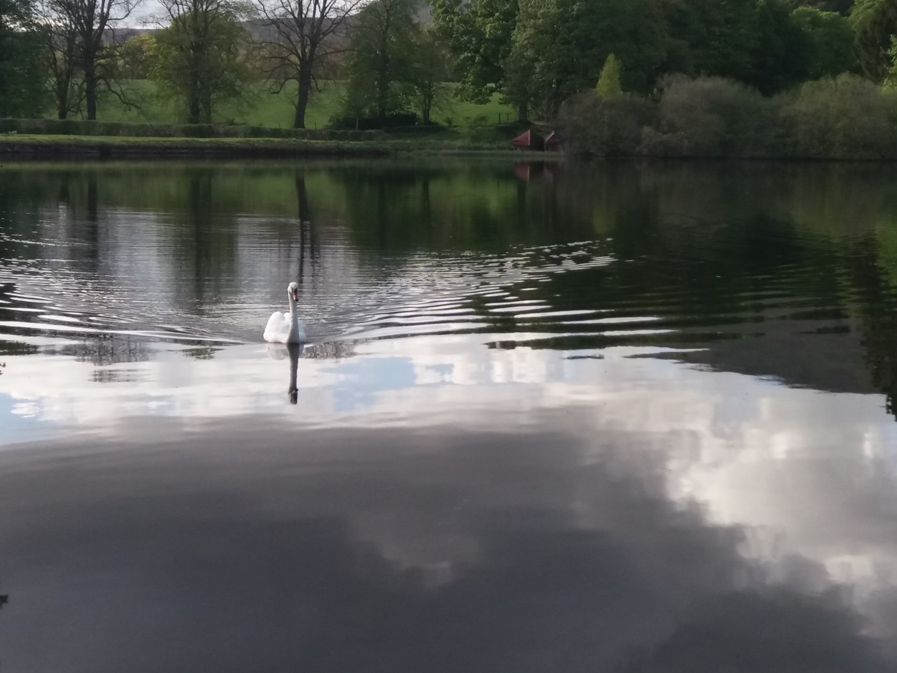
- Pretty swan coming to meet me – Just for scenic interest!
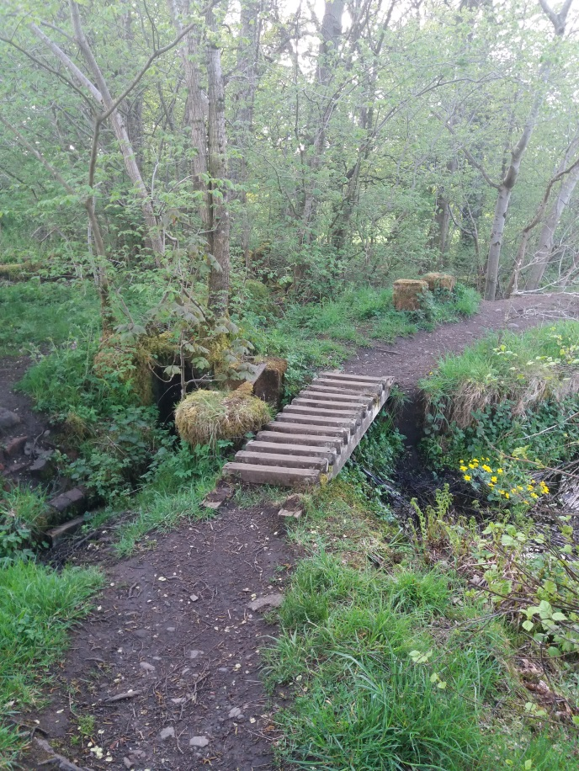
- Wooden footbridge (No handrails) across exit “steam” going into brick lined culvert. (possible feed race to lower old Glorat Mill)
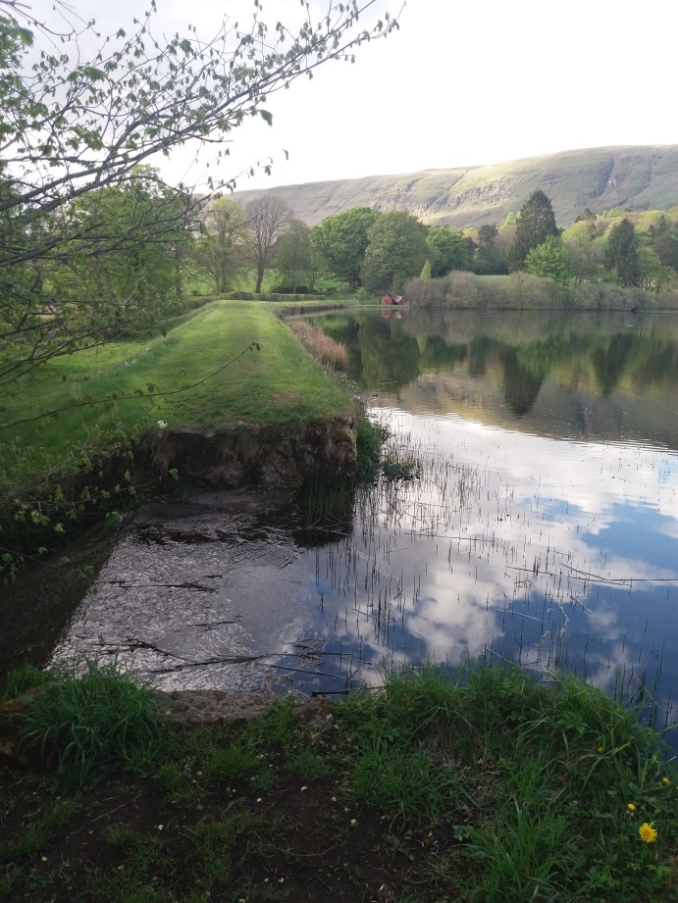
- Top of exit weir from Alloch Dam, dilapidated boatshed? visible in distance. It’s possible that there used to be a bridge across top of weir to gain access towards Boatshed.
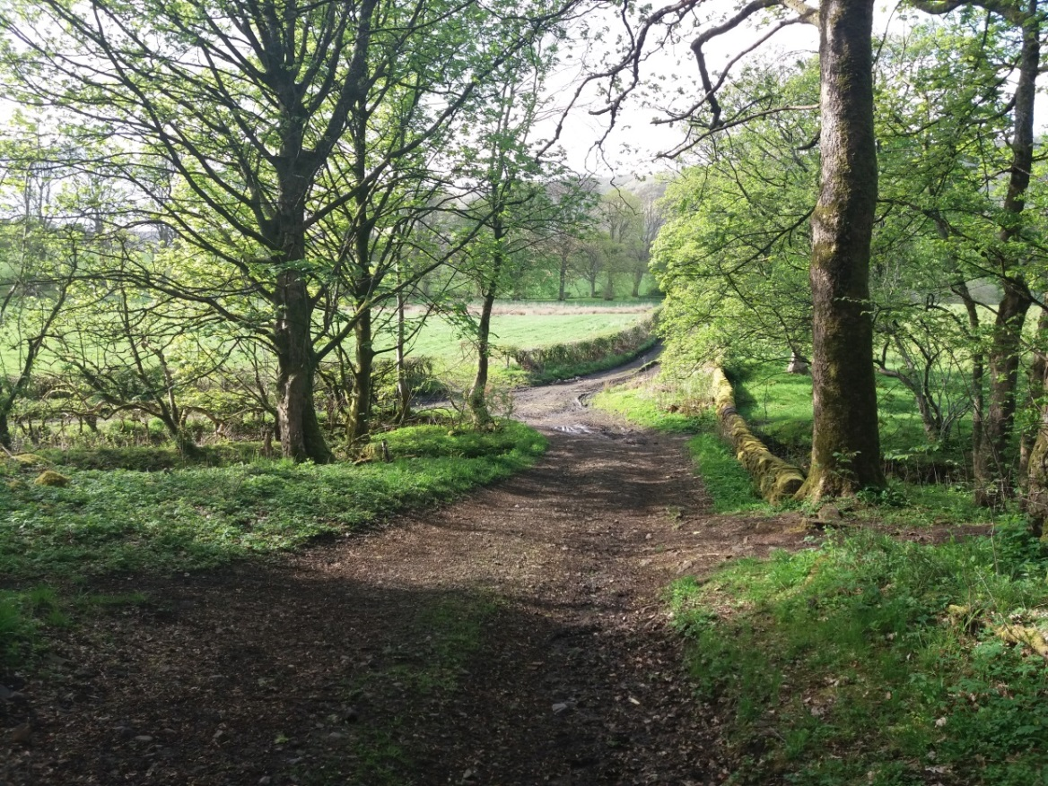
- View (looking North) from access track to fields south of Alloch Dam, Core Path from Alloch Dam can be seen at RHS, while alternative (Not Core path) in direction of ruin of Glorat Mill can be seen on LHS.
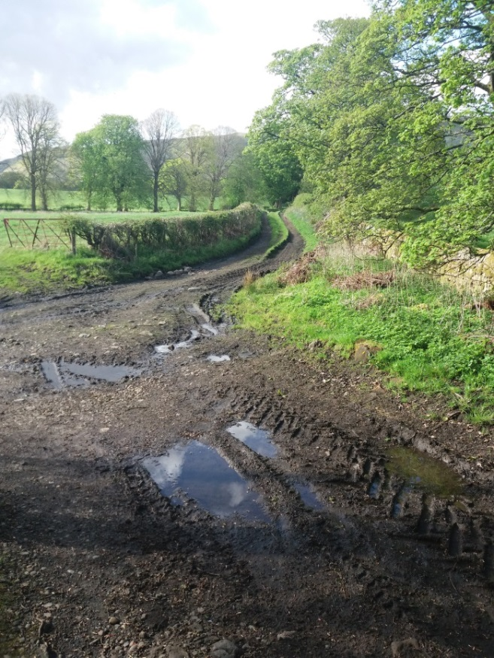
- View looking north towards where track access to fields south of Alloch Dam, track from Campsie Road – A891 to…. and path from Alloch Dam converge. Area deeply rutted and muddy.
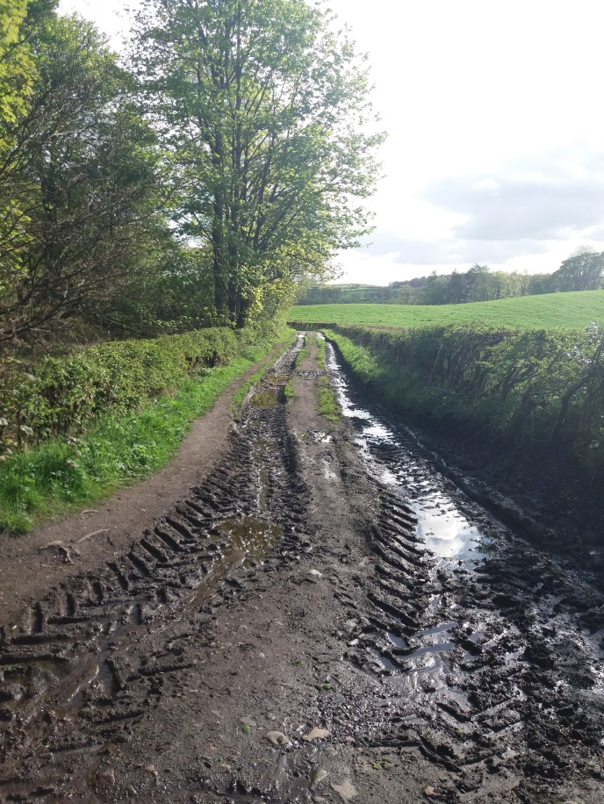
- View looking South along deeply rutted track leading towards Campsie Road (A891). Centre of track or LHS only are suitable for walking. Picture taken where footpath from Alloch Dam meets access track from Campsie Road.
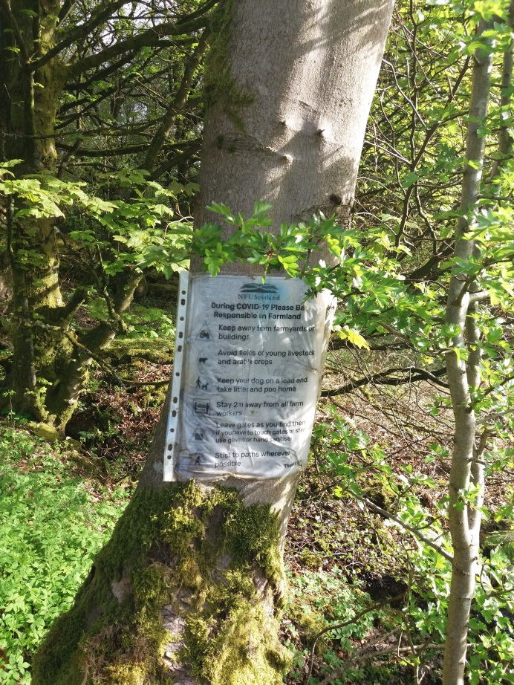
- EDC poster affixed to tree at path and track junction detailing Covid precautions.
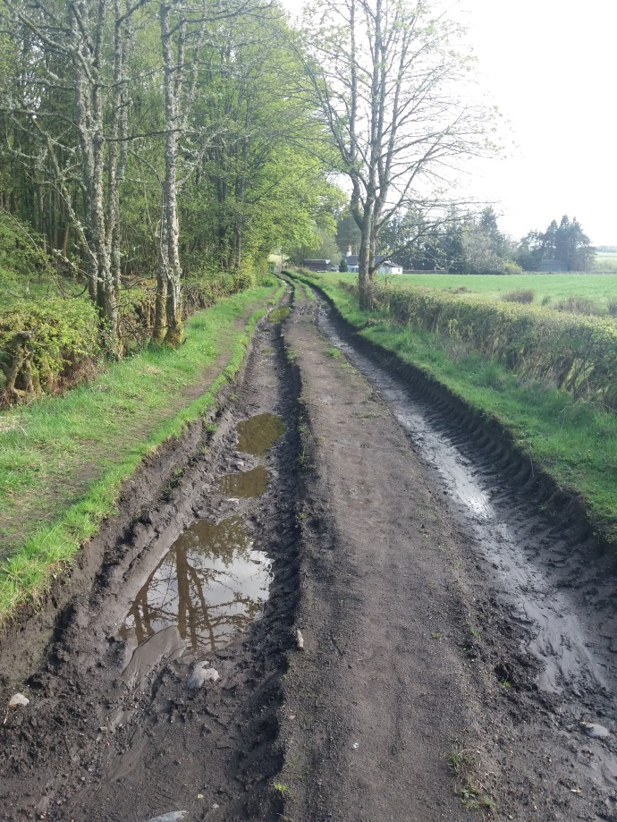
- View looking South along deeply rutted track leading down to Campsie Road – Millgate Cottage on Campsie Road visible in distance. Centre of track on LHS only area suitable for walking.
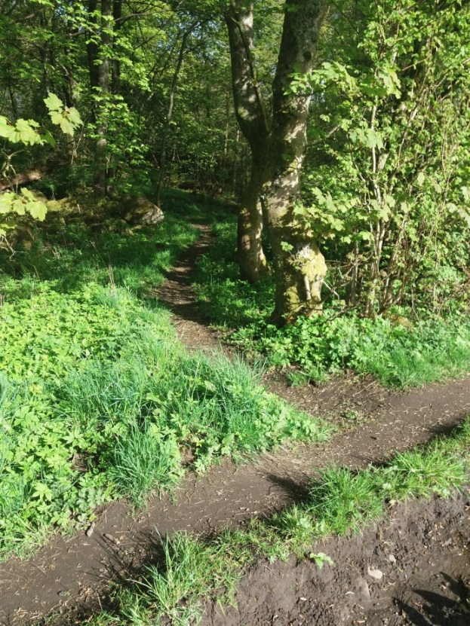
- Informal path leading off access track from Campsie Road towards Ruin of Glorat Mill.
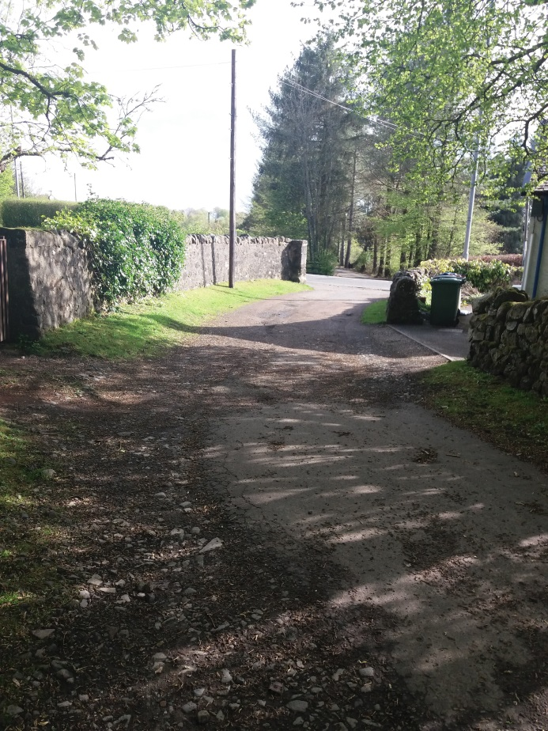
- View looking South towards end of Wells Core Path walk at Campsie Road (A891) Millgate cottage on RHS.
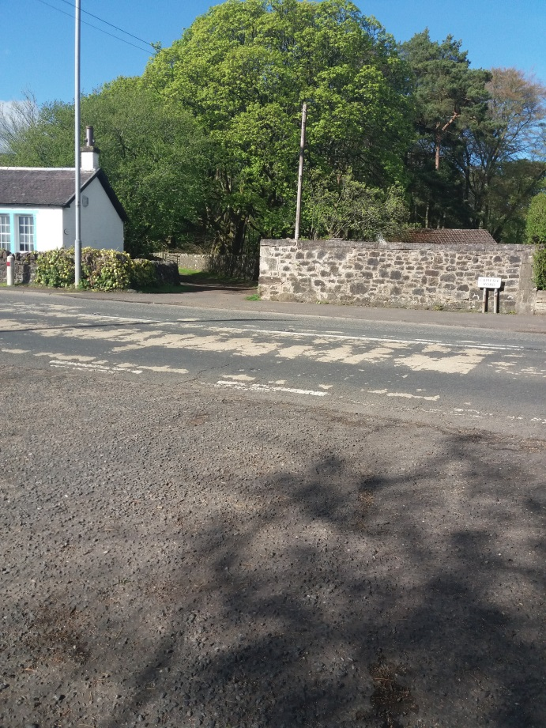
- View looking north across Campsie Road (A891) to end/start of Wells Core Path Walk, with Millgate Cottage at RHS.

