Informal Survey of “Westerton” Core Path for MoCCC
This Core path runs from …… Road in Lennoxtown back to Milton of Campsie entering the Village by way of the access Road to Westerton Form, Glorat House etc.
The path is different from most of the other Core Paths for a couple of reasons:
- If one starts from Milton of Campsie it is harder to locate the point at which to leave the farm road unless one knows where. As you walk up the farm road there is a style over a wall into a field, this route (although round the field edges) will take you to the back of the houses accessed from …. But does involve some further fence climbing and some very soft and muddy ground.
- The route from the start is not obvious in so far as it is not well trodden, however the route is very easy if one follows the field edges, and is careful of the livestock in the field. For this reason it is not recommended for those with dogs.
As with most of the other Core Paths this route is not suitable for wheelchair users or those with prams or buggies. There is a requirement to use a flight of steps and a number of styles over fences and walls. Walking shoes or boots are recommended as 50% of the walk is through fields currently used for pasture.

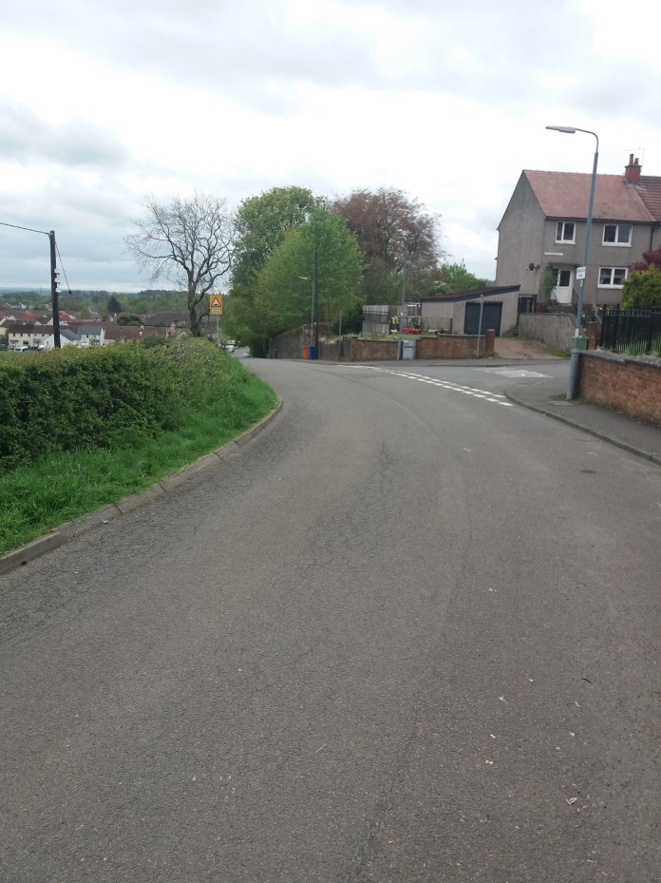
- View down (South) Bencloich Road (Lennoxtown) from start of walk
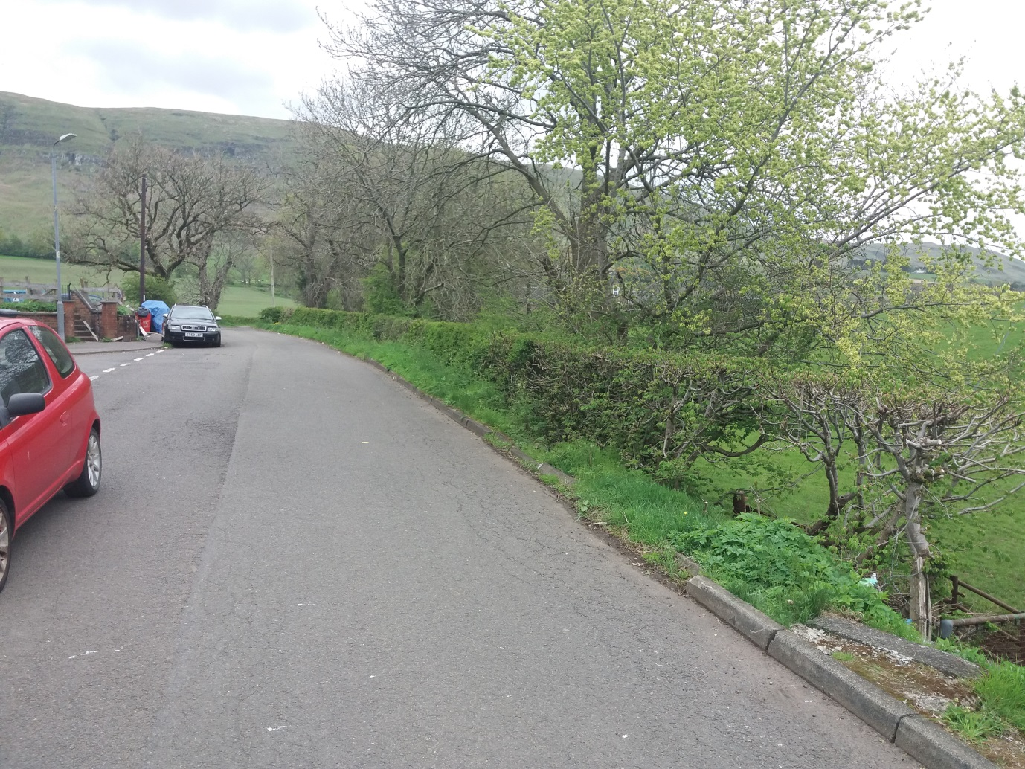
- View up (North) Bencloich Road (Lennoxtown) from start of walk. Flight of steps into field just visible on right of picture.
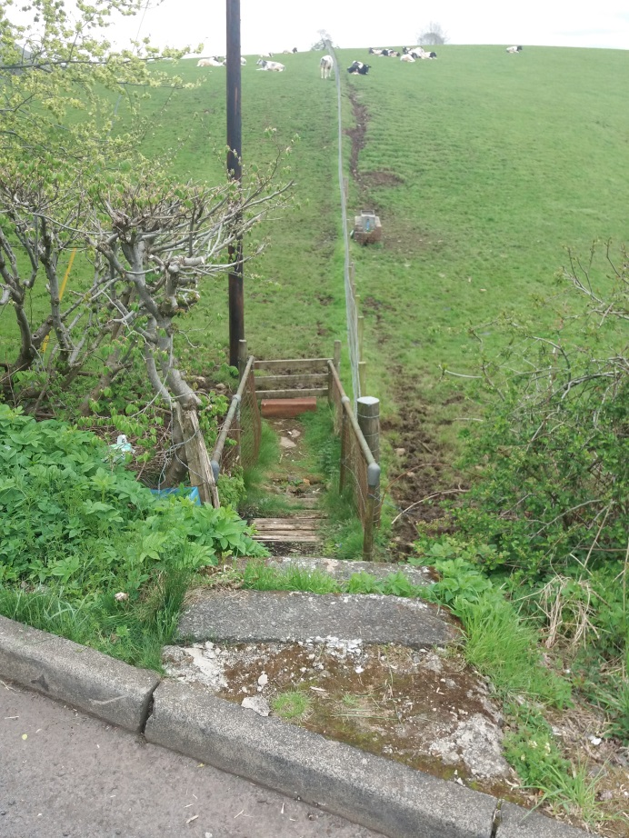
- View down flight of steps into field at start of walk. Crazing cattle in field visible on crest of hill. Walk continues across field following fence line.
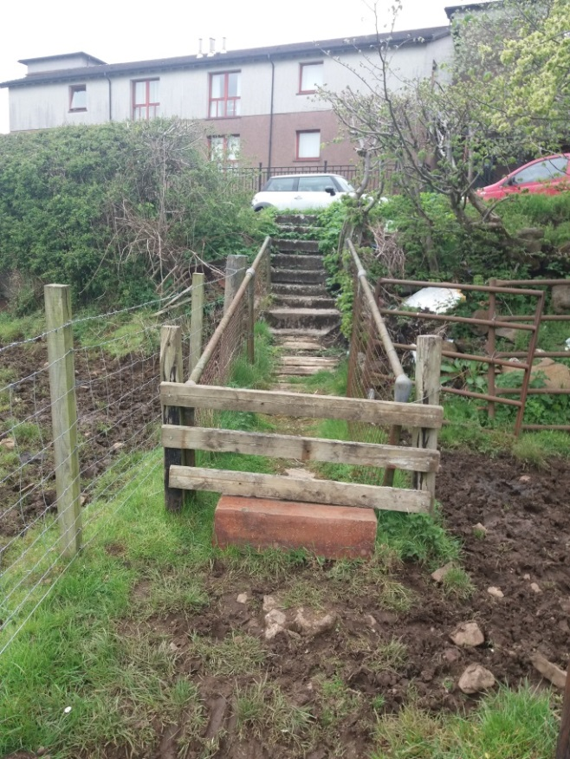
- View from start of walk in field back up the flight of steps to Bencloich Road. Note there is a requirement to climb over the fence/style.
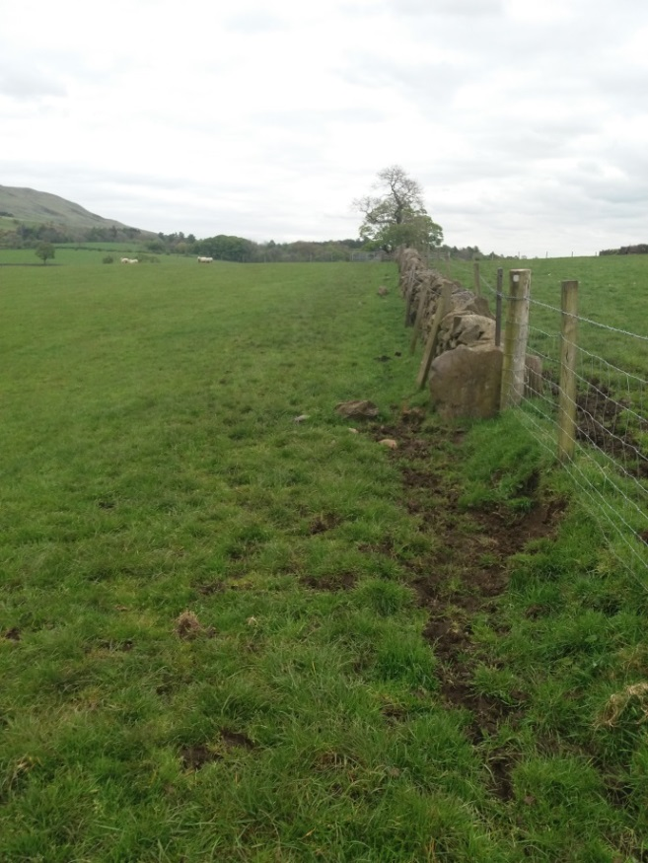
- Path follows fence line, keeping it on ones right.
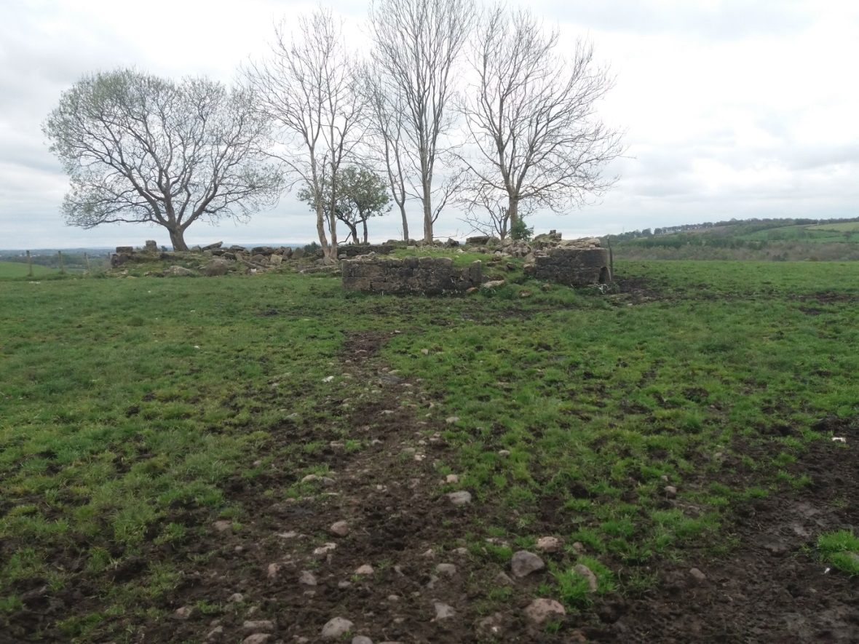
- Point of interest, ruined farm dwelling/building on RHS in adjacent field mid-way through first field of walk.
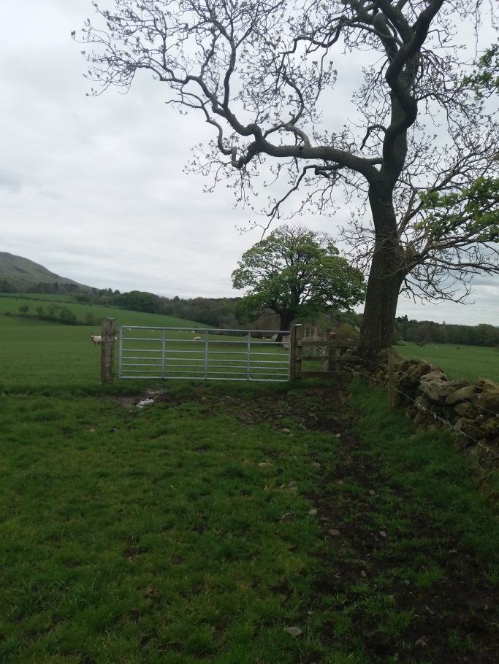
- Walk continues into next field, by climbing over style to right of gate, and again following fence line.
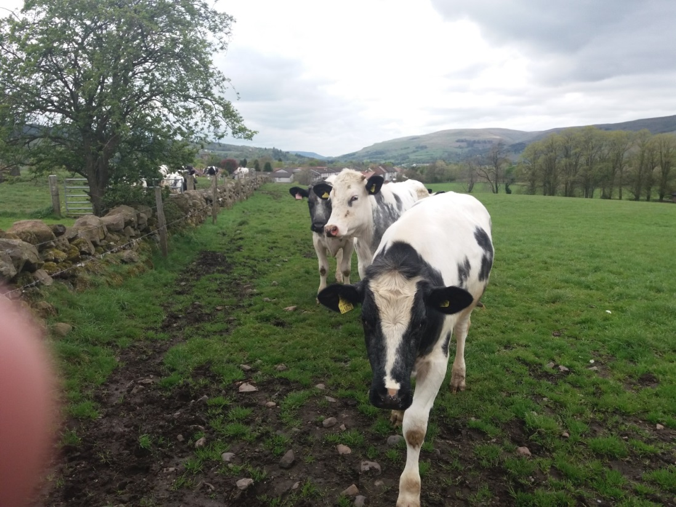
- Be prepared for grazing cattle to follow (closely) as you walk through the field. Picture taken just before crossing style in picture 7.
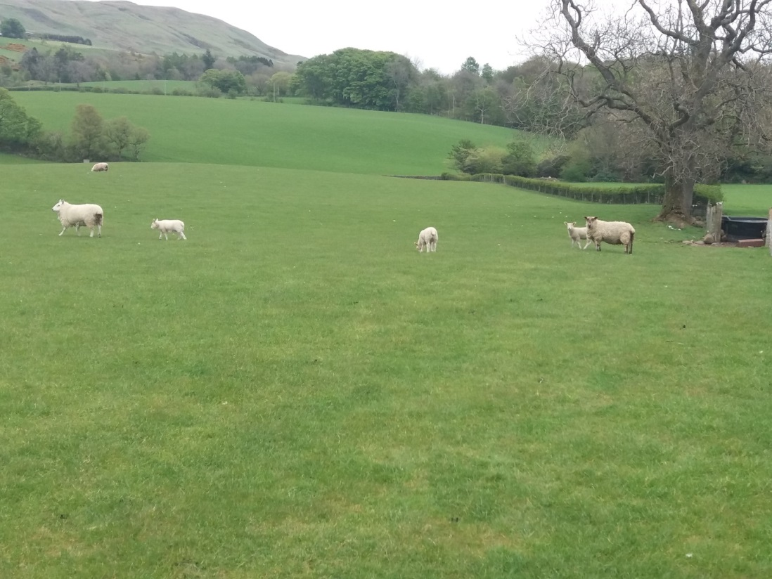
- Again be prepared for livestock in second field. This time sheep and lambs, which are more timid that the cattle.
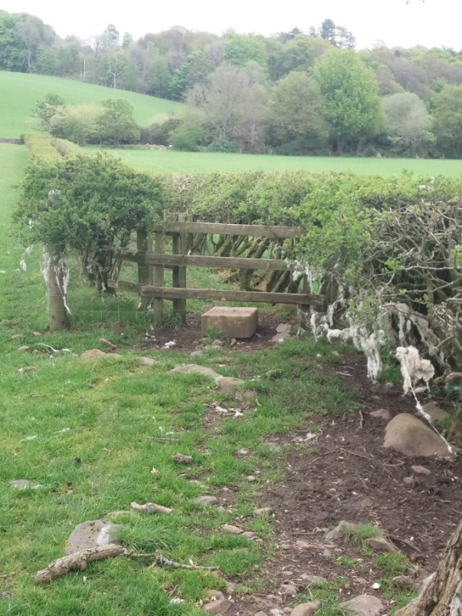
- Approximately halfway through the second field, just past the large tree on right of picture 9, the path continues between two rows of hedges after climbing over another style.
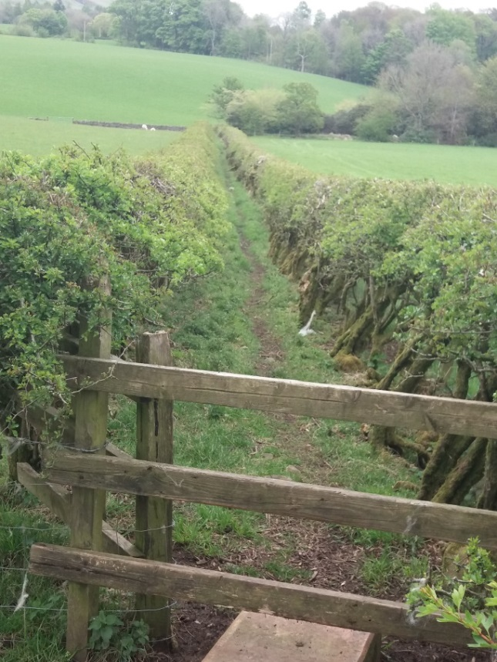
- View from style of path continuing between two rows of hedges.
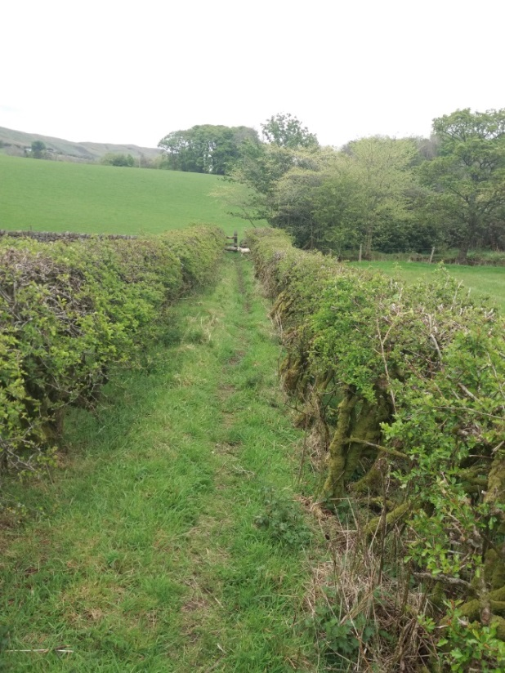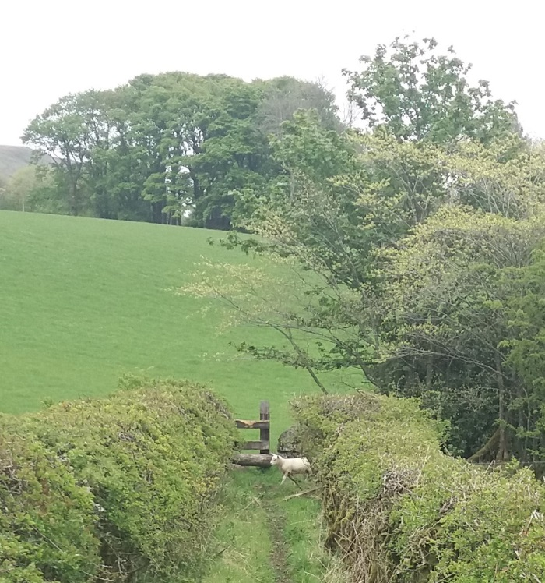
- Looking towards the end of this section one had to pause for a couple of young lambs to return back to the field after they had wandered through gaps in the hedges.
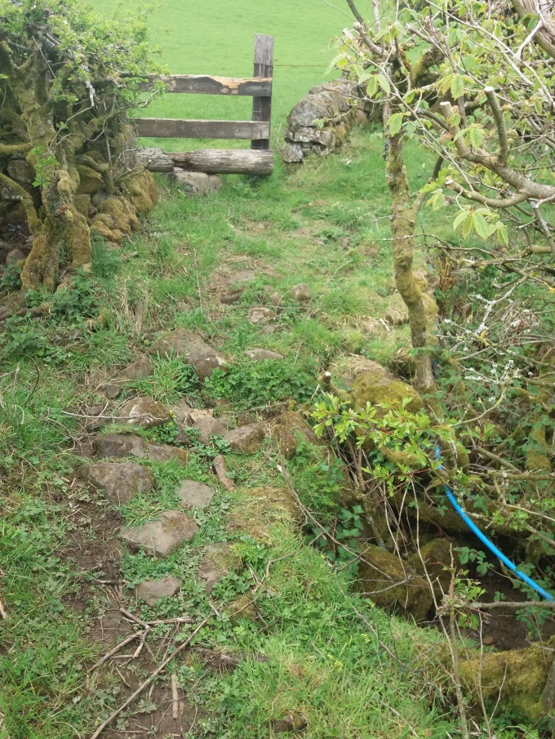
- At the end of this section you cross a culverted stream and climb over another style into field three.

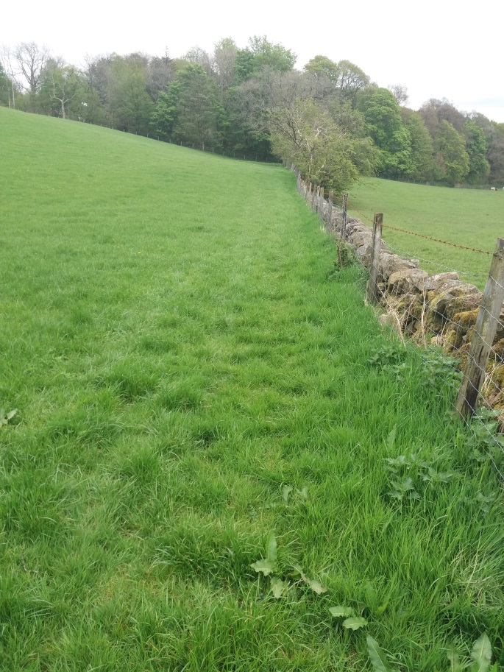
- On entering field three again one follows the wall on right along the field edge.
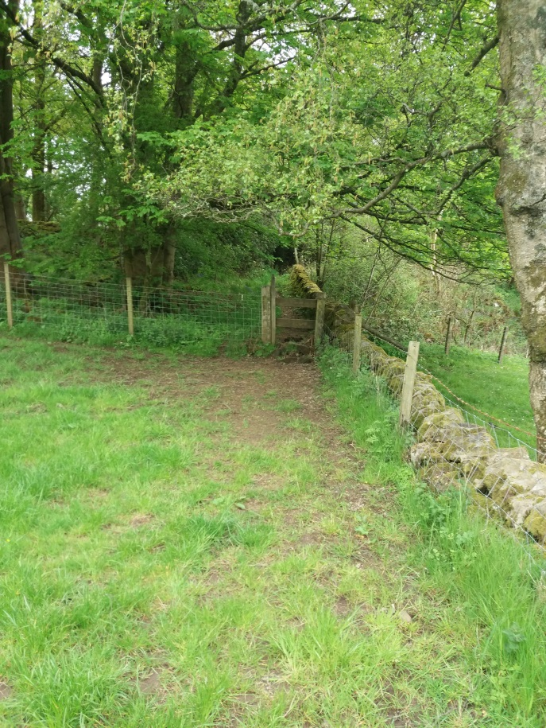
- On reaching the end of the field one climbs over the style and follows the path through the wooded section of the walk.
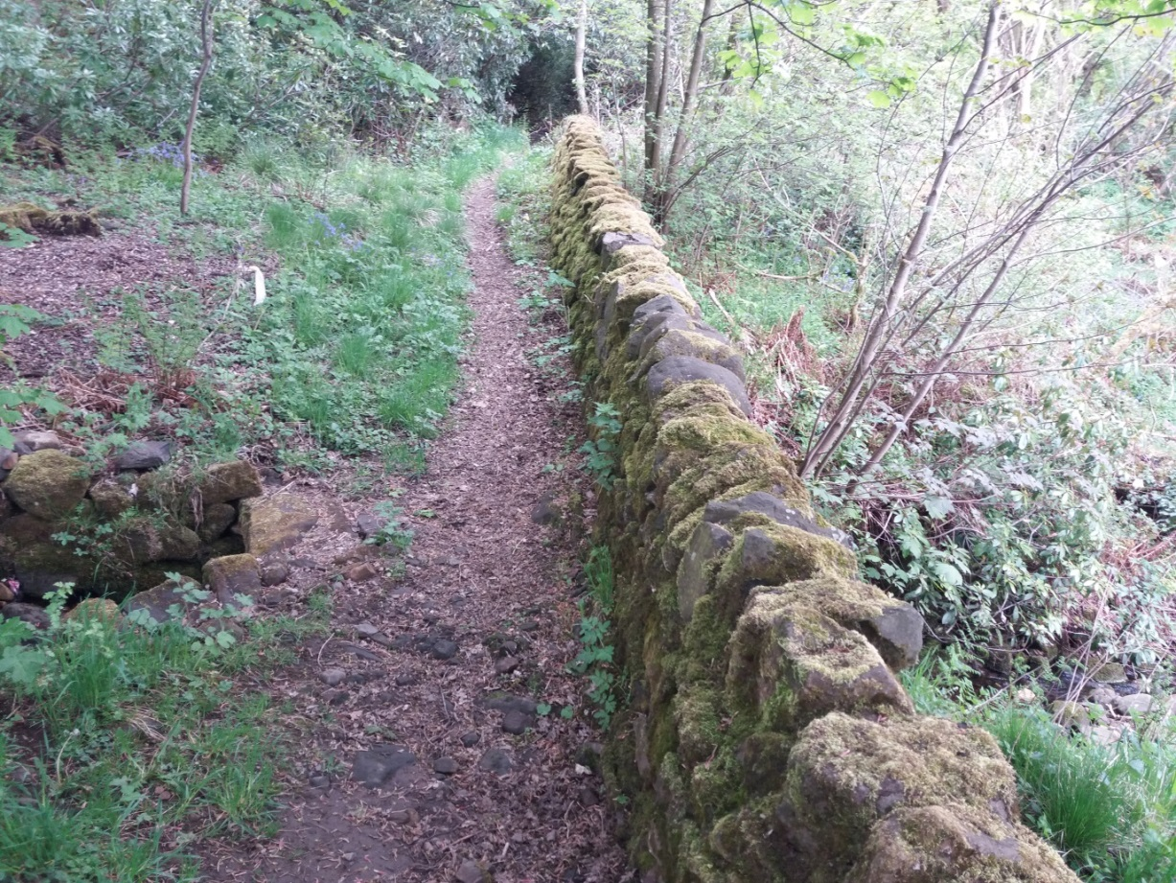
- Once over the style continue over the culverted stream and follow the path.
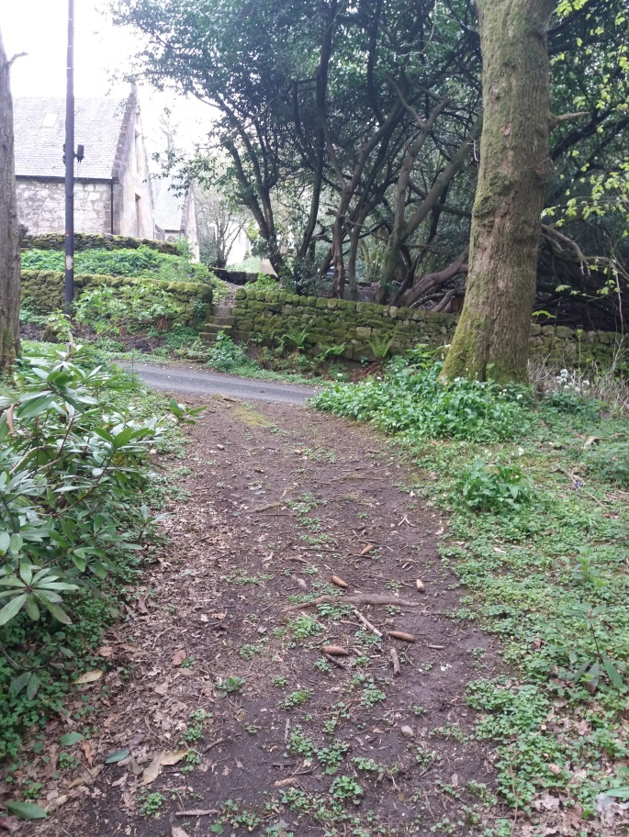
- Continue till the point where the path meets the farm Road opposite the farm building of Glorat House and turn right down the farm Road. If walking the route from Milton of Campsie one would turn left here from the farm Road.
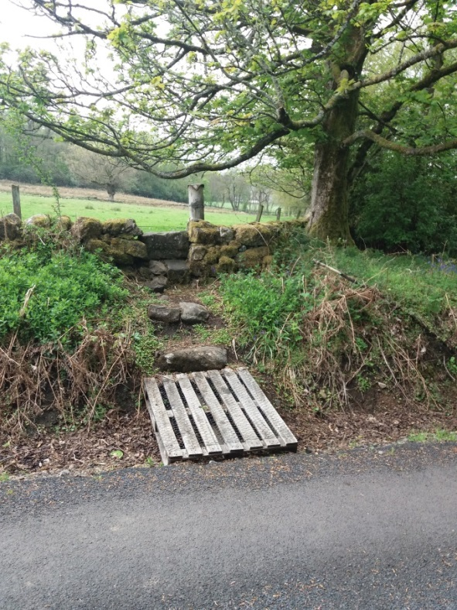
- As one continues down the farm Road just after the wooded section one will notice this access point a stone style into the field on Right (left had side if walking up from Campsie Road). As indicated at the start while one can climb over into the field, as with the first section of the walk being undertaken, on the other side there is no obvious path to follow. However if one follows the field edge one can end up in Lennoxtown behind the houses accessed from … Road, however it is not an obvious route and requires climbing fences at least one burn.
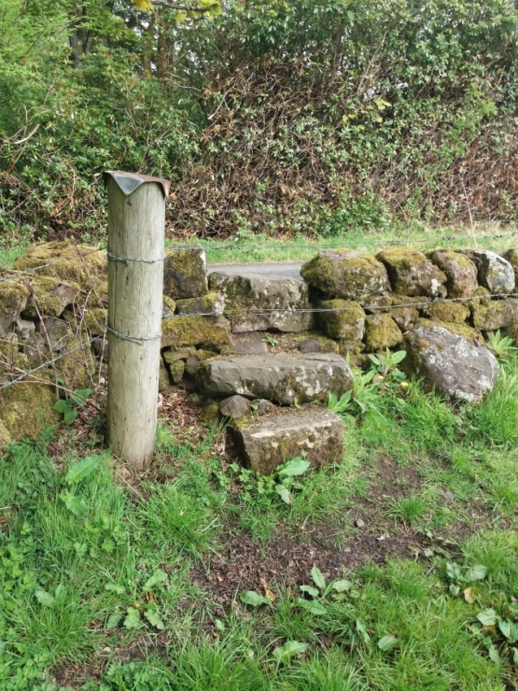
- View of field side of stone style in picture 18.

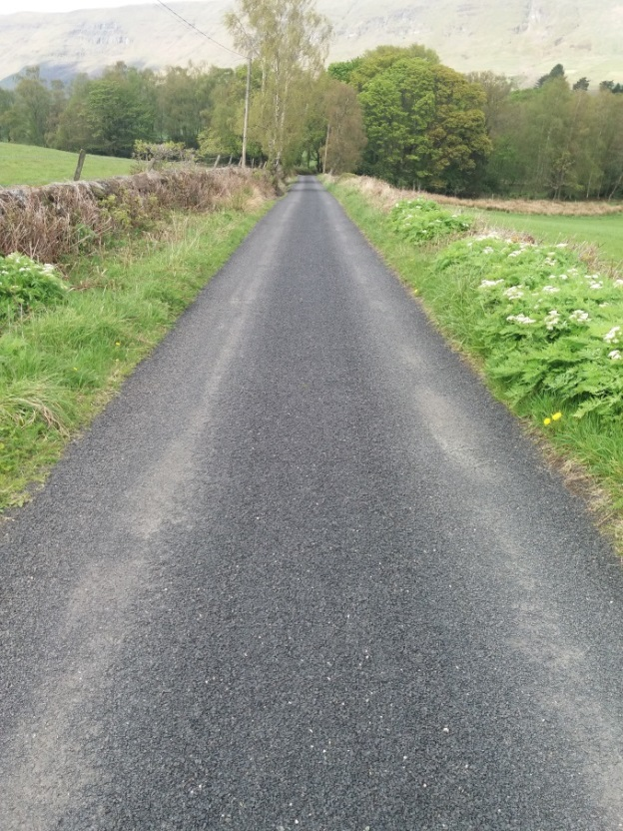
- View looking back up (North) farm road towards wooded area just past where the stone style in picture 18 is located. Note good road surface.

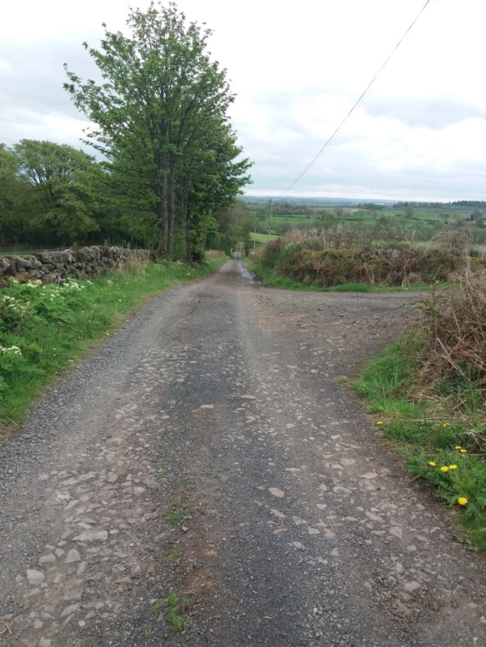
- View, again looking south, further down farm Road after road surface has changed to compacted stone. Farm road to right is success to Westerton Farm.
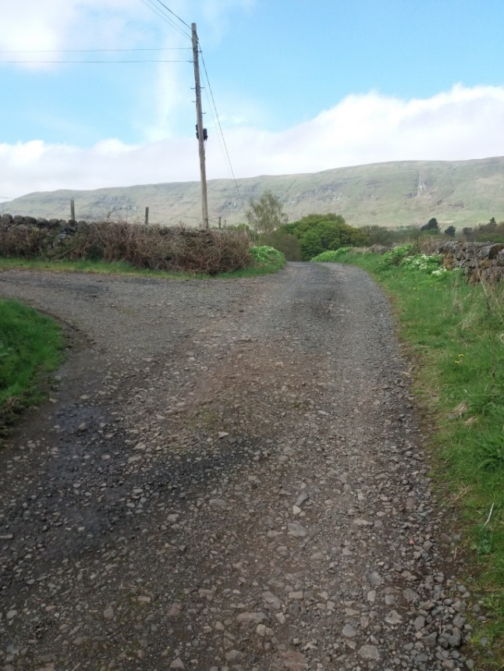
- View looking north up farm Road just below access to Westerton Farm.
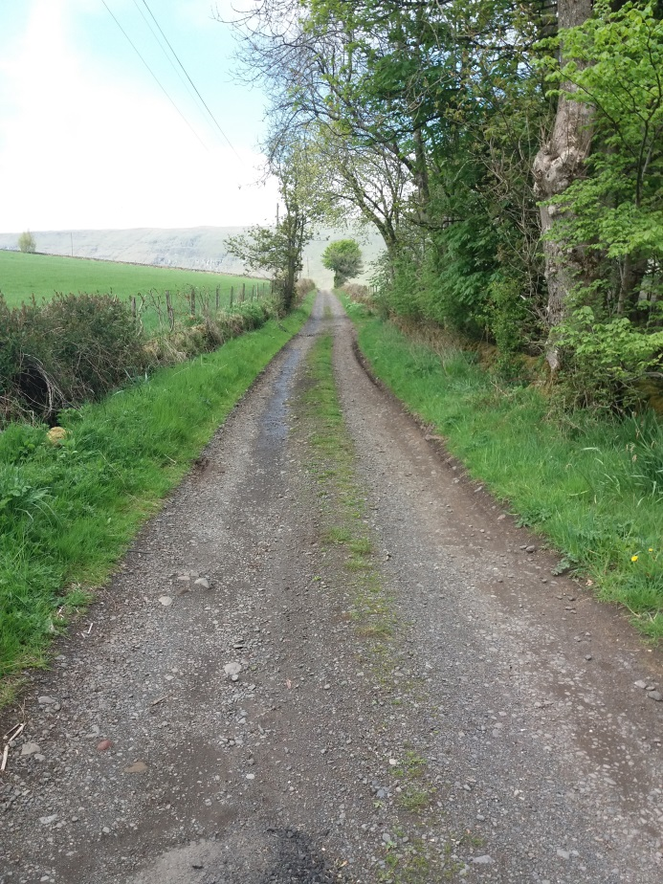
- View looking north up farm road just past gate house cottage at entrance to Glorat House Drive.
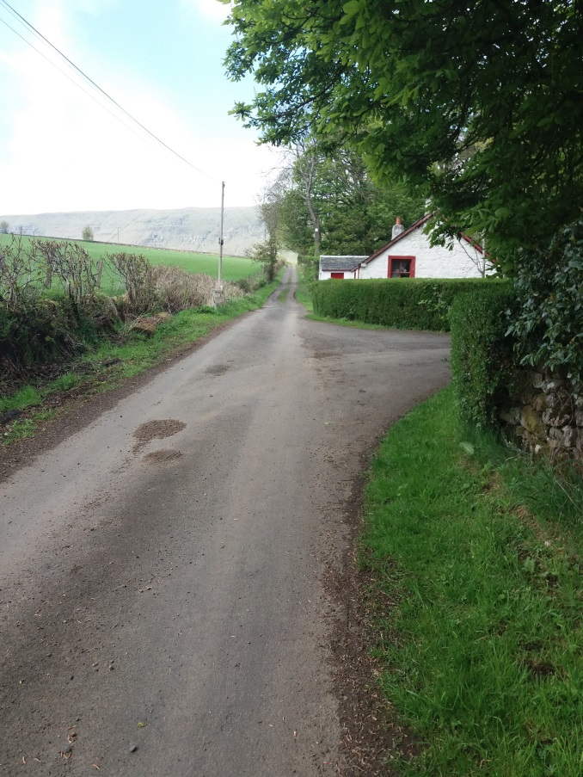
- View looking north up farm Road, with access to main drive to Glorat House and gate House? In centre of picture.
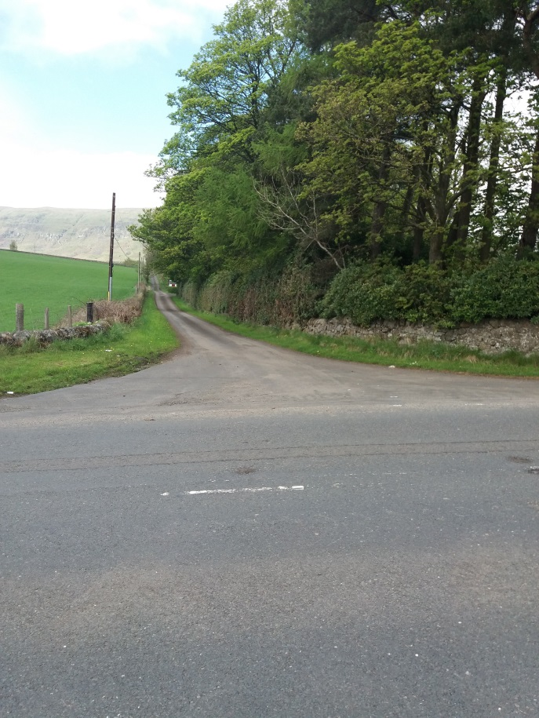
- View across Campsie Road (A891)at edge of village up Farm Road. Edge of gate house shown in picture 24 is just visible in centre left of picture.
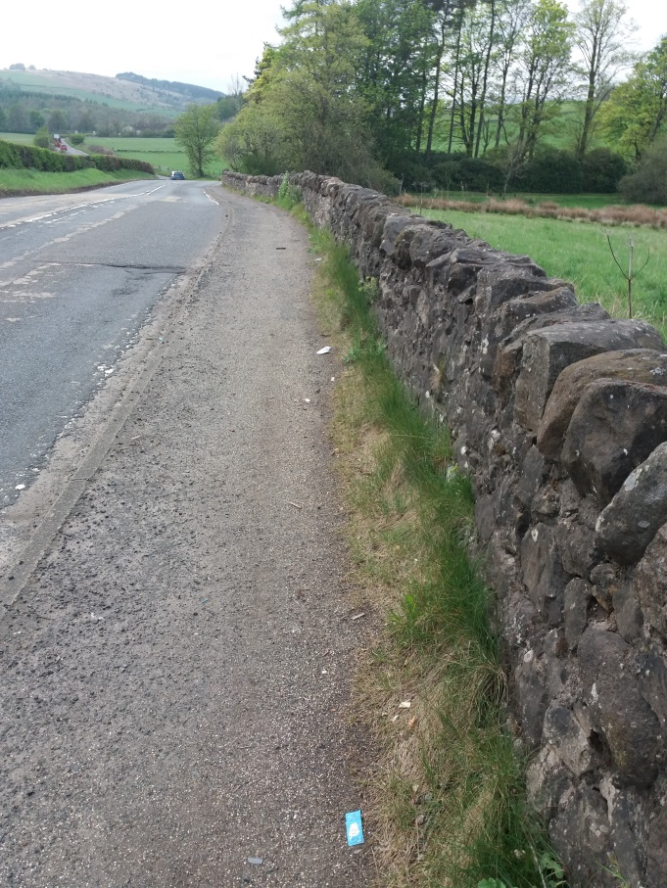
- View of poor pavement surface and build of weed growth and detritus at heel of pavement of Campsie Road (A891) between Millgate Cottage and Farm Road/Glorat House access. Access Road is at end of tree line in centre of picture

