Informal Survey of Woodburn Loch Core Path for MoCCC
The core path up to Woodburn Reservoir is not really a path. It consists of a farm road with the first section macadamised then a short section of compacted stone and finally a further section of macadamised road.
The walk is rather isolated in so far as it does not connect directly with any of the other paths around the village; however it can be accessed by the footpath along Antermony Road from the village. The views from the Trout Fishery at the top end of the road are quite spectacular on a good day with views almost right across the central belt and as far as Tinto Hill in South Lanarkshire. While the walk up the Road is suitable for those in a wheelchair (provided they have assistance), pram of buggy the pavement access from the village to the start is not suitable. As the hill road is quite steep in places the person assisting also requires strength and energy!
Note while I have included notes of the route from Milton of Campsie to the start of the Road up to Woodburn Reservoir, only the Road up to the Reservoir from its junction with Antermony Road (A891) is classed as a Core Path.
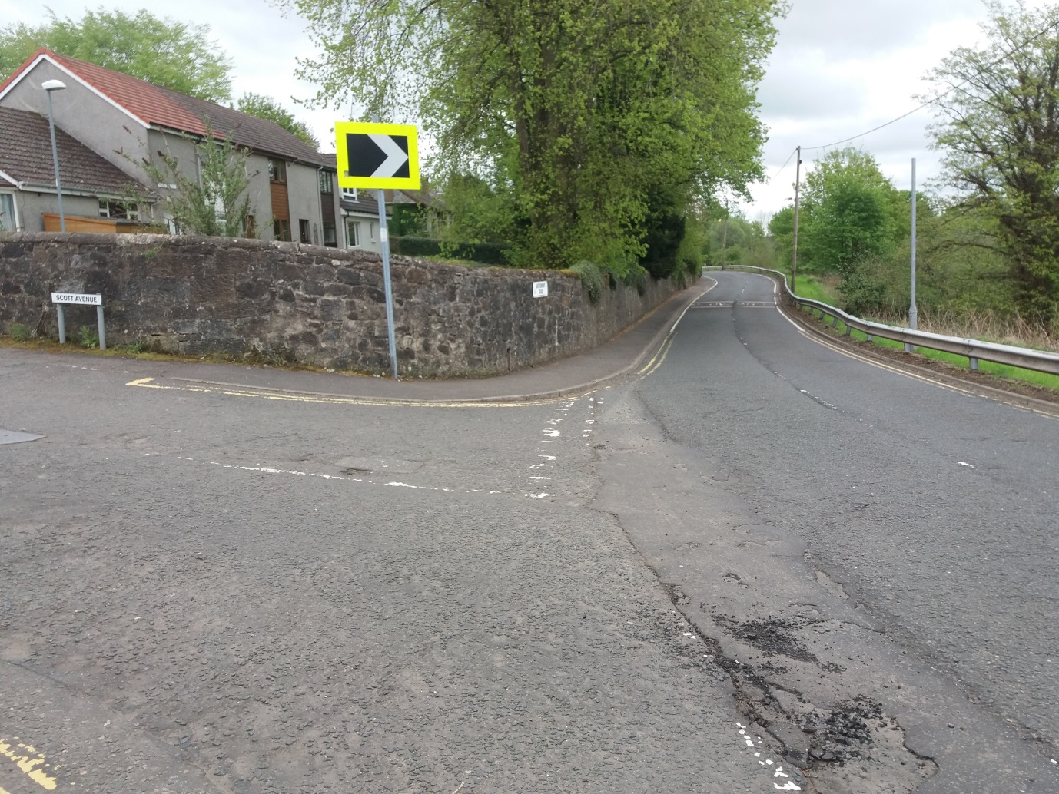
- View from junction of Scott Avenue and Antermony Road (A891), just past the Co-op towards Kilsyth with pavement on LHS.
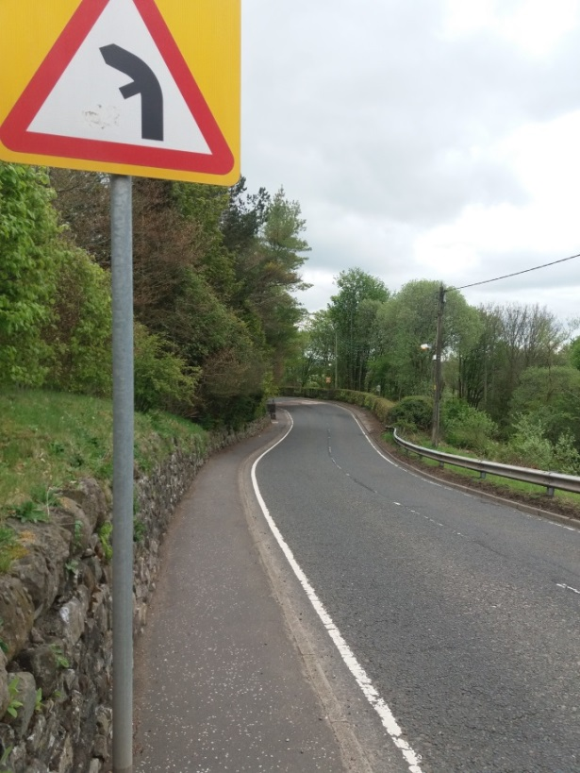
- Pavement continues along Antermony Road (A891) on LHS with street signage indicating bends in road.
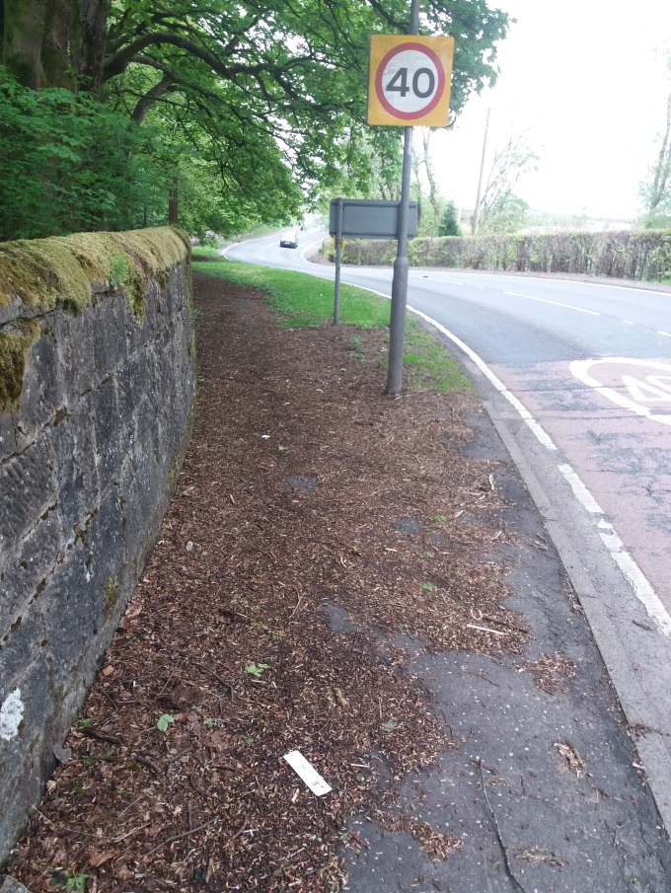
- As the footpath continues past the Village Sign post and speed change sign from 30 to 40 there is a short section of grass verge between the footpath and the road. Note significant build of leaves and detritus from overhanging trees on footpath.
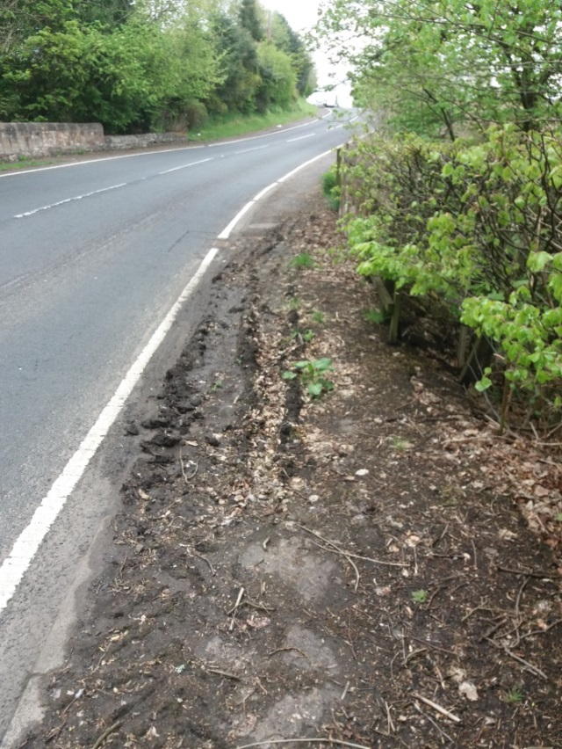
- Just past the first bend there is a footpath on both sides of the road however on RHS (as you walk out of the village) at a there is a section that is heavily covered by mud and detritus. Around Nos 67 – 71. Footpath on RHS stops around N0 1 Alton Holdings.
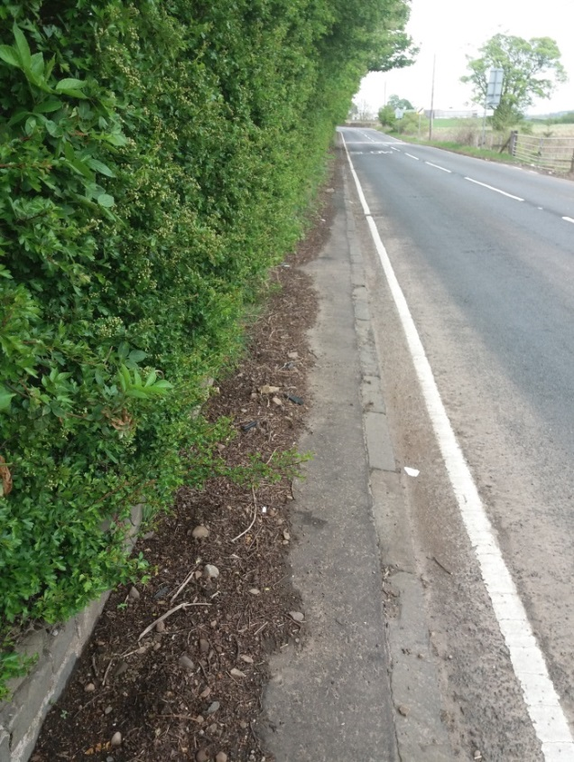
- Continuing along the footpath the soil and detritus builds up again, in addition the hedge line thickens and extends out over the footpath, making walking difficult at times. NOTE one is walking with ones back to the oncoming traffic.

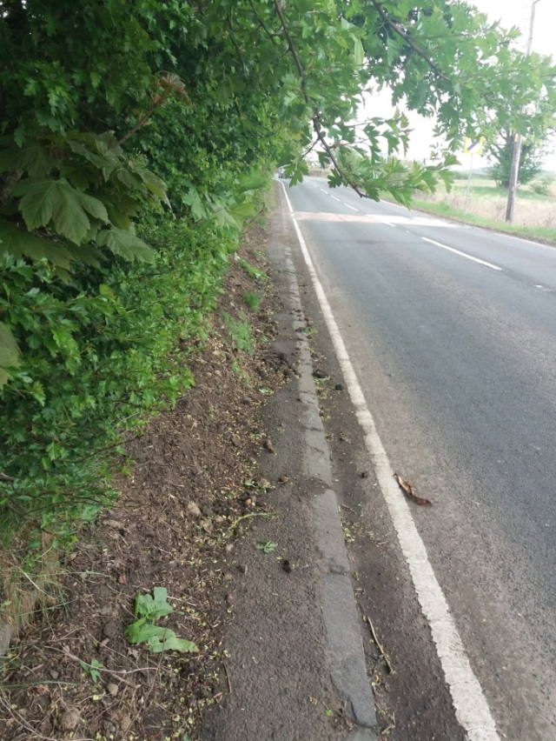
- The detritus and soil continues to build up on the heel of the footpath reducing its with by 50% to a maximum depth on 30 -40 cm at the heel, low branches also make walking difficult. However the condition of the footpath improves as one approaches Lochmill.
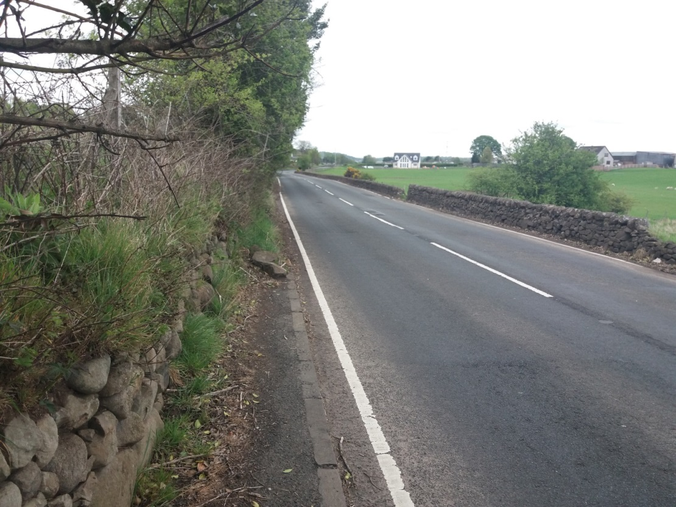
- Just past Lochmill the footpath end with path being available some 20m further along on the RHs of the road behind the wall visible in picture.
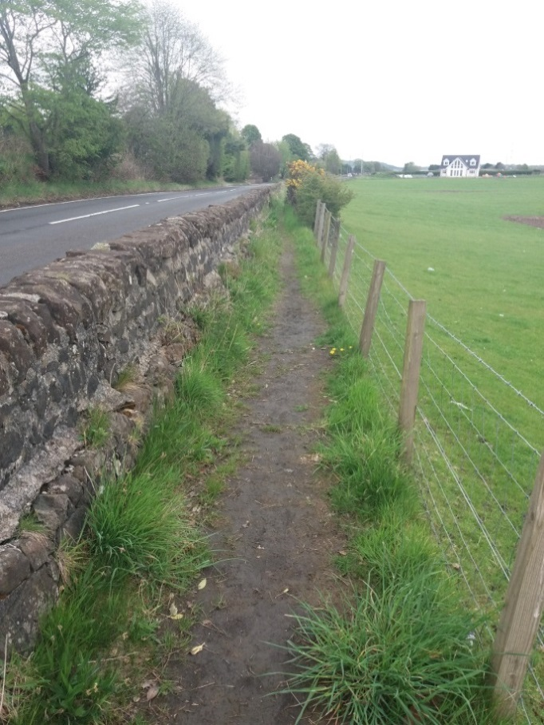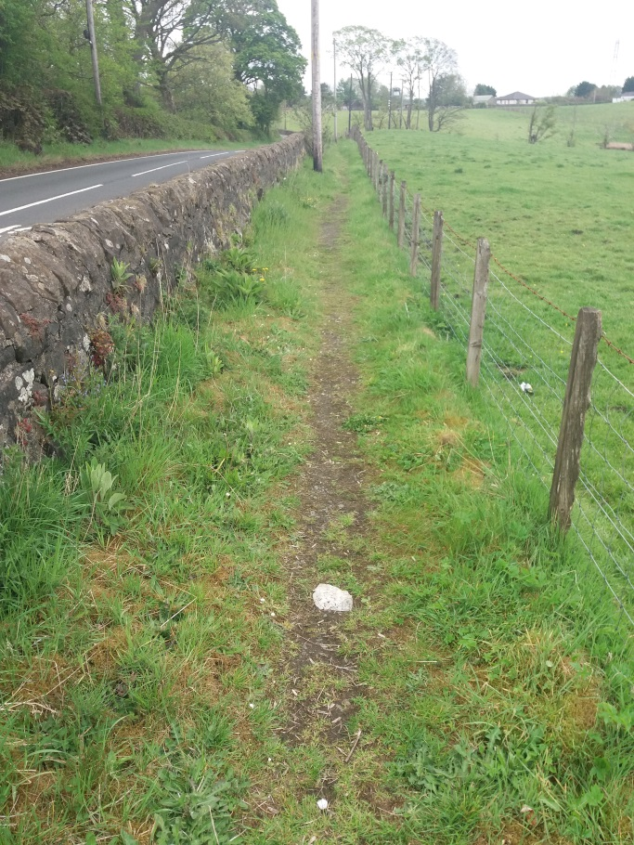
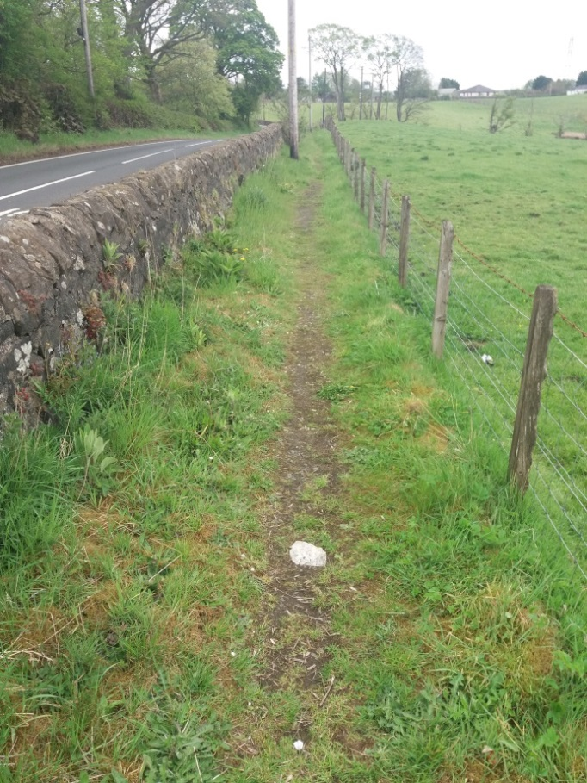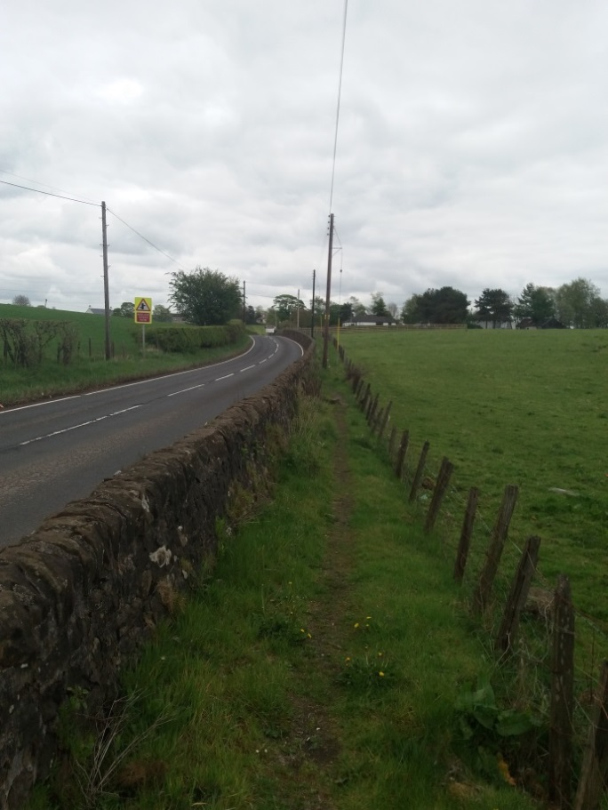
- The path on the RHS is located between a stone wall and a fence. The path is well worn although there is grass build up on both sides and continues until the Core Path Road up to Woodburn Reservoir

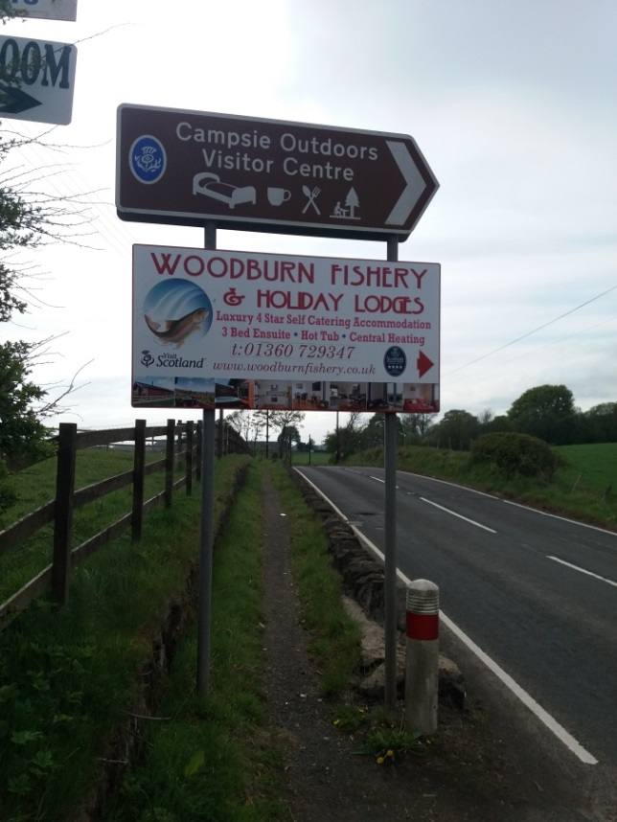
- View looking back toward Milton of Campsie from end of footpath on Antermony Road and direction signage to Visitor Attraction.
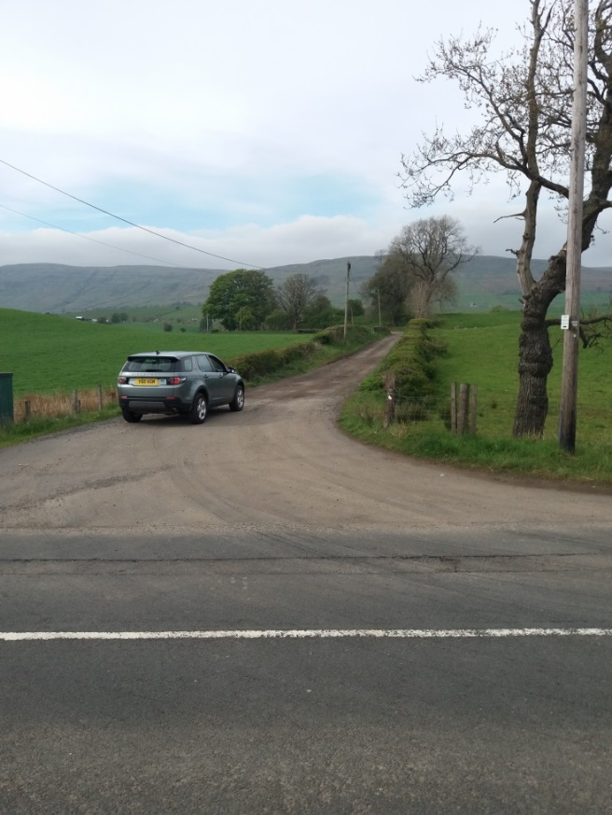
- View taken from beside directional signage shown in picture 9 of start of Core Path road to Woodburn Reservoir.
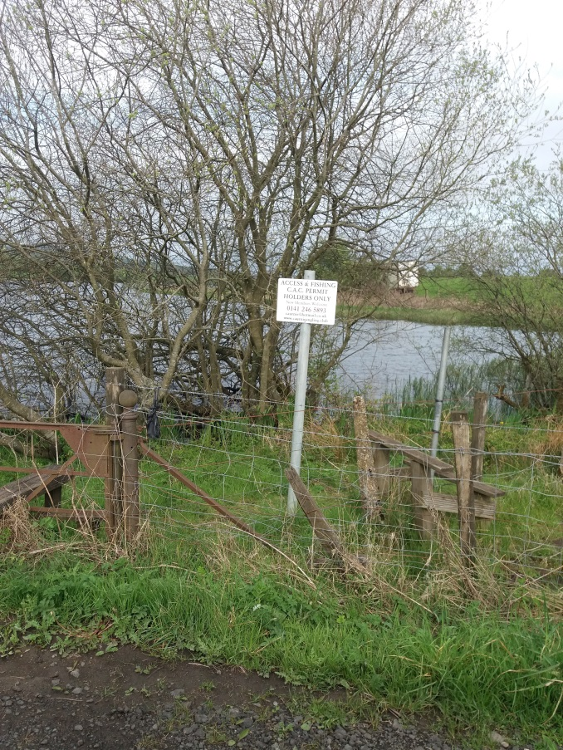
- View of signage in connection with arrangements for fishing permits in “lower” loch.
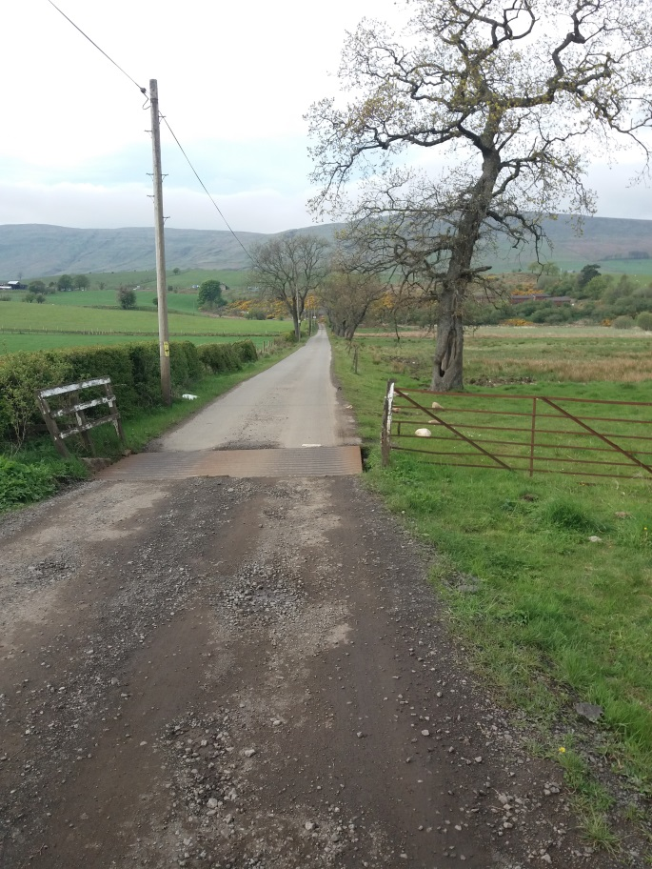
- View of change in road surface at cattle bride just past end of “lower “ loch.
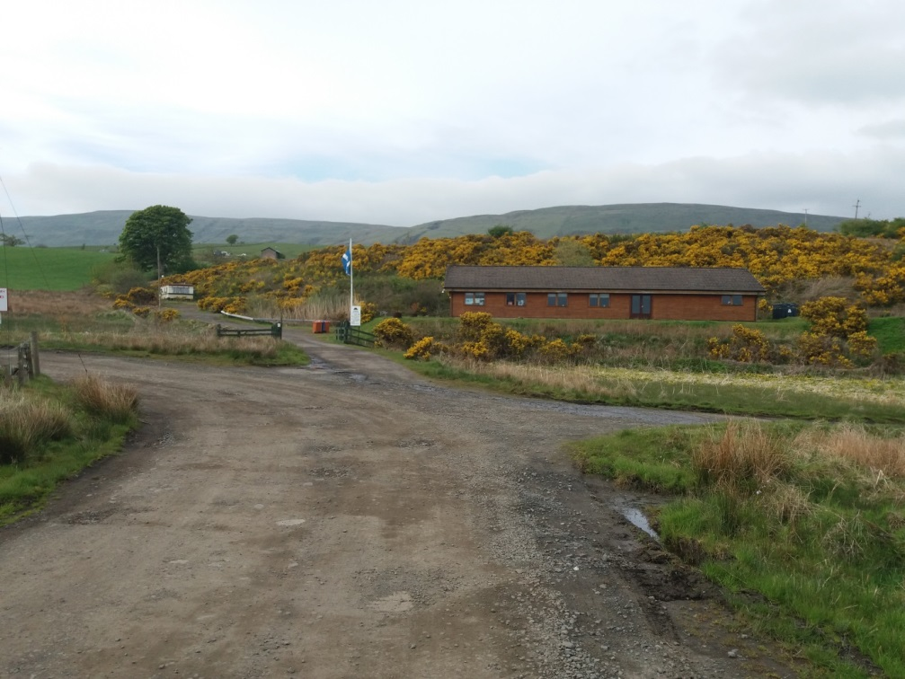
- By the time one has roached he Holiday lodges the road surface has changed again, however is generally in good condition and suitable for walking and all cars. At the entrance to the Holiday Lodges the (Core Path) road forms a T junction with the LH leg continuing up the hill to Woodburn Reservoir (Fishery)and the RH leg continuing along to other small building.
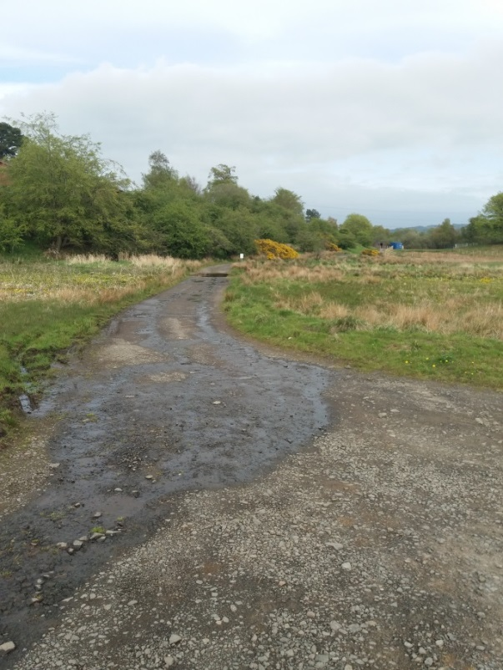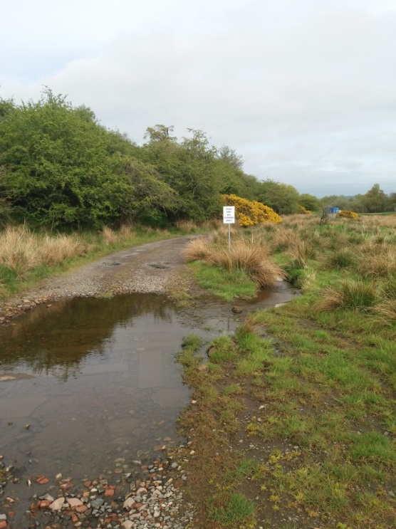
- The Road forming the RH leg is in a poorer condition with access to the end requiring the use of a Ford for which there is no “dry” pedestrian access.
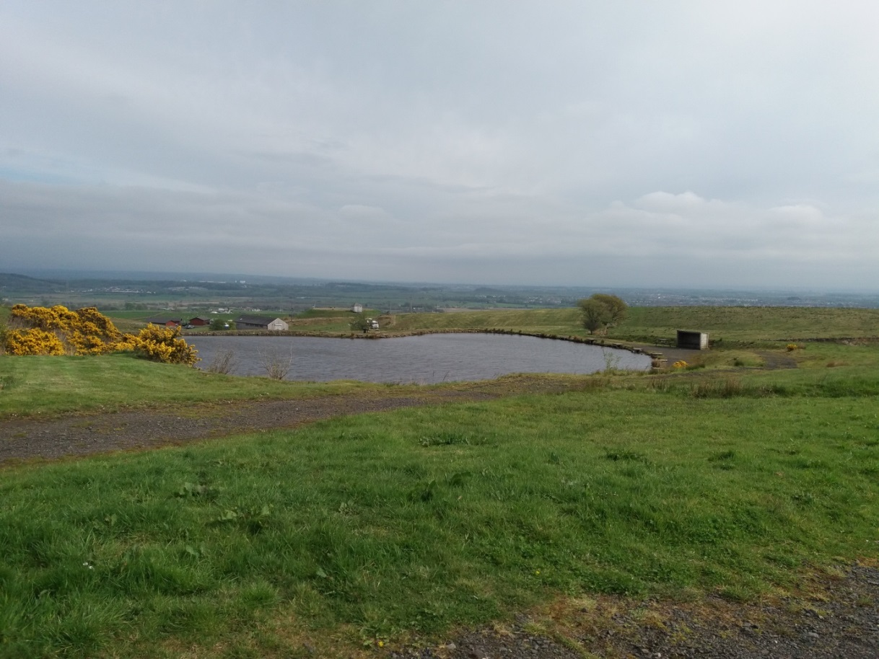
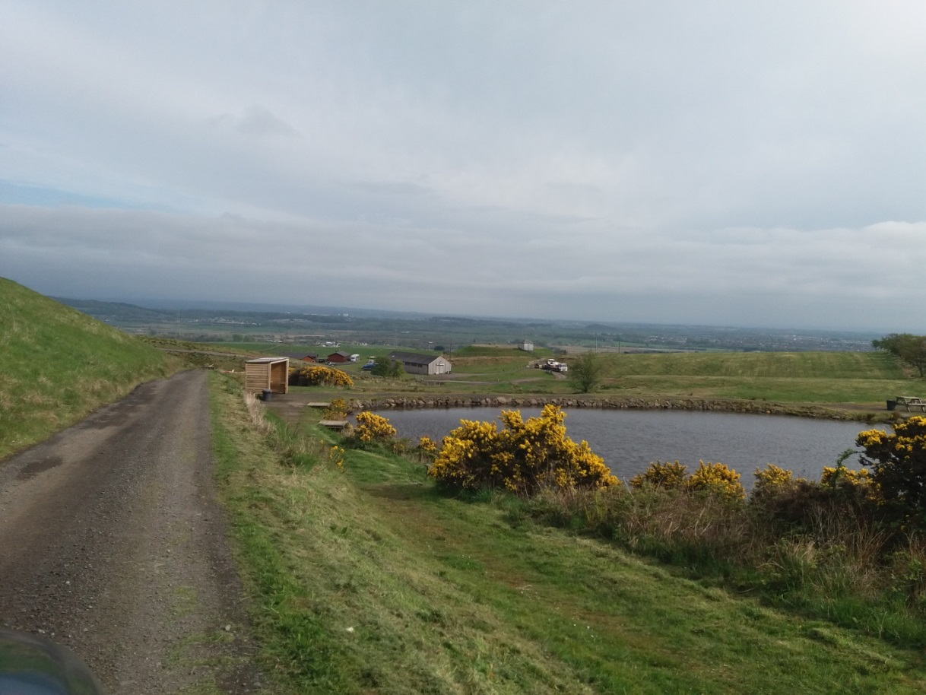
- Continuing some distance up the RH leg of the junction at the Holiday Lodges one arrives Woodburn Reservoir Fisheries wher two “fishing ponds, car park and Visitors centre is located.
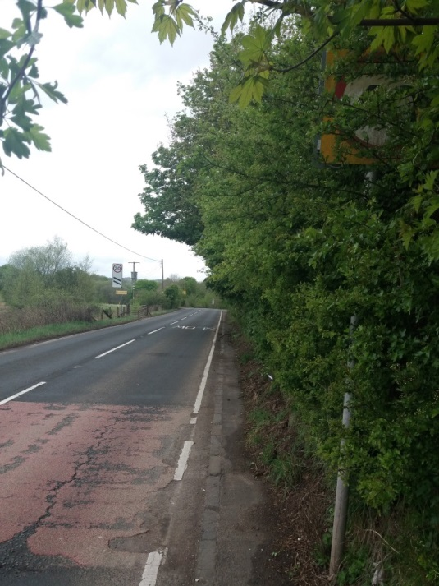
- On returning back down the hill and turning right onto Antermony Road (A891) to Milton of Campsie it is noticeable that that on nearing Milton of Campsie that a number of the road signs are obstructed by overgrown trees/hedges. The above view is on the 40MPH sign on the RHS of road with the 200m marker for the speed limit change to 30MPH visible in the distance on left. NOTE the corresponding 40MPH sign on the LHS side is clearly visible by road users.
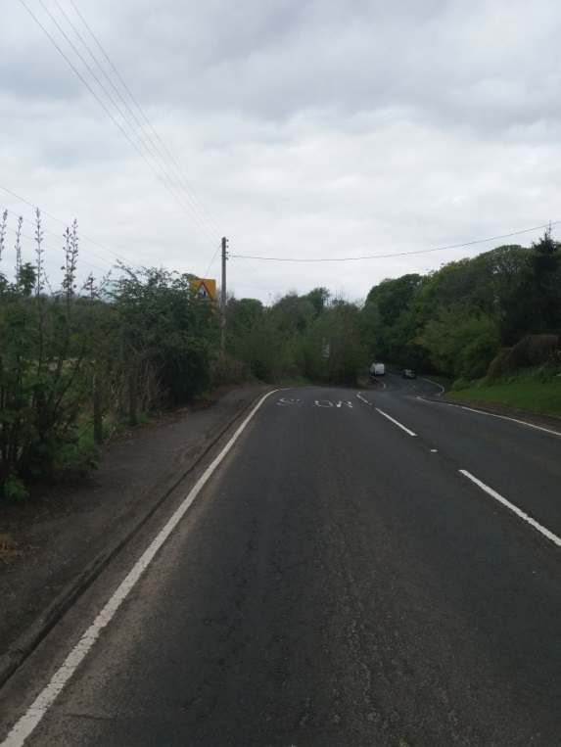
- The above picture (taken safely from a drivers viewpoint in the road) shows the “Reduce Speed Now, Right Hand Bend” warning sign obstructed by overgrown trees/hedges as the A891 nears Milton of Campsie. Just visible further along the road on the left is the edge of the 100M warning of speed limit change to 30MPH road sign also obstructed by vegetation.

