

The Existing Museum and its work in the Community.

The Existing Museum is In the Village area at Standford Hill Prison Eastchurch.
The museum was started a few years ago in one of the RAF training rooms built in the 1920’s.
Since it opened we have continued to add to our collection and increase the volunteer team.
As a result of the hard work of the team, we have increased our annual visitor numbers to over 3000.
Any of these will make use of the café, providing training opportunities for the prisoners.

Other Attractions in Swale and their Visitor Numbers:
Fleur De Lis, Heritage centre Faversham 2518
Minster Gatehouse Museum 2500
Chart Gunpowder Mill 900
Bredgar and Wormshill Light Railway 6626
Oare Gunpowder Works 8984

There are other attractions in Swale that do not publish their visitor numbers, but it is clear that even working from a single room with inadequate facilities, we are attracting a good number of visitors.
We have volunteer prisoners from time to time, and are pleased to work with the prison staff to help with the re-integration process. As the museum grows, we will increase this opportunity.

In recognition of the work we are doing we have received the Jonathon Horn Preservation Award and a Red Plaque

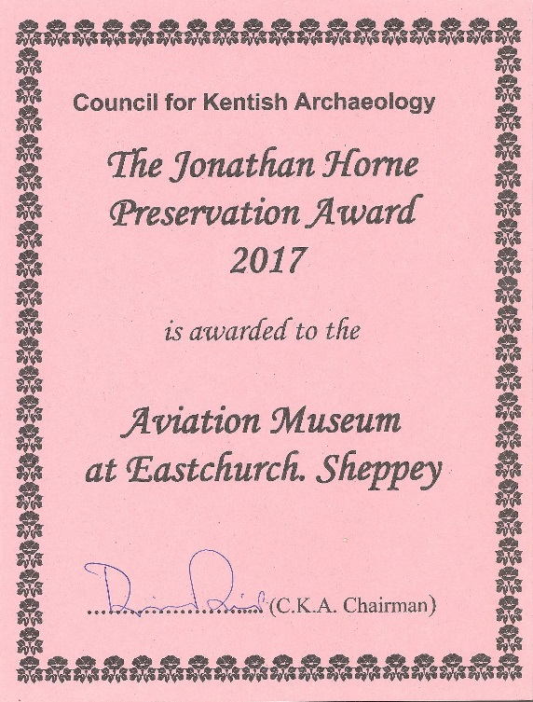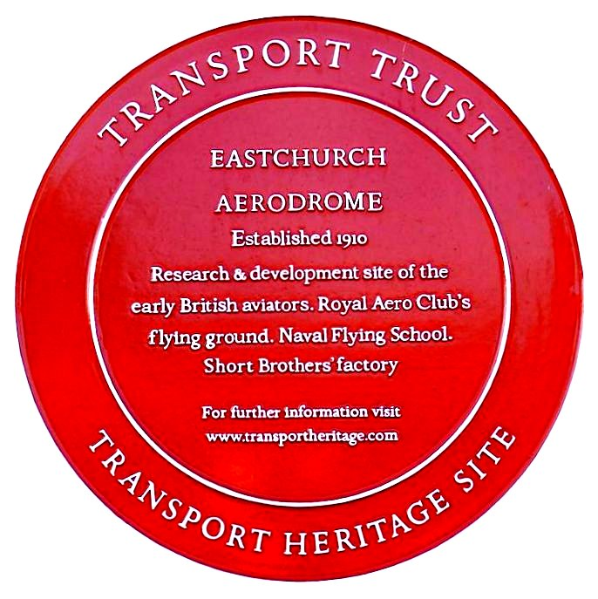

We have also received a commemoration stone from the Airfield of Britain Conservation Trust, to mark the importance of the site and to remember all those who served here.
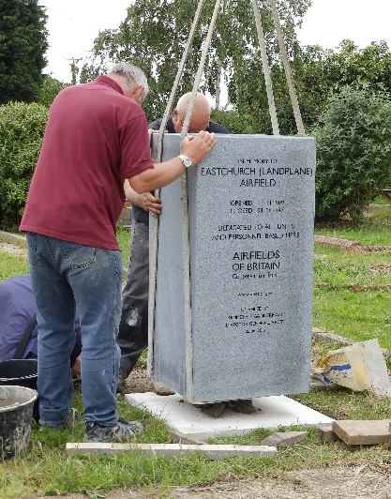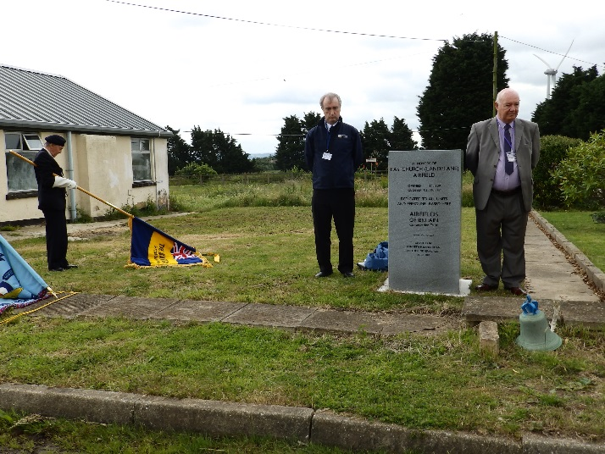

Memorials Register
The museum team are engaged in several research projects.
The Sheppey Memorial Project - which is based at the museum - seeks to list those connected to Sheppey who have given their lives in service or as a result of enemy action after 1900.
To further our aims, we are:
Involved in a project aimed at recording the many women who served in various capacities during the wars, and also those who contributed to aircraft production.
Collecting a large number of books and other source material relating to the Aviation heritage of Swale, and we now have an important research facility. This will be further expanded when we complete the extension.
Maintaining an internet presence and have a Facebook page and a Website that are frequently updated and which receive many good 4 or 5 star reviews on Facebook and Trip Advisor.
Members of the Wheels of Time scheme, a very successful initiative to encourage young people to visit local attractions to collect badges. The scheme will have even more participating attractions this year.
Working with local schools - including the special needs schools - to provide educational visits and outreach work.
We have taken on being part of the Kent Children's University, becoming a Learning Destination.
We also work with local care homes to give museum tours and talks to people with memory problems.
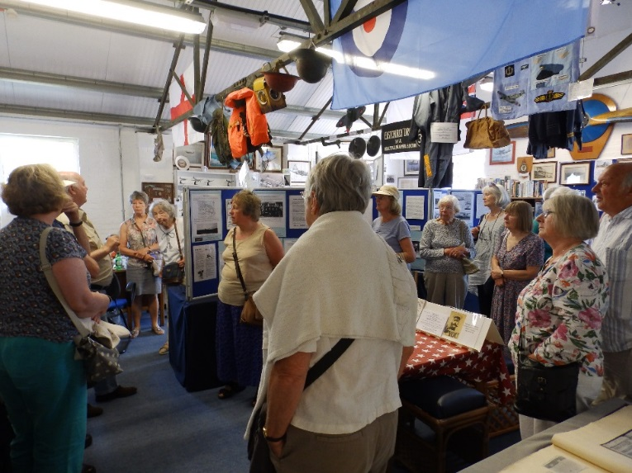

Many events are held at the museum.
Recently we hosted a parade to commemorate the centenary of the founding of the RAF. This was attended by veterans, youth groups, and service cadet units from all three services.
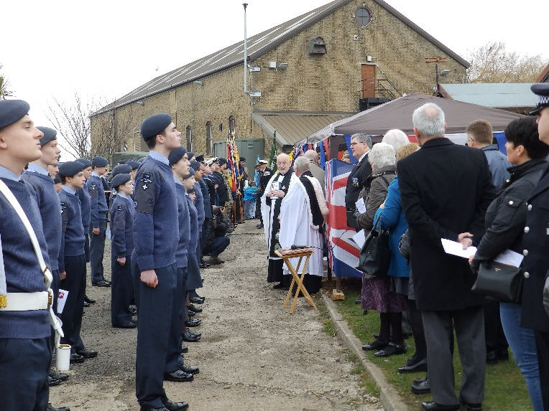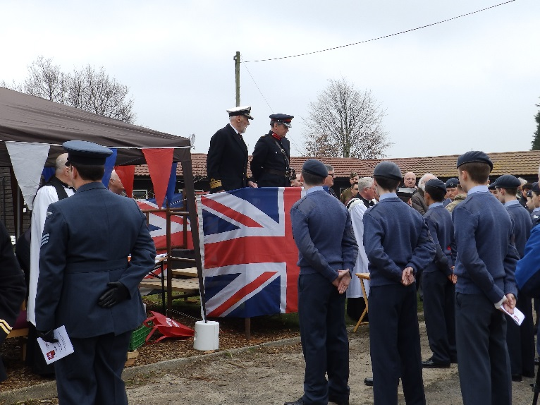

Last year we were honoured with a visit from HRH the Duke of Kent.
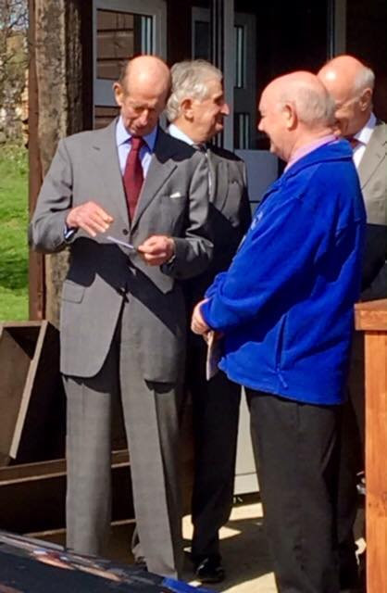

Commeration
We have commissioned a statue of Frank McClean to commemorate the contribution made by him at Eastchurch, to British Aviation.
The picture below is of the Short Brothers Statue at Shellness by the same artist.
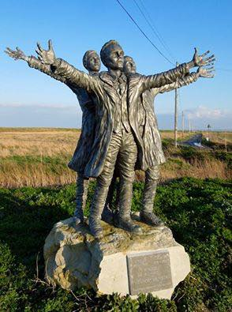
Several events have been held that have been officiated by Paul Auston, Deputy Lieutenant of Kent.
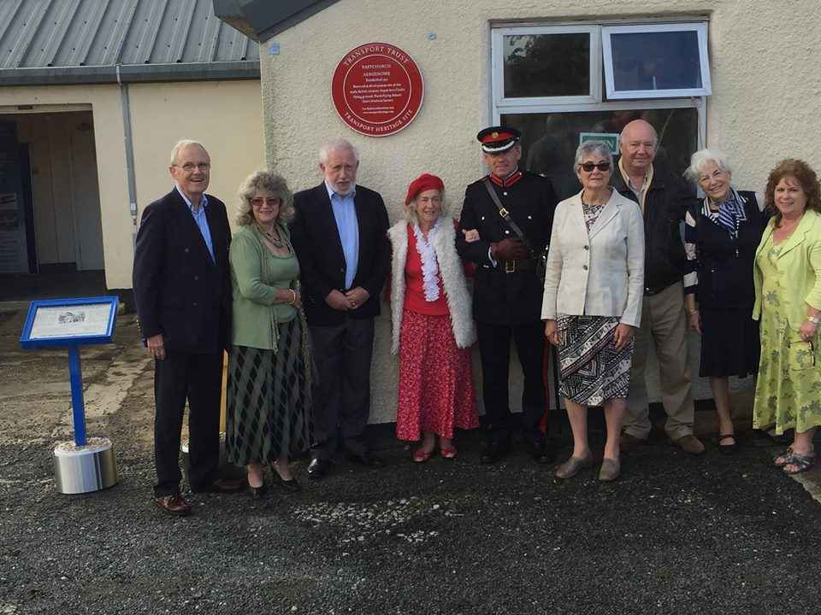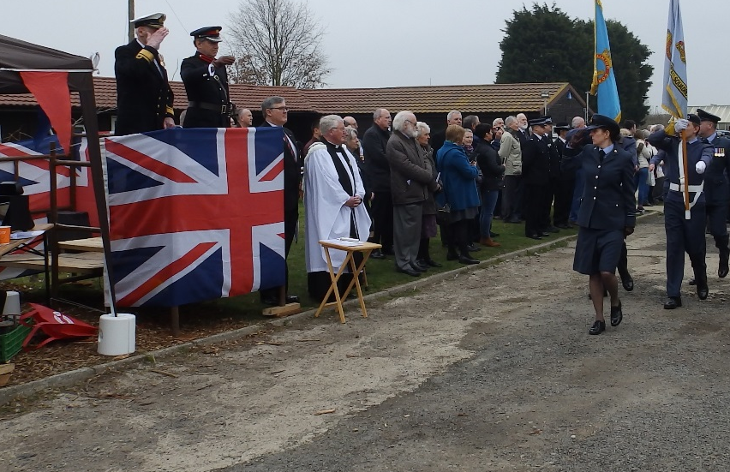
He is now the patron of the Sheppey Heritage Trust, and looking forward to helping us with future projects.

