

The Business Model.

We have found an attraction that is a very good match for the proposed Aviation Museum in the old hangars at Eastchurch.

The Tangmere Military Aviation Museum.

Note :- The text in blue is taken from their web site.
In 1981, West Sussex County Council donated a large SECO hut to the group and in June 1982, following much hard endeavour, the embryo Museum opened its doors to visitors. We have grown considerably since then to exhibit a vast number of artefacts.
Staffed entirely by volunteers, our mission statement can be described thus:
The Museum exists to promote awareness of the United Kingdom’s military aviation heritage and to educate present and future generations in military aviation by:
- Exhibiting the history of aircraft and personnel involved in military aviation with particular reference to RAF Tangmere and its unique place in that history.
- Serving as a memorial to those allied airmen and airwomen who gave their lives in the service of this country.
In 1987, the Museum became a Charitable Trust and Limited Company. As such, its full title is the Tangmere Military Aviation Museum Trust Ltd and it is governed by Memorandum and Articles of Association.
The Museum’s governing body is the Trust Council, comprising 9 elected Trustees who, in effect, constitute the Company’s Board of Directors.
The Council is responsible for all matters of policy, including the allocation of departmental budgets. Day to day management is delegated to the Museum’s Director who oversees a Management Team comprising the following areas of responsibility: Curator, Operations, Safety, Education, Engineering, Publicity and Simulators.
The cafeteria (operated via franchise) and shop (Museum Trading Company) respond directly to the Trust Council.

Tangmere Military Aviation Museum is located in a corner of the old Tangmere airfield, famed as an RAF fighter station from 1918 until Fighter Command left in 1958.
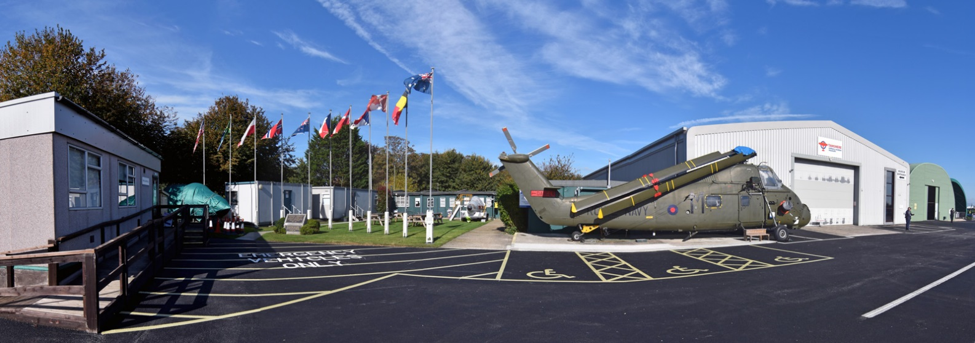
It was opened by a group of aviation enthusiasts in 1982 to promote public awareness of the United Kingdom’s military aviation heritage, to educate present and future generations in military aviation and to serve as a memorial to airmen and airwomen who gave their lives in the service of this country.

Since that time it has been managed and run entirely by volunteers and in 2017 was awarded the Queen’s Award for Voluntary Service.

Now one of the UK’s leading aviation museums, it is home to an impressive display of historic aircraft and has a unique collection of aviation memorabilia stretching from the First World War through to the Cold War.

Amongst the many attractions, there are numerous interactive displays and aircraft cockpits and simulators for visitors to experience. Light refreshments may be purchased in the Museum’s acclaimed NAAFI Tea Room. A museum with something for all members of the family to enjoy

Comparison of Tangmere to the Eastchurch Proposals

The covered space at Tangmere is slightly larger than the hangars, but the Eastchurch project will include the use of the Mill Café and existing museum, so is effectively the same size.

The size of the site is about the same as the Eastchurch Project. Tangmere have recently expanded their car park and this has helped them to increase their visitor numbers.

They have no paid staff and are run by a large team of volunteers, but the café is a franchise.
The visitor numbers for 2017 were 32,000, and the entry is:-

- Adults: £9.00*
- Over 60s: £7.00
- Children between 5 and 17: £3.00**
- Children under 5: FREE
- Family ticket (2 adults and 2 children): £21.00
- Disabled visitors: prices as above but there is no charge for assigned carers
- £7 on production of Service ID or Defence Privilege Card.

Contd/-

OPENING
The museum is open every day between February 1st and November 30th.
March to October:
10.00am to 5.00pm
February and November:
10.00am to 4.30pm
(Last admissions are one hour before closing each day)

This generated around £200,000 per year. We would be looking at a similar number for our project but would like to eventually exceed this number, with a figure of 50,000 as a design capacity.

We would run similar opening hours, dependent on how this fits in with Standford Hill. We would expect to have a higher number of offenders helping on week days and more volunteers at the weekend. This gives 300 open days per year and an average visitor number of around 100 per day.

Data from Duxford Aviation Museum tells us that they receive their maximum number of visits in July and September, with 16% for each month. For our project with 32,000 per year, this would be 5,200 or an average of 170 per day. This could be up to 300 on a busy Saturday and therefore 100 car parking spaces and room for coaches would be required to support the business plan.

The company accounts for Tangmere show that their operating expenditure is around £195,000 per year, so they have funds of around £5,000 for updating the collection etc. They collect significant funds from outside sources to pay for extras such as extending the car park and we will also have to continue raising funds to pay for new exhibits etc.

Tangmere is close to Chichester and not far from Portsmouth and Brighton. It is also about 2 hours from London. Eastchurch has a very similar population profile with Maidstone and the Medway towns nearby and London about 1.5 Hours travel.

The Tangmere site has no runway and so there is no flying on site, but the project is over 30 years old and has collected an impressive collection of artefacts and exhibits and has a large team of enthusiasts to run it.

Eastchurch also has no runway, we do however have the advantage of the site history and the hangars that will be the oldest hangars open to the public in Europe, with connections to the founding of the Royal Naval Air Service. We are building a team of volunteers and a collection of exhibits, but it will be some time before we can match Tangmere.

We do however have the advantage of working with Standford Hill Prison, with the opportunity of using prison volunteers to help run the museum. This will be addressed in a separate section of the report.

Tangmere run a program of events each year including military vehicle and veteran car shows, to do this they make use of a section of runway that still survives nearby. At Eastchurch we will not have a show ground, but it may be possible to use some of the adjoining areas to run events jointly with the Prison.

It should be noted that we will not be in competition with Tangmere. The focus of their exhibits is mostly WW2 and after and we will be WW1 and before. They only briefly mention the Fleet Air Arm and do not mention the Royal Navy Air Service.

