
The Hangar Project
The plan below shows an example of how the boundaries could be established. The top red area is the site of the hangars and has an area of approx. 0.7 hectares. The lower red area is the car and coach park and has an area of approx. 0.9 hectares. The blue area is the roadways over which access would need to be granted.
The exact positions of the various boundaries will need clarifying in order to ensure that existing building access and functions are not affected. The car parking area has been selected on the basis of land not currently in use and the existence of concrete oversights from demolished buildings, meaning that all the car parking areas are using existing hard surfaces, thus minimising the cost and environmental impact of the project.
It would be worth considering including the blue area in the lease and retaining any access rights required by Standford Hill Prison. This would allow us to raise money from external scources to upgrade and repair the road.
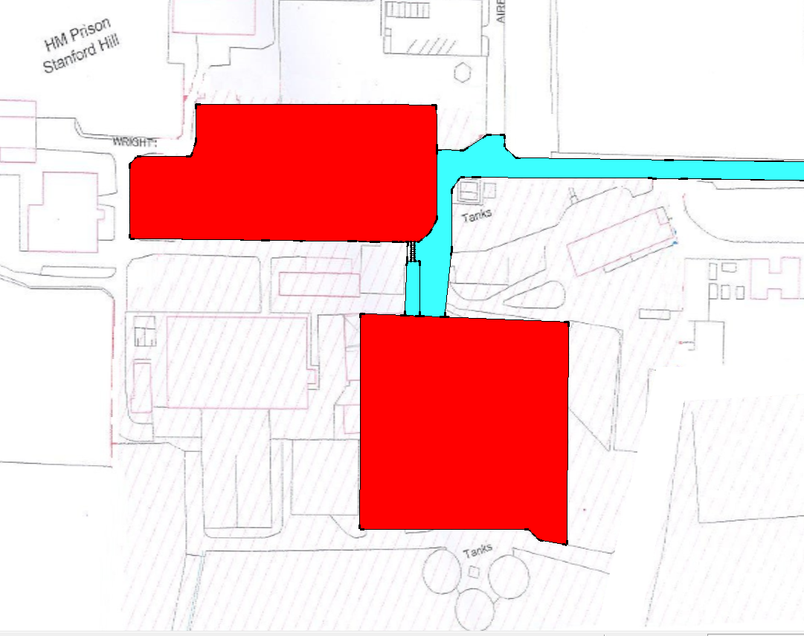
The plan below gives a view of how the site would look.
The main car park areas utilising existing hard surfaces would give parking for approx. 100 cars and up to 10 coaches. The location of the site makes it difficult to park nearby or to use public transport.
Therefore we need to have a large car park to support the business plan in order to attract the significant funding that the project would require.
The area above the Hangars would provide a show ground, there are several old concrete oversights in this area and these could be used to hold events such as military vehicle shows. The income from these events would help fund additional improvements to the museum.
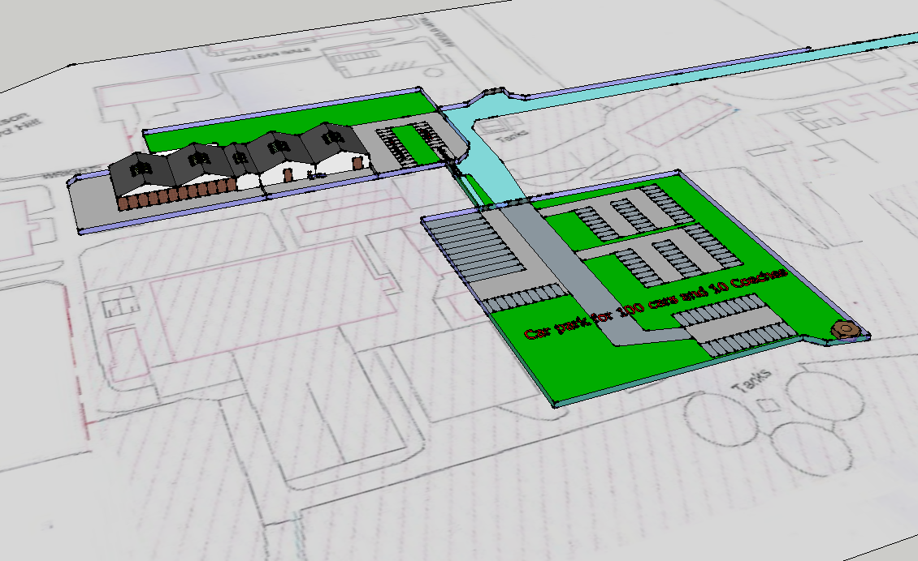
In order to obtain funding for the project we would need to have security of tenure.
It would need to be a minimum of 25 years and a rolling 30 years, as the funding bodies will insist on 25 years after completion of the restoration project to ensure the public get value for money from the investment.
In order to keep the project in good order we will need to keep seeking new funding as time goes by and if the lease is running out this will not be possible, plus the buildings will deteriorate towards the end of the lease period.
The best option for us would be freehold, assuming we can raise the funding to pay for it.

