The Master Plan
This is the inside of the existing museum during a visit from a local care home.
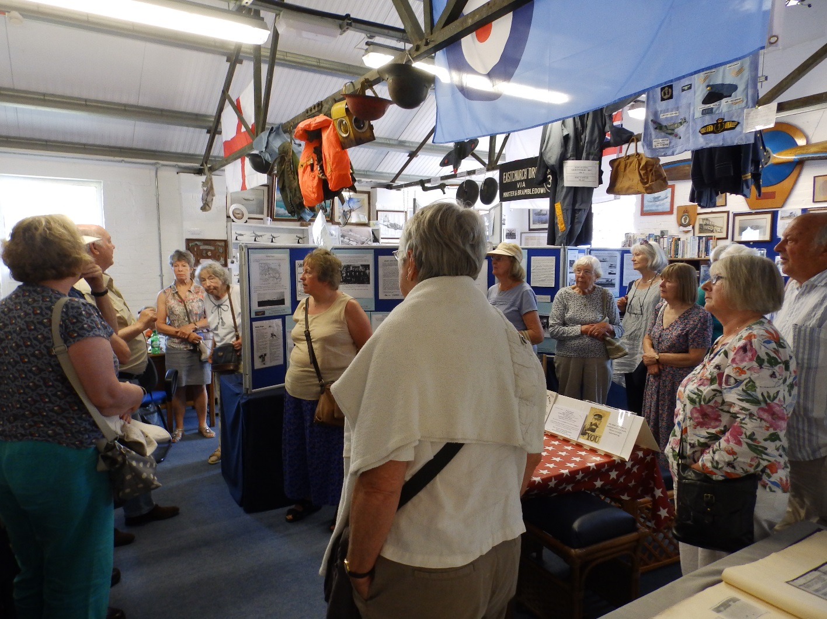

The master plan for the restoration of the buildings and conversion into a tourist attraction is :
Phase 1)
The first part of the project is already under way, to develop and expand the existing museum.
In 2018 we made a start on the museum extension. Planning and building permission have been granted and ground work is completed. This puts us in a good position to complete the building in time for part of the 2019 season.
The existing museum has increased its visitor numbers each year and in 2018 we had 3103. With the new extension we will expect to top 5,000 and push towards 10,000 over the next few years. The museum extension is also going to allow us to increase our team of volunteers, our collection of exhibits and our range of sales items for the gift shop. We will be able to develop our education offering with school parties, making use of the new audio visual room to tell the story of the site.
The museum is currently free entry, but we ask for a small donation towards costs. In 2018 donations were £2404. The extension will allow us to justify the introduction of an entry charge, expected to be £2.00. This will generate £8,000 rising to £16,000 per year. The average spend per head in the gift shop is £0.60, the new enlarged gift shop should generate an average spend of £1 per head and this will add £2,500 rising to £5,000 after costs. The introduction of an entry fee will make it possible to start a “Friends Of” group. We would charge maybe £4 a year for this and it will generate additional funds. The income should be a total of £10,000 rising to £20,000. The annual overhead of the museum is as yet not fully known, but it is expected to be around £10,000 so we will start to show a profit when the visitor numbers grow beyond 5000. This can then be invested into Phase 2.
This is the layout of the museum extension that we hope to have in use later this year.
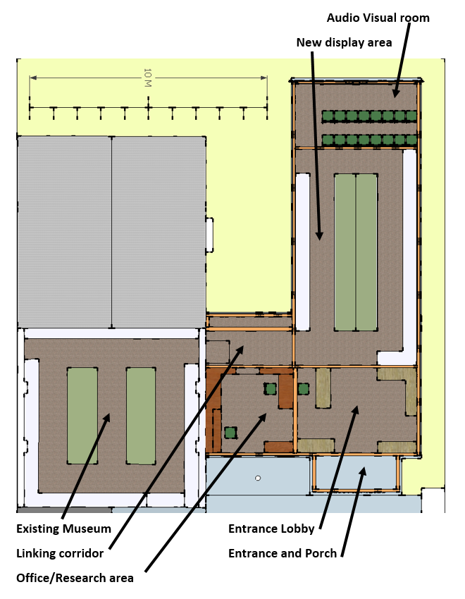

This is how the Museum Extension will look when completed.
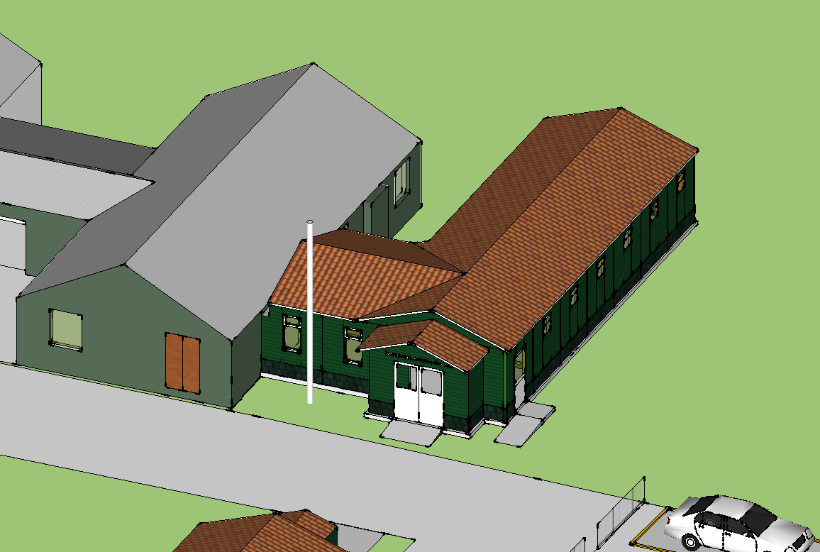
Phase 2)
This will be bringing the Eastern pair of hangars into use as a museum.
The Flying Start Project that was intended to celebrate the centenary of flying in Britain in 2009 included the use of these hangars and the surrounding area and received full planning consent. This consent will have lapsed, but the use has been established and planning should be straightforward. The original plan generated far more traffic than we are likely to, at a time when the road system in the area was in far worse shape.
The Eastern pair have been heavily modernised. The external walls have been replaced with concrete blocks and the roof has been covered with steel roof sheeting. It is our intention to tidy this up and make it a usable space for museum displays etc. We do not intend to restore the building to its original form, as this would be expensive and of little value, however, it may be possible to re-clad the exterior with corrugates steel. This would give the exterior a period look, and would help preserve the framework and improve the thermal efficiency. There is a glass walled office inside the building that would serve as an entry point and there is a toilet block attached to the back. There are 2 cold store rooms that could be used to form an audio visual room and an education room. The building can be made useable with no major structural alterations. By utilising the existing layout the cost can be controlled.
We will need to bring some of the car park on line to support Phase two. The concrete slab nearest the museum will be tidied up and an access ramp made. Some of the coach parking can

also be made available and staff parking and disabled parking can be provided next to the Museum. The cost of this can be kept fairly low.
Once we have access to the Eastern hangars and they have been made safe, we will run hard hat tours as this will help raise funds and also provide an opportunity for the public to see the project as it progresses. The building can then be occupied in sections.
We will do as much of the work as possible using both external and prison volunteers, as most of the work will be painting, lining out, repairing and maintaining windows etc, so will not require specialised tradesmen.
The materials can be obtained from various local charity sources of which the list below is a sample:-
- Queenborough Fisheries Trust, around £30,000 a year to distribute in our area
- Big Local Lottery , have stated their support and can give sums of several thousand pounds each year
- The Wind Turbine fund. The 4 new turbines will generate £22,000 for good causes in Eastchurch each year, for at least 10 years.
- Swale Borough Councillors have £4000 each to distribute
- Kent County Councillors have £15000 each to distribute.
- The Parish Councils on Sheppey have given us funds in the past and can be asked again.
- Various local firms have supported Phase one with free building materials worth many thousands of pounds and we would expect this to continue as the project expands.
We would expect to be able to bring in from Phase 1 and outside funders, around £30,000 to £50,000 per year to pay for Phase 2. The completion of this will take from 2 to 4 years, depending on the difficulties encountered and the availability of funds.
During Phase 2 we will also be expanding our volunteer team, our collection of exhibits and the range of goods in our gift shop.
Phase 2 will enable visitor numbers to increase towards 25,000 per year, including education visits and special events. The running costs of Phase 2 are not yet fully known, but the account from the Tangmere Aviation Museum give a guide, the entry fee will need to be increased to reflect the new facilities, and a figure of £6 will generate around £100,000 per year and this should cover the overheads at this point. Our aim will be to increase visitor numbers in order to generate a cash surplus to invest in Phase 3.

Inside the Eastern pair of Hangars.

This view is now several years old as the building is now off limits. We believe that the general condition has not deteriorated any further
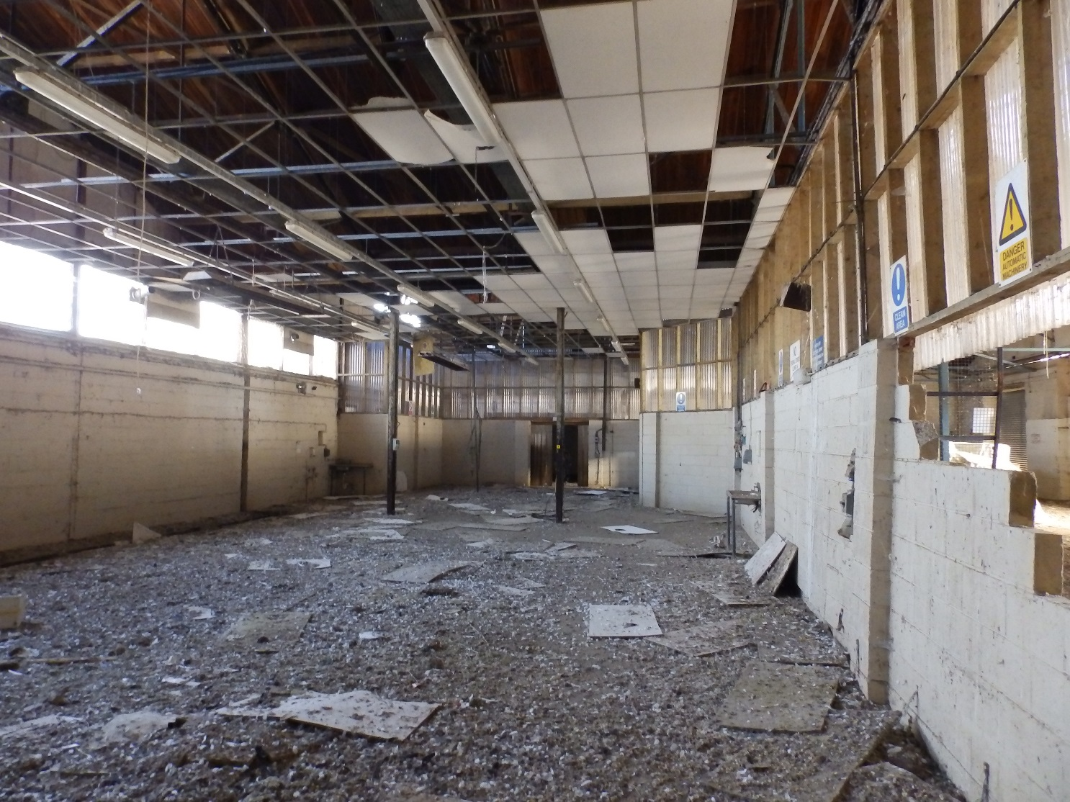

The Eastern pair showing the front section including the old office area.

This part of the building was used for food processing when the prison had a farm.
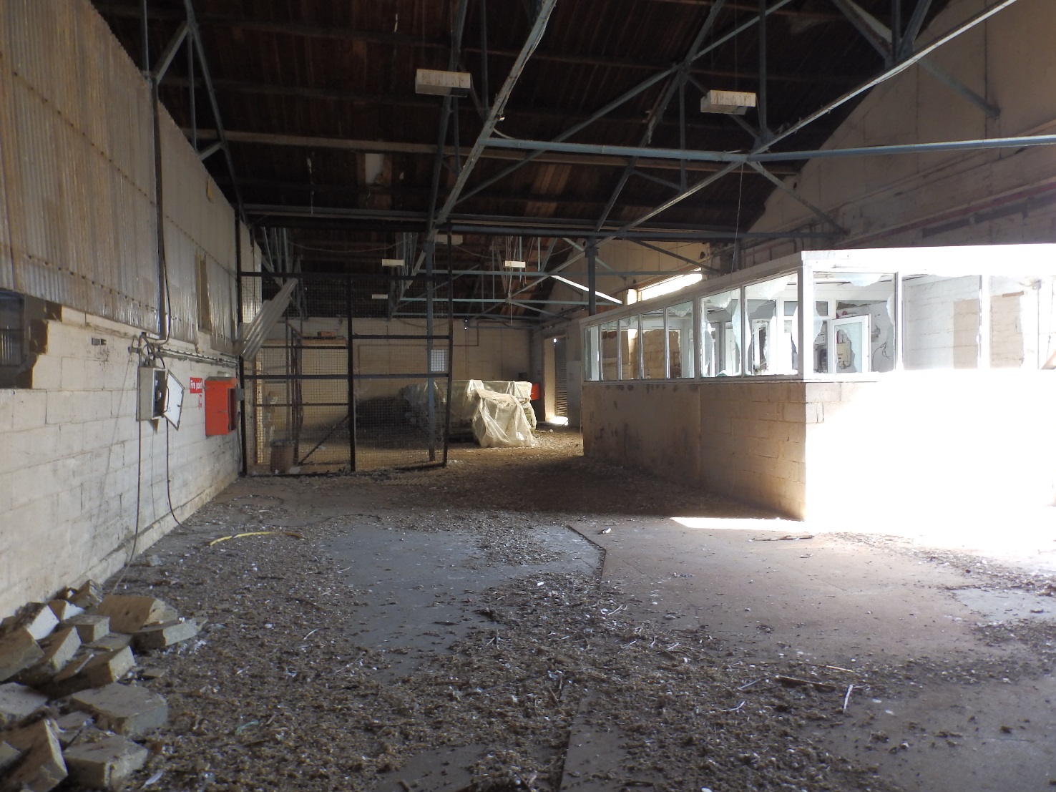
Phase 3)
Phase 3 will be to restore the Western pair of hangers to their original condition. These hangars have not been modernised. This means that elements of the original fabric survive, but in a very poor condition. The task of restoring them will be a specialised one and will be expensive and take some time.
We will seek Lottery funding at an early stage in Phase 2, as this can take several years to achieve. During this time we will seek advanced funding to put a shelter over the building in order to dry it out and protect the remaining fabric of the original structure.
We will need to get professional help to run Phase 3 and this can be funded from various sources. Once the building is dry and safe, there are tasks that a volunteer team can take on such as cleaning and preserving the framework.
The specialised part of the work however will cost several million pounds. A proper estimate will take some time to determine. The Lottery will look more favourably on the project if Phase 1 is completed and Phase 2 is being funded locally, plus we are demonstrating that the business plan is working so far.
The Western pair would be best used by putting suitable replica aircraft in them. A lot of the aircraft of special interest to the site have not as yet been rebuilt, so we can put together a unique collection that will be of international significance. This could easily cost another million pounds.



The Western hangers will be unheated, as they would have originally been. To heat them would mean compromising substantially the restoration, so we will keep the Eastern pair for interpretation displays in a well-lit heated environment and use the Western hangers to recreate the period from 1912 to 1914.
It will be possible to move the exhibits in the Western pair to free up one on the hangars for special events, such as period entertainment, film shows etc, and this could generate extra money.
The work of the museum will not end after Phase 3. There are many opportunities to build upon this, but they are best left for future discussion.
The really successful museums are the ones that grow organically over a long period of time. This is because they embed themselves into the local area and become valued and protected.
This will be a long term project and may take 10 years or more to get to the end of Phase 3. Tangmere Military Aviation Museum was founded in 1982 and is still growing.
The pictures below, taken before the building was closed due to safety concerns, give an indication of the condition of the Western pair of hangars and deterioration in this area is rapid. Some work needs to be carried out urgently to prevent the cost of repair from escalating.
These hangars could soon be on the at risk register.

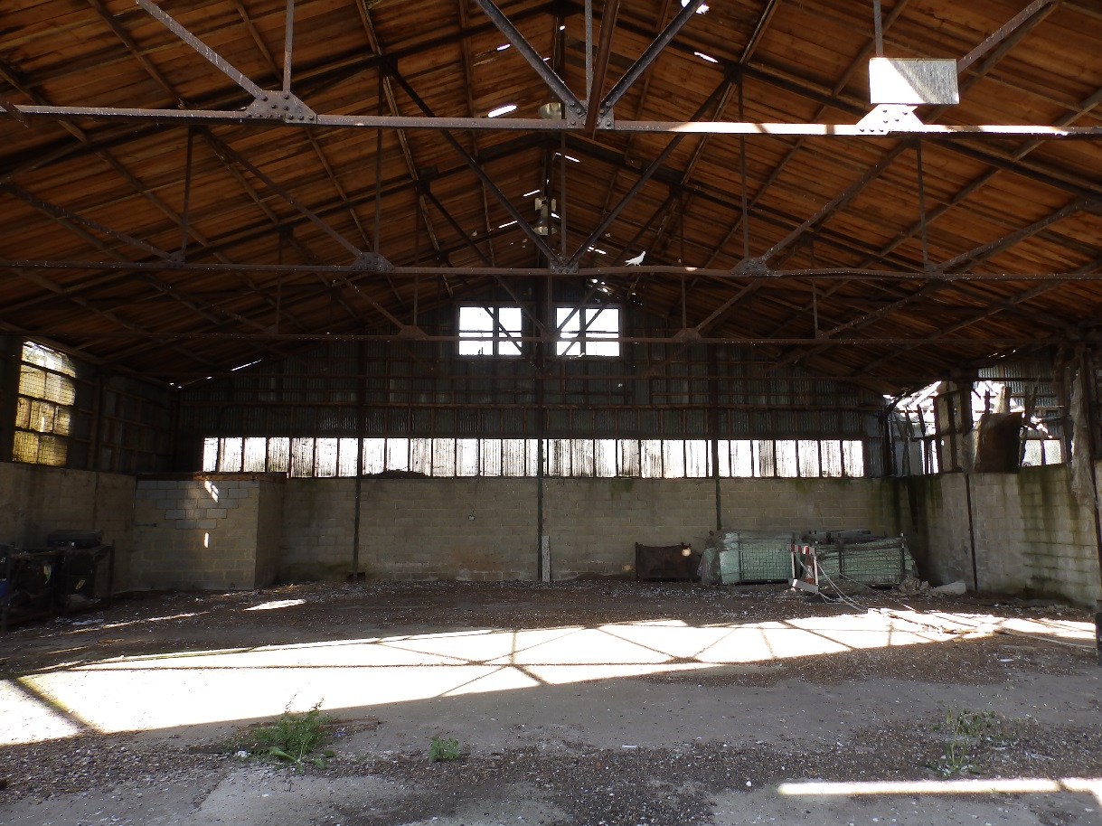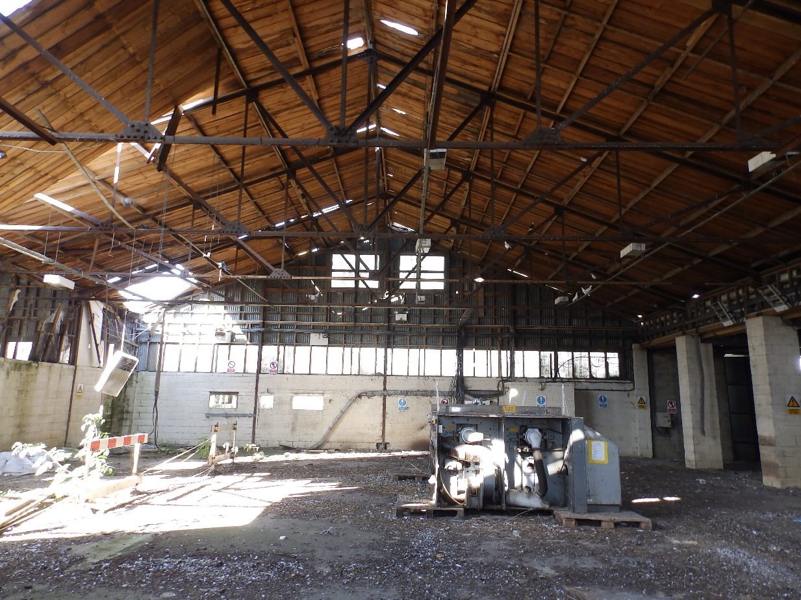
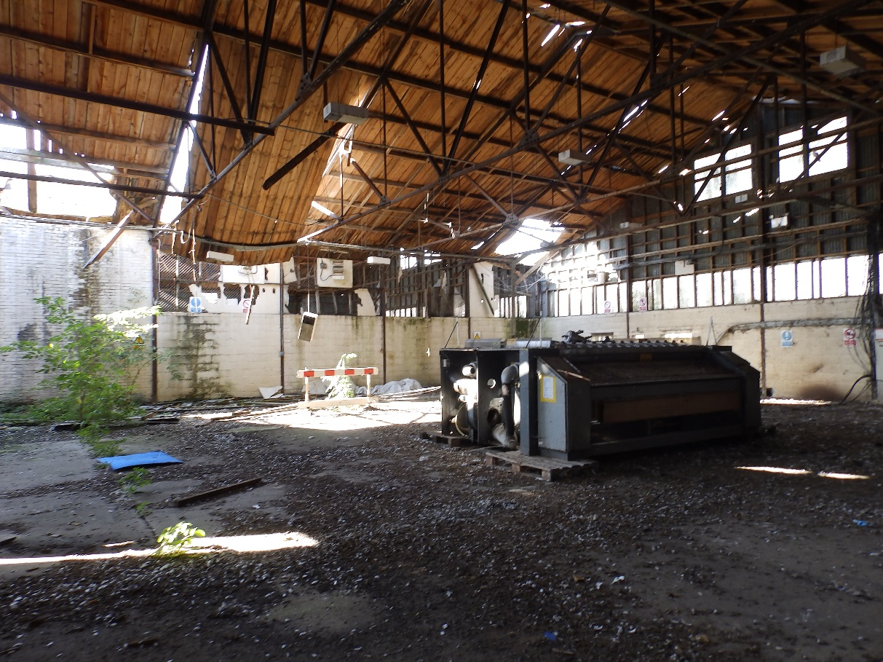

This picture shows the section added soon after the buildings were built, to fill in the gap between the two pairs of hangars. The roof trusses are said to be salvaged from older building on the base and therefore could be from 1909, making them the oldest surviving part of a hangar in Europe and possibly the world.
