
The Museum Offering.
This is a summary of the nature of the heritage and educational offering that would be possible in the hangars. It is not intended to be definitive, but to give an indication of the opportunities available.
Core Offering.
The main subjects will be:-
The Early Aviation Heritage of Eastchurch and Sheppey.
This will cover the period from 1908 to 1918 and will include the first British flights and the connection with the early aviators such as Rolls, Grace, Brabazon, etc, also the foundation of the world’s first aircraft factory by the Short Brothers with help from the Wright Brothers.
Very few original artefacts exist from this period, but there is a great wealth of written and photographic material. We will be able to construct models and replicas and give audio visual presentations to cover the period.
Many important problems were overcome by the early aviation pioneers and we can demonstrate what the problems were and how they were resolved. This will be used to inspire a new generation to take an interest in engineering.
This is Charles Rolls of Rolls Royce fame, learning to fly in a Short Wright Glider from Standford hill. 1908 I
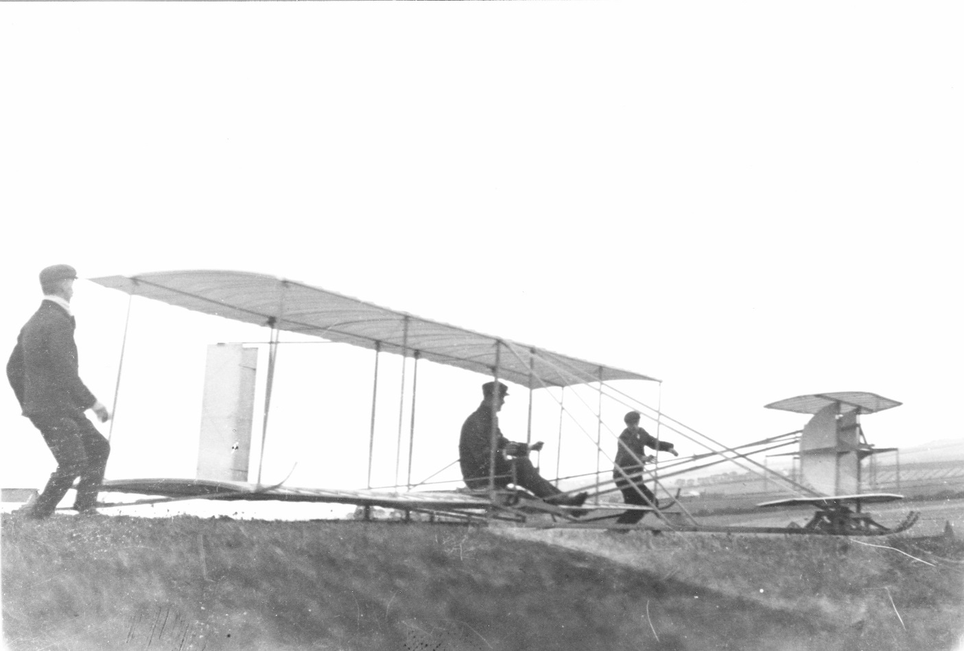

These are the famous founding fathers picture taken on Sheppey in 1908. It shows the Wright Brothers surrounded by all the early aviators of the time.
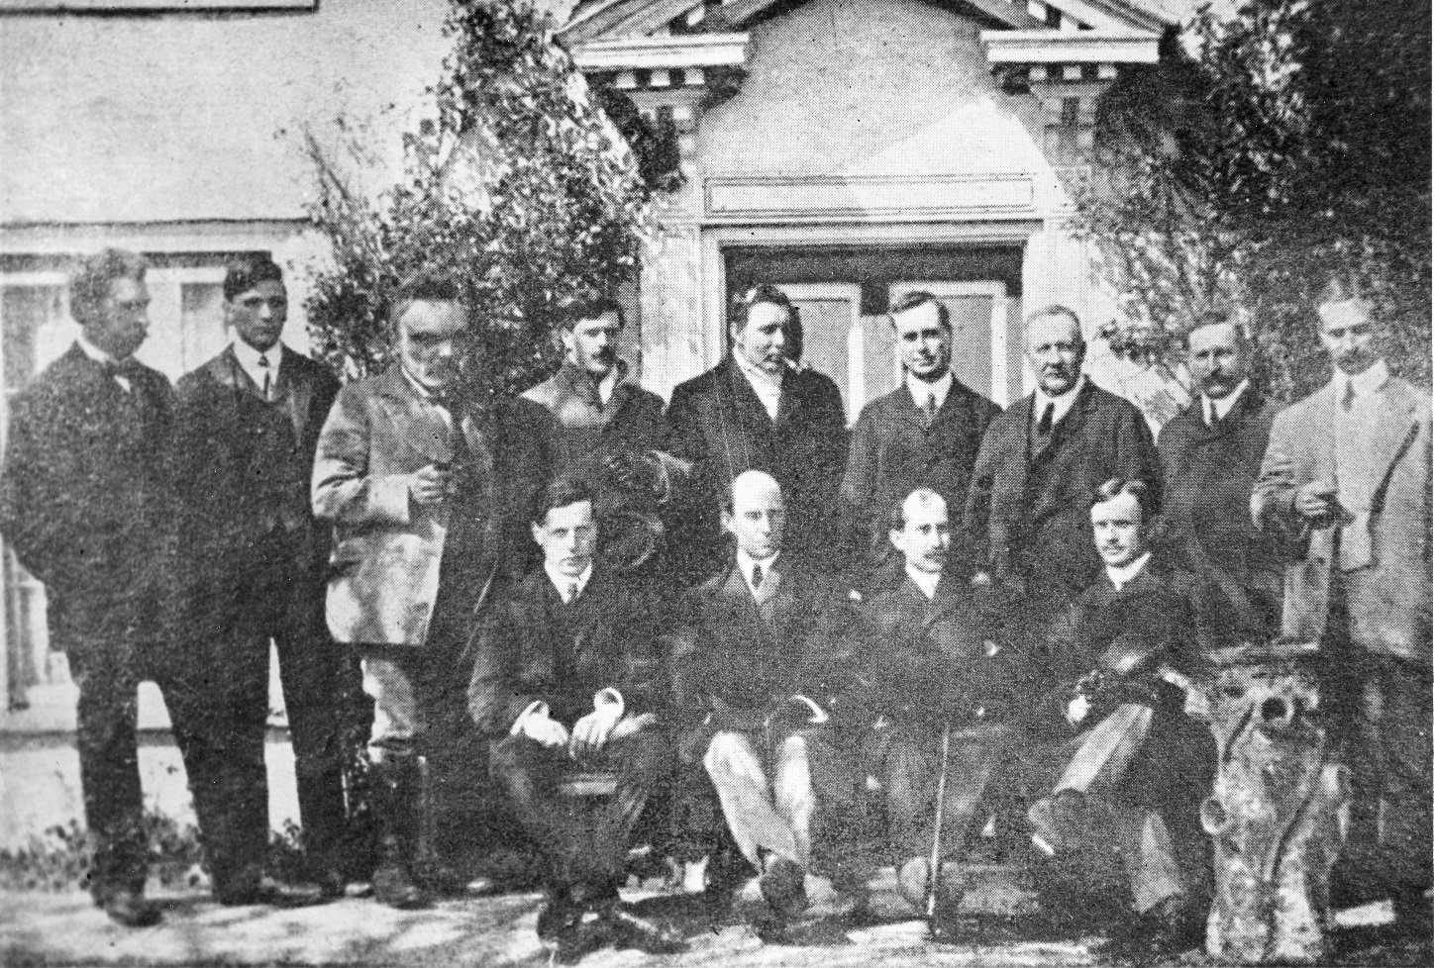
The Triple Twin, one of the world’s first twin engine aircraft. It was built at Eastchurch by Short Brothers.

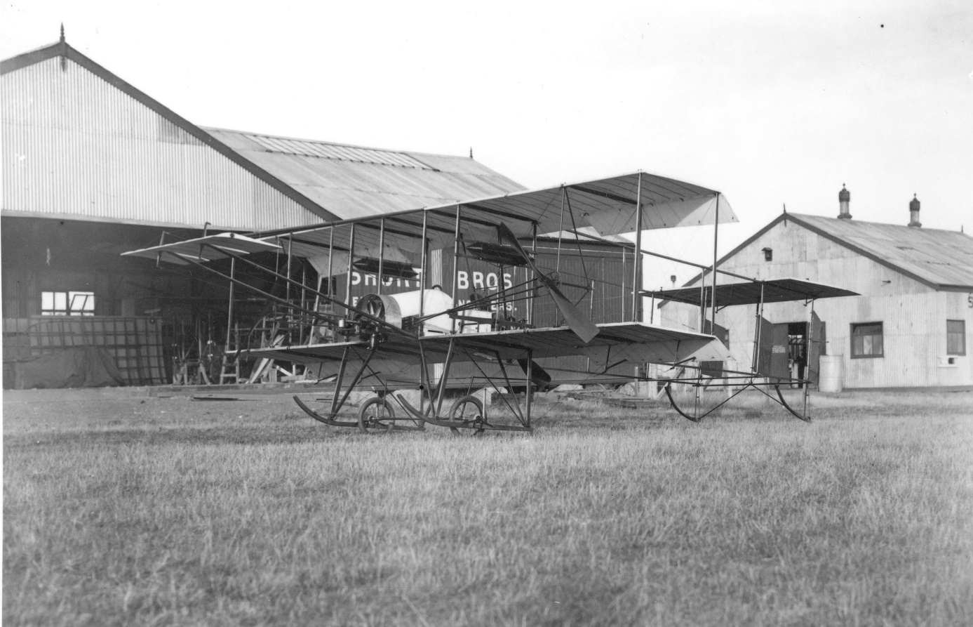

The Airbase as it was in 1912.
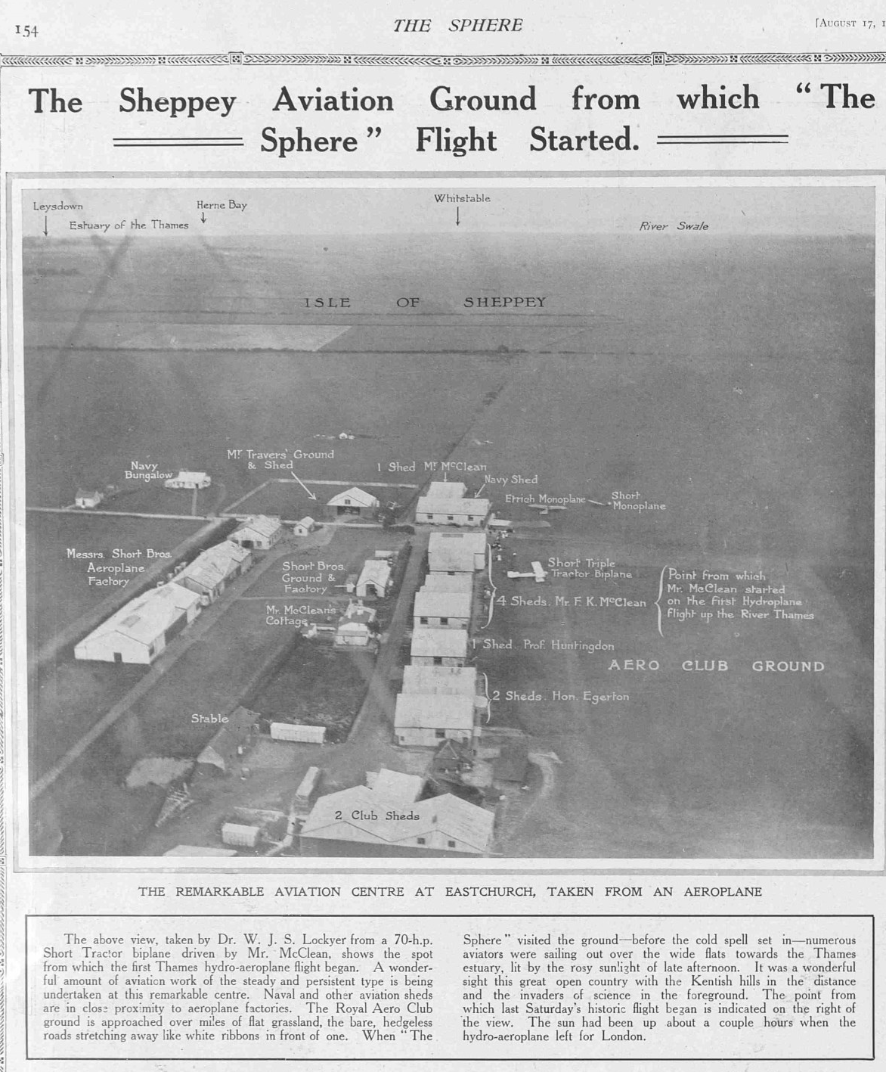
The foundation of the Royal Naval Air Service.
The Navy set up their first flying school in the hangars at Eastchurch and from this the new service was created. The site is connected with many of the early navy pilots and Winston Churchill was a regular visitor.
The service went on to play a pivotal role in WW1 and was then merged with the Royal Flying Corps to form the RAF. The site has strong connections with all 3, but it is the RNAS that will be our main focus. There is a small section covering the RNAS at Yeovilton Fleet Air Arm Museum, but we will be able to shine a much brighter light onto what is a mostly forgotten service.

We will cover the training of the first 4 navy pilots and their achievements, such as the first British take off from a ship and the founding of the Royal Naval Aviation School in the actual hangars that still survive, during the period from 1909 till 1918.

Plan of the RNAS in 1913. Aeroplane shed No1 was destroyed in WW2. The remaining sheds are No2 and No3
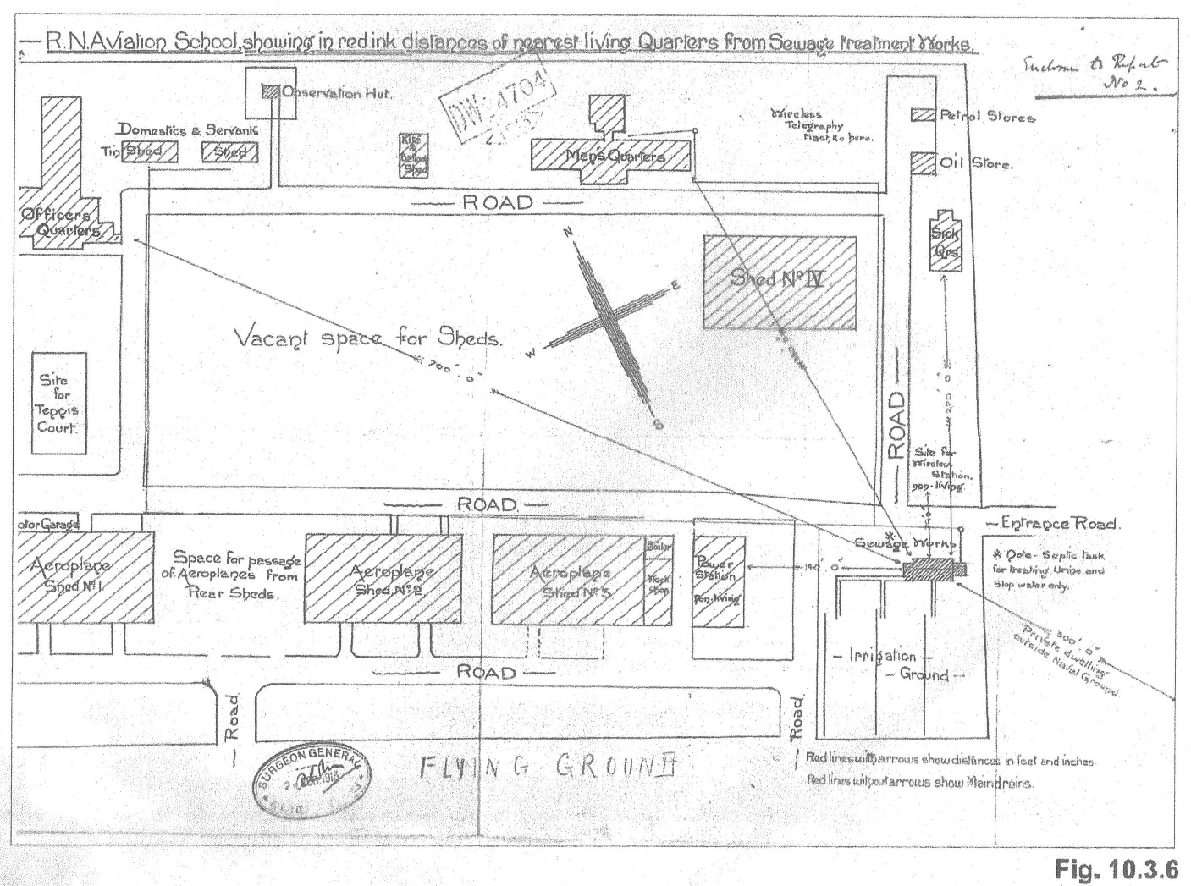

This aerial photo from 1912 shows the Navy Base under construction

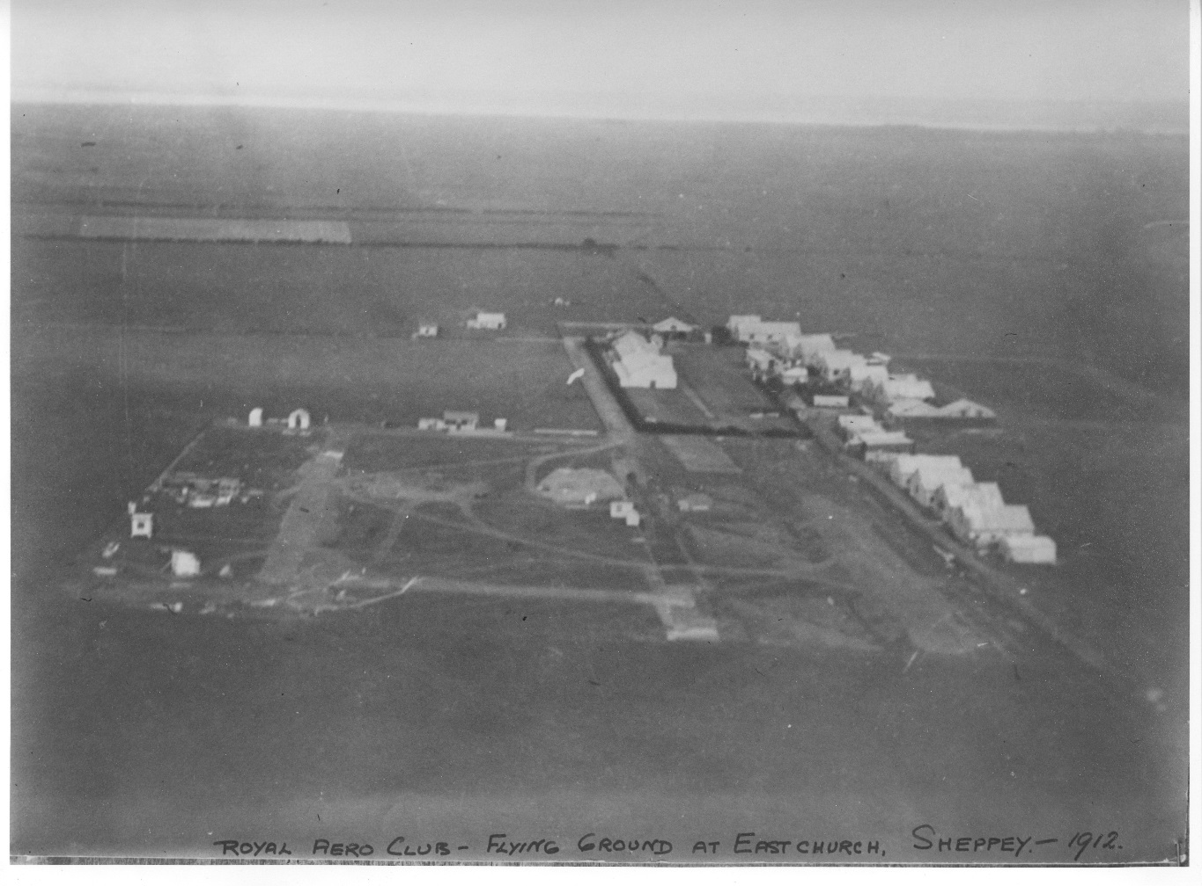

This picture from 1913 shows the Navy base mostly completed. The 4 remaining hangars can be clearly seen in the centre
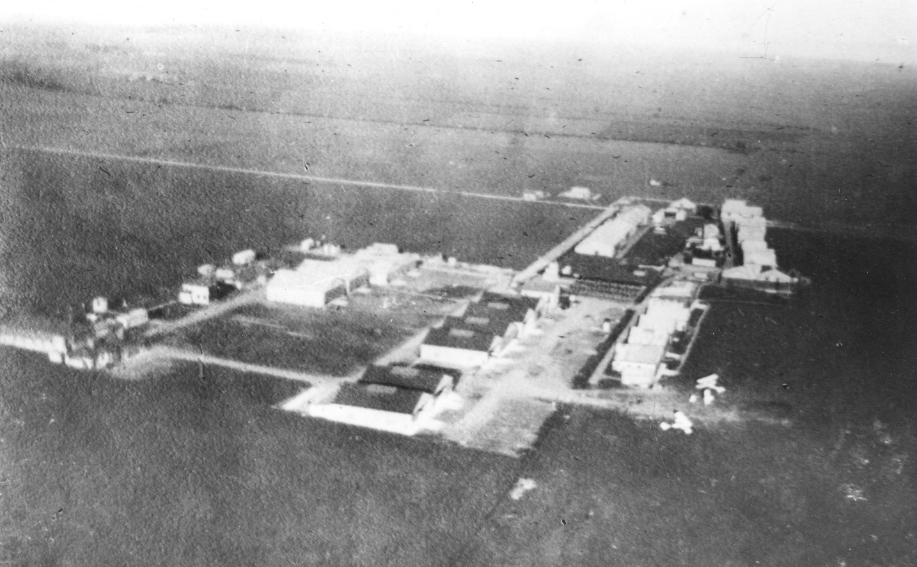

This picture taken in front of Hangars No1 and No2 shows testing of short take off methods later used to launch planes from barges towed behind warships. This Technique was used to bring down a Zeppelin over the North Sea in WW1
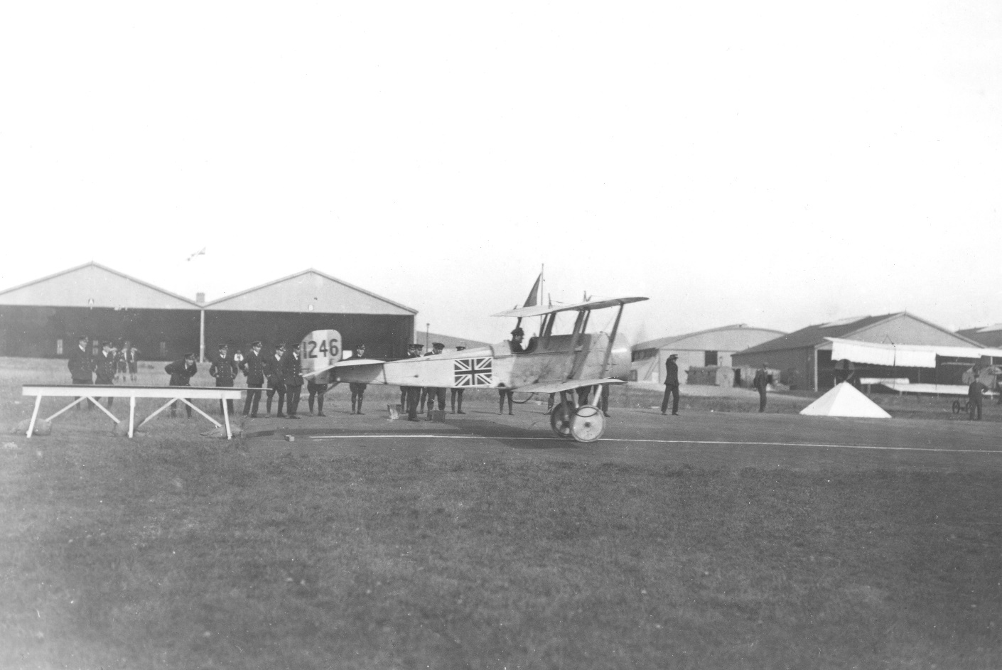

This is a twin engine aircraft from WW1. The western pair of hangars can be seen on the right.
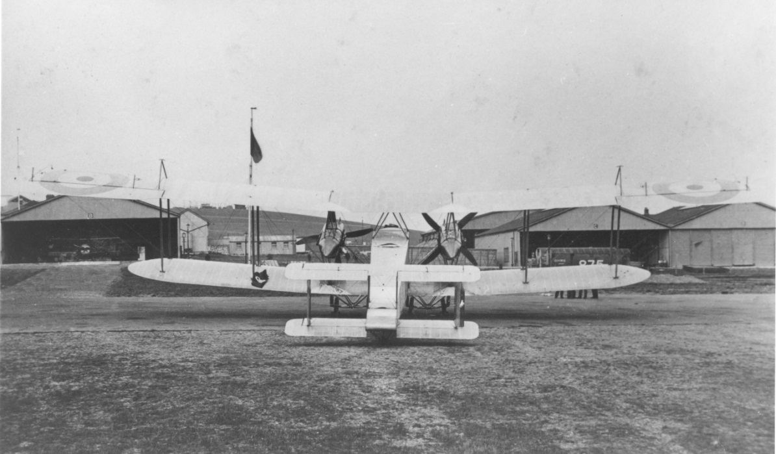
The aircraft below has an experimental bomb sight fitted. The sign in the roof is still there and warns not to place weight on the trusses.
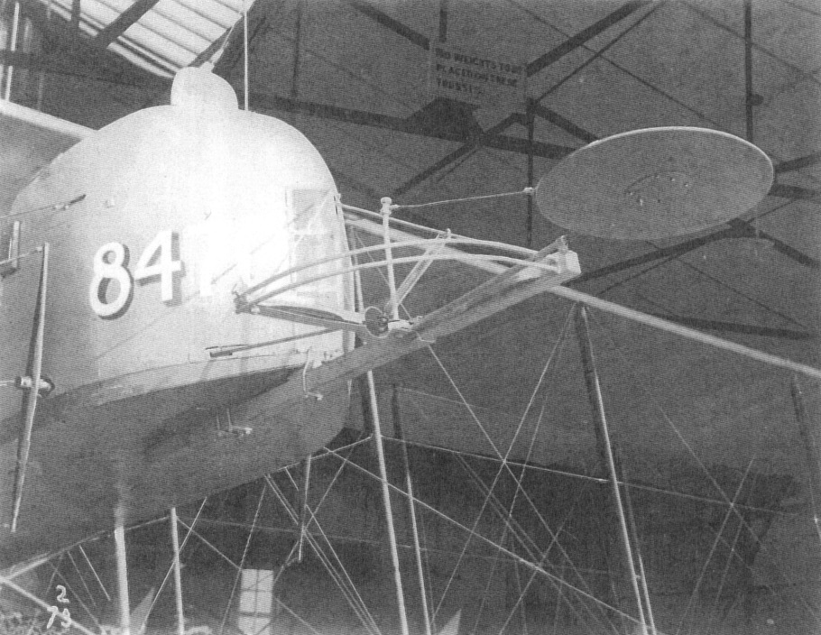
The Sopwith Company did most of their testing work at Eastchurch and this experimental aircraft is parked in front of one of the Halbrow hangars which is painted in WW1 camouflage. Note the landscape painted on the hangars.
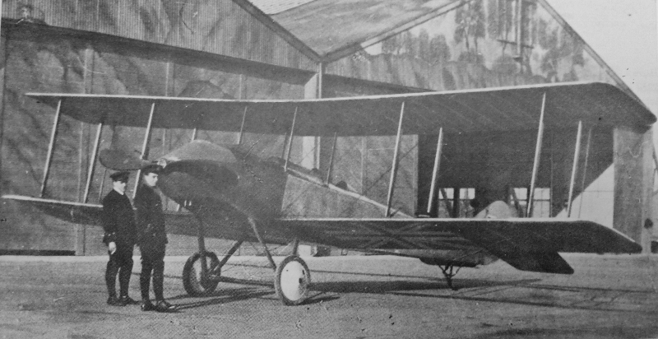
The museum can then choose to cover additional areas of broader interest to the site. These may be as permanent exhibitions if space is available, as a permanent small exhibition, or as temporary displays that would be changed each year to give people a new reason to attend. Suggestions for such exhibitions are:
The history of the Short Brothers at Rochester. The move to Rochester started during WW1 and the Shorts factory stayed at Rochester until the end of WW2. There is currently no museum in Rochester covering this and our proximity to the Medway Towns means that this is worth considering.
The contribution of the RNAS during WW1. As the founding site of the RNAS, this topic could be covered. No other museum is doing justice to this subject.
The effect of the Aerodrome on the surrounding area. The Short Brothers and then the various Air Forces became major employers drawing on a long established skills traditions in the area. The story of how ship builders became aircraft workers and how the various trades were developed and exploited. The story of how the local economy took advantage of the activity on the site and the large number of new occupants and how this story continues to this day with the prison complex.
The history of the Sheppey Light Railway, how it was pivotal in the selection of the site and how it served the site until it closed after WW2. The Airbase had its own railway sidings that fed through to within feet of the Hangars. The SLR is not covered in any other museum and there is potential to increase visitor numbers by covering this topic.
The airbase at Grain was a sister base to Eastchurch and should be included. There is no other museum covering this topic.
The development of sea plane that follows on from the first landing on water by a British pilot, Arthur Longmore, in a Short Biplane in Sheerness Harbour.
The development of the aircraft carrier that follows on from the first British pilot, Charles Rumney Samson, to take off from a ship in Sheerness Harbour.
The development of armoured vehicle that follows on from the work of the Eastchurch pilots who went to the war in France as the RNAS.
The life and work of Sir Stanley Hooker, born on Sheppey to a local family. He went on to play a major part in the development of the Merlin Supercharged Aviation engine that powered the Spitfire, the Hurricane and the Lancaster. He also played a significant part in the development of jet engines for the Meteor, the Vulcan and the Concord to name just a few. His life and work should be an inspiration to the next generation.
The development of multi-engine aircraft, starting from the world’s first twin engine biplane and the world’s first twin engine monoplane, both built and tested at Eastchurch.
The science of crash investigation that was founded at Eastchurch when Horace Short was asked by the Royal Aero Club to establish the cause of the crash the killed Charles Rolls at the Bournemouth Air Show in 1910.
James McCudden VC, As a boy on Sheppey he would have been inspired by the early aviators at Eastchurch. He went on to be the British number 1 fighter Ace of WW1.
Women at War, To explore the role of women from 1909 onwards, both in the construction of aircraft, and in military service.
The Polish Airforce. To tell the story of the polish air force in WW2 when Eastchurch was used as a transit training camp for all of them.
This is just a brief overview, but demonstrates that there is more than enough heritage to fill the hangars and to attract the number of visitors required. In addition, to keep renewing the museum’s displays to get people to come again, as we want the museum to develop and grow indefinitely in the way that other attraction such as the Tangmere Military Aviation Museum, and Stow Marries WW1 RFC Air Base are doing.
The hangars themselves are one of the main attractions as they will be the earliest aviation buildings open to the public in Europe. A study of the other museums covering early aviation has shown that we will be unique and therefore able to attract visitors from a very wide area and to work with the other museums to promote each other’s sites.
We will also continue to develop the work we are already doing with local schools and youth organisations, in order to support the teaching of modern history, and the STEM subjects. The provision of purpose built audio visual and education rooms within the Hangars will enable us to develop and enhance our current offer in this area and increase the number of visits from this sector of the community.
We will also continue our work with the elderly.
The museum is helping local care homes by providing stimulating outings for people with conditions affecting the memory.

