7/29/2019

**BUILDING INFORMATION MODELING (BIM)**

**LECTURES NOTES**

**SUBMITTED TO: *SIR FAISAL REHMAN***

**SUBMITTED FROM: *ZARA ASGHAR***

**Registration No: *18PWCIV5165***

**SECTION: “C”**

**2ND SEMESTER**

**LECTURE: 1**

**BIM INTRODUCTION**

**BUILDING INFORMATION MODELING (BIM)**

**DEFINITION:**

                      BIM is a digital representation of physical and functional characteristics of a facility. A BIM is a shared knowledge resources for information about a facility forming a reliable basis for decision during its life cycle; defined as existing from earliest conception to demolition.

BIM is an intelligent 3D model based process that gives architecture, engineering and construction professionals the insight and tools to more efficiently plan, design, construct and manage building and infrastructure.

BIM is the technique which we use in software.

BIM is the combination of Drawing and Design. BIM another name (VDC) Virtual Design Construction.

**USER'S OF BIM**

1. Facility manager

2. Owner

3. General contractor

4. Architect

5. Structure Engineer

6. Detailer

7. Mechanical engineer

8. Site manager

9. Erector

Building information modeling extends this beyond 3D, augmenting the three primary spatial dimensions (width, height and depth) with time as the fourth dimension (4D) and cost as the fifth (5D).More recently there are also references to a sixth dimension (6D) representing building Senvironmental and sustainability aspects, and a seventh dimension (7D) for through-life facility management, although there are conflicting definitions (6DBIM )

 BIM therefore more cover than geometry.. It also covers spatial relationships, light analysis, geographic information, and quantities and properties of building components...

**TYPES OF BIM SOFTWARES**

1. BIM Execution Planning Software

2. BIM Content Management Software

3. BIM Modeling Software

4. Generative Design Software / Algorithmic BIM Software

5. BIM Performance / BIM Analysis Software

6. BIM Collaboration Software

7. BIM Validation / BIM Checking Software

8. Preconstruction BIM 4D/5D Software

9. Construction BIM Software

10. Facilities Management BIM Software

**LECTURE: 2**

**FREECAD INTRODUCTION**

**FREECAD:**

                Free CAD is a free and open source general purpose parametric 3D CAD modeler and a building information modeling (BIM) software with finite element method (FEM) support.

                It is a parametric designing tool. Free cad is based on work bench.            A workbench can be considered as a set of tools especially groups for certain task.

* Arch Work bench : architectural element
* Draft Work bench:  2D tools and basic 2D and 3D cad
* Tech Draw Work bench : advance drawing work sheet
* Spread Sheet Work bench : large table

Commands: Line (LI) , Wire (WI) , View (panel) , Circle (CI) , Orth mode (shift )

**LECTURE : 3**

* Step No 1

For opening new document: Press ctrl+ or file

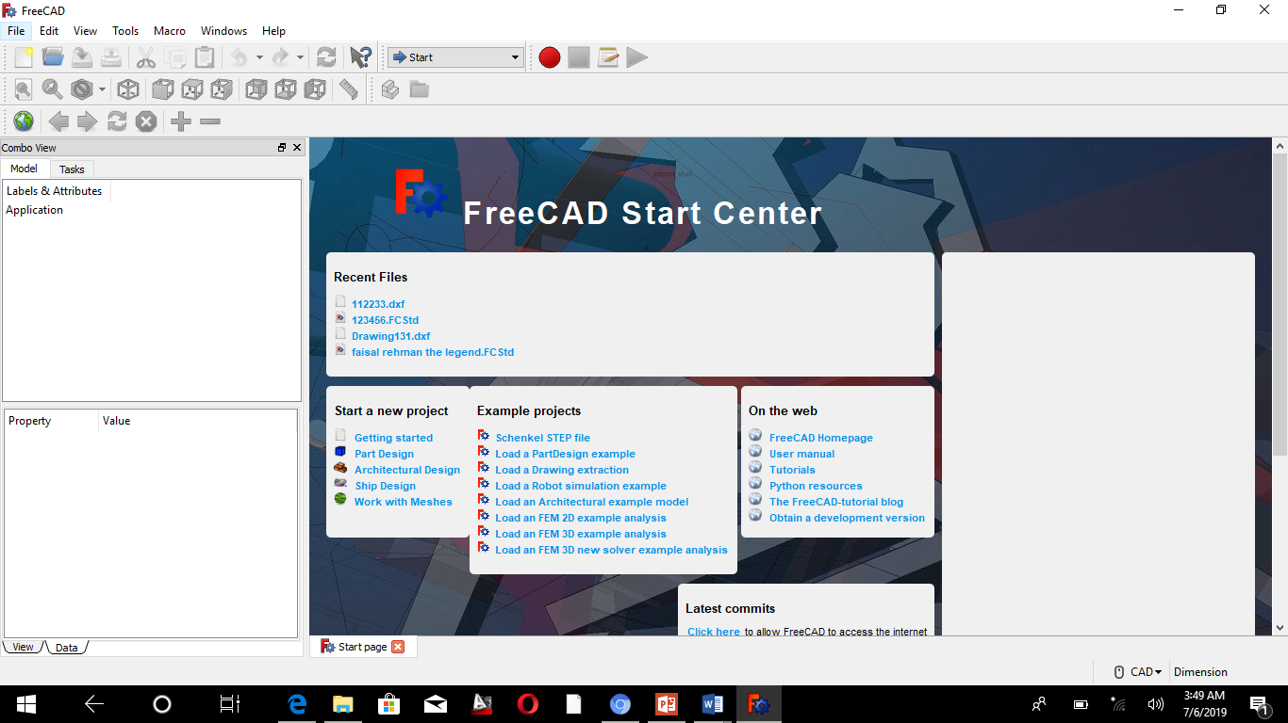

* Step No 2

Open BIM work bench

View>workbench>Bim or W-2

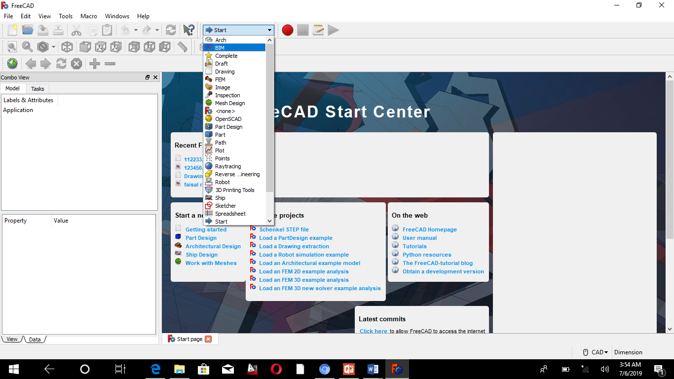

* For zoom in or zoom out

Command: ctrl+ or ctrl-

* For fitting the selected content on the screen

Command: (V, S) or Symbol: 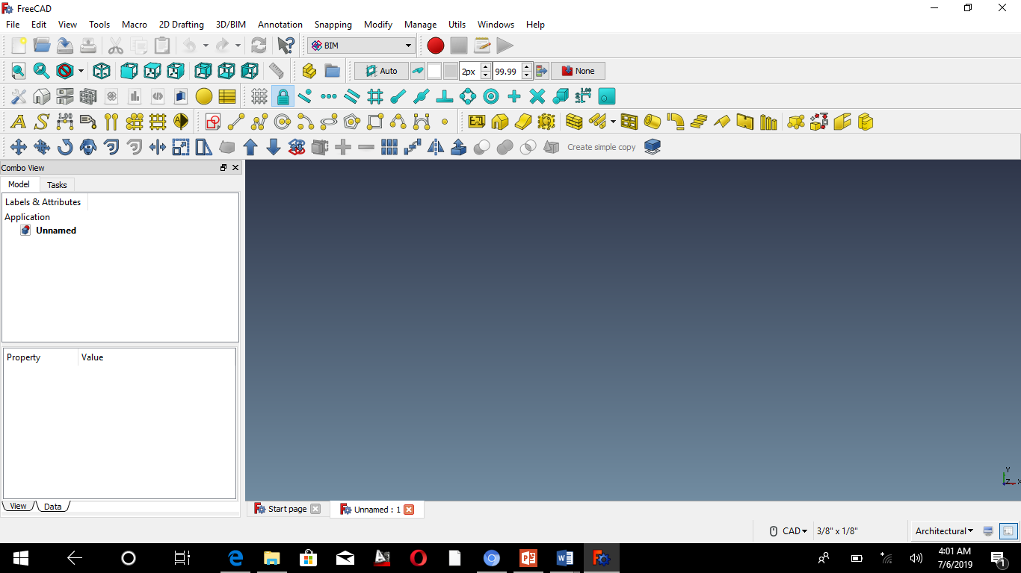

* Open report view:

(View>panel>report view> it tell you what to do next)

* **You can adjust snaps from tool bar**
* Snap tools**:** use it for line press shift button to activate Ortho mod
* Draw line: Click on line icon or 2D Drafting > line, Li

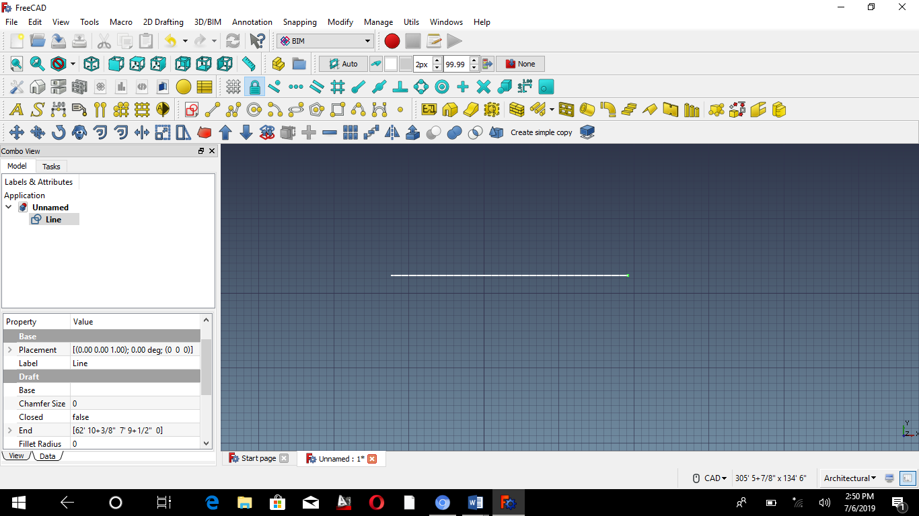

* Combo view : view>panel>combo view it contains property windows



Select line then select data tab from property window

In data tab we are able to change different properties of line.

For example: height, length, width etc.



* Draw a line with angle. Shortcut “L” > to lock angle

**2d Drafting modeling tool bars**

1. Line Offsets
2. Rectangle trim
3. Circle explode
4. Arc extrude
5. Text
6. Dimensions

* For online help 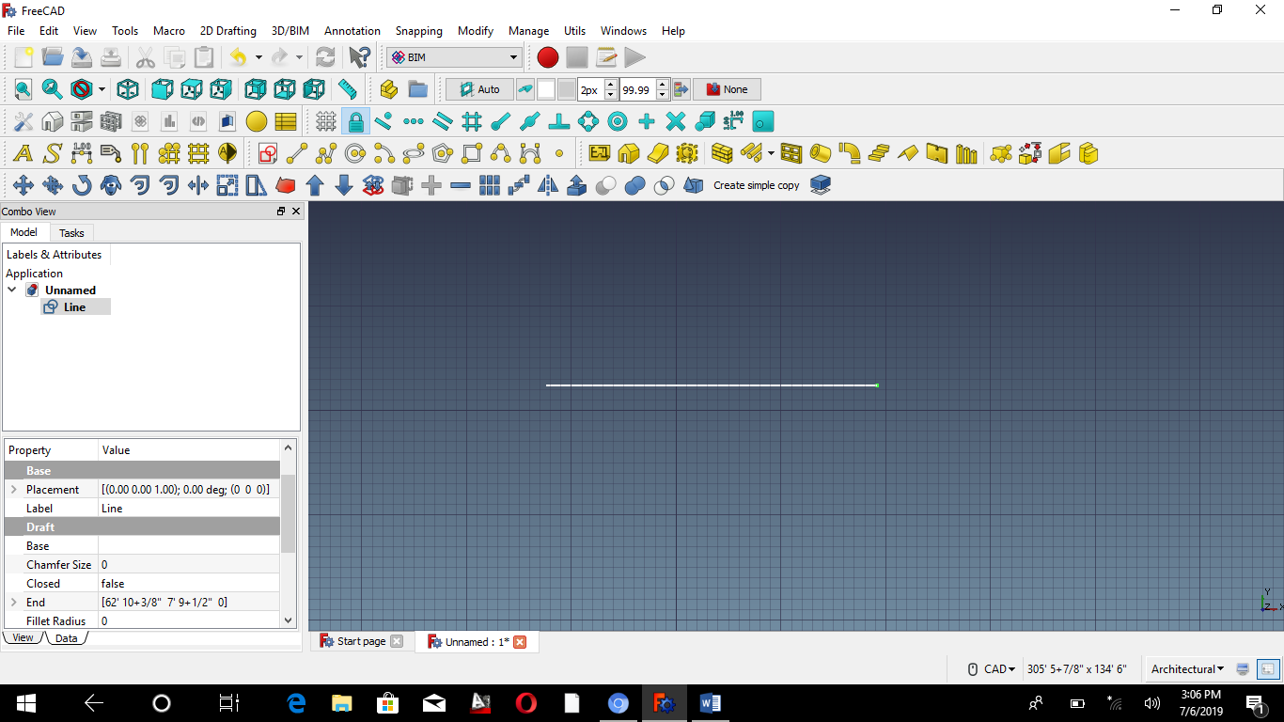 or key board shortcut is = shift F1
* Offset : it is used to make a copy of an object its command is

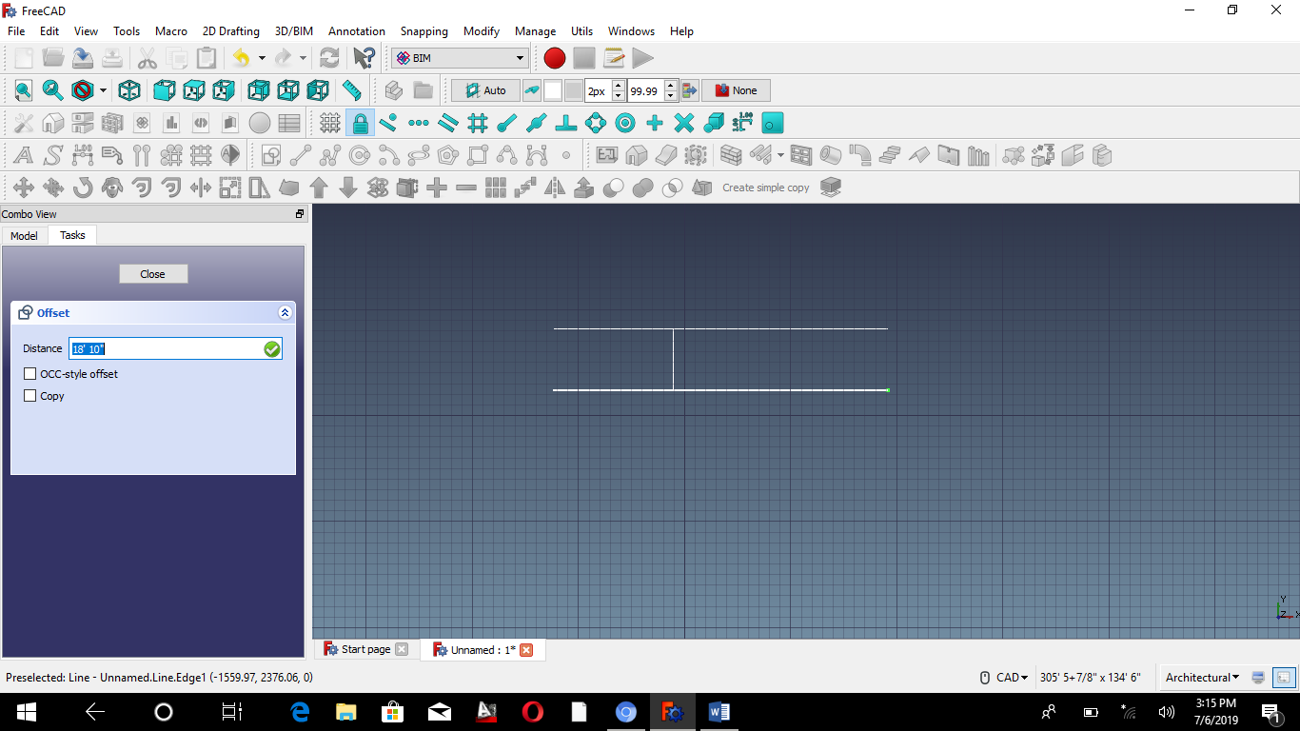

Line offset

**LECTURE: 4**

**How to make two walls and slab in freed cad software**?

* Open free cad > select a BIM workbench > by ctrl+N command open a new file or document.
* Firstly change its unit and navigation style / CAD

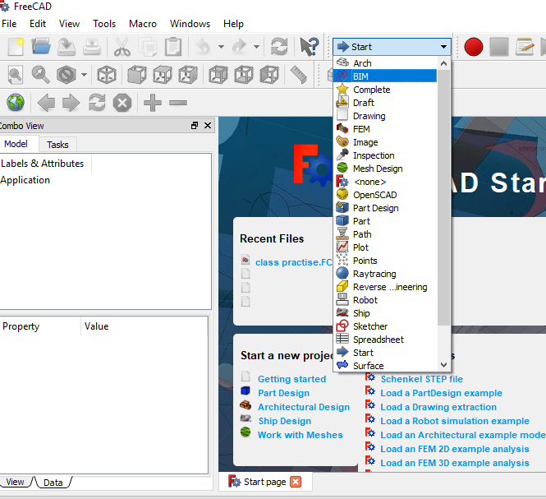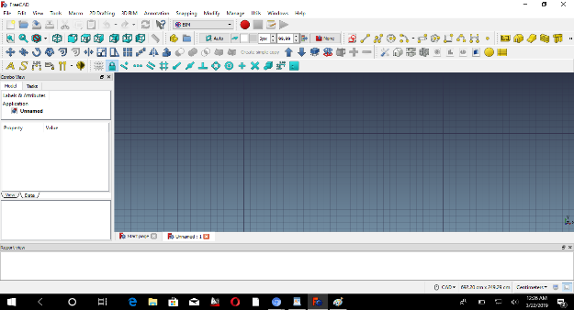

There are several way to select a wall

1. press 3D BIM > wall
2. second directly select an object (wall) from tool bar
3. Wall command is W,A

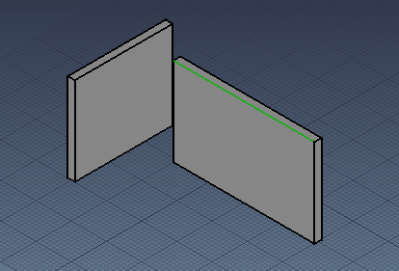 Height of walls =250cm

We can also change the properties of wall for example its length, width, height etc.

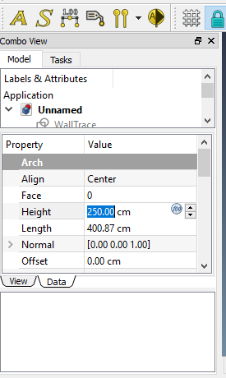

* Select a rectangle ( command Rec ) for slab then change the properties of rectangle

1. first make its face true
2. Press on placement and change its position, Z-axis value= 250 cm
3. Press on structure > select rectangle and change its property of role = Slab
4. height of rectangle 20cm

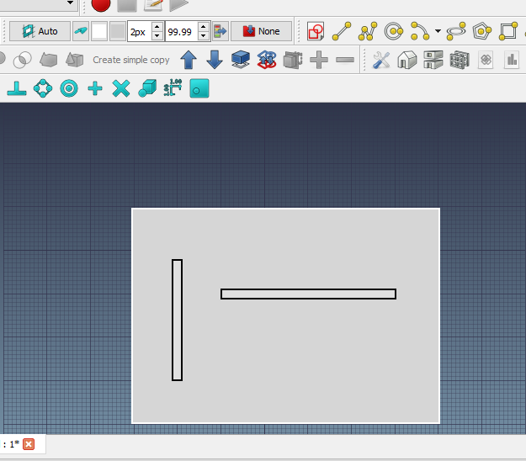

**Top view (**press 2 for top view**)**

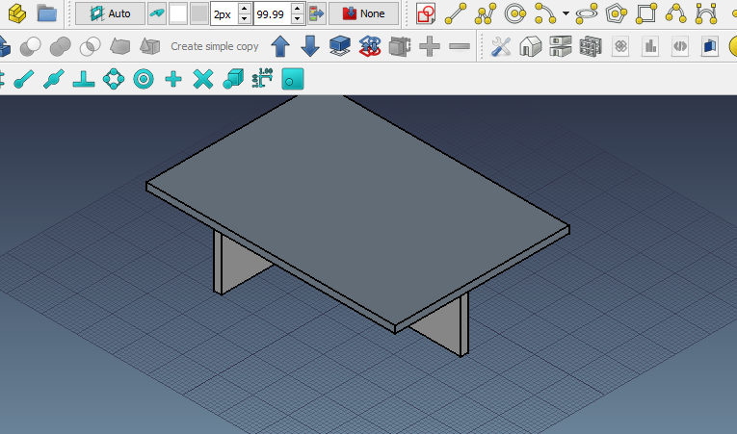

**3D view (**For 3D view press 0)

**IFC:** Standard format which store everything for example drawing file. Its key board shortcut is shift +B

**LECTURE: 5**

**OBJECTIVE:**

1. To construct Axis
2. To construct Axis System
3. To construct Grid
4. To construct Working Plane

**T0 CONSTRUCT AXIS**

**Step 1:**

Select arch from work bench

Select top view

Select axis / ||, Click on its combo view: Go to property and change its >distance = (1, 5) axis distance value be 5000mm

Go to length > value 1200cm

(**This axis was constructed vertically its name is axis**)

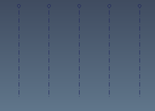

**Step 2:**

**To construct horizontal axis**

Again select axis / ||

You will see Axes001

Go to property (Data) >length=2200cm

Placement>angle90 >position X=(-700cm), y=(-250cm)

Go to view you can do labeling of axes

1. Bubble size>200cm
2. Font size >200cm

Now to make axis system

Firstly you have to select axes & axes001

Now go and select axis system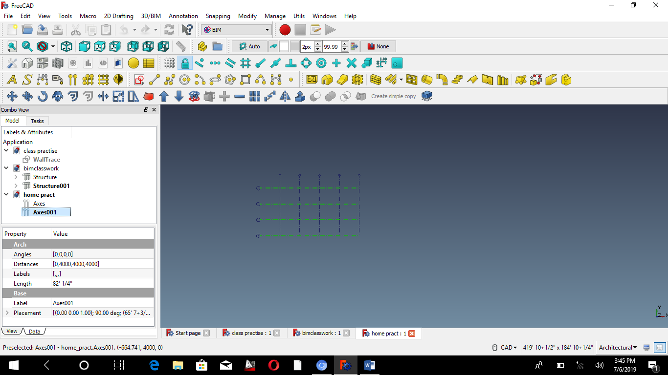



**TO CONSTRUCT GRID**

Double click on grid Q

Grid is actually show the frame of doors and window

Double click on grid: to change its property >total width=200cm >total height=159cm

Add column > 2(50cm)

Add row>3(50 cm each)

Go to view > display mode > wire frame

To make cupboards you can create span/remove span

**TO CONSTRUCT WORKING PLANE**

**Step 1:**

Select floor /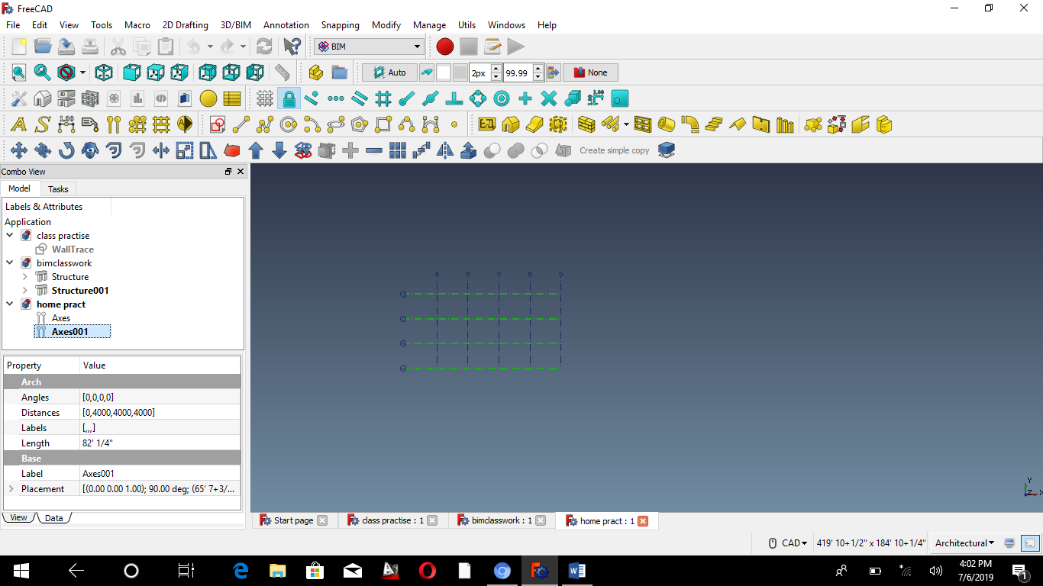 /FL

To create the working plane proxy of floor

Go to units >select create working plane proxy

As to consider WPP, select floor and WP proxy by ctrl>select add/

**Step 2:**

Select floor001 >WPproxy001>go to placement >position z=800cm

Go to axonometric view/press “0”

Double click on WP proxy001

* You will see the difference in floors height

NOTE: To active WP proxy double click on it

Than you can work on many floors at a time.

**LECTURE: 6**

**Steps:**

1. Export object from part design module to part module
2. Apply analysis
3. Apply material (steel, concrete)
4. Apply constrain (boundary condition)(SPC single point constrain)
5. Apply load
6. Mesh (dividing structure in finite element)
7. Apply section
8. Perform analysis
9. And then check analysis results

**STEP 1**

* Part Design > work bench
* Sketch > XZ Plane
* Draw a datum line
* Press keep length 3000mm/300cm

**STEP 2**

* Part work bench
* Advanced utility
* Make edge

**STEP 3**

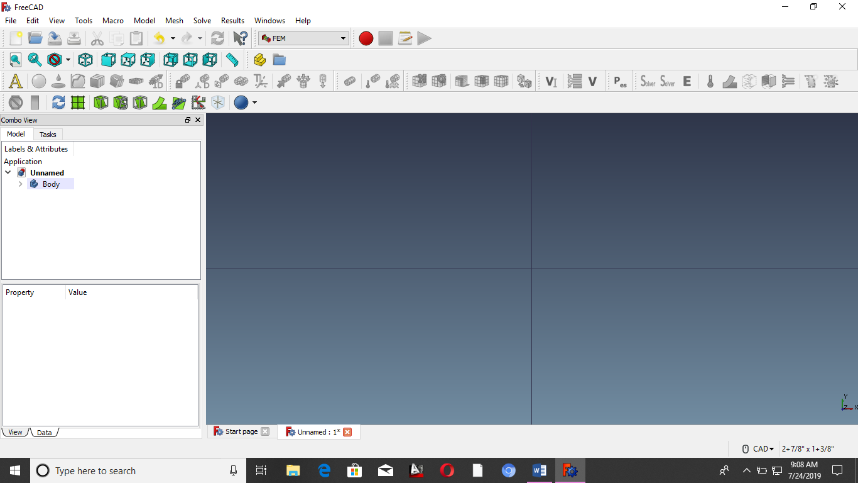 Add analysis solver. Also known by calculac XCCX tool

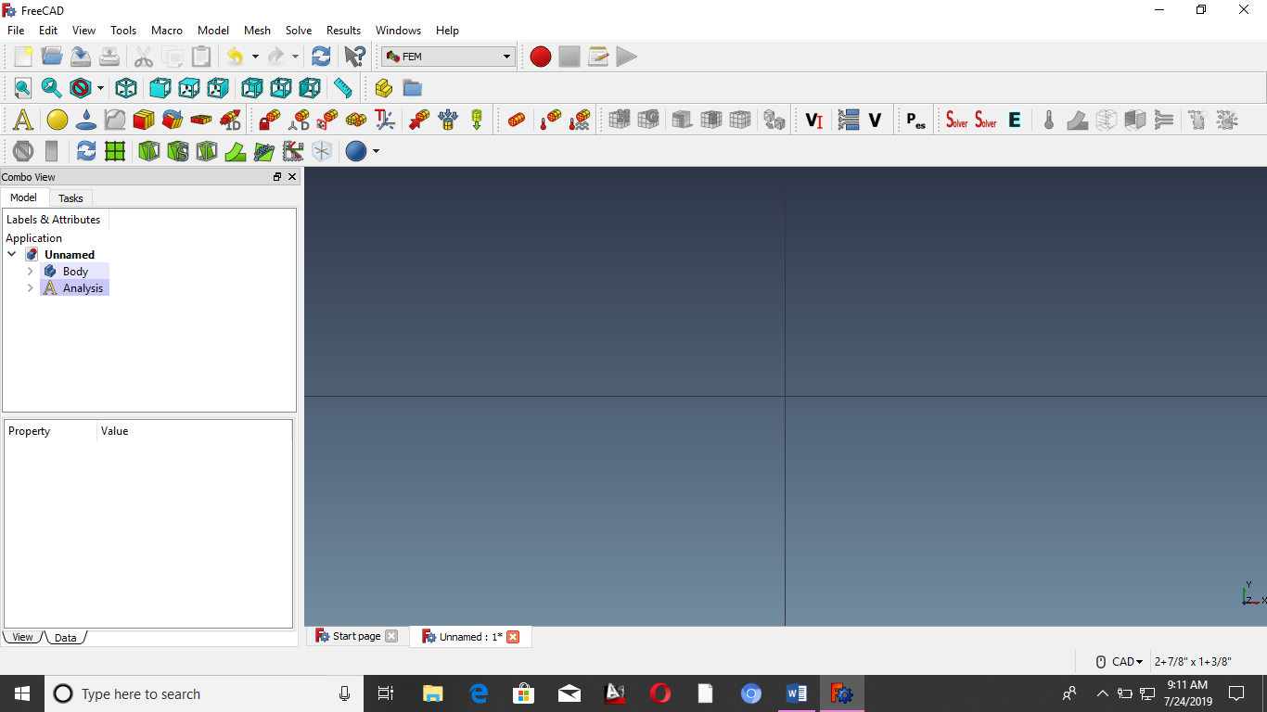 Material, then select concrete Generic

Value of Young Modules =32.00 Gpa

Poisson = 0.170

 Constrain is used to lock something

Click on one edge> then red color will appear

Add in reference

**STEP 4**

* Create FEM force 
* Add in reference
* Point load = 10000

**STEP 5**

* For meshing select the line
* Click on G-mesh 
* Shape 3D
* Max elements 30cm

**STEP 6**

* FEM beam cross-section
* Width 25 cm
* Height 25 cm
* Add orientation

**STEP 7**

* Click on calculix tool
* Static
* Write input files

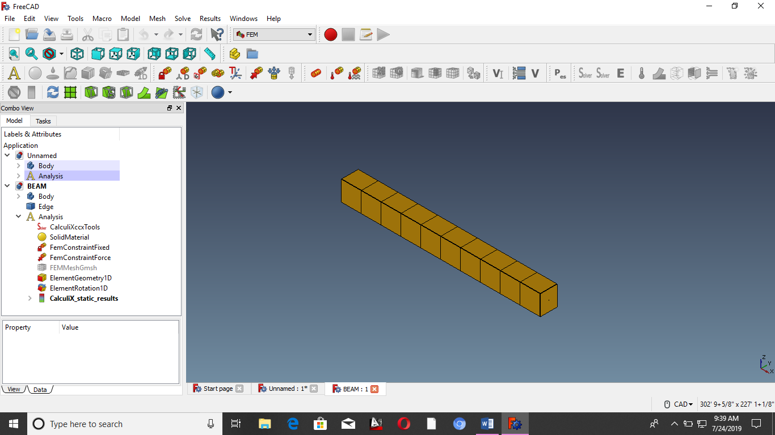

BEAM DEFLECTION

**LECTURE: 7**

**STEP 1**

* Arch work bench
* Edit> preference > draft
* Grid and snapping
* 1000mm Grid spacing

**STEP 2**

* Select wire > on grid snapping
* Press line 4 times to make 4 lines
* Vertically 3m ; Horizontally 4 m

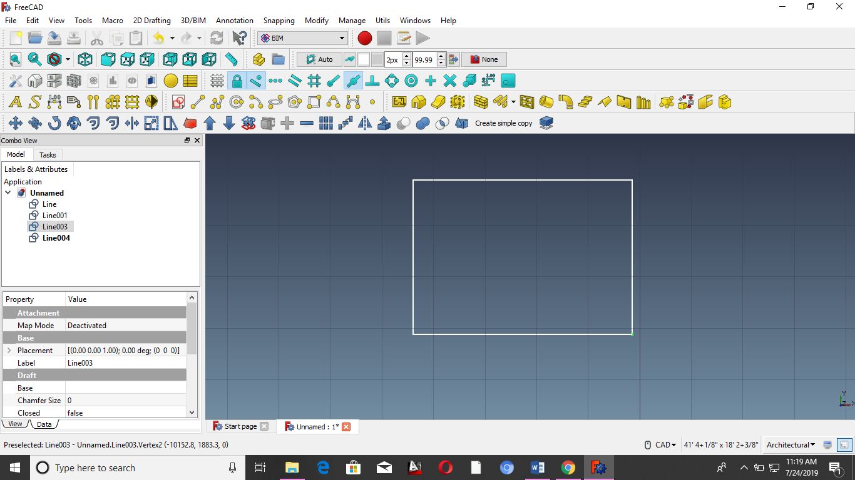

* Change the property of lines
* Make it face false
* Select all line and then press wall icon
* Again select walls and change its property to (Align)
* Select all wall and then press icon

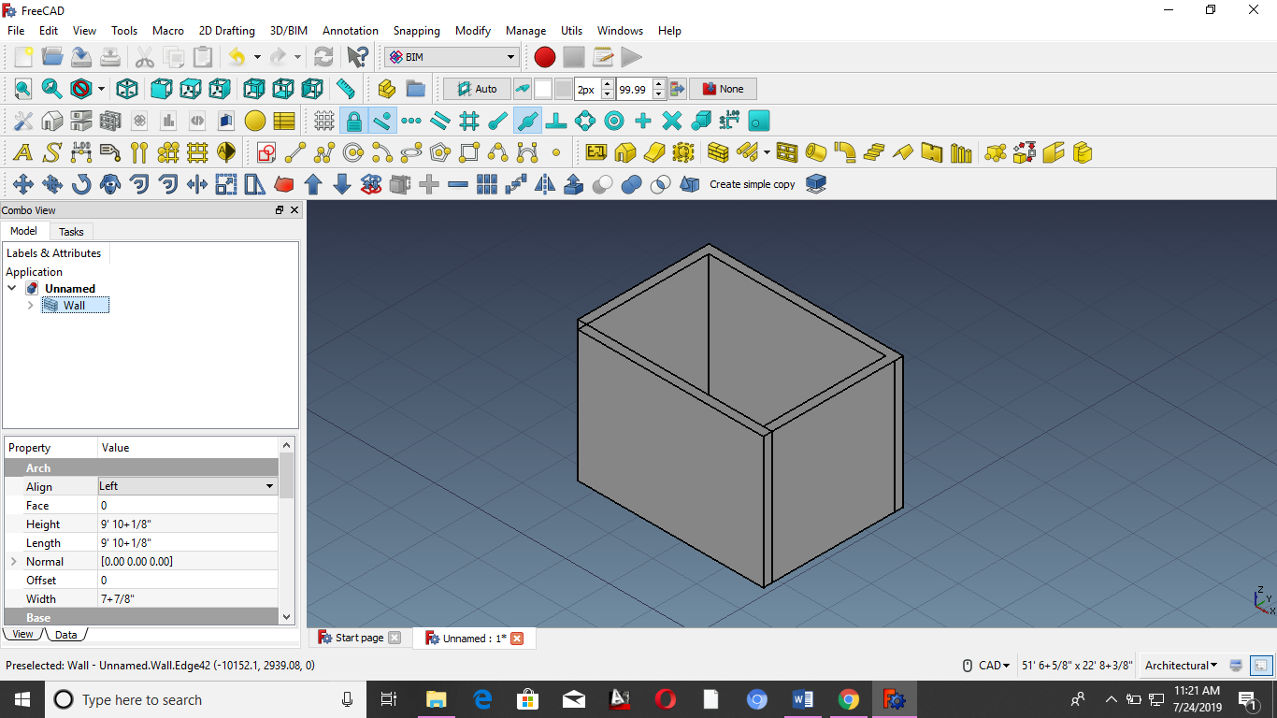

**STEP 3**

* Select the front face of wall
* Click on window icon 
* Task > give 900mm width , 2100mm height
* W2 (30mm) , W1 (100mm) , O2 (35mm) , O1 (50mm)
* On the nearest snap
* Select door
* Change the property of Door >base> placement> position
* Create window object > open two pane window
* Width (1000mm) , height (1000mm)
* H1 (100mm) , H2 (100mm) , W1 (100mm) , W2 (30mm) ,O1 (35mm) , O2 (35mm)
* Select window to change its position
* Base > placement > position x=600mm , y=0mm ,z=1100mm

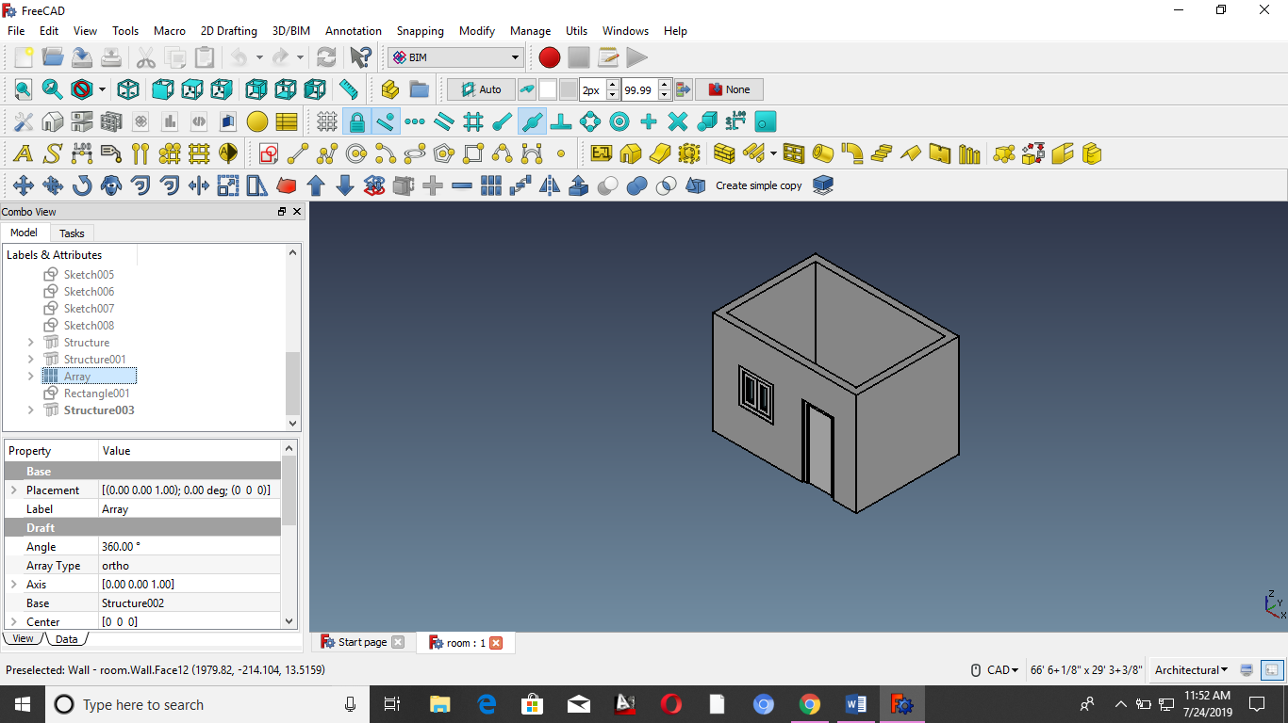

**STEP 4**

* Draw a rectangle and convert it into structure
* Change its properties
* Height ( 200mm )
* Normal (0 , 0 , -1)
* Ifc role > footing

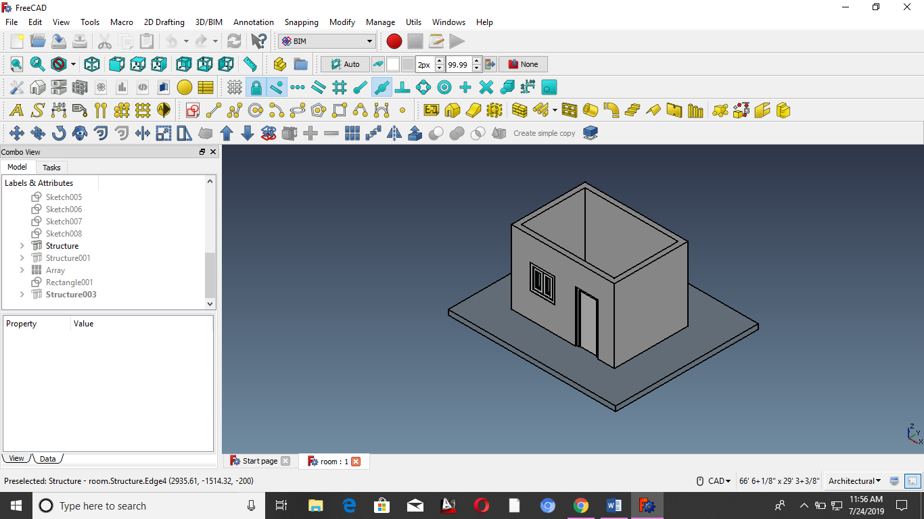

**STEP 5**

* Make a metallic beams
* Structure
* Task > category HEB > preset HEB 180 > height 4000mm
* Then change its properties according to the requirement
* Click on array > property > numbers (6)
* Interval x=764mm

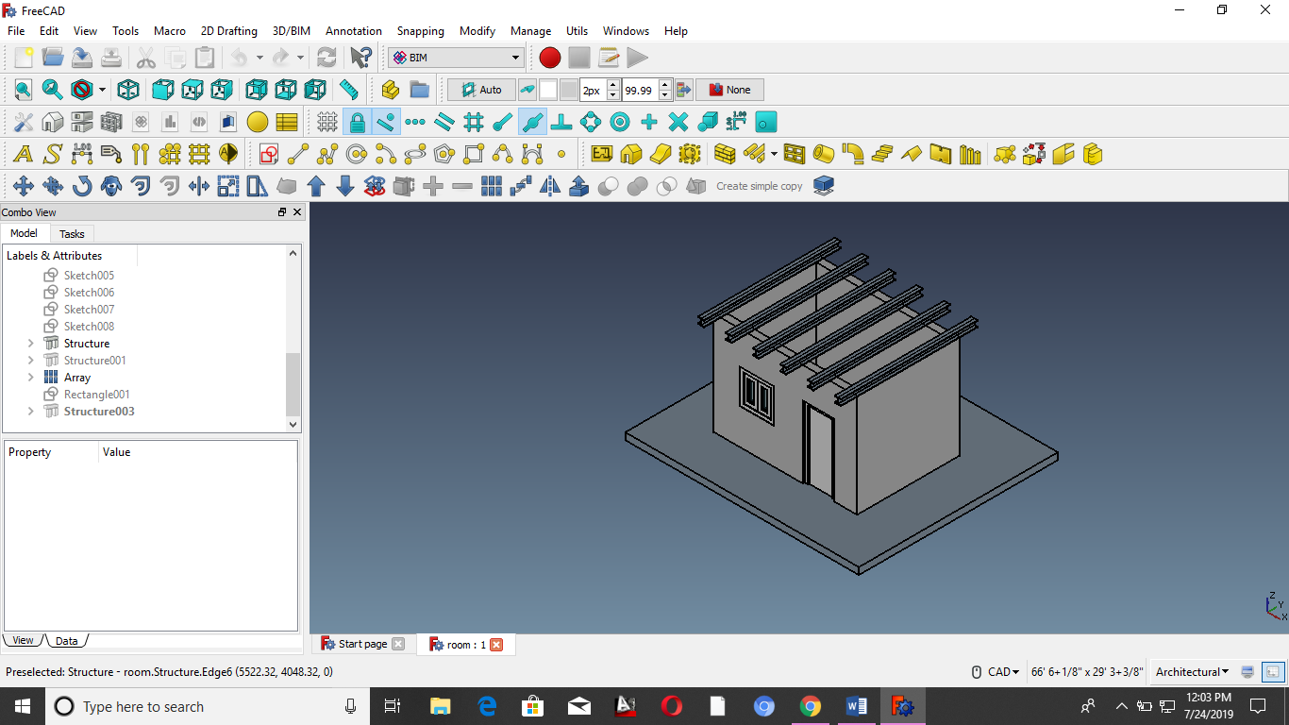

**STEP 6**

* Select the corner of girder and touch to the other end of girder
* Make a rectangle
* Convert it into slab
* Select the slab and change its property
* Height 200mm
* Role > slab

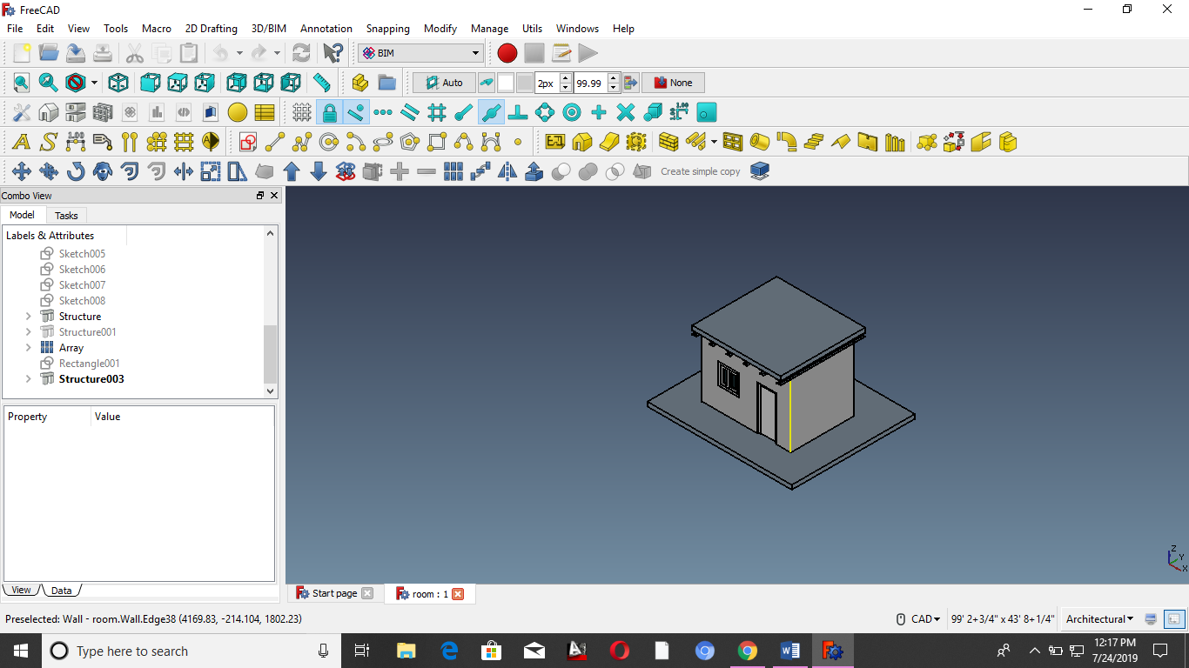

**Unit house**

**LECTURE 8**

**STEP 1**

* Arch work bench > new file > select rectangle
* Length of rectangle (10’) & Height of rectangle (10’)
* Make its structure than its height (3”)
* Make it face false
* Take an offset of rectangle (0.5’)
* Rename the structure 1 & 2
* Property > role > footing
* Make its face true
* Transparency (50%)

**STEP 2**

* Select the front face
* U shape rebar
* Task > orientation ( bottom)
* Front cover > default values
* Except dia ¾”
* Amount 12
* Select the side face
* U-shape rebar’s
* Task > orientation ( bottom )
* dia ¾”
* Amount 6
* All values >2.5”
* Select the front face
* U shape rebars
* Task > orientation ( top)
* Front cover > default values
* Except dia ¾”
* Amount 12
* Select the side face
* U-shape rebars
* Task > orientation (top )
* dia ¾”
* Amount 6
* Front cover = 3.25”
* Bottom cover= 3.25”
* Top cover =3.25”
* Fight side cover =2.5”
* Left side cover= 2.5”

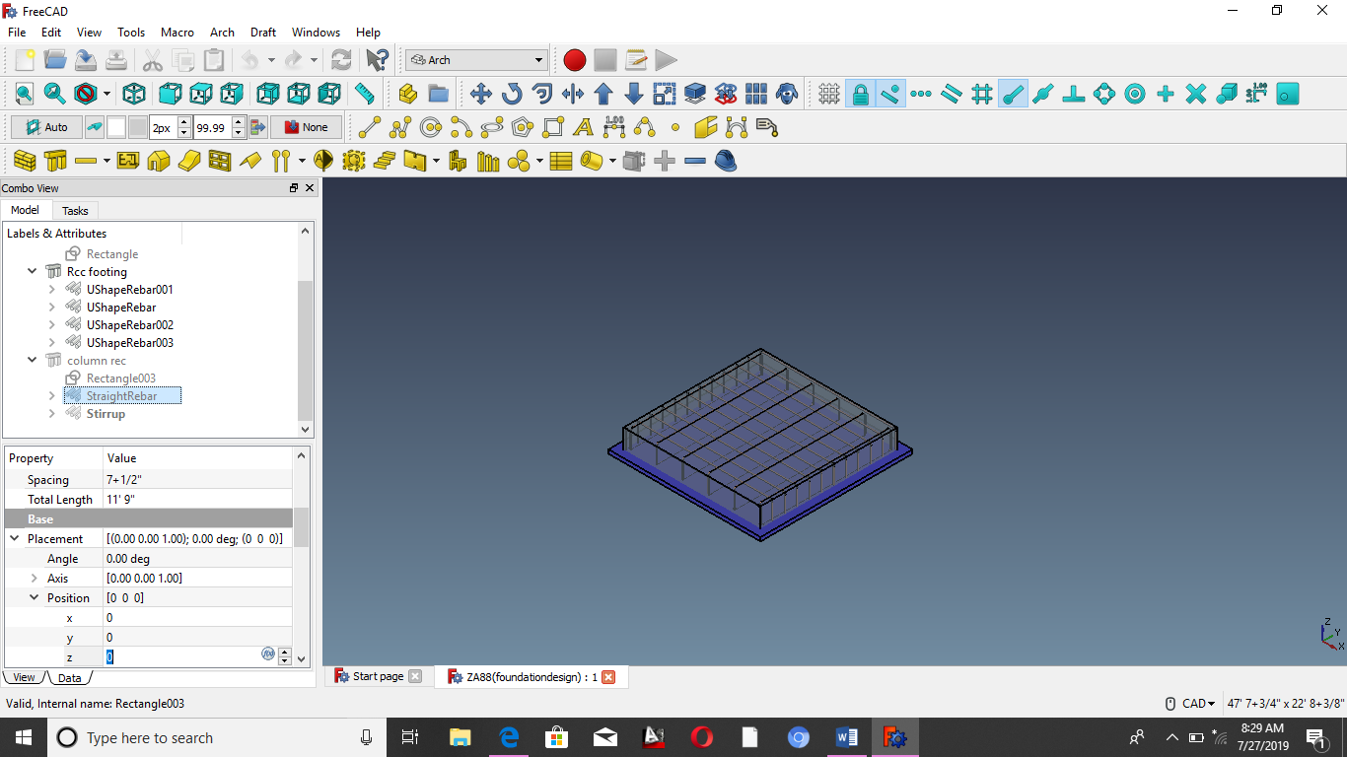

**FOR STIRRUPS**

* Select top face of column
* Select stirups
* Left cover = 1+3/4”
* And copy it in other option except front cover where 2+1/2”
* Bent factor cover =5
* Rounding =2
* Diameter=1/2”
* Pick the face>apply and then ok

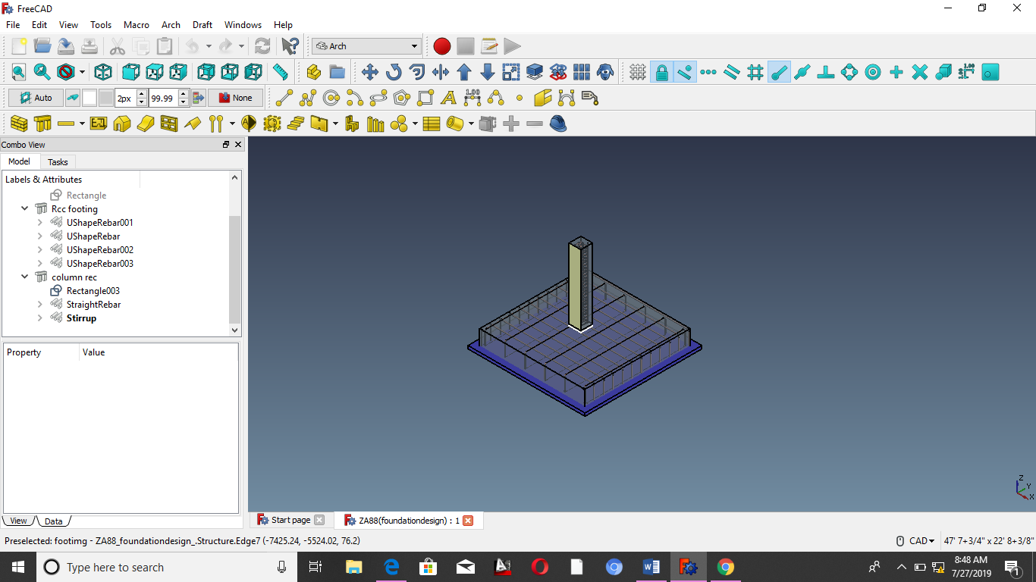

**CONCLUSION**

We have made PCC footing , RCC footing and column with having vertical parts and stirrups.

**LECTURE 9**

**MAKE A TRUSS**

* Open arch workbench
* On grid
* Front view
* Make horizontal lines
* Having length 3’
* Make vertical line > front elevation
* Axial members : which form triangle

**STEP 2**

* Select all lines
* Click on pipe icon
* Pipe diameter ½”
* Select all pipes =12’
* Go to front view
* Make two vertical lines
* Length = 12’
* These pipe diameter =1/2”

**STEP 3**

* Select all 14 pipes
* Array > pipe 001
* pipe no :x=1 ; y=4 ; z=1
* Pipe002 > Intervals > x= -3
* No : x=5

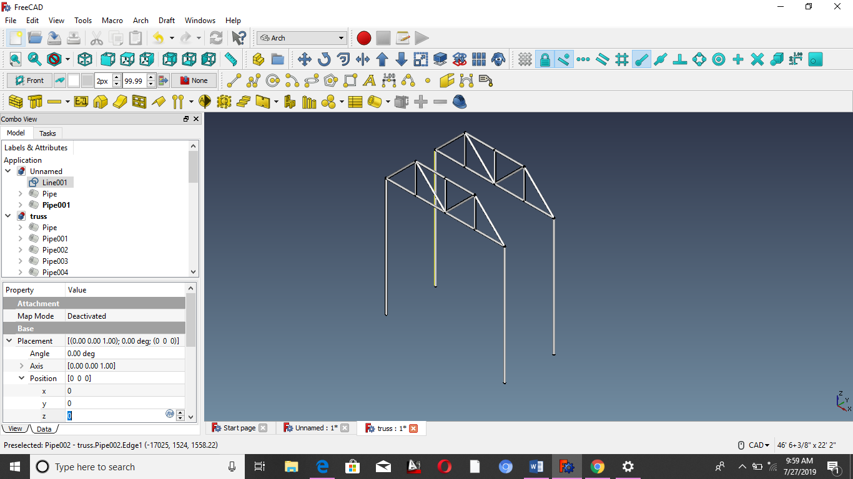

**LECTURE 10**

**SPREAD SHEET**

**Step 1**

First we have to make some object in freecad

For Example : let consider we have made a wall in freecad

**STEP 2**

So after making wall change the work bench to spread sheet work bench

**STEP 3**

Than press on the spread sheet icon to create a spread sheet

Double click on the spread sheet condition will open.

**STEP 4**

Let make a table for wall

|  |  |  |  |
| --- | --- | --- | --- |
| S.NO | Length | Height | Volume |
| 1 | Wall. Length | Wall. Height | Wall . volume |
|  |  |  |  |