
6/30/21

Name
Company name if applicacle
146 Indian Way
Stuart FL 34996

Hello,

My name is Mike Antheil. I hope you will pardon the direct letter, I am in the business of solar PV (electricity) and I saw on Google Sunroof that your roof is particularly suited for a solar installation. The reason I say this is because of the amount of non-gabled, nonshaded, south, east and west facing surfaces on your roof.

I am writing to you today because solar PV is a powerful investment which delivers compelling and reliable savings regardless of market uncertainty or stability.

Using open-source solar irradiance modeling, as you can see your roof reflects a significant amount of sunlight on an average day.

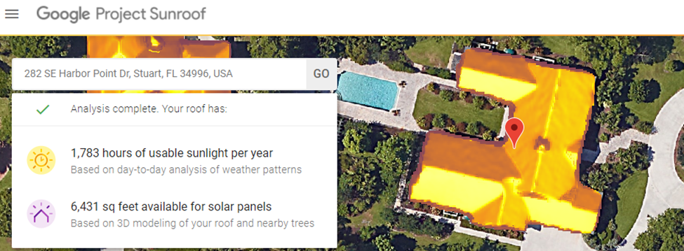
There is enough solar irradiance on your property to completely eliminate your power bill.

Contact us to generate a formal, custom proposal for your property at no cost.

In a nutshell, we would love to help you install a solar system on your home.

Solar power truly is an investment worth making. A few more important points about solar to consider are:
• An average return-on-investment (ROI) of 8 years on equipment that is warrantied to produce power for more than 25 years.
• It acts as a hedge against inflation and the rising cost of electricity.
• Solar is a well known and quantifiable offset of carbon emissions. Produce your own homegrown energy from the sun.
• A recent study by Zillow showed that a solar PV system increase the resale value of the home by an average of 4.6%.
• Battery backup systems can power your home during power outages and provide energy independence.
• A federal tax credit of 26% drops at the end of 2022.

Call us today or visit us online at www.SailfishSolar.com to find out about the feasibility of solar PV on your property. This letter is only meant to serve as an estimate of what is possible, please allow us to create a customized quote for your home based on all of your specific variables, consumptions habits and investment goals. Variables can include roof type, property shading, average utility bills, and plans for battery backup power.

We have been in the solar industry for 15 years, over which time we have developed solar projects, advanced solar policy and financed some of the largest solar systems in Florida. We are offering my solar expertise to friends and neighbors to help build solid, dependable solar projects in my hometown. It would be my honor to help you!

Mike Antheil
Sailfish Solar
772.678.6923 Office
561.703.4345 Mobile
mike@sailfishsolar.com

