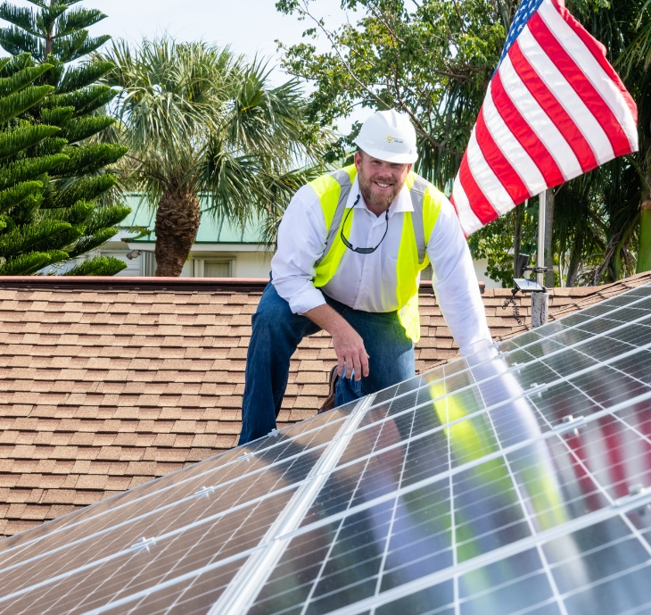
.

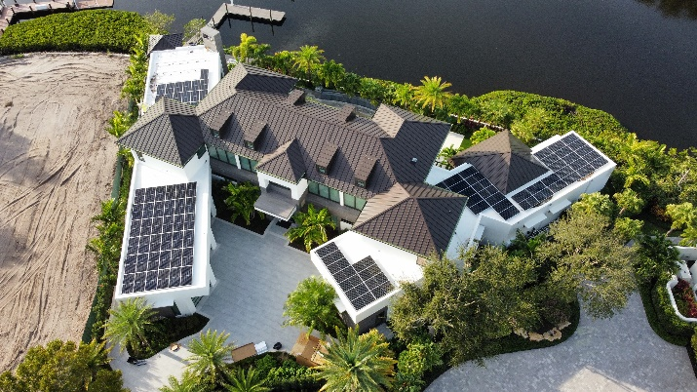

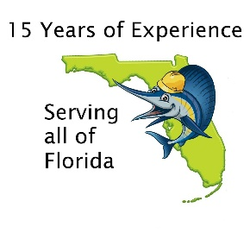
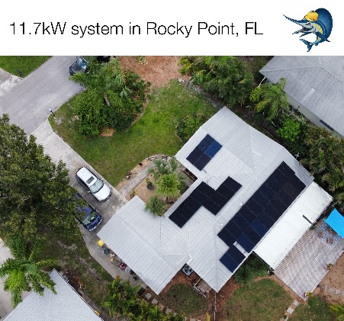
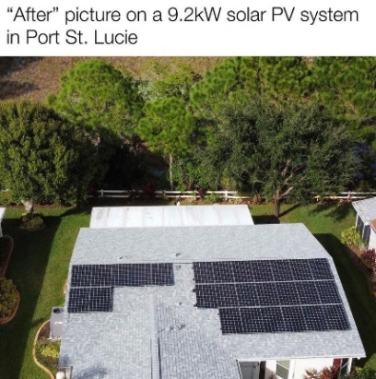
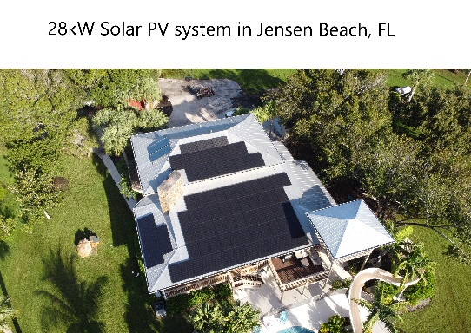


Call or email us today for a free estimate and consultation on the costs, considerations, and feasability of solar power for your home or business.

772.934.9091
Sales@SailfishSolar.com
www.SailfishSolar.com


Follow us online!
“Excellent! Very professional, they get the job done when they say they will, and it’s done right the 1st time. It’s good to see this kind of service still exists. Good leadership, and courtesy.”
– Carlos Hernandez

Financing Available
- $0 Down
- Payments can be lower than your current electricity bill
- Federal tax credit
How sunny is your rooftop??
Relying on his 15 years of experience in the solar industry, our principal, Mike Antheil expertly guides the solar design, installation and financing process from beginning to end. Mike has spent the past two decades financing renewable energy and energy efficiency projects all over the United States. Mike serves on several boards of Florida and US based non-profits dedicated to the responsible advancement of renewable energy in the United States and he has been a key leader in statewide initiatives to bring clean energy to scale in Florida.

cafe
- Superior returns - Solar PV systems carry an average return-on-investment (ROI) of 7.5 years on equipment that is warrantied to produce power for more than 25 years. That means that if you finish paying for your system in 8 years, you will have at least 17 years of completely free electricity from your system.
- Powerful hedge - Solar electricity can act as a hedge against not only the rising cost of electricity, but also a hedge against inflation. In a normal economy, the cost of electricity will rise 2-5% a year, while the levelized cost of your solar system will stay the same. In an economy where any sort of inflation is taking place, if the strength of the dollar were to weaken, the value of the system will become greater.
- Resale Value - A recent study by Zillow showed that a solar PV system increases the resale value of a home in Florida by an average of 4.6%. That is a huge increase that could be between 15k and 18k on an average fl home.
- Federal Tax Credit - A federal tax credit of 30% expires at the end of 2032. 30% is a significant offset of the upfront cost of a solar system. This is a credit, not a deduction, meaning it comes off of the bottom of what you owe on your taxes, not off the top.
- Reliable backup power - Battery backup systems can power your home during power outages and provide energy independence. Although there is not a specific ROI for batteries, having reliable power during a power outage can sometimes be invaluable.
- Carbon offsets - Reliable backup power Solar is a well known and quantifiable offset of carbon emissions. You can lock in monthly carbon offsets with your own homegrown solar power.
- Easy access - Financing is widely available, giving homeowners access to solar right away.

7 Key Considerations about Solar PV (Electricity)

