Meadows Hospital Auxiliary, Vidalia

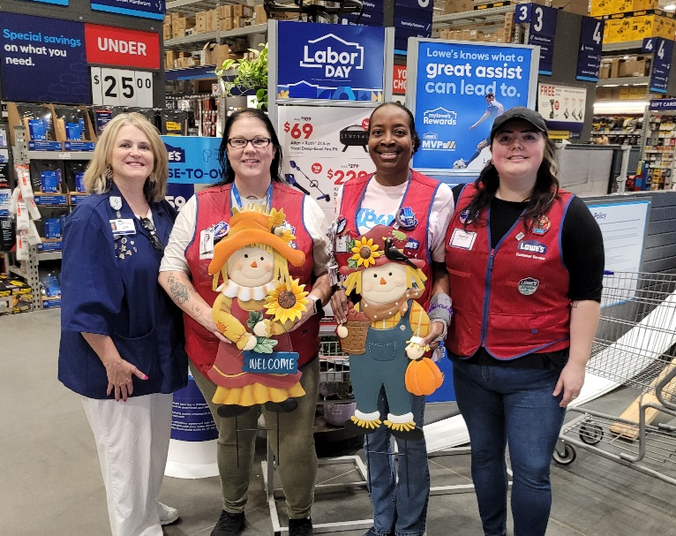
Lisa Parker, Jo Hall , Lisa Whitehead, and Kenna Cheney
Meadows Hospital Auxiliary is gearing up for our annual conference. Lowes of Vidalia has donated a set of yard art figures for the Silent Auction. Get ready to make a bid!

