"Message from President-Elect Willie Robinson". 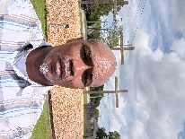
"It's with great honor and humility that I write this message to you. At this point in my life, I can say with absolute certainty that volunteering is my true calling from the Almighty God. When I'm volunteering, I feel that I'm doing my best service. When I'm not volunteering, I'm thinking about how good it will be bringing joy to someone's life. As I reflect on the 10+ years that I've been volunteering the one thing I truly feel remained the same is that it's better to serve than to be served. Also, it's not the position you're serving in but the quality of the service you provide to individuals. As President-Elect I plan to continue to provide quality service. As fellow volunteers, you might feel the same way about serving. As I see you volunteering in the hospitals, it tells me that you're enjoying it. Lastly, I would like to thank everyone who made this possible for me, and I promise that you will not be disappointed. I appreciate your trust and support."
Warms Regards,
Willie Robinson, COVS President-Elect 2023-2024

