Message from the President 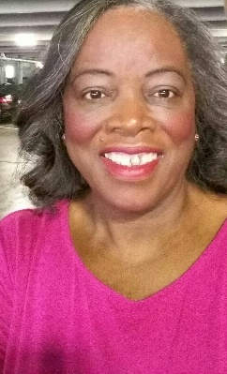
Ida Byrd

Greeting to all volunteers in our hospital across this beautiful state of Georgia, thank you for your service and hard work at your prospective hospital. I know all of you have put in a lot of hard work and time at your hospital planning your spring district meeting and achieving your goals. As I attended each district meeting, every meeting was different and exceptional, great take-aways from each meeting, great speakers, games, and different activities. The food was superb and tasty. I want to take this time to give a big shout out to all the district directors and your committee for a job well done.

A Big shout to all of the executive board members, board of management committee chairs and District Directors making your way out each quarter to the BOM meeting. Some of you have to deal with different things to get there but you manage to push through and make it. So that's why you are a ray of sunshine, you always shine through even in the toughest time, so continue to be that ray of sunshine in your hospitals and your community. Again, thanks for your services.

Ida Byrd
COVS President 2023-2024

