COVS CONFERENCE COMING SOON!!! October 21-22, 2024
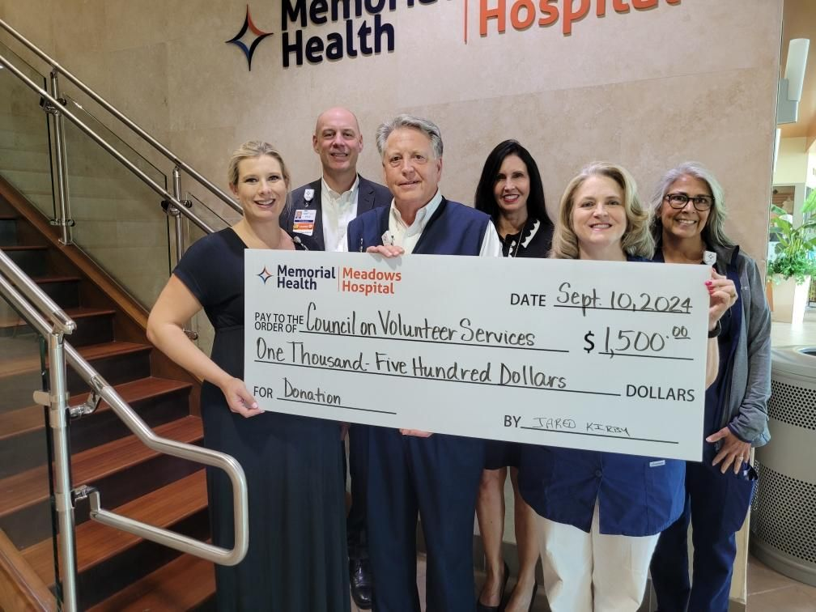
Memorial Health Meadows Hospital, Vidalia, GA
Hillary Moore- Vice-President Human Resources and Director of Volunteer Services
Donald Parker- SE District Director/President Meadows Hospital Auxiliary
Lisa Parker-SE District Director/Treasurer Meadows Hospital Auxiliary
Mike Hagan-Vice-President Operations
Sandra Kate Ellington-Ethics & Compliance Officer
Kris Cuthair-Chief Nursing Officer

HCA (Memorial Health Meadows Hospital in VIdalia and Memorial Satilla Health in Waycross have) has joined together to become a GOLD SPONSOR for this year's annual Council on Volunteer Services Georgia Health Care Conference being held in Macon in October. Hospital volunteers come together from across the state to learn new trends in the healthcare industry, share innovative ideas to better serve the patients and employees in their local hospitals, and to renew friendships through fellowship. This annual conference is a time for all volunteers who serve selflessly to be renewed, refreshed, and reunited in their common mission of strengthening their communities through service. HCA values their volunteers and the services they help to provide to carry out their commitment to the care and improvement of human life as evidenced by their support of this year's conference.

