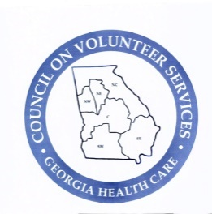
Council on Volunteer Services
Georgia Health Care
2024-2025

“Volunteers make a sweet path of hope.”
District Directors

Northeast
(Until District Directors are elected for Northeast District, you may contact Liz Eckenfels, President-Elect, for information. Her contact information is:
Liz Eckenfels
4367 Claresbrook Lane
Acworth, GA 30101
678-463-8232
liz.covsga@gmail.com
WellStar Kennestone Hospital
Northwest
(Kevin Miller has resigned. If you need assistance, you may contact Liz Eckenfels, President-Elect, for information. Her contact information is:
Liz Eckenfels
4367 Claresbrook Lane
Acworth, GA 30101
678-463-8232
liz.covsga@gmail.com
WellStar Kennestone Hospital
Southeast
Lisa Parker Donald Parker
108 Redwood Drive 108 Redwood Drive
Vidalia, GA 30474 Vidalia, GA 30474
912-293-7951 912-293-2472
parkerlisa1963@gmail.com parkerdonald1957@gmail.com
Meadows Health Meadows Health
Southwest
Laura Brooks Donna Lee
202 South Green Street 168 Country Lane
Doerun, GA 31744 Moultrie, GA 31768
405-287-4821 229-291-7159
lrbrks5@gmail.com lady1100honda@yahoo.com
Colquitt Regional Medical Center Colquitt Regional Medical Center

