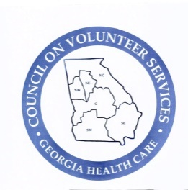
Council on Volunteer Services
Georgia Health Care
2024-2025

Volunteers make a sweet path of hope.”

Board of Management Nominating Committee

Ida Byrd
Past President/Nominating Committee Chair
MedicaTanner Medicall Center
Northwest District

Liz Eckenfels
President Elect
WellStar Kennestone Hospital
Northwest District

Northeast District
To be named

Northwest District
To be named

Southeast District
Beth Lewis
Meadows Hospital Memorial Health

Southwest District
To be named

