How Kids SHOULD NOT interact with dogs Fact Sheet
It’s common sense. Just imagine how people should interact with each other
Reason 1: For instance, most people dislike it when others stick their grimy hands in their meal. Similarly, dogs want to eat in peace.
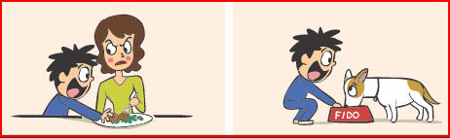
Reason 2: We teach children that it’s clearly wrong to steal toys from each other. It’s also rude to steal toys from the dog. Kids should be taught to leave Fido’s toys alone.
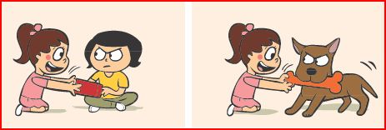
Reason 3: Kids frequently can’t help but get in your face. They often have to be trained to maintain the appropriate social distance. Similarly, putting your face into a dog’s face, even if it’s all in the family, can be irritating to the dog, especially when the dog has no control over the child’s behavior.
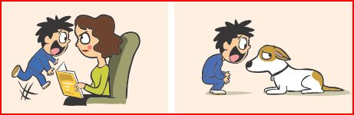
Reason 4: Most people dislike being disturbed when they are resting or sleeping. But fortunately for us humans, we can often close or lock our bedroom door. Similarly, dogs need a safe location where they can be away from kids and excitement. Kids should avoid bugging them in their “private” location or any time they are sleeping or resting. If they call the dog from far away and the dog chooses to get up and come over to the child, this type of interaction is okay. But if the dog chooses to be left alone, he should be.
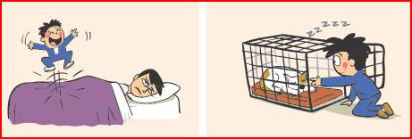
Reason 5: Kids dislike being handled roughly, and so do dogs. Dogs can be trained to tolerate or sometimes even enjoy this handling, so that they are not reactive when an accident occurs but in general children should be taught to be polite and gentle with dogs
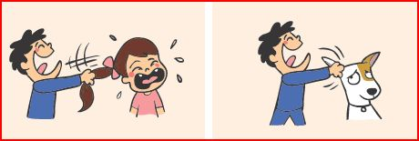
Reason 6: It’s rude to climb on, step on, or otherwise invade someone’s personal space. It’s also rude to do the same things with dogs.
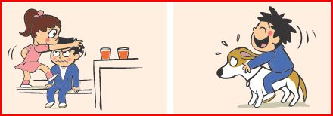
Reason 7: Loud screaming can frazzle humans, imagine its effect on the more sound-sensitive dog!
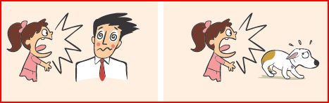
Reason 8: We often forget that even some friendly gestures, such as pinching a child’s cheeks, may be irritating. In general, dogs dislike being hugged, even by family members. You can tell by the expression on their face. It’s important for children to know the types of interactions their pet likes and also to realise that other dogs may not have the same tolerance as their dog does.
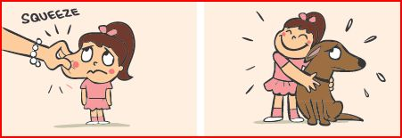

Types of Child-Dog Interactions That are Appropriate
With all of these DON’Ts, it must seem like kids can’t interact with pets at all. In reality, they just need to be taught to be polite and kind to pets, instead of treating their companion like he’s stuffed animal. Parents should also teach their children to read the signs that Fido is fearful or anxious, so that the child knows to back-off.
Once the children understand that they should be kind to their pet, they can be taught appropriate games to play. For instance, fetch where the dog willingly gives the toy and remains polite before it’s tossed is fun for dogs who love to retrieve. Kids and pets love to learn tricks that result in rewards such as yummy treats or bits of the dog’s meal/kibble.
All dogs need their exercise, and kids can be a part of this too if the dog is well-trained. Hide-n-seek is a great way for dogs to learn to have fun, and the dog is practicing his search and rescue skills.
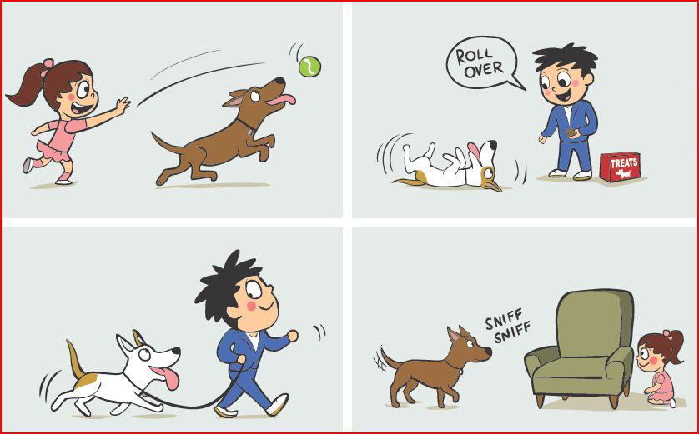
Even if the child is generally well-behaved and the dog very tolerant, it’s essential for all interactions to be supervised. Accidents can happen in a split second.
