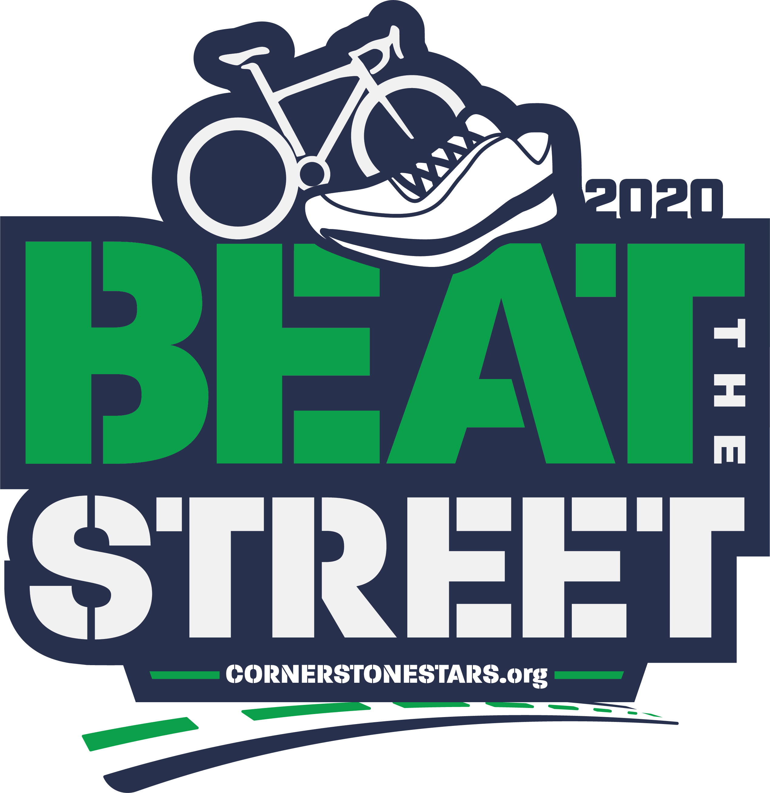

Half Marathon, 10K, 5K Run, 1M Fun Run,
30 mile, 50 mile & 70 mile Bike Tour
May 2, 2020
4th & Elm Church Parking Lot

Platinum Level Sponsorship- $5,000
- Large logo at top of all advertisements (2 spots available)
- Business featured at fiesta dinner table & 6 tickets
Gold Level Sponsorship - $1,000
- Logo on t-shirt and cinch sack
Business featured at fiesta dinner table & 4 tickets
- Logo on window posters, signs, and banners
Silver Level Sponsorship - $500
- Smaller logo on t-shirt and cinch sacks
- 2 Tickets to fiesta dinner
- Smaller logo on banner
Bronze Level Sponsorship - $250
- Name of business or individual listed on t-shirt and cinch sack
- 2 tickets to dinner
- Name listed on banner

*All sponsorship levels will have the opportunity to put advertisements in cinch sacks
(business cards, brochure, coupon, pen, magnet, etc.)
* All sponsorship levels will be given a booth/table on day of race if desired and requested

Yes! Our business would like to be a sponsor for the 8th annual Beat the Street for Little Feet Half Marathon, 10K , 5K , 1 mile Fun Run, 30, 50 and 70 mile bike tours!

We DO_________ want to have a booth or table on race day.
We DO NOT______ want to have a booth or table on race day.

I understand that I will have a check (amount listed below based on your level of sponsorship) made out to Cornerstone Christian School, along with a business card/logo by my chosen date. Signature______________________________
This will ensure that your logo or name is listed on the banners, posters, t-shirts and advertisements correctly. We can pick up the donation or you can mail it to:
Cornerstone Christian School
P.O. Box 917
Sweetwater, TX 79556
Once your check is received, you will receive a letter of receipt for a donation to our 501(c)(3) organization. Thank you for your support! We are striving for this to be an event that everyone looks forward to each year.

Please check your sponsorship level and preferred date of donation check:
_________ Platinum ($5,000)
_________ Gold ($1,000)
_________ Silver ($500)
_________ Bronze ($250)

_________This month
_________ December 1st
_________February 1st
_________March 28th

Business Name ______________________________________
Signature _____________________________________________
Title of your position ________________________________
Date ___________________________________________________

