**AECT 2500HD COMPRESSED EARTH BLOCK MACHINE WITH HOPPER**

**Machine Specifications and Production Limits**

**Weight: 4000** pounds (2500 Heavy Duty)

**Dimensions: 133** in. long (with ball hitch) or **131** in. long (with a Pental hitch) x **81** in. wide x **109** in. high when Hopper is open, and **85** in. high when hopper is closed. (**332.74** cm. long (Pental) x **205.74** cm. wide x **276.86** cm. high w/ hopper open **215.9** cm.closed.) Road clearance approximately **12** inches (**30.5** cm)

**Power Source:** 22 HP -3 Cylinder Yanmar Water Cooled Diesel Engine

**Hydraulic System Volume:** Worldwide hydraulics, 50-gallon tank capacity, Beta rated filtration system

With oil cooler.

**Hopper Capacity:** 85 - 105 Blocks (depending on block thickness), one yard of soil

**Block Production Rate:** Approximately 480 blocks per hour. Soil only blocks ejected by the machine are immediately ready to place in the wall or to stack on pallets for temporary storage. Cement or Lime stabilized blocks must be cured as per normal curing method.

**Block Sizes:** Typical block size is 6” (15 cm) X 12” (30.5 cm) X 2.0 to 4.5” (5.0 cm to 11.5 cm) thick and weigh between 9-18 pounds (4.1 Kg t0 8.1 Kg) depending on the soil and block thickness. Soil only blocks are bonded together using the wet thin soil slurry or other conventional methods. The soil slurry is made with only water and screened soil. Blocks can also be placed in the wall using the traditional thick mud mortar method.

**Features:**  and EC compliant. Replaceable Tray contact wear plates, Replaceable Breech liners, 5 foot removable gravity roller conveyor and stand are standard.

**Warranty Requirements:** We require 2 days for training 1- 4 people.

On the Machine, Soil Selection, Site Management and Product Safety to

Validate the Warranty.

**Trailer Characteristics:** Can be towed at legal highway speeds by interchangeable 2” ball

hitch or by Pental hitch by a ½ ton truck. This includes electric brake

and USA lighting package.

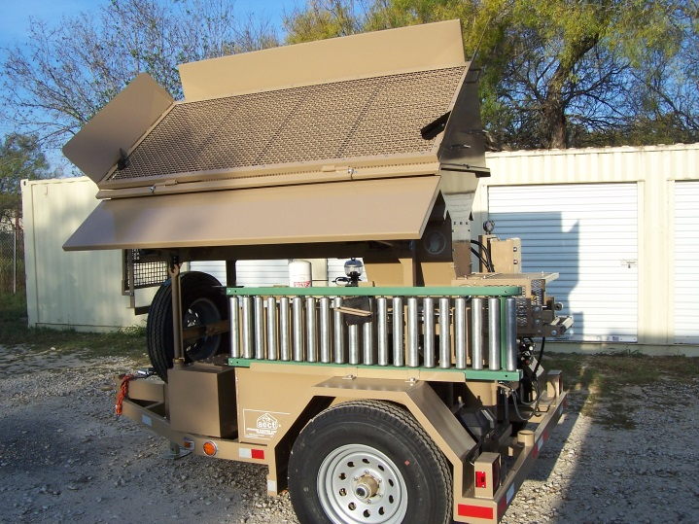 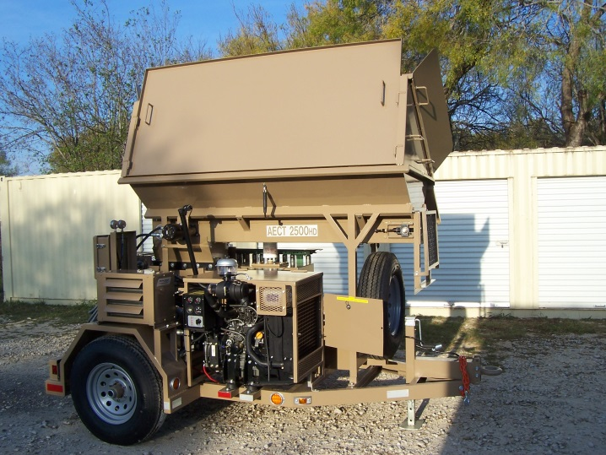

*ADVANCED EARTHEN CONSTRUCTION TECHNOLOGIES, INC.*

11595 Highway 181 South, San Antonio, Texas 78223

Phone: 210-400-9831 Fax: 210-633-3231

e-mail: ryan@AECTearthblock.com website: www.aectearthblock.com