**AECT 2001A COMPRESSED EARTH BLOCK MACHINE**

**Machine Specifications and Production Limits**

**Weight:** 1640 pounds

**Dimensions:** 81 in. long by 68 in. wide by 51 in. high

206 cm. long by 142.2 cm. wide by 130 cm. high

Road clearance approximately 6 inches (15 cm)

**Power Source:** 7.0 HPYanmar diesel engine

**Hydraulic System Volume:** Worldwide hydraulics, 19.5-gallon tank capacity, Beta rated filtration system

**Hopper Capacity:** 8 – 9 Blocks, can be loaded by hand with shovels or buckets

**Block Production Rate:** Approximately 300 blocks per hour or 2400 per 8 hour day. Blocks ejected by the machine are immediately ready to place in the wall or to stack on pallets for temporary storage

**Block Sizes:** Typical block size is 6” (15 cm) X 12” (30.5 cm) X 2.0 to 4.5” (5.0 cm to 11.5 cm) thick and weigh between 9-18 pounds (4.1 Kg t0 8.1 Kg) depending on the soil and block thickness. Blocks are bonded together using the wet thin soil slurry or other conventional methods. The soil slurry is made with only water and screened soil. Blocks can also be placed in the wall using the traditional thick mud mortar method.

**Features:**  and EC compliant. Replaceable Tray contact wear plates, Replaceable Breech liners, 5 foot removable gravity roller conveyor and stand are standard

**Warranty Requirements:** We require 2 days for training 1- 4 people.

On the machine, soil selection, site management and Product Safety to

Validate the Warranty.

**Trailer Characteristics:** Can be towed at 60 mph by 2” ball hitch by compact car or truck. Machine can be moved easily by hand on site. Removable brake lights and turn signals setup for connecting towing vehicle to machine. Optional hitches available for an additional charge by ordering before manufacturing begins.

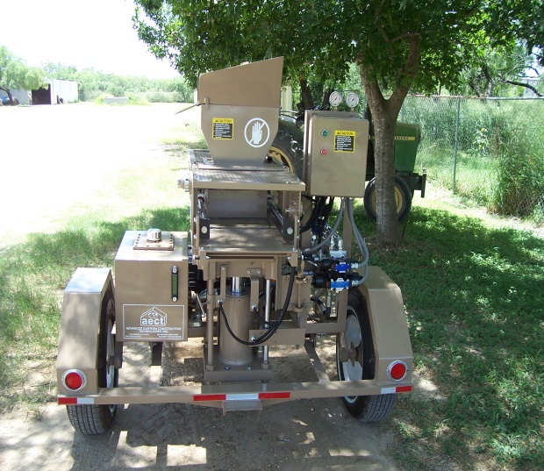 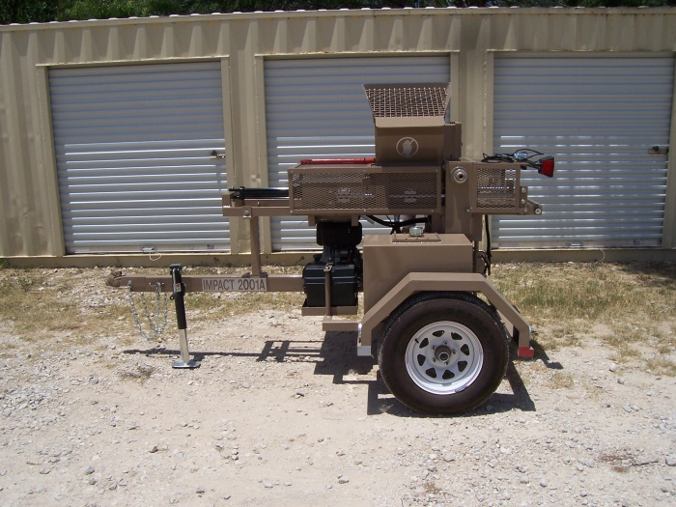

*Advanced Earthen Construction Technologies, Inc.*

11595 Highway 181 South, San Antonio, Texas 78223

Phone: 210-400-9831 Fax: 210-633-3231

e-mail: ryan@aecteartblock.com website: www.AECTearthblock.com