**AECT 3500 COMPRESSED EARTH BLOCK MACHINE**

**Machine Specifications and Production Limits**

**Weight:** 5200 lbs. with fuel and hydraulic tanks full

**Dimensions:** 7.38 ft. wide by 13.67 ft. long by 8.92 ft. high (operational height)

2.25 m. wide by 4.17 m. long by 2.72 m. high

Travel height – 6.83 ft. (2.08m high)

**Power Source:** Yanmar liquid cooled diesel engine with Murphy oil and water safety switches

**Fuel Consumption:** 1.5 gallons per hour

**Hydraulic System Volume:** Worldwide hydraulics, 40 gallons capacity, Beta rated filtration system

**Air to Oil Cooler:** Operating ambient temperature range +28°F to +110°F.

**Automated Controls:**  Omron Industrial Programmable Controller in a NEMA 12 box, all Solid State

**Ram Press Force:** 2900 psi available, average applied pressure for 10 x 14 inch block is 1100 psi

**Block Production Rate:** 480 blocks per hour for average 3½ inch thick block

**Block sizes:** Typical block size is normally 10” x 14” x 3.5” (25.4 cm x 35.6 cm x 8.89 cm); interior wall blocks typically 7” x 14” x 3.5” (17.8 cm x 35.6 cm x 8.89 cm); 8” x 14” x 3.5” size plates are optional with an additional charge; machine makes blocks for walls of 7”, 8”, 10”, or 14” thickness; block thickness is variable from 2 to 4.5”

**Features:**  and EC compliant. Replaceable Tray contact wear plates, Replaceable Breech liners, 10 ft. conveyor and stand are standard equipment.

**Trailer Characteristics:** 6000 lb. axle with hydraulic/surge brakes normal USA lighting package, may be towed at legal highway speed or as road conditions dictates, Pental/Lunette hitch standard. Optional hitches available for an additional charge by ordering before manufacturing begins.

**Recommended Daily**

**Maintenance Schedule:** 45 minutes daily; recommended maintenance schedule available

**Periodic Engine Maintenance:** As recommended by the engine manufacturer

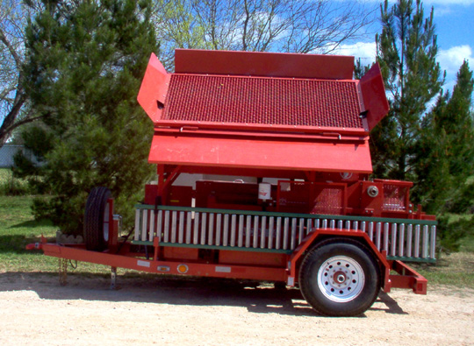 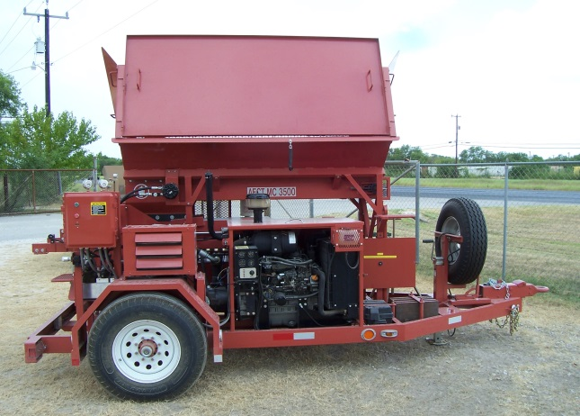

*A E CT*

11595 Highway 181 South, San Antonio, Texas 78223 Phone: 210-400-9831 Fax: 210-633-3231

E-mail: ryan@AECTearthblock.com website: www.AECTearthblock.com