THANK YOU FOR SIGNING UP FOR K-9 Defense and Foothills Canine Academy-Dog Reactivity Workshop!
Please return via email as soon as possible to crystal@k9defense.com, and no later than December 1st.
Dog Aggression and Reactivity Workshop Questionnaire
- Dog Name?
- Breed?
- Age?
- Gender?
- Spay or Neutered?
- What food does your dog eat? (Include treats and scraps.)

- Look at the images below and compare them to your dog. Which is closest to your dog (Left, Center, Right)?
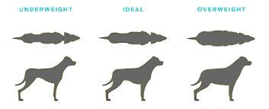
- What type of equipment do you use with your dog? (Nylon flat collar? Choke Chain? Prong? Harness? Face Harness? Nylon Leash? Retractable Leash? Electric Collar? Bark Collar? Etc.)

- How do you reward your dog?

- Do you have other pets in the household? If so, please list the number and type.

- On a scale of 1-5 (with 5 being extremely severe), how severe would you consider your dog’s reactivity?
1 2 3 4 5
- Is your dog reactive to people or dogs or both?

- Do you know what triggers your dog’s reactivity? If yes, please explain.

- How often do you see your dog respond in a reactive way?

Page 1 of 2

Dog Name: _________________________________

- How do you respond when your dog is reactive? (If you are on a walk, do you pull on the leash? Yell? Change directions? Wait for the other dog to pass? Or something else?)

- Please give us a brief example of your dog’s reactivity.

- Has your dog ever bitten anyone?
- If so, was it a bite and release or did the dog hold on?
- Please explain the situation in a few sentences:

Please list anything else you feel might be important for our trainers to know before the workshop:

Page 2 of 2

