Cordova village SPRING 2019 newsletter
Spring is finally here! Summer is approaching fast…Please remember to watch for children and remind them to look before crossing streets.

Golf cart inspection REMINDER—MAY 4th
Spring Clean-Up Dates:
Dumpsters will be here on May 3rd thru May 5th.
Dumpsters will be located at the Civic Center.
NO E-WASTE THIS TIME
Cordova Day Celebration is July 13th. Mark your calendars. More info to follow.

FLUSHING HYDRANTS
May 13th thru May 15th
If your water is discolored, run your faucet for 5-10 minutes.
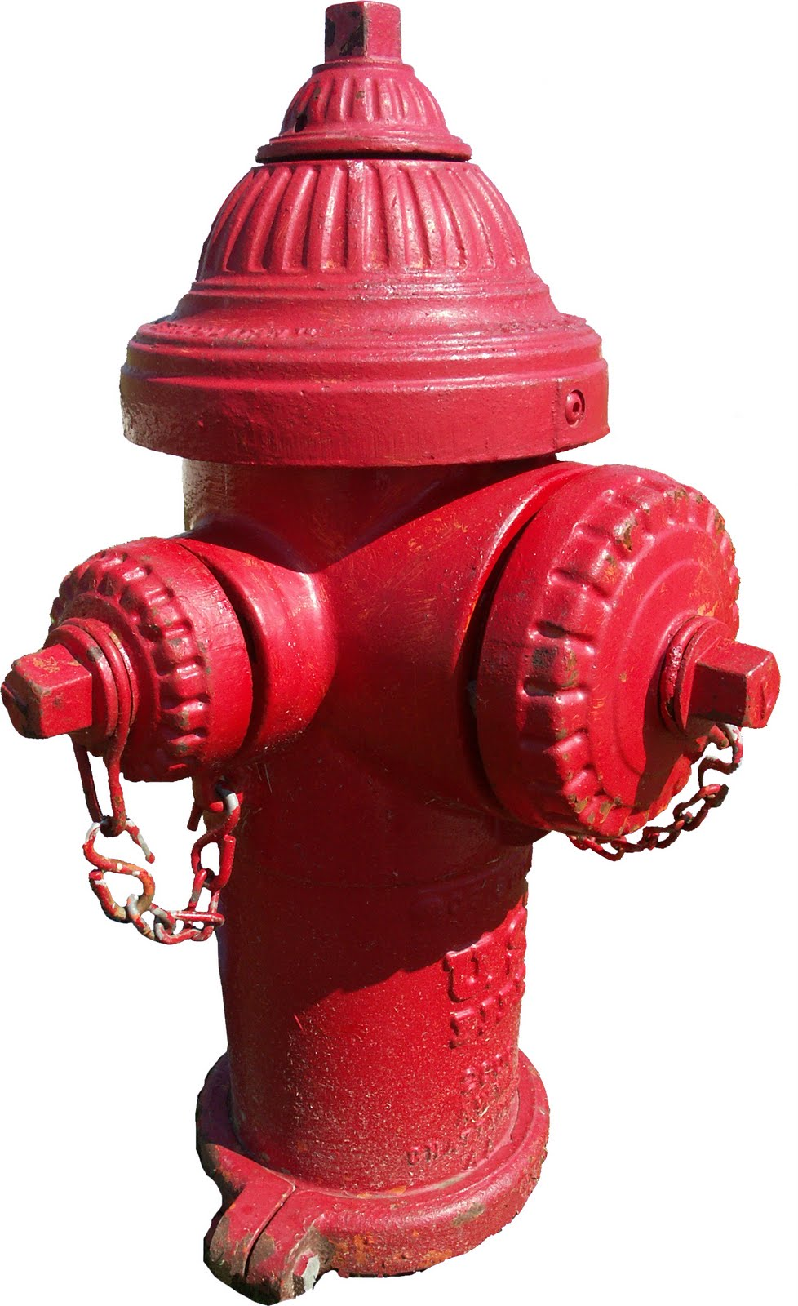

On Saturday, May 4th, golf carts will be inspected at the Village Hall from 8:00 a.m. till noon. Please bring a photocopy of golf cart insurance card with you to the inspection. Any golf carts driven on roads must be inspected. Must be at least 18 years of age to drive. Per Ordinance 2009-15, golf carts are not able to cross Hwy 84 due to Cordova not having a designated crossing point. Cost of inspection is $25.00 due that day. Rain Date is May 11th.
Please contact Dave Rogers at (309)654-2151 if you have questions.
River’s Edge Park Information
This Park is a first come first serve park. However, if you are wanting to reserve the inside of the pavilion you will need to call the Village Hall at (309)654-2646.
There is a $25.00 fee to rent the inside of the Pavilion. This fee will be refunded after the Pavilion is cleaned and inspected. Someone from the Board will unlock the facility for you. You will not receive a refund if the Pavilion is not clean.

SPRING GARAGE SALES 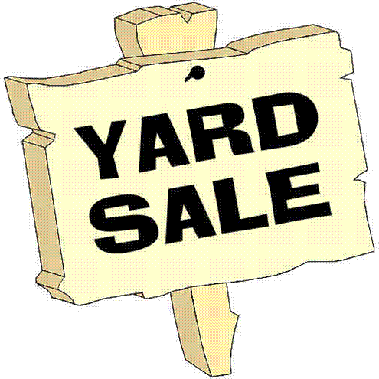
June 14 & 15
Sign up at Library to get on Map.

EMAIL COMMUNITY ALERTS
A reminder that the Village can NO LONGER send out free text message alerts through Nixle. We can send out free email community alerts but you need to sign up on your own. Directions for signing up are as follows:
- Go to Nixle.com
- Resident Login (at top right)
- Receive Alerts from your Local Agencies. Click Sign up (in green)
- Enter your email
- Create a password
- Enter Full Name
- Mobile Phone
- Click “I Accept. Sign Me Up.”
- Enter Home Address
- City
- State Zip
- Hit Continue
After signing up, you will receive a notification you are signed up. It will say you will receive texts and emails, but you will just get the free emails.
Village of Cordova
PO Box 6
Cordova IL 61242

