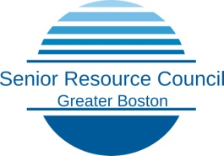

APPLICATION FOR 1 HOUR CONSULT

The SRC makes itself available for a 1-hour consultation with sandwich Generation Professionals who are looking to create a care team for their loved one. The goal for you should be to create a team that will take care of the health and cognitive needs of your loved one(s) so you can support them with love while also still maintaining your family and pursuing a career. Due to limited capacity, an application is required so we can best serve those that need our help the most. Please fill out the following and then return it to us. All shared information is treated confidentially.

Requestor Name and Contact Info

**Your Name: Phone #: Email:**

**Your Loved One’s name, age and marital status:**

**Your relationship to your loved one:**

**Other key people involved with your loved one and relationship:**

**Who is the primary caretaker?**

Current Situation for your Loved One

**Living situation:**

**Financial Situation:**

**Physical Health:**

**Cognitive Abilities:**

Future Scenario for you and your Loved One

**Considering the above categories, please describe an ideal situation for them and you. In other words, what do you want to see happen in the future for your loved one:**

**What would be an ideal situation for you and your family and career while taking care of your loved one:**

Please send this completed form to : [srcgreaterboston@gmail.com](mailto:srcgreaterboston@gmail.com)