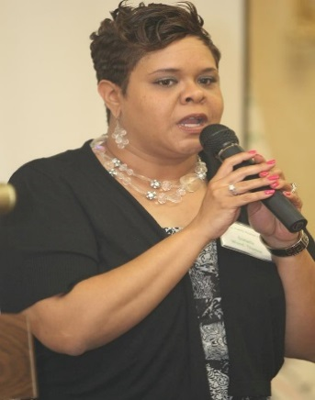

DANIELLE J THOMAS

Danielle J Thomas is the founder of Restoring Consultant Services INC. Danielle was given a vision in 2018, to push mental health awareness in businesses and organizations to increase the awareness of how important our mental health is to our daily life. In August of 2024, she received a Nonprofit Management certificate from the University of Greensboro. She has a master’s Degree in Ministry from Carolina University, a bachelor’s degree in Communications from Salem College, and an associate degree in Arts from Forsyth Technical Community College.  For the past six years, Danielle has volunteered and provided outreach for the Winston Salem and surrounding communities.  She currently provides bi-weekly group sessions at a local shelter within the city of Winston-Salem where she has actively volunteered since 2012 consistently. She created workshops that included prioritizing life skills, increasing self-care, and motivational inspiration. Individuals have been able to utilize these skills by preparing for job interviews and techniques of ways to overcome life challenges. These skills also inspire individuals to never give up when they face adversity.

Danielle believes that the mind is one of the most powerful organs in our body and our negative thoughts can affect our health and the way we see the world.  Through consulting and seminars, Danielle can provide the tools necessary to assist in understanding and developing skills to deal with daily struggles in work and at home.  In her spare time, Danielle enjoys volunteering in the community and helping others. Danielle loves a good movie, swimming, playing pool and spending time with her family. She believes in hard work and dedication to achieve personal goals.

Danielle Thomas

336-972-0906

Email: restoringconsultantservices@yahoo.com

To schedule a consultation please contact Danielle Thomas by telephone at 336-972-0906 or email: [restoringconsultantservices@yahoo.com](mailto:restoringconsultantservices@yahoo.com).