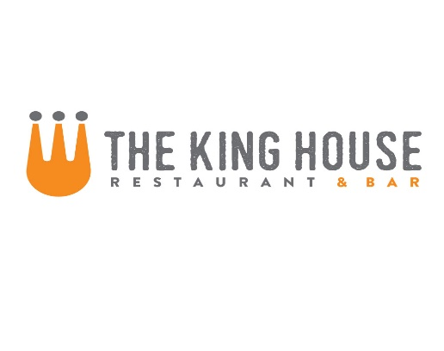

**Noodles**

{Add ons: chicken 5, steak 8, salmon 7, shrimp 7}

Fresh Linguini with Heirloom Cherry Tomatoes, Basil, Goat Cheese and Pine Nuts 11

Mac and Cheese with Penne, Applewood Smoked Bacon, and Dijon Bread Crumbs 12

Chinese BBQ Pork Ramen with Bok Choy, Shitake Mushrooms, Poached Egg and Scallions 12

Rigatoni with House-Made Italian Sausage, Pinot Grigio and Tomato Cream 15

**Entree**

Roasted Amish Chicken with Summer Vegetables, Potato Puree and Lemon Herbed Chicken Jus 18

8-oz Prime Flat Iron Steak with Roasted Baby Carrots, Potato Puree and Madeira Sauce* 20

10-oz Hanger Steak with Roasted Baby Carrots, Potato Puree and Madeira Sauce* 28

Ribeye with Baby Carrots, Potato Puree and Madeira Sauce* 12oz-$28 16oz-$34

Australian Rack of Lamb with Sautéed Vegetables, Potato Puree ad Madeira Sauce* 36

Bacon-Wrapped Pork Tenderloin with Apple Compote and Creamed Arugula* 19

Scottish Salmon with Warm Citrus Rice Salad, Frisse and Walnut Pesto 20

Alaskan Halibut with Mixed Vegetable Cous Cous, Chive Butter and Pommodoracio Semi-dried Tomatoes 28

**Sides**

Fries: Big 6 Small 3

Grilled Asparagus with Lemon 7

Green Beans with Prosciutto Butter and Almonds 7

**Starters**

Miso Glazed Pork Ribs with Sesame and Scallions 9

Crispy Calamari with 3 Sauces: Sweet and Sour, Kimchi BBQ, and Creamy Citrus Sesame 10

Fresh Ricotta Cheese with Tomato Confit, Aged Balsamic and Pine Nut-Basil Oil 10 extra bread $1

Wild Jumbo Shrimp Sautéed with Lemon, Parmesan and Piquillo Pepper Butter 12

King House Nachos – steak 11 or chicken 9

**Soups and Salads**

{Add ons: chicken 5, steak* 8, salmon* 7, shrimp 7}

Soup - Ask Server for Today’s Selections Cup 5 Bowl 8

Bacon, Lettuce and Tomato Salad with Buttermilk Chive Dressing 8

Hearts of Romaine with Avocado Dressing, Dijon Bread Crumbs and Cotija Cheese 8

Baby Mixed Greens, Seasonal Vegetables, Toasted Almonds and Lemon Vinaigrette 8

Mixed Greens, Oranges, Candied Pecans and Goat Cheese with Bacon and Maple Vinaigrette 9

Small House Salad with Tomatoes, Cucumbers and Red Onion 4

**Flatbreads**

Smoked Ham, Mushroom and Ricotta Cheese with Aged Balsamic and Truffle Oil 12

Italian Sausage with Parmesan Cream, Mozzarella and Cherry Tomatoes 12

**Sandwiches**

Please See Reverse Side

M-Th. 4pm-9pm Fri-Sat 4pm-10pm Sun 3pm-9pm

**Dinner Menu**

* These Items are served raw or undercooked, or contain or may contain raw or undercooked ingredients. Consuming raw or undercooked meats, poultry, seafood, shellfish or eggs may increase your risk of food­borne illness, especially if you have certain medical conditions. —Minnesota Department of Health