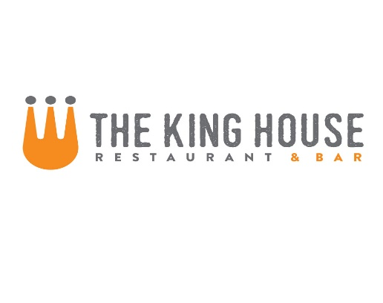

**Noodles**

{Adds: chicken 5, steak 8, salmon 7, shrimp 7}

Fresh Linguini with Cherry Tomatoes, Basil, Goat Cheese and Pine Nuts 11

Mac and Cheese with Penne, Applewood Smoked Bacon, and Dijon Bread Crumbs 12

Chinese BBQ Pork Ramen with Bok Choy, Shitake Mushrooms, Poached Egg and Scallions 12

Rigatoni with House-Made Italian Sausage, Pinot Grigio, Tomato Cream and Parmesan Cheese 15

**Sandwiches**

Served with pickles and fries

Shaved Roast Pork Shoulder with Provolone, Arugula and Cherry-Chipotle Relish 11

Cheesesteak – Shaved Ribeye, Sautéed Onions, Peppers and Cheese Whiz 12

The Alright Burger – Our 7 oz Ground Beef Patty with your choice of cheese on a Home-made Bun with Lettuce, Tomato and Onion* 11

(bacon $1, mushrooms, $0.50)

Fried Chicken Sandwich with Citrus Pickles and Sriracha Aioli 11

Grilled Chicken Sandwich with your choice of cheese on a Home-made Bun with Lettuce, Tomato and Onion 11 (other add-ons (50¢ - $1)

Reuben – Thick Cut Corned Beef, Kraut, 1000 Island and Swiss Cheese on Marbled Rye 13

**Starters**

Miso Glazed Pork Ribs with Sesame and Scallions 9

Crispy Calamari with 3 Sauces: Sweet and Sour, Kimchi BBQ, and Creamy Citrus Sesame 10

Fresh Ricotta Cheese with Tomato Confit, Aged Balsamic and Pine Nut-Basil Oil 10 extra bread $1

Wild Argentinian Red Shrimp Sautéed with Lemon, Parmesan and Piquillo Pepper Butter 12

King House Nachos – steak 11 or chicken 9

**Soups**

Ask Server for Today’s Selections Cup 5 Bowl 8

**Salads**

{Adds: chicken 5, steak* 8, salmon* 7, shrimp 7}

Bacon, Lettuce and Tomato Salad with Buttermilk Chive Dressing 8

Hearts of Romaine with Avocado Dressing, Dijon Bread Crumbs and Cotija Cheese 8

Baby Mixed Greens, Seasonal Vegetables, Toasted Almonds and Lemon Vinaigrette 8

Mixed Greens, Oranges, Candied Pecans and Goat Cheese with Bacon and Maple Vinaigrette 9

Small House Salad with Tomatoes, Cucumbers and Red Onion 4

**Flatbreads**

Smoked Ham, Mushroom and Ricotta Cheese with Aged Balsamic and Truffle Oil 12

Italian Sausage with Parmesan Cream, Mozzarella and Cherry Tomatoes 12

* These Items are served raw or undercooked, or contain or may contain raw or undercooked ingredients. Consuming raw or undercooked meats, poultry, seafood, shellfish or eggs may increase your risk of food­borne illness, especially if you have certain medical conditions. —Minnesota Department of Health

**Lunch Menu**