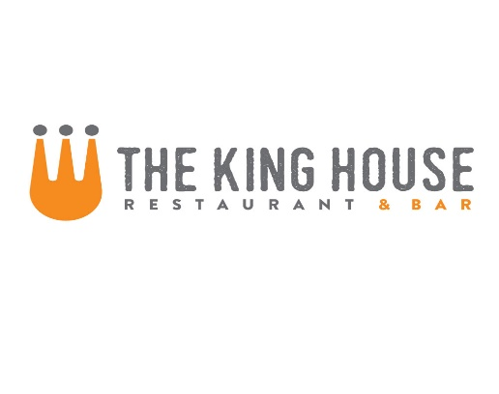

* These Items are served raw or undercooked, or contain or may contain raw or undercooked ingredients. Consuming raw or undercooked meats, poultry, seafood, shellfish or eggs may increase your risk of food­borne illness, especially if you have certain medical conditions. —Minnesota Department of Health

**Noodles**

{Adds: chicken 5, steak 8, salmon 7, shrimp 7}

Fresh Linguini with Cherry Tomatoes, Basil, Goat Cheese and Pine Nuts 12

Mac and Cheese with Penne, Applewood Smoked Bacon, and Dijon Bread Crumbs 12

Chinese BBQ Pork Ramen with Bok Choy, Shitake Mushrooms, Poached Egg and Scallions 13

Rigatoni with House-Made Italian Sausage, Pinot Grigio, Tomato Cream and Parmesan Cheese 15

**Sandwiches**

Served with pickles and fries

Shaved Roast Pork Shoulder with Provolone, Arugula and Cherry-Chipotle Relish 11

Cheesesteak – Shaved Ribeye, Sautéed Onions, Peppers and Cheese Whiz 12

The Alright Burger – Our 7 oz Ground Beef Patty with your choice of cheese on a Home-made Bun with Lettuce, Tomato and Onion* 11

(bacon $1, mushrooms, $1)

JW’s Fried Chicken Sandwich with Citrus-Pickles and Sriracha Aioli 11

Grilled Chicken Sandwich with your choice of cheese on a Home-made Bun with Lettuce, Tomato and Onion 11 (bacon $1, mushrooms, $1)

Reuben – Thick Cut Corned Beef, Kraut, 1000 Island and Swiss Cheese on Marbled Rye 13

**Starters**

Miso Glazed Pork Ribs with Sesame and Scallions 9.5

Crispy Calamari with 3 Sauces: Sweet and Sour, Kimchi BBQ, and Creamy Citrus Sesame 10.5

Fresh Ricotta Cheese with Tomato Confit, Aged Balsamic and Pine Nut-Basil Oil 10 extra bread $2

Wild Argentinian Red Shrimp Sautéed with Lemon, Parmesan and Piquillo Pepper Butter 12

King House Nachos – steak 11 or chicken 10

**Soups**

Ask Server for Today’s Selections Cup 5 Bowl 8

**Salads**

{Adds: chicken 5, steak* 8, salmon* 7, shrimp 7}

Mixed Greens, Seasonal Vegetables, Spiced Almonds and Lemon Thyme Vinaigrette 8

Mixed Greens, Oranges, Candied Pecans and Goat Cheese with Bacon and Maple Vinaigrette 9

Arugula and Endive Salad with Apples, Oranges, Bacon, Creamy Honey Vinaigrette and Spiced Almonds 9

Side Salad with Tomatoes, Cucumbers and Red Onion 4.5

**Flatbreads**

Smoked Ham, Mushroom and Ricotta Cheese with Aged Balsamic and Truffle Oil 12

Italian Sausage with Parmesan Cream, Mozzarella and Cherry Tomatoes 12

**Lunch Menu**