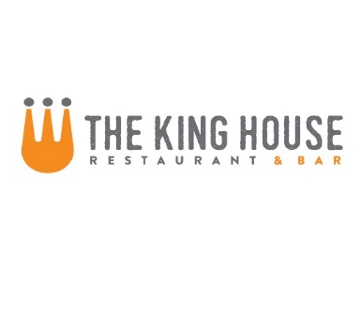

**Happy Hour Menu**

**Available M-Sat: 4pm-6pm and Sun: 11am-8pm**

**Beverages**

Tap Beers $2 off

Domestic Taps $1 off

All Bottles $1 off

Wines by the Glass $2 off

All Rail Drinks $2 off

**Food**

Miso Glazed Pork Ribs with Sesame and Scallions 7

Crispy Calamari with 3 Sauces: Sweet and Sour, Kimchi BBQ, and Creamy Citrus Sesame 8

Fresh Ricotta Cheese with Tomato Confit, Aged Balsamic and Pine Nut-Basil Oil 8

King House Nachos – steak 9 or chicken 7

Italian Sausage Flatbread with Parmesan Cream, Mozzarella and Cherry Tomatoes 10

Cheesesteak with Sautéed Onions, Peppers and Cheese Whiz Served with pickles and fries 9

The Alright Burger – Our Ground Beef Patty with your choice of cheese on a Home-made Bun with Lettuce, Tomato and Onion* 9

Fried Chicken Sandwich with Citrus Pickles and Sriracha Aioli 9



