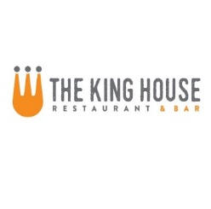

**Beverages**

Tap Beers $2 off

Domestic Taps $1 off

All Bottles $1 off

Wines by the Glass $2 off

All Rail Drinks $2 off

**Food**

Fresh Ricotta Cheese with Tomato Confit, Aged Balsamic and Pine Nut-Basil Oil 9

Miso Glazed Pork Ribs with Sesame and Scallions 8.5

1lb of Chicken Wings choice of sauce: sweet and sour, bbq, buffalo, or dry rub 7.5

Crispy Calamari with 3 Sauces: Sweet and Sour, Kimchi BBQ, and Creamy Citrus Sesame 9

King House Nachos – shredded beef, pork or chicken 9

Italian Sausage Flatbread with Parmesan Cream, Mozzarella and Cherry Tomatoes 10

Smoked Ham, Mushroom and Ricotta Cheese with Frisse and Arugula Salad, Aged Balsamic and Truffle Oil 10

Chicken and Pesto with Smoked Tomatoes, Red Onion, Mozzarella and Parmesan 10

Mac and Cheese with Penne, Applewood Smoked Bacon, and Dijon Bread Crumbs 10 {Add ons: chicken $4, steak $7, salmon $6, 3-shrimp $6}

The Alright Burger – Our 7 oz Ground Beef Patty with your choice of cheese with Lettuce, Tomato and Onion* 9.5

(bacon $1, mushrooms, $1)

BBQ Beef or Pork—Shredded BBQ Beef or Pork topped with French Fried Onions on our Sesame Seed Bun 9 served with coleslaw

Cheesesteak with Sautéed Onions, Peppers and Cheese Whiz Served with pickles and fries 10

Johny W’s Fried Chicken Sandwich with Citrus Pickles and Sriracha Aioli 9.5





**Happy Hour Menu**

**Available M-Sun: 4pm-6pm**