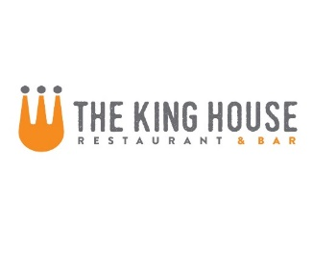**New Year’s Eve 2019**

**Starters**

Burrata Cheese with Tomato Confit, Aged Balsamic and Pine Nut-Basil Oil served with crostini $12

Miso Glazed Pork Ribs with Sesame and Scallions $10.5

Crispy Calamari with 3 Sauces: Sweet and Sour, Kimchi BBQ, and Creamy Sesame $11

Pan Fried Crab Cakes with Lemon Aioli $16

Wild Jumbo Shrimp Sautéed with Lemon, Parmesan and Piquillo Pepper Butter $12

Lamb Meat Balls with Red Wine Syrup, and Roasted Oyster Mushroom Salad $15

French Onion Soup $5 Lobster Bisque $8

**Salads**

Roasted Pear, Prosciutto and Arugula Salad with Spiced Almonds and Pomegranate Syrup $13

5-oz Prime Sirloin Steak over Mixed Greens with Sautéed Mushrooms, Seasonal Veg, Blue Cheese and Smoked Tomato Vinaigrette $17

**Noodles**

{Add ons: chicken $4, steak $7, salmon $6, 3-shrimp $6}

Fresh Linguini with Lobster, Snow Peas, Parmesan and Smoked Tomato Butter $35

Fresh Linguini with Tomatoes, Basil, Goat Cheese and Pine Nuts $12

Pappardelle with Braised Veal Shoulder and Porcini Mushroom Stroganoff $27

**\*Steaks and Other Meats**

Steaks served with Roasted Baby Carrots, Sautéed Onion, Potato Puree and Madeira Sauce

Add ons: extra madeira-$2 Smoked Tomato-$2, Mushrooms-$2, 3-shrimp $6

8-oz Beef Tenderloin Filet * $38

Ribeye * 12oz - $28 16oz - $34

16-oz Bone-in Comfrey Farms Duroc Pork Chop with Potato Puree, Jalapeno-Cheddar Spoon Bread, Brussels sprouts and Bacon-Sriracha Jam $27

Au Bon Canard Duck Breast with Mushroom Risotto, Fried Root Vegetable Salad and Balsamic $27

Butter Poached Amish Chicken with Braised Leeks, Carrots and Peas $23

**Seafood**

Chilean Salmon with Warm Citrus Rice, Frisse, Arugula Salad and Walnut Pesto $20

Sea Scallops with Roasted Butternut Squash, Bacon Al pastor, Pepitas and Cotija Cheese $22

Crab Crusted Barramundi with Cous Cous, Avocado, and Piquillo Pepper $30

**Sides**

Roasted Butternut Squash with Brown Sugar and Butter 8

Sautéed Brussels Sprouts with Bacon 7.5