**Date: 21/02/2025**

### Question Paper Code

**55/1/3**

### Time: 3 hrs.

Class-XII

**PHYSICS (Theory)**

**(CBSE 2025)**

### Max. Marks: 70

**GENERAL INSTRUCTIONS**

**Read the following instructions very carefully and strictly follow them:**

(i)

This question paper contains **33** questions. **All** questions are compulsory.

1. Question paper is divided into **FIVE** sections – Sections **A**, **B**, **C**, **D** and **E**.
2. **In Section – A :** Question Nos. **1** to **16** are Multiple Choice (MCQ) type questions, carrying **1** mark each.
3. **In Section – B :** Question Nos. **17** to **21** are Very Short Answer (VSA) type questions, carrying **2** marks each.
4. **In Section – C :** Question Nos. **22** to **28** are Short Answer (SA) type questions, carrying **3** marks each.
5. **In Section – D :** Question Nos. **29** and **30** are Case-Based questions, carrying **4** marks each.
6. **In Section – E :** Question Nos. **31** to **33** are Long Answer (LA) type questions, carrying **5** marks each.
7. There is no overall choice. However, an internal choice has been provided in few questions in all the sections except Section A.

You have to attempt only one of the choices in such questions.

1. Use of calculators is **NOT** allowed.

**SECTION-A**

1. 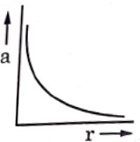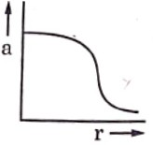A charge *Q* is in position. Another charge *q* is brought near charge *Q* and released from rest. Which of the following graphs is the correct representation of the acceleration of the charge *q* as a function of its distance *r* from charge *Q*?

(A) (B)

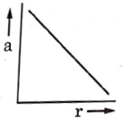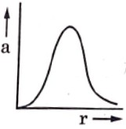

(C) (D)

### Answer (A)

**Sol.** We use Coulomb’s Law and Newton’s Second Law to determine the acceleration of charge *q*.

* + The force on *q* due to *Q* is
  + Acceleration is given by:

*F*  *kQq*

*r* 2

*a*  *kQq*

*mr* 2

This means that acceleration varies inversely with *r*2. The correct graph should show a decreasing function of *r*

with a sharp drop. The correct option is (A)

1. Two conductors *A* and *B* of the same material have their lengths in the ratio 1 : 2 and radii in the ratio 2 : 3. If

they are connected in parallel across a battery, the ratio *vA*

*vB*

of the drift velocities of electrons in them will be

(A) 2 (B) 1

2

(C) 3

2

### Answer (A)

**Sol.** The formula for drift velocity is:

(D) 8

9

*vd* 

*I*

*nAq*

Where *A* is the cross-sectional area. Since conductors are made of the same material, *n* and *q* are constant. Given:

* Lengths: *lA* : *lB* = 1 : 2
* Radii: *rA* : *rB* = 2 : 3

*R*  *l*  *I*  *VA*

*A*

⇒ *VA*  *neAv*

*l*

*l*

*d*  *vd*

 *v ne**l*

Here voltage *v* and *n*, *e*,  are all same for both conductor so, *v*  1  *v A*  2

*d l v* 1

*B*

1. A 1 cm segment of a wire lying along *x*-axis carries current of 0.5 A along +*x* direction. A magnetic field

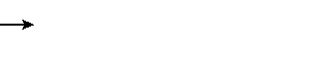*B*  (0.4 mT) ˆ*j* + (0.6 mT)*k*ˆ is switched on, in the region. The force acting on the segment is

(A)

(C)

(2 ˆ*j*  3*k*ˆ) mN (6 ˆ*j*  4*k*ˆ) mN

(B)

(D)

(3 ˆ*j*  2*k*ˆ) N (4 ˆ*j*  6*k*ˆ) N

### Answer (B)

**Sol.** The forces on a current-carrying wire in a magnetic field is:

*F* = *l*(*L* × *B*)

Given:

*I* = 0.5*A*, *L*  1*i*ˆcm *B*  (0.4*m*ˆ *T*ˆ*j*  0.6 *m*ˆ *Tk*ˆ)

Using cross product:

*L*  *B*  *i*ˆ  (0.4 ˆ*j*  0.6*k*ˆ)

Using vector cross-product rules:

*i*ˆ  ˆ*j*  *k*ˆ, *i*ˆ  *k*ˆ   ˆ*j*

# *i*ˆ  (0.4 *j*ˆ  0.6*k*ˆ)  0.4*k*ˆ  0.6 *j*ˆ

Multiply by *I* = 0.5:

# *F*  (0.2*k*ˆ  0.3 *j*ˆ)

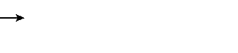Length was in cm and magnetic field in mT. So, in SI unit *F*  (0.2*k*ˆ  0.3 *j*ˆ) 105 N

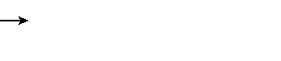*F*  (2*k*ˆ  3 ˆ*j* ) N

1. The ratio of the number of turns of the primary to the secondary coils in an ideal transformer is 20 : 1. If 240 V ac is applied from a source to the primary coil of transformer and a 6.0  resistor is connected across the output terminals, then current drawn by the transformer from the source will be.

(A) 4.0 A (B) 3.8 A

(C) 0.97 A (D) 0.10 A

### Answer (D)

**Sol.** Using the transformer equation

*NP*  *VP NS VS*

Given:

*NP* : *NS* = 20 : 1, *VP* = 240 *V*

*V*  *VP*  240  12*V*

*S* 20 20

Using Ohm’s Law,

*I*  *VS*

*S R*

 12*V*  2*A*

# 6

From the transformer current relation:

*I*  *I*  *NS*

*P S NP*

*I*  2*A*  1

*P*

# 20

#  0.10*A*

1. You are required to design an air-filled solenoid of inductance 0.016 H having a length 0.81 m and radius 0.02

m. The number of turns in the solenoid should be

(A) 2592 (B) 2866

(C) 2976 (D) 3140

### Answer (B)

**Sol.** We use the formula for the number of turns per unit length of a solenoid:

*L* = 0*n*2*Al*

where:

* *L* = 0.016*H* (Inductance)
* *l* = 0.81*m* (Length of solenoid)
* *r* = 0.02*m* (Radius)
* *A* = *r*2 (Cross-sectional area)
* n = *N l*

(Turns per unit length)

Rearranging for *N*:

*N* 

*L*

0 *A*

 *l*

Substituting values:

*N*  

0.016

4  107     0.022

  0.81

16  81

100  1000  1011 162

*N*  4  9  1000  9000

4 

= N  2866

1. A voltage *v* = *v*0 sin*t* applied to a circuit drives a current *i* = *i*0 sin(*t* + ) in the circuit. The average power consumed in the circuit over a cycle is

(A) Zero (B) *i*0*v*0cos

(C)

*i*0*v*0

2

(D)

*i*0*v*0 cos  2

### Answer (D)

**Sol.** The instantaneous power in an AC circuit is given by:

*P* = *Vi* = *V*0sin(*t*) × *i*0sin(*t* + )

Using the average power formula over a cycle:

1. *X*-rays are more harmful to human beings than ultraviolet radiations because *X*-rays
2. Have frequency lower than that of ultraviolet radiations.
3. Have wavelength smaller than that of ultraviolet radiations
4. Move faster than ultraviolet radiations in air
5. Are mechanical waves but ultraviolet radiations are electro-magnetic waves

### Answer (B)

**Sol.** *X*-rays are more harmful than ultraviolet (*UV*) rays because:

* They have a shorter wavelength than UV rays.
* Higher energy per photon, leading to deeper penetration into human tissues, causing ionization and DNA damage.

1. A point source is placed at the bottom of a tank containing a transparent liquid (refractive index *n*) to a depth

H. The area of the surface of the liquid through which light from the source can emerge out is

(A)

(C)

*H* 2

(*n*  1)

*H* 2

*n*2  1

(B)

(D)

*H* 2

(*n*2  1)

*H* 2

(*n*2  1)

### Answer (A)

**Sol.** For a point source placed at the bottom of a tank, the emergent area through which light escapes depends on total internal reflection and Snell’s Law. The area of the liquid surface through which light emerges is given by:

*H* 2

A =

(*n*2  1)

*H* 2

= (*n*  1)

1. In a photoelectric experiment with a material of work function 2.1 eV, the stopping potential is found to be 2.5

V. The maximum kinetic energy of ejected photoelectrons is

(A) 0.4 eV (B) 2.1 eV

(C) 2.5 eV (D) 4.6 eV

### Answer (C)

**Sol.** Using the **photoelectric equation**

KEmax = *eVs*

Where

* *Vs* = 2.3 V (Stopping potential)
* *e* = 1.6 × 10–19C (Charge of electron) KEmax = 2.5 × 1 = 2.5 eV

1. When a p-n junction diode is forward biased
2. The barrier height and the depletion layer width both increase.
3. The barrier height increases and the depletion layer width decreases.
4. The barrier height and the depletion layer width both decrease.
5. The barrier height decreases and the depletion layer width increases.

### Answer (C)

**Sol.** When p-n junction is forward biased:

* The barrier potential decreases.
* The depletion layer width decreases due to carrier injection.

1. Let e, *p* and *d* be the wavelength associated with an electron, a proton and a deuteron, all moving with the same speed. Then the correct relation between them is

(A) *d* > *p* > *e* (B) *e* > *p* > *d*

(C) *p* > *e* > *d* (D) *e* = *p* = *d*

### Answer (B)

**Sol.** Wavelengths associated with an electron (*e*), proton (*p*), and deuteron (*d*), all moving with the same speed.

### Using de Broglie’s equation:   *h*

*mv*

* Since all particles have the same speed (*v*), their wavelengths are inversely proportional to their masses.
* Electron has the smallest mass, so it has the longest wavelength.
* Deuteron has the highest mass, so it has the shortest wavelength.

**Mass relation:** *me* < *mp* < *md* thus, wavelength relation: *e* > *p* > *d*

1. Which of the following figures correctly represent the shape of curve of binding energy per nucleon as a function of mass number?

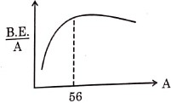

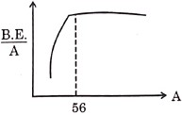

(A) (B)

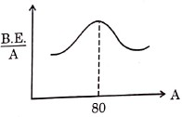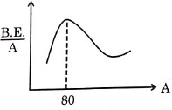

(C) (D)

### Answer (A)

**Sol.** Here are some observations on the binding energy per nucleon vs. mass number (A) curve.

* The curve starts low for lighter elements.
* Peaks around A = 56 indicating maximum stability.
* Decreases slowly heavier elements.

**Correct answer :** (A) (The curve peaks around A = 56 and then decreases.)

**Note:** Question numbers 13 to 16 are Assertion (A) and Reason (R) type questions. Two statements are given – one labelled Assertion (A) and the other labelled Reason (R). Select the correct answer from the codes (A), (B), (C) and

(D) as given below.

1. Both Assertion (A) and Reason (R) are true and Reason (R) is the correct explanation of Assertion (A).
2. Both Assertion (A) and Reason (R) are true, but Reason (R) is not the correct explanation of Assertion (A)
3. Assertion (A) is true, but Reason (R) is false
4. Assertion (A) is false and Reason (R) is also false
5. **Assertion (A):** We cannot form a p-n junction diode by taking a slab of a p-type semiconductor and physically joining it to another slab of a n-type semiconductor.

**Reason (R):** In a p-type semiconductor *e* >> h while in a n-type semiconductor *e* >> h

### Answer (C)

**Sol. Assertion (A):** True A *p*-*n* junction cannot be formed just by joining *p*-type and *n*-type semiconductors physically due to lack of diffusion and formation of a depletion region.

**Reason (R):** False In a p-type semiconductor *e* << h while in a *n*-type semiconductor *h* << *e* also electron and hole concentrations do not justify why a p-n junction cannot form this way.

1. **Assertion (A) :** The potential energy of an electron revolving in any stationary orbit in a hydrogen atom is positive.

**Reason (R) :** The total energy of a charged particle is always positive.

### Answer (D)

**Sol. Assertion (A) : False:** The potential energy of an electron in an orbit is **negative**, as it is bound to the nucleus.

**Reason (R) : False:** Total energy of a charged particle can be negative (e.g., bound systems like atoms) Both Assertion and Reason are false.

1. **Assertion (A) :** It is difficult to move a magnet into a coil of large number of turns when the circuit of the coil is closed.

**Reason (R) :** The direction of induced current in a coil with its circuit closed, due to motion of a magnet, is such that it opposes the cause.

### Answer (A)

**Sol. Assertion (A): True.** Moving a magnet in a coil with a large number of turns induces a greater back EMF, making movement difficult.

**Reason (R): True.** According to Lenz's Law, induced current opposes the change causing it.

1. **Assertion (A):** The deflection in a galvanometer is directly proportional to the current passing through it.

**Reason (R):** The coil of a galvanometer is suspended in a uniform radial magnetic field.

### Answer (A)

**Sol.** Both are true, and reason correctly explains assertion.

**SECTION-B**

1. *n* identical cells, each of e.m.f *E* and internal resistance *r*, are connected in series. Later on it was found out that two cells ‘*X*’ and ‘*Y*’ are connected in reverse polarities. Calculate the potential difference across the cell ‘*X*’

### Sol. Given:

* *n* identical cells, each with emf = *E* and internal resistance = *r*, connected in series.
* Two cells *X* and *Y* are connected in reverse polarity, *E*eq = (*n* – 4)*E*, *r*eq = *nr*

Net current since the cell *x* is reversed, the potential difference is *v* = *E* + *ig*

*V*  *E*  (*N*  4)*E*  *r*

 *nr* 

*V*  2  4  *E*

 *n* 

Correct Answer:  2  4  *E*

 *n* 

 

1. (a) In a diffraction experiment, the slit is illuminated by light of wavelength 600 nm. The first minimum of the pattern falls at  = 30°. Calculate the width of the slit.

## OR

(b) In a Young’s double-slit experiment, two light waves, each of intensity *I*0, interfere at a point, having a path

difference

● on the screen. Find the intensity at this point.

8

**Sol.** (a) Diffraction experiment : *a* sin = *m* for first minimum (*m* = 1):

● 600 10–9 m 600 10–9 m 6

*a*  

sin

sin30

*a*   1.2 10 m 0.5

Correct Answer: 1.2 m

## OR

(b) Young’s double-Slit Experiment: Intensity at path difference

Using trigonometric values: *I*  4*I*  0.922  3.4*I*

0 0

Correct Answer: 3.4*I*0

● : *I* 

8

4*I*0

cos2   

 

 8 

1. A double convex lens of glass has both faces of the same radius of curvature 17 cm. Find its focal if it is immersed in water. The refractive indices of glass and water are 1.5 and 1.33 respectively.

**Sol.** Given:

* Convex lens, *R* = 17 cm
* Refractive indices: Glass = 1.5, Water = 1.33 Using Lensmaker’s formula:

4  3 4 

−

3  2 3 



− 3   

2*v*1  17

 4  3 

4 3  3 2 

−    

3*f* 2*v*1 17

⇒ 4 

3*f*

2 1

6 17

⇒ *f*  68 cm

1. An electron in Bohr model of hydrogen atom makes a transition from energy level – 1.51 eV to – 3.40 eV. Calculate the change in the radius of its orbit. The radius or orbit of electron in its ground state is 0.53 Å.

**Sol.** Given:

* Initial energy E1 = – 1.51 eV for *n* = 3
* Final energy E2 = – 3.40 eV for *n* = 2
* Ground-state radius r1 = 0.53Å Using Bohr’s radius formula: *rn* = *r*0*n*2 Change in *r* = *r* = *r*0(9 – 4) = 5*r*0

⇒ *r* = 5 × 0.53Å = 2.65 Å

1. A *p*-type Si semiconductor is made by doping an average of one dopant atom per 5 × 107 silicon atoms. If the number density of silicon atoms in the specimen is 5 × 1028 atoms m–3, find the number of holes created per cubic centimetre in the specimen due to doping. Also give one example of such dopants.

**Sol.** A *p*-type silicon (Si) semiconductor is doped with an average of one acceptor atom per 5 × 107 silicon atoms. We need to determine the number of holes created per unit volume and the number of dopant atoms per cubic centimeter.

### Step 1: Calculate the number of silicon atoms per unit volume

We use the atomic density of silicon:

Atomic density of Si = 5 × 1028 atoms/m3

Since 1 m3 = 106 cm3, we convert this to atoms per cm2: Atomic density of Si = 5 × 1022 atoms/cm3

### Step 2: Find the number of dopant Atoms per cm2

Given that one acceptor atom is added per 5 × 107 Si atoms, the number of dopant atoms per cm2 is

5 1022 atoms/cm3

5 107

= 1015 acceptor atoms/cm3

### Step 3: Find the number of Holes Created per cm3

Each acceptor atom creates one hole in a *p*-type semiconductor. Thus, the number of holes per cm3 is also:

1015 holes/cm3

**Step 4:** Example of such dopant is Aluminium

**SECTION-C**

1. (a) Two batteries of emf’s 3 V and 6 V and internal resistance 0.2  and 0.4  are connected in parallel. This combination is connected to a 4  resistor. Find :
2. the equivalent emf of the combination
3. the equivalent internal resistance of the combination
4. the current drawn from the combination

## OR

1. (i) A conductor of length *I* is connected across an ideal cell of emf *E*. Keeping the cell connected, the length of the conductor is increased to 2*l* by gradually stretching it. If *R* and *R*  are initial and final values of resistance and *v*d and *vd* are initial and final values of drift velocity, find the relation between
   1. *R*  and *R* and (ii) *vd* and *v*d.
   2. When electrons drift in a conductor from lower to higher potential, does it mean that all the 'free electrons' of the conductor are moving in the same direction?

**Sol.** (a) Two batteries of emf 3 V and 6 V with internal resistance 0.2  and 0.4  respectively, are connected in parallel to a 4  resistor. We need to find:

1. Equivalent emf of the combination

The formula for equivalent emf when batteries are in parallel

*E*  *E*1*R*2  *E*2*R*1

*eq R*  *R*

1 2

Substituting values:

3  0.4  6  0.2

*Eeq* 

0.2  0.4

 1.2  1.2  2.4  4 V

0.6 0.6

1. Equivalent internal resistance

The formula for equivalent internal resistance:

*r*  *R*1*R*2

*eq R*  *R*

1 2

 0.2  0.4  0.08  0.133 

0.2  0.4 0.6

1. Current drawn from the combination Using Ohm’s Law:

*I*  *Eeq R*  *req*

 4

 0.97*A*

4  0.133

## OR

### (i) Relation between final and initial resistance and drift velocity

.

* + Resistance of a conductor is given by: *R*   1

*A*

Since length is doubled (*l* – 2*l*) and volume remains constant, the cross-sectional area becomes

*A*  *A*

2

*R*  

2*l A* /2

 4*R*

So, *R*  = 4*R*

* + Drift velocity is given by: *vd* 

*l nAq*

Since *A* 

*I*

*A* , the new drift velocity is and *I*  *I*

2 4

*v*   4  *I*

*d*

 *vd*

*n*  *A*  *q*

 2 

 



2*nAq* 2

So, *v*   *vd*

*d* 2

### Final Relations:

* + - *R*  = 4*R*
    - *v*   *vd*

*d* 2

### Motion of free electrons in a conductor

* + Electrons drift from lower to higher potential, but they move in the opposite direction of current.
  + Not all free electrons move in the same direction because their motion is random due to thermal agitation.
  + The net drift velocity is in the direction opposite to conventional current flow.

1. A particle of charge *q* is moving with a velocity *v* at a distance ‘*d*’ from a long straight wire carrying a current ‘*I*’

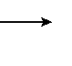

*E*

as shown in figure. At this instant, it is subjected to a uniform electric field undeviated. It terms of unit vectors *i* , *j* and *k* , find

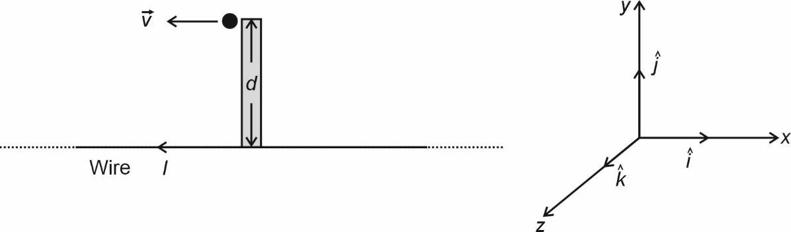such that the particle keeps moving

|  |  |  |
| --- | --- | --- |
|  | (a) | The magnetic field *B* , |
| (b) | The magnetic field *Fm* , and |
| **Sol.** | (c)  (a) | The electric field *E*, acting on the charge.  The magnetic field at a distance *d* from an infinitely long wire carrying current *I* is: |

*B*  0*I*

2*d*

Using the right-hand rule, the direction of *B* is perpendicular to the plane, pointing into the page (i.e., along

*k* direction).

1. Magnetic force *FB* on charge *q FB* = *q*(*v* × *B*)

Given *v* = *vi*ˆ and B =

*i*ˆ  (*k*ˆ)  ˆ*j*

0*I* (–*k*ˆ), using the cross-product:

2*d*

*F*  *qv*  0*I*  *j*ˆ

 2*d* 

*B*  

Answer: *FB*

 *qv*0*I j*ˆ 2*d*

1. Electric field *E* required to balance *FB*

For the particle to move undeviated, the electric force *FE* must cancel out the magnetic force *FB*.

*FE* + *FB* = 0 qE = –*FB*

*F*

*B*

*E*  

*q*

Substituting *FB*:

*E* 0*Iv* ˆ

  *j*

2*d*

*E*

0*Iv* ˆ

Answer:

  *j*

2*d*

1. An ac source of voltage  = *m* sin*t* is connected to a series combination of LCR circuit. Draw the phasor diagram. Using it obtain an expression for the impedance of the circuit and the phase difference between applied voltage and the current.

**Sol.** Let an AC voltage source of the form *v* = *Vm*sin*t* be connected to an LCR circuit consisting of an inductor (*L*), a capacitor (*C*) and a resistor (*R*) in series

The total impedance *Z* of the circuit is given by

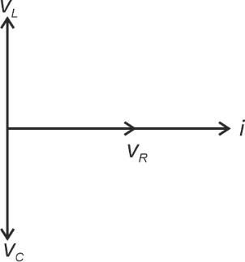*Z* 

*R* 2  ( *XL* – *XC* )2

Where

* *XL* = *L* is the inductive reactance

1

* *XC*

 *C*

is the capacitive reactance

Thus,

*R*  *L* – *C* 

2



1 2





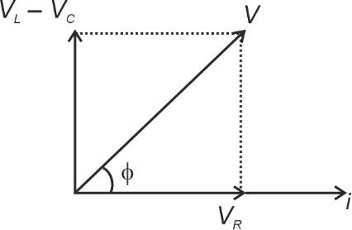*Z* 

The current in the circuit is given by:

*I*  *Vm* sin(*t* )

*Z*

The phase angle f between the applied voltage and current is given by

*L* – 1

tan   *XL* – *XC*

 *C*

*R R*

* If *XL* = *XC* the circuit is inductive and current lags the voltage.
* If *XC* = *XL* the circuit is capacitive and current lags the voltage.
* If *XL* = *XC* the circuit is resonance and current is in phase with voltage.

### Phasor Diagram

(Phasor diagram consists of voltage phasors for resistor, inductor, and capacitor. Voltage across *R* is in phase with current, across *L* leads current by 90°, and across *C* lags current by 90°)

1. (a) A parallel plate capacitor is charged by an ac source. Show that the sum of conduction current (*I*c) and the displacement current (*Id*) has the same value at all points of the circuit.

(b) In case (a) above, is Kirchhoff’s first rule (junction rule) valid at each plate of the capacitor? Explain.

**Sol.** (a) Maxwell introduced the concept displacement current *Id* to account for the changing electric field in a capacitor. The displacement is given by:

*I*   *d**E*

*d* 0 *dt*

where E is the electric flux.

The conduction current *Ic* in the circuit due to charge movement is:

*I*  *I*  *dQ*

*c dt*

Since the changing electric field inside the capacitor produces a displacement current equal to the conduction current, we have:

*Ic*  *Id*

Thus, at all points in the circuit, the total current remains continuous:

*Ic*  *Id*  *I*

(b) Is Kirchhoff’s first rule (junction rule) valid at each plate of the capacitor? Explain.

Yes, Kirchhoff’s junction rule states that the sum of currents entering a junction is equal to the sum of currents leaving the junction. In a capacitor, although there is no physical movement of charge across the plates, displacement current ensures continuity. Therefore, Kirchhoff’s junction rule remains valid.

1. (a) Mention any three features of results of experiment on photelectric effect which cannot be explained using the wave theory of light.
2. In his experiment on photoelectric effect, Robert A. Millikan found the slope of the cut-off voltage versus frequency of incident light plot to be 4.12 × 10–15 Vs. Calculate the value of Plank’s constant from it.

**Sol.** (a) Mention three features of results of the photoelectric experiment which cannot be explained using the wave theory of light.

* 1. **Instantaneous emission of electrons –** According to wave theory, energy is spread over the wavefront so electrons should take time to accumulate enough energy. However, photoemission is instantaneous.
  2. **Existence of threshold frequency –** Wave theory predicts that any frequency of light should eventually eject electrons if the intensity is high enough, but in reality, photoemission only occurs above a specific frequency.
  3. **Dependence of kinetic energy on frequency –** The kinetic energy of emitted electrons depends on light frequency, not intensity, contradicting wave theory.

(b) Robert Millikan found the slope of the cut-off voltage vs. frequency plot to be 4.12 × 10–15 Vs. Calculate the value of Planck's constant

From Einstein's photoelectric equation:

eV0 = *hf* – *f*

where *e* is charge of an electron, *V*0 is stopping potential, and *h* is Planck's constant.

Slope of *V*0 vs. *f* graph  *h*

*e*

Given:

*h*  4.12  1015 Vs

*e*

Since *e* = 1.6 × 10–19 C,

*h* = (4.12 × 10–15) × (1.6 × 10–19)

*h* = 6.592 × 10–34 Js

1. (a) Draw circuit arrangement for studying V-I characteristics of a p-n junction diode.
2. Show the shape of the characteristics of a diode.
3. Mention two information that you can get from these characteristics.

**Sol.** (a) A circuit diagram is needed with a diode, ammeter, voltmeter and a variable power source in forward and reverse bias.

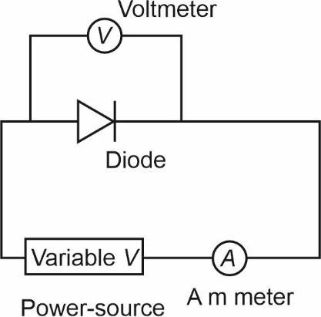

Characteristics:

(b)

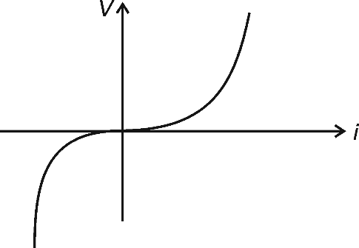

* + The forward bias shows an exponential increase in current after a threshold (–0.7 V for Si, ~0.3 V for Ge).

|  |  |  |
| --- | --- | --- |
|  | (c) | * The reverse bias shows negligible current until breakdown. Information obtained:  1. Threshold voltage – The minimum voltage required to conduct in forward bias. 2. Breakdown voltage – The voltage where reverse current suddenly increases. |
| 28. | (a) | Define ‘Mass defect’ and ‘Binding energy’ of a nucleus. Describe ‘Fission process’ on the basis of binding energy per nucleon. |
|  | (b) | A deuteron contains a proton and a neutron and has a mass of 2.013553 u. Calculate the mass defect for it in u and its energy equivalence in MeV. (*mp* = 1.007277 u, *mn* = 1.008665 u, 1u = 931.5 MeV/c2) |
| **Sol.** | (a) | * **Mass defect (*****m*) :** The difference between the sum of the masses of individual nucleons and the |

actual mass of the nucleus.

* + **Binding energy:** The energy required to separate a nucleus into its individual protons and neutrons.

### Fission and Binding Energy:

In nuclear fission, a heavy nucleus (e.g., uranium-235) splits into smaller nuclei, releasing energy. This occurs because the binding energy per nucleon of the smaller fragments is higher than that of the original nucleus, leading to the release of excess energy.

(b) **Answer (2.225 MeV)**

Mass of deuteron *md* = 2.013553 u

Total mass of proton and neutron : *md* + *mn* = 1.007277 + 1.008665 = 2.015942 u Mass defect : *m* = 2.015942 – 2.013553 = 0.002389 u

Binding energy : *BE* = *m* × 931.5

*BE* = 0.002389 × 931.5 = 2.225 MeV

Thus, the binding energy of deuteron is 2.225 MeV.

**SECTION-D**

Question numbers **29** and **30** are case study based questions. Read the following paragraphs and answer the questions that follow.

1. A thin lens is a transparent optical medium bounded by two surfaces, at least one of which should be spherical. Applying the formula for image formation by a single spherical surface successively at the two surfaces of a lens, one can obtain the ‘lens maker formula’ and then the ‘lens formula’. A lens has two foci – called ‘first focal point’ and ‘second focal point’ of the lens, one on each side.

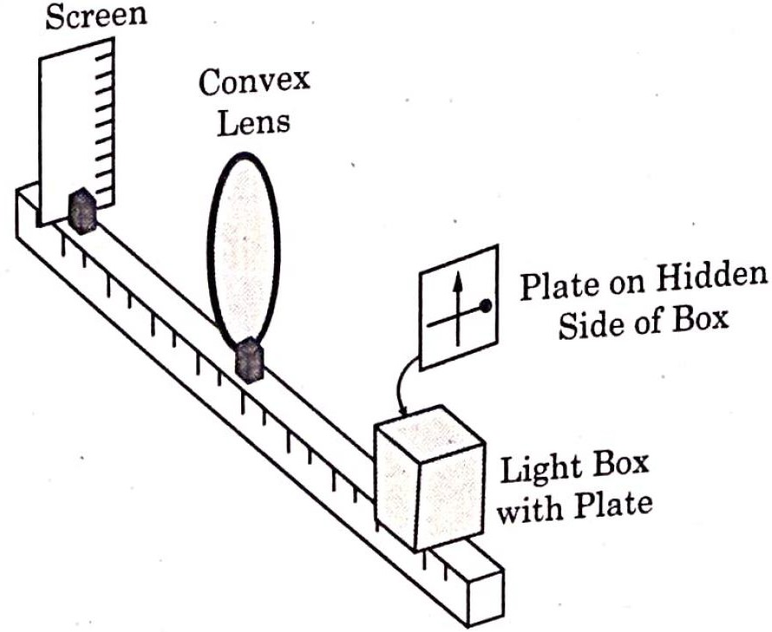

(i)

Consider the arrangement shown in figure. A black vertical arrow and a horizontal thick line with a ball are painted on a glass plate. It serves as the object. When the plate is illuminated, its real image is formed on the screen.

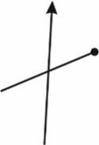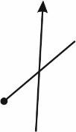Which of the following correctly represents the image formed on the screen?

(A) (B)

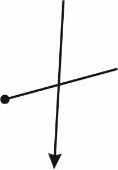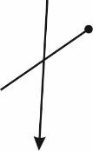(C) (D)

* 1. Which of the following statement is incorrect
     1. For a convex mirror magnification is always negative.
     2. For all virtual images formed by a mirror magnification is positive.
     3. For a concave lens magnification is always positive
     4. For real and inverted images, magnification is always negative
  2. A convex lens of focal length ‘*f*’ is cut into two equal parts perpendicular to the principal axis. The focal length of each part will be:
     1. *f* (B) 2*f*

(C)

*f* (D) *f*

2 4

## OR

1. If an object in case (i) above is 20 cm from the lens and the screen is 50 cm away from the object, the focal length of the lens used is
   1. 10 cm (B) 12 cm

(C) 16 cm (D) 20 cm

1. The distance of an object from first focal point of a biconvex lens is *X*1 and distance of the image from second focal point is *X*2. The focal length of the lens is
   1. *X*1 *X*2 (B)

*X*1  *X*2

(C) (D)

*X*1*X* 2

*X*2

*X*1

### Sol. (i) Answer (C)

From the given setup, the real image formed by the lens is inverted, so the correct answer is option (C)

### Answer (A)

* 1. Incorrect the magnification for a convex mirror is always positive because the image is always virtual and upright
  2. Correct virtual images are always upright so magnification is positive
  3. Correct A concave lens always forms virtual, upright and diminished images, giving positive magnification.
  4. Correct, Real images are inverted and magnification is negative

### Answer (B)

1  1  1

*f*eq

⇒

*f*1 *f*2

1  2

*f f*1

⇒ *f*1

 2*f*

Option (B) is correct answer

## OR

### Answer (B)

If an object is placed 20 cm away from the lens and the screen is 50 cm away from the object, find the focal length of the lens.

Using the lens formula:

1  1  1

*f v u*

Given:

*u* = –20 cm, *v* = 30 cm

1  1 

*f* 30

1  1 

1

20

1

*f* 30 20

Taking LCM (60)

1  5

*f* 60

⇒ *f* = 12 cm

Correct answer option (B)

### Answer (C)

Using the formula:

*f* 

*X*1*X*2

Thus, the correct answer is (C)

*X*1*X* 2

1. A circuit consisting of a capacitor *C*, a resistor of resistance *R* and an ideal battery of emf *V*, as shown in figure is known as *RC* series circuit.

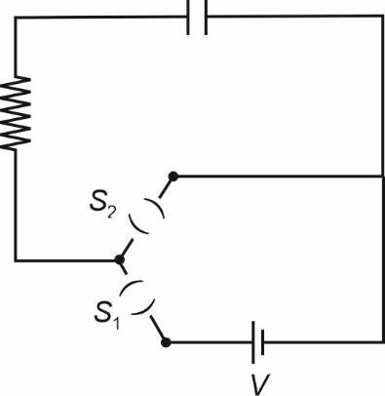

As soon as the circuit is completed by closing key *S*1 (keeping *S*2 open) charges begin to flow between the capacitor plates and the battery terminals. The charge on the capacitor increases and consequently the potential difference *Vc* (= *q*/*C*) across the capacitor also increases with time. When this potential difference equals the potential difference across the battery, the capacitor is fully charged (*Q* = *VC*). During this process of charging, the charge *q* on the capacitor changes with time *t* as *q* = *Q*[1 – *e*–*t*/*RC*]

The charging current can be obtained by differentiating it and using

Consider the case when *R* = 20 *k*, C = 500 *F* and *V* = 10 *V*.

*d* (*emx* )  *memr* .

*dx*

1. The final charge on the capacitor, when key *S*1 is closed and *S*2 is open, is
   1. 5 C (B) 5 mC

(C) 25 mC (D) 0.1 C

1. For sufficient time the key *S*1 is closed and *S*2 is open. Now key *S*2 is closed and *S*1 is open. What is the final charge on the capacitor?

|  |  |  |
| --- | --- | --- |
| (A) Zero | (B) | 5 mC |
| (C) 2.5 mC | (D) | 5 C |

1. The dimensional formula for RC is
   1. [ML2T–3A–2] (B) [M0L0T–1A0]

(C) [M–1L–2T4A2] (D) [M0L0TA0]

1. The key *S*1 is closed and *S*2 is open. The value of current in the resistor after 5 seconds, is
   1. 1 mA



2 *e*

*e* mA

* 1. 1 mA



*e*

* 1. 1 mA

2*e*

## OR

1. The key *S*1 is closed and *S*2 is open. The initial value of charging current in the resistor, is
   1. 5 mA (B) 0.5 mA

(C) 2 mA (D) 1 mA

### Sol. (i) Answer (B)

Final charge on the capacitor when *S*1 is closed and S2 is open The final charge on the capacitor is given by:

*Q* = *CV*

Given

*C* = 500 mF = 500 × 10–6 F, V = 10*V*

*Q* = (500 × 10–6) × 10 = 5 × 10–3*C* = 5 m*C*

### Answer (A)

When *S*1 is open and *S*2 is closed, the capacitor will discharge through the resistor. The charge on the capacitor decreases exponentially as:

*q* = *Qe*–*t*/*RC*

For a long time, *t*  , so

*q* = *Qe*– = 0

Thus, the final charge is zero.

### Answer (D)

**Dimensional formula of *RC* (Time Constant)**

The time constant t for an *RC* circuit is:

⧫ = *RC*

Dimensional formula:

* + *R* (Resistance) = ML2T–3A–2
  + *C* (Capacitance) = M–1L–2T4A2

*RC* = (ML2T–3A–2)(M–1L–2T4A2)

= M0L0T1A0 = T

Thus, the dimensional formula is M0L0T1A0

### Answer (A)

The current during charging follows:

− *t*

*i*  *I*0*e RC*

Initial current:

*I*  *V*

0 *R*

 10

20  103

 0.5 mA

For *t* = 5 s, using *RC* = 10 s

− 5

*I*  0.5*e* 10 

0.5

*I*  1 mA



*e*



2 *e*

## OR

### (iv) Answer (B)

Initial value of charging current At *t* = 0, the charging current is:

*I*  *V*

0 *R*

 10

20 103

 0.5 mA

**SECTION-E**

1. (a) (i) (1) What are coherent sources? Why are they necessary for observing a sustained interference pattern?

(2) Lights from two independent sources are not coherent. Explain.

1. Two slits 0.1 mm apart are arranged 1.20 m from a screen. Light of wavelength 600 nm from a distant source is incident on the slits.
   1. How far apart will adjacent bright interference fringes be on the screen?
   2. Find the angular width (in degree) of the first bright fringe.

## OR

(b) (i) Define a wavefront. An incident plane wave falls on a convex lens and gets refracted through it. Draw a diagram to show the incident and refracted wavefront.

(ii) A beam of light coming from a distant source is refracted by a spherical glass ball (refractive index 1.5) of radius 15 cm. Draw the ray diagram and obtain the position of the final image formed.

**Sol.** (a) (i) (1) Coherent sources are two light sources that maintain a constant phase difference and have the same frequency.

Necessity for interference:

For sustained interference patterns, the superposition of waves should produce constructive and destructive interference at fixed positions. If the phase difference changes randomly (incoherent sources), the interference pattern will not be sustained.

(2) Two independent sources emit light randomly, with different phases and frequencies. This causes variations in the phase with time. Thus, independent sources are not coherent.

(ii) (1) Find fringe width (distance between adjacent bright fringes). Fringe width is given by:

  *D*

*d*

Where:

● = 600 × 10–9 m (wavelength)

*D* = 1.20 m (distance between screen and slits)

*d* = 0.1 mm = 1.0 × 10–4 m

  (600 10–9 )(1.20) 

1.0  10–4

7.2 mm

(b) (i)

(2) Angular fringe width is given by:

❑  

*d*

❑  600 10–9

1.0  10–4

❑ = 6 × 10–3 rad = 0.343°

## OR

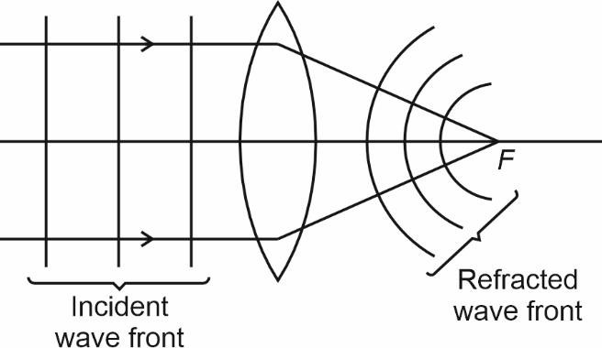

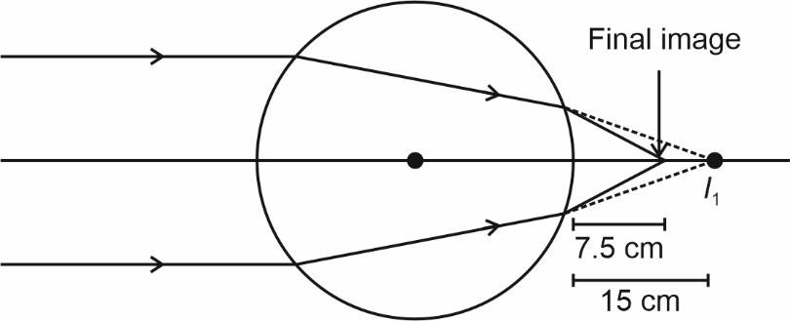

(ii)

Parallel beam will converge at focus of the lens.

**1st refraction**

1.5  1  1.5  1

*V*  *R*

*V* = 3*R*

*V* = 45 cm

### 2nd refraction

1  1.5  1 1.5

*V* 15

1  4

*V* 30

15

*V* = 7.5 cm

1. (a) (i) Two point charge 5 C and –1 C are placed at points (–3 cm, 0, 0) and (3 cm, 0, 0) respectively. An external electric field *E*  *A r*ˆ where *A* = 3 × 105 Vm is switched on in the region. Calculate the change

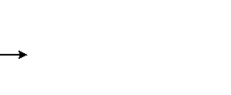

*r* 2

in electrostatic energy of the system due to the electric field.

* 1. A system of two conductors is placed in air and they have net charge of +80 C and –80 C which causes a potential difference of 16 V between them.

1. Find the capacitance of the system.
2. If the air between the capacitor is replaced by a dielectric medium of dielectric constant 3, what will be the potential difference between the two conductors?
3. If the charges on two conductors are changed to +160 C and –160 C, will the capacitance of the system change? Give reason for your answer.

## OR

(b) (i) Consider three metal spherical shells *A*, *B* and *C*, each of radius *R*. Each shell is having a concentric metal ball of radius *R*/10. The spherical shells *A*, *B* and *C* are given charges +6*q*, –4*q*, and 14*q* respectively. Their inner metal balls are also given charges –2*q*, +9*q* and –10*q* respectively. Compare the magnitude of the electric fields due to shells *A*, *B* and *C* at a distance 3*R* from their centres.

(ii) A charge –6 C is placed at the centre *B* of a semicircle of radius 5 cm, as shown in the figure. An equal and opposite charge is placed at point *D* at a distance of 10 cm from *B*, A charge +5 C is moved from point ‘*C*’ to point ‘*A*’ along the circumference. Calculate the work done on the charge.

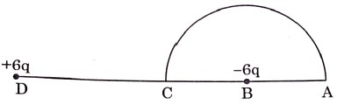

**Sol.** (a) (i) Two point charges 5 C and –1 C are placed at point (–3 cm, 0, 0) and (3 cm, 0,0), respectively. An external electric field is switched on. Calculate the change in electrostatic energy.

The external electric field is given by:

*E*  *A* , *A*  3 105 Vm

*r* 2

As *dV*  *E*  *dV*  *E*  *A*

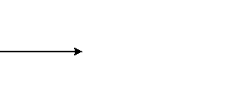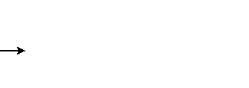

*r*

*U*  *UE*

* *UE*
* *Uq q*  *Uq q*

*q*1 *q*2

1 2 1 2

(As field is created by point charge or uniform spherical distributed charge)

*A A* 

5  1

106

 *U* 

*r*

*q*1  *r*

*q*  3 105  

2 3 102 

1 2

= 40 J

1. A system of two conductor has charge +80 C and –80 C with potential difference 16 V.
   1. Find capacitance:

*C*  *Q* 

*V*

80 106

16

*C* = 5 × 10–6 *F* = 5 F

* 1. If air is replaced by a dielectric of constant *k* = 3, find the new potential difference.

*C*  *kC*  3  5 *F*  15 *F*

Since charge remains the same,

○ *Q* 80 106

*V*  *C*  15 106

*V* = 5.33 V

* 1. If charge change to +160 C and –160 C, does capacitance change?

No, capacitance *C* depends only on geometry and dielectric medium, not on charge. Thus, capacitance remains 5 F (in air) or 15 F (with dielectric).

## OR

1. (i) Given Data:
   * Three spherical shells A, B and C of radius R
   * Each shell has a concentric metal ball of radius R/10
   * Charges on the shells:
     + A: +6*q*
     + B: –4*q*
     + C: 14*q*
   * Charges on the inner metal balls:
     + A: –2*q*
     + B: +8*q*
     + C: –10*q*
2. Given
   * Charge *q* – +5*C* is moved along the semicircle from point *C* to *A*.
   * A charge –6*C* is placed at *B*.
   * Distance *CB* – 10 cm and radius of semicircle = 5 cm Concept used:

The work done in moving a charge in an electric field is given by:

*W* = *q*V

where *V* = *VA* – *VC*, the potential difference between points *A* and *C*.

* + In conductors, not charge appears on external most surface.
  + According to shell theorem, field of sphere is corresponding to field of point charge for act side points

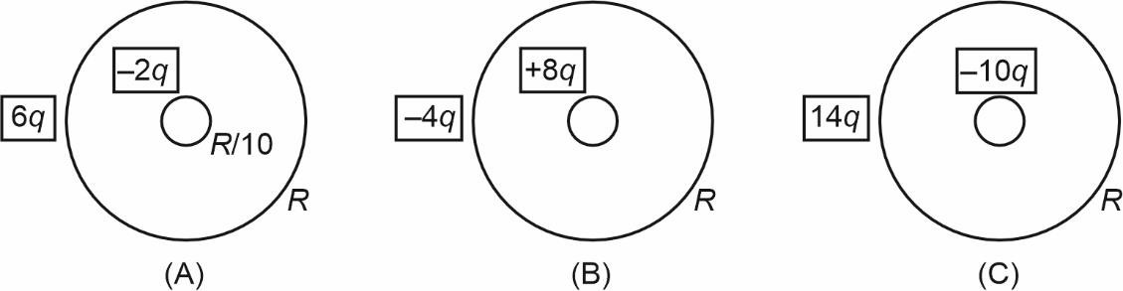

*QA* = –4*q QB* = +4*q QC* = 4*q*

* + Field for act side points *E*  *kq*

*r* 2

As *q* and *r* are same for *A*, *B* and *C*. The for *EA* = *EB* = *EB*

Potential for a point charge

*v*  *q*

40*R*

*v*  –*Q*  *Q*  – 2 *Q*

*A* 4 *R* 4 3*R* 3 4 *R*

0 0 0

*vC* 

*Q*

4 *R*

– *Q*  0

4 *R*

0 0

*w* = *q* (*vA* – *vC*)

⇒ –6  –2 6 10 10–6  9 109 

*w*  5 10  

3



5 10–2

– 0



 (–) 5  2  6  9 10–1

3  5

*W* = –3.6 J

1. 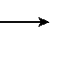(a) (i) A proton moving with velocity *V* in a non-uniform magnetic field traces a path as shown in the figure.

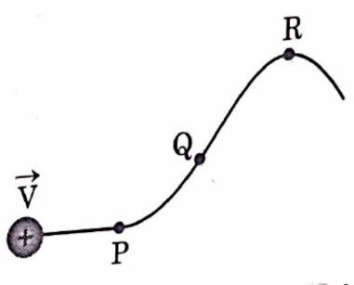

The path followed by the proton is always in the plane of the paper. What is the direction of the magnetic field in the region near points *P*, *Q* and *R*? What can you say about relative magnitude of magnetic fields at these points?

* 1. A current carrying circular loop of area A produces a magnetic field B at its centre. Show that the magnetic moment of the loop is

2*BA A*

0 

## OR

(b) (i) Derive an expression for the torque acting on a rectangular current loop suspended in a uniform magnetic field.

(ii) A charged particle is moving in a circular path with velocity *V* in a uniform magnetic field *B* . It is made to pass through a sheet of lead and as a consequence, it looses one half of its kinetic energy without change in its direction. How will (1) the radius of its path (2) its time period of revolution change?

**Sol.** (a) (i) Motion of a proton in a non-uniform magnetic field

The force on a moving charge in a magnetic fields is given by Lorentz force

The direction of force follows the right-hand rule

At *P*, force is upward, magnetic field is directed inside the place. At *Q*, force is zero as path is straight line so magnetic field is zero. At *R*, force is downward so magnetic field is outside the plane.

If radius of curvature is less, field will be greater *r*  *vm*

*Bq*

*BQ* < *BP* < *BR*

(ii) Magnetic field at the centre of a circular loop

The magnetic field at the centre of a circular loop carrying current *I* is:

*B*  0*I*

2*R*

Since area *A* of the loop is

*A* = *R*2

*R* 

Substituting this in *B*:

*B* 

0*I*

*I* 

*M*  *IA* 

**OR**

Let the sides of rectangle be *a* and *b* and *I* is the current in the loop

*A*

❐

2 *A*

❐

2*B A*

0 

2*BA A*

0 

1. (i)

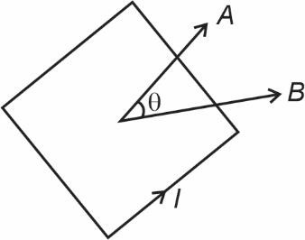

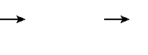

⧫  *M*  *B*

*m* = *IA* = *Iab*

⧫ = *IabB*sin

Where  is angel between area vector and magnetic field.

* 1. Effect of energy loss on circular motion Concept used:
     + Radius of circular motion in a magnetic field:

*r*  *mv*

*qB*

* + - Kinetic energy relation:

KE  1 *mv* 2

2

* + - Time period:

*T*  2*m*

*qB*

### Radius of path

* + Initial kinetic energy KE1

 1 *mv* 2

2

* + After losing half of its energy:

KE  1 KE  1 *mv* 2

2 2 1 4

* + Since KE  *v*2, new velocity is:

*v*  *v*



2

* + New radius :

*r*   *mv*  *mv*  *r qB*



2*qB*



2

Thus, the new radius is *r* .



2

### Time period

* + Time period formula:

*T*  2*m*

*qB*

* + Since time period is independent of velocity, the new time period remains same as before

*T* = *T*

❑  