Majestic Cycling 2022 Race Calendar
Majestic Cycling Events presents M22 Cup Series. Majestic Cycling will be hosting several races throughout the 2022 race calendar.
We will be hosting five races with the Turbulent Fixed Gear Crit Series; including three races at the Majestic Crit course in Ontario, CA, 1 During La Verne Stage Race Crit only, the final race will be at the La Verne Grand Prix.
Additionally, we will be hosting seven races through the M22 Cup Series: including three races at the Majestic Crit course, two races at the Rosena Ranch Circuit, Race the Victorville Crit course and the final race at the La Verne Grand Prix at the end of the season. Look for rules and point board on majesticcycling.com website. Rules and more race information will be posted by January 2022.

We are proud to announce on March 25th-27th La Verne Stage Race. This will also be a USC Collegiate Cycling Event. We will be posting more information on event also in January.
Race Date and Series Info.

- M22 Cup Series

- January 16th Majestic Crit #1 opener Ontario
- February 20th UCLA GP Victorville #2
- February 27th Rosena Ranch Circuit Race #3
March 25-27 La Verne Stage Race (Not Part of Series)
- May 1st Rosena Ranch Circuit Race #4
- June 26 Cajon Pass Circuit Race #5
- August 14th La Verne Grand Prix #6

M22 / Majestic Cup Series Top 3 Riders with most points Cash and Prizes
Jersey
Yellow Over all points Leader
Green Prims/Point Winner
Cat 3
Cat 4
35/45+
55/60+
30+3/4
Women 4
Women 1-3
Pro 1/2

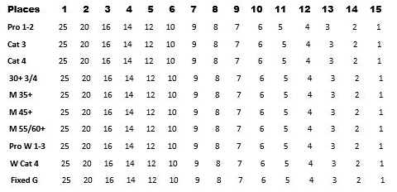
Rules The Top 3 riders in each division will be overall winner. Points will be awarded for top 15 riders in each category. Please see point board all standing will be on ontheday.net There will also be prim laps announced before each race 7 Points awarded top 3 riders to cross the line 1st 4 point 2nd 2 points & 3rd 1 point / Rosena Ranch Circuit Race top 3 riders (Bell Laps) 10 Points 1st 5 Points 2nd 3 points & 3rd 2 Points All will be added to your total points after each race.

