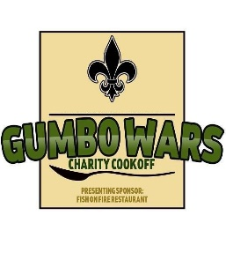
Gumbo Wars
7937 Daetwyler Drive
Orlando, Fl 32812
Junior Anglers Program
REGISTRATION / INJURY WAIVER FORM

I__________________________ (YOUR NAME), Being of sound mind and body acknowledge that I and my dependents(s) (children’s names)
______________________ ________________________ ________________________
______________________ ________________________ _________________________
Will be attending today’s Hook Kids on Fishing, Gumbo Wars.
In the event I or my dependents are injured or suffer any short-term or long-term physical harm, I release Gumbo Wars Hook Kids on Fishing, its organizers, promoters, sponsors, instructors, board of directors, staff, contract hires, participants, etc. from any and all liabilities now or in the future including but not limited to medical, hospital, paramedic or ambulatory care.
I also understand and agree that photographs and video may be taken throughout the Gumbo Wars JAE program. I hereby give permission for any and all photographs or video taken at this program to be used for the advertisement and promotion of this educational program.
I hereby affirm that I have read fully, understand and agree with the above statements.

HOOK KIDS ON FISHING
INJURY WAIVER FORM
Signature: _______________________________ Date: __________________________
Contact Information: (Please Print)
Name: ____________________________________________________
Relationship: _______________________________________________
Email Address: ______________________________________________
Emergency Cell Phone Contact: _________________________________

