Annual Dues. Please check preference

- $25.00 for individual
- $40.00 for family membership

Name ______________________________________________
Address ____________________________________________
City/State/Zip _______________________________________
Phone _____________________________________________
Email* _____________________________________________
*Your monthly newsletter will be emailed unless otherwise indicated

Please make checks payable to Grand Valley Orchid Society and send check to:
Grand Valley Orchid Society
2139 Chesapeake NE
Grand Rapids, MI. 49505
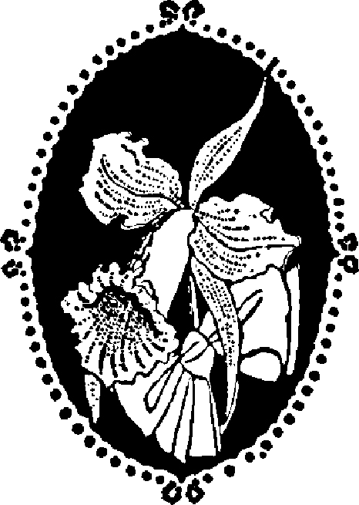
Grand Valley Orchid Society
Membership Application

