Razor Energy was founded by Doug Bailey and Frank Muller. Doug Bailey (President and CEO) is a designated accountant and has been engaged in the oil and gas industry since the early 2000’s. Starting with various restructuring mandates, Mr. Bailey evolved into a founder of Canadian Phoenix, which sold to Renegade Petroleum, and Hyperion Exploration. Most recently, Mr. Bailey co-founded Striker Exploration Corp. (“Striker”), which amalgamated with Gear Energy Ltd. in July 2016.

**RAZOR Management**

**The Company**

Razor Energy is an Alberta based publicly listed junior energy company engaged in acquisition, exploration, development and production of petroleum and natural gas, primarily in Alberta. Since inception the company has bought mature, producing long-life legacy light oil fields in the Swan Hills and Kabob formations and enhanced the value and production by implementing optimization of water floods and utilizing new tertiary recovery technologies as well as recompleting wells and drilling initial wells. RZE started operations in February 1, 2017 with the reverse takeover of a CPC (formed in 2010) and then did their qualifying transaction via the acquisition of producing assets in the Swan Hills area.

Frank Muller (Snr VP, COO) is a professional geoscientist with 32 years of experience in Western Canada, primarily Alberta. Mr. Muller’s experience includes Chevron Canada, Hillcrest Resources and Jordan Petroleum. Mr. Muller co-founded Real Resources and WestFire Energy where he held increasingly senior managerial/executive roles. Most recently, Mr. Muller co-founded Striker, which amalgamated with Gear Energy Ltd. in July 2016

**RAZOR Properties**

RZE started operations in February 1, 2017 with the reverse takeover of a CPC (formed in 2010) and then did their qualifying transaction via the acquisition of producing assets in the Swan Hills area. In Q2/17 it added to its asset base via the acquisition of complementary assets in the Kaybob area. In Q4/17 and Q1/18 Razor added to its working interests in the Kaybob area. They have year-round access to their producing areas.

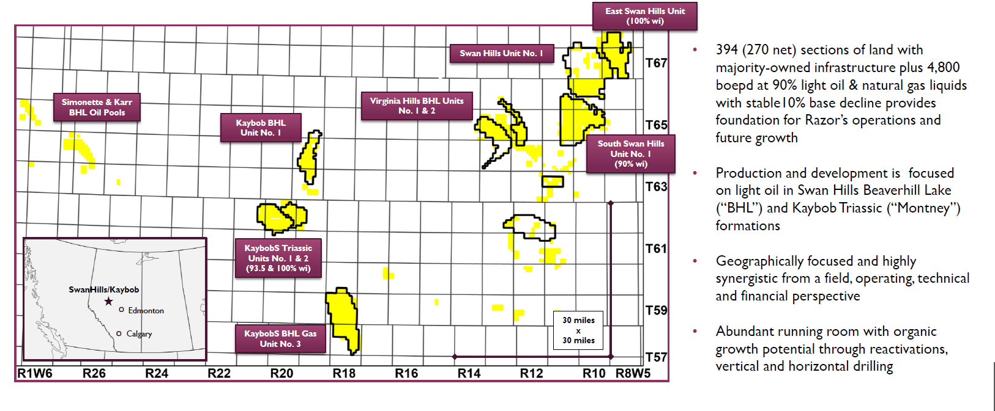

**RAZOR Production Profile**

Recompletions are a big part of the RZE story as they cost only $150,000 to complete and bring production up from miniscule levels to an average of 39 boe/d. Since the start of RZE they have recompleted/reactivated 63 gross wells which have added 1,750 boe/d net to Razor. In 2017 they reactivated 25 gross wells and added 880 boe/d of production. In Q1/18 they reactivated seven gross wells (6.4 wells net) that added 40 b/well. The capital e􀃕ciency is excellent at under $4,000/boe and they continue to work with three service rigs on this growth initiative.

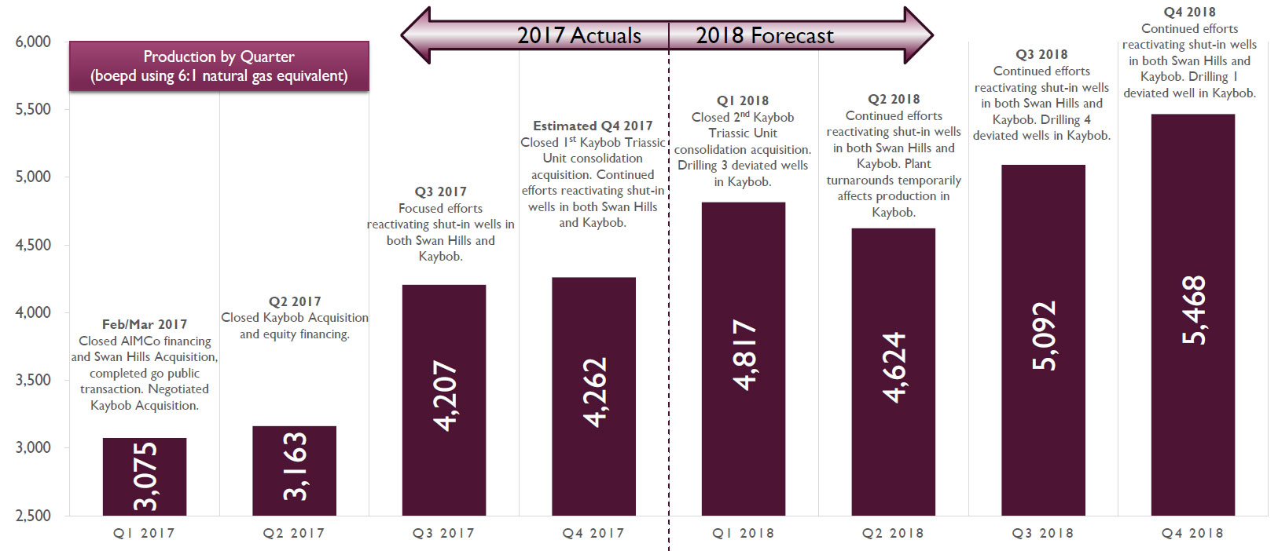

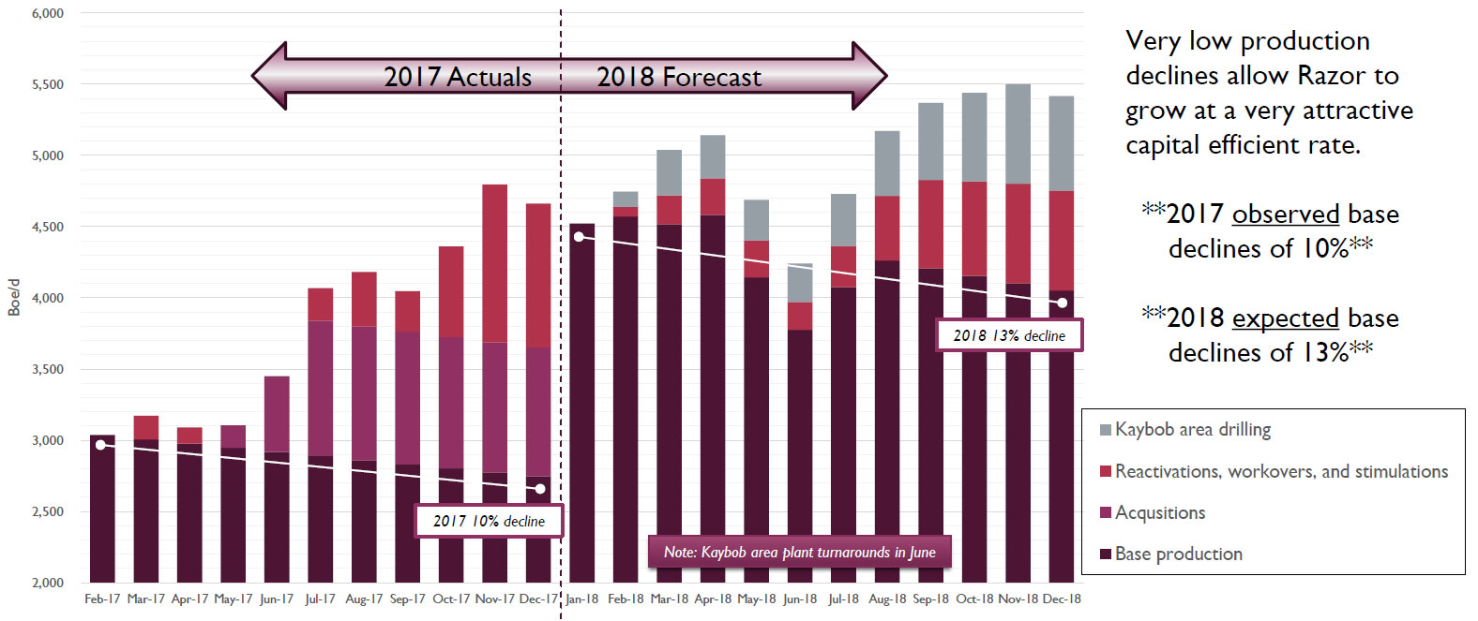

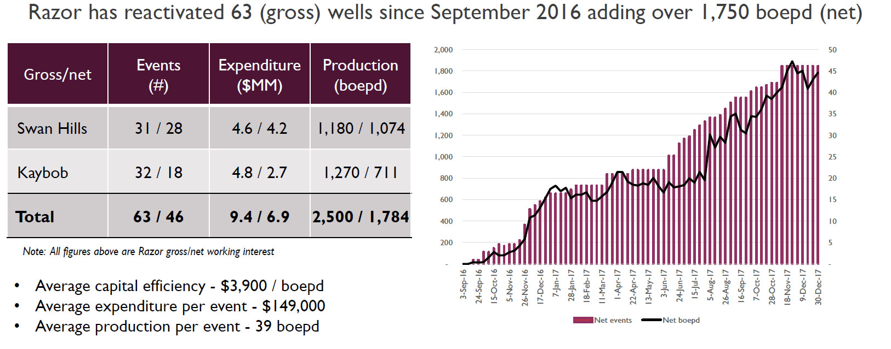

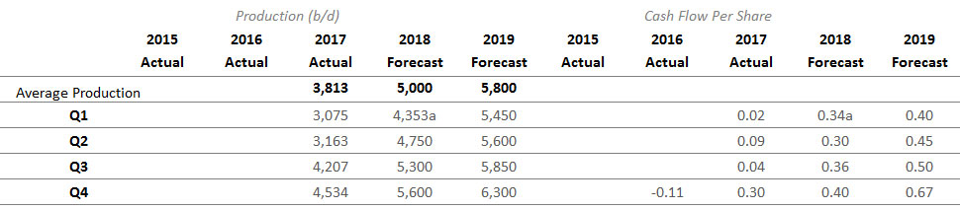

**Financial Performance:**

In 2018, Razor plans on spending $38.4M; $8M to drill four new well drills in the Kaybob area, $12M for recompletions in their two core areas, $8.6M on natural gas power etc., $5.9M for land and acquisitions, and $2.9M for end of life expenditures to meet their LMR goals. Depending upon opportunities, we may see some of the Kaybob spending move to purchase tuck under acquisitions if great deals come available. The need for their own electricity is due to these costs now being 25% of operating costs and having their own sourced electricity will lower these costs this year and in the future. **RZE needs to recomplete only 20 to 25 wells per year to keep production flat.**

In 2017 they purchased the core assets of the company for $32.75M funded by an issue of shares for $17.25M and the proceeds of $30M of debt provided by AIMco.

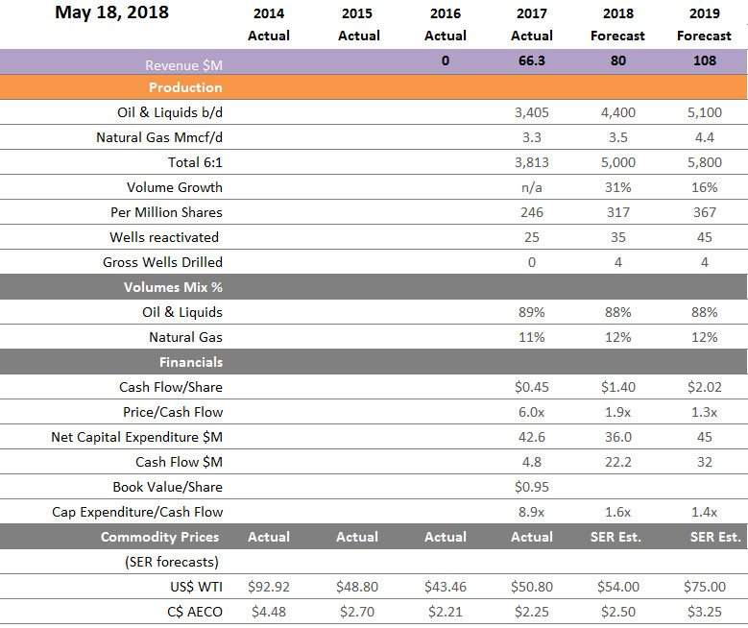

*Source: Canaccord Genuity – August 30,2018*

**Corporate Valuation Sheet: *(go to*** [***www.alliancecapitalparters.ca/clients***](http://www.alliancecapitalparters.ca/clients) ***for full report access)***

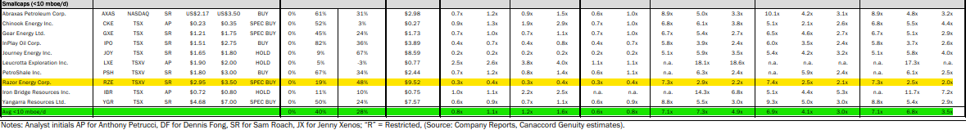

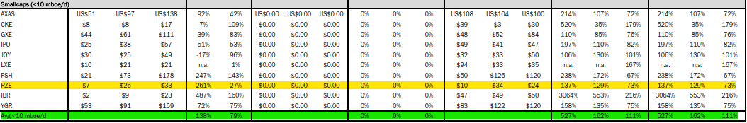*Asset Value Transaction Comps:* 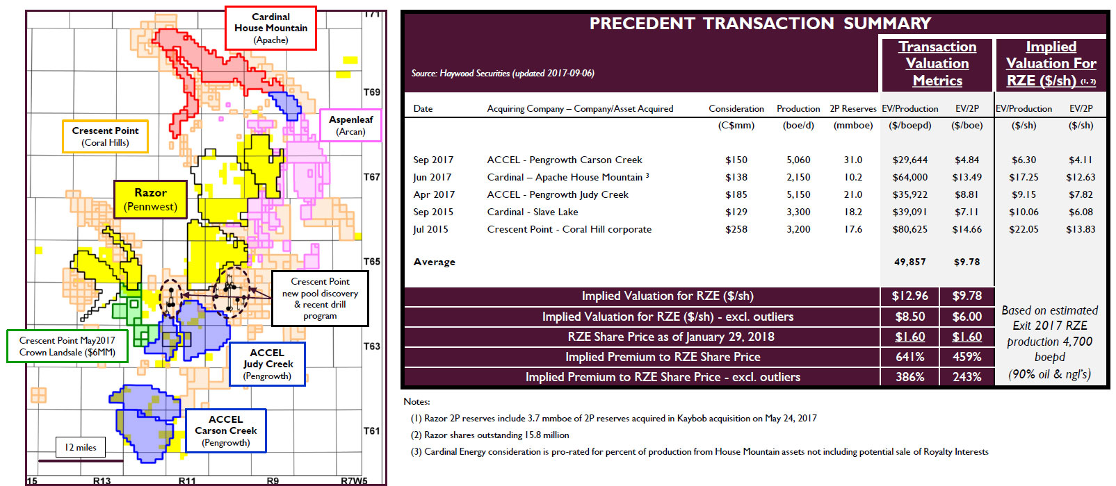

PEER Averages Target Pricing:(Aug 30, 2018)

Price/NAV: 2x $ 6.18

EV/DACF (2018): 2x $ 6.18

EV/BoeProd: 2.67x $ 8.25

Go to [www.alliancecapitalpartners.ca/clients](http://www.alliancecapitalpartners.ca/clients) for full report access.

**Synopsis and Conclusion:**

Since inception in spring of 2017 the management team at RAZOR Energy has utilized debt funding from Alberta Investment Management Corporation (AIMco) and equity issuance to acquire existing production and facilities and subsequently add recompletion production from a large inventory of wells to generate accretive cash flow and significant increases to property reserves.

Cash flow is now sufficient to capitalize further re-completion production additions and continue to grow both cash flow and reserves.

Peer valuations dwarf RZE despite its lower exploration and production life profile. At current oil pricing RZE reflects a significant value upside.