ACP – Client Review and Program

The most successful investor marketing program is undertaken with a clear purpose and objective, a well-crafted strategy and message, and a selection of tools deployed in a coordinated manner to achieve results. Selection of the high value target audience and timing to correspond with corporate developments to maximize interest. Further consistency in message and regular communications is critical to maintaining investor interest and loyalty.

Effective Investor Marketing should involve a multifaceted, coordinated program utilizing numerous tools that through synergies create the maximum return on the time and effort and investment.

While many practitioners choose to focus on a single aspect of marketing reach, the true value is in a multiprong approach.

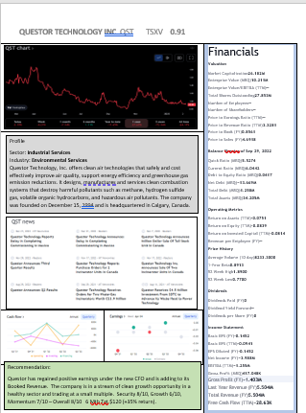

Corporate Valuation Targets

It’s important to have a grasp of the prospective value of the company upon successful execution of its strategic plan. This involves pro-formas, financial formulas and sector averages and peer studies.

Corporate Performance Plan

Compiling a plan to achieve the milestones and deliverables necessary to realize target valuation targets becomes the benchmark for the company to generate ROI for stakeholders.

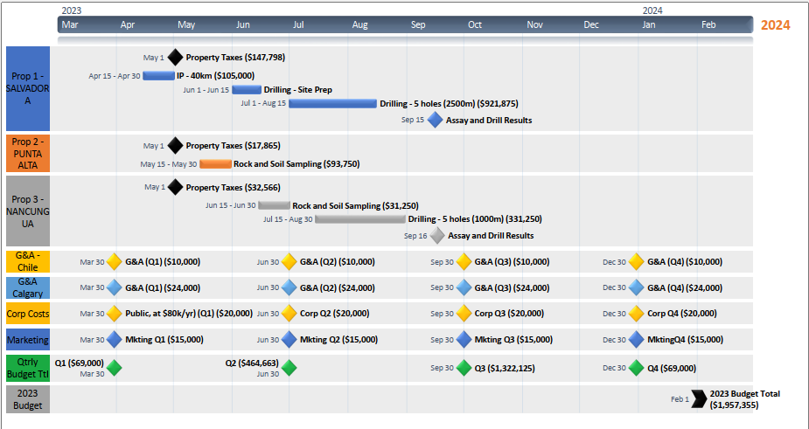ormance Plan

Target Investor Network and Outreach

There are 3 tiers of outreach groups that can extend across several regions (Cda, USA, Eur). 1. Primary Network 2. Peer Holder Network 3. Qualified Investor Network.

Endorsement supported by a compelling investment story delivered consistently over time is key to engagement.

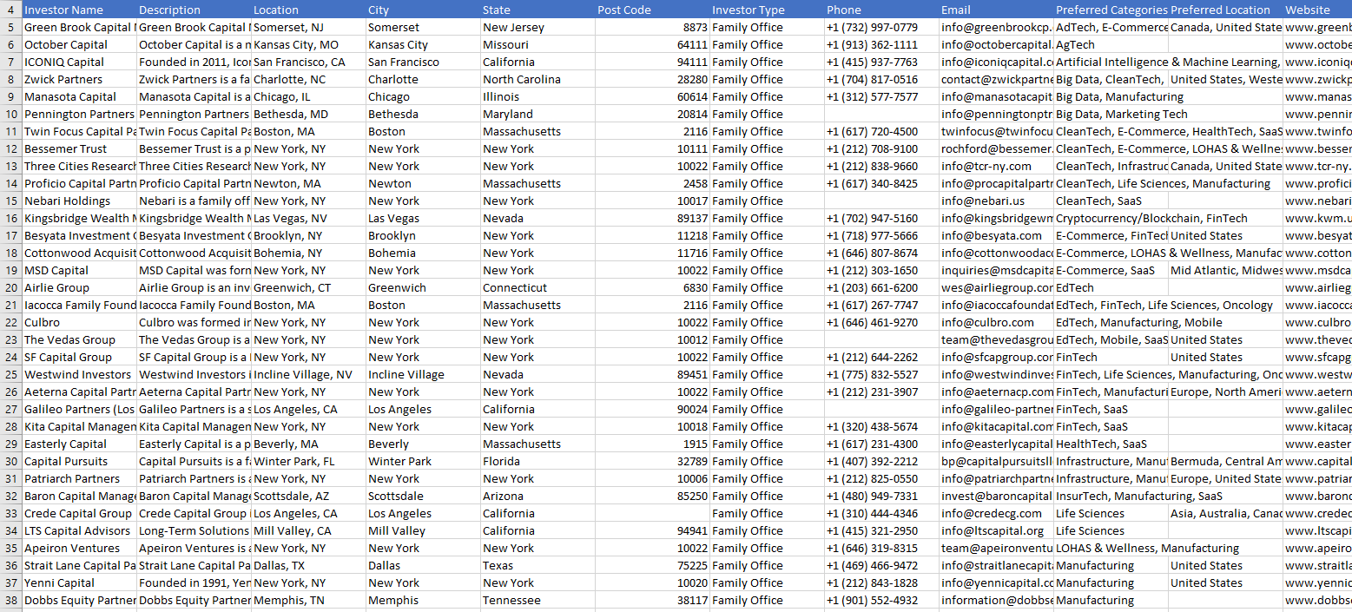

Corporate Performance Plan

A Strategic Plan put to calendarized Deliverables and budget allows for time sensitive tracking of Deliverables and achievement of Milestones in keeping with the path to generating returns and a higher corporate valuation.

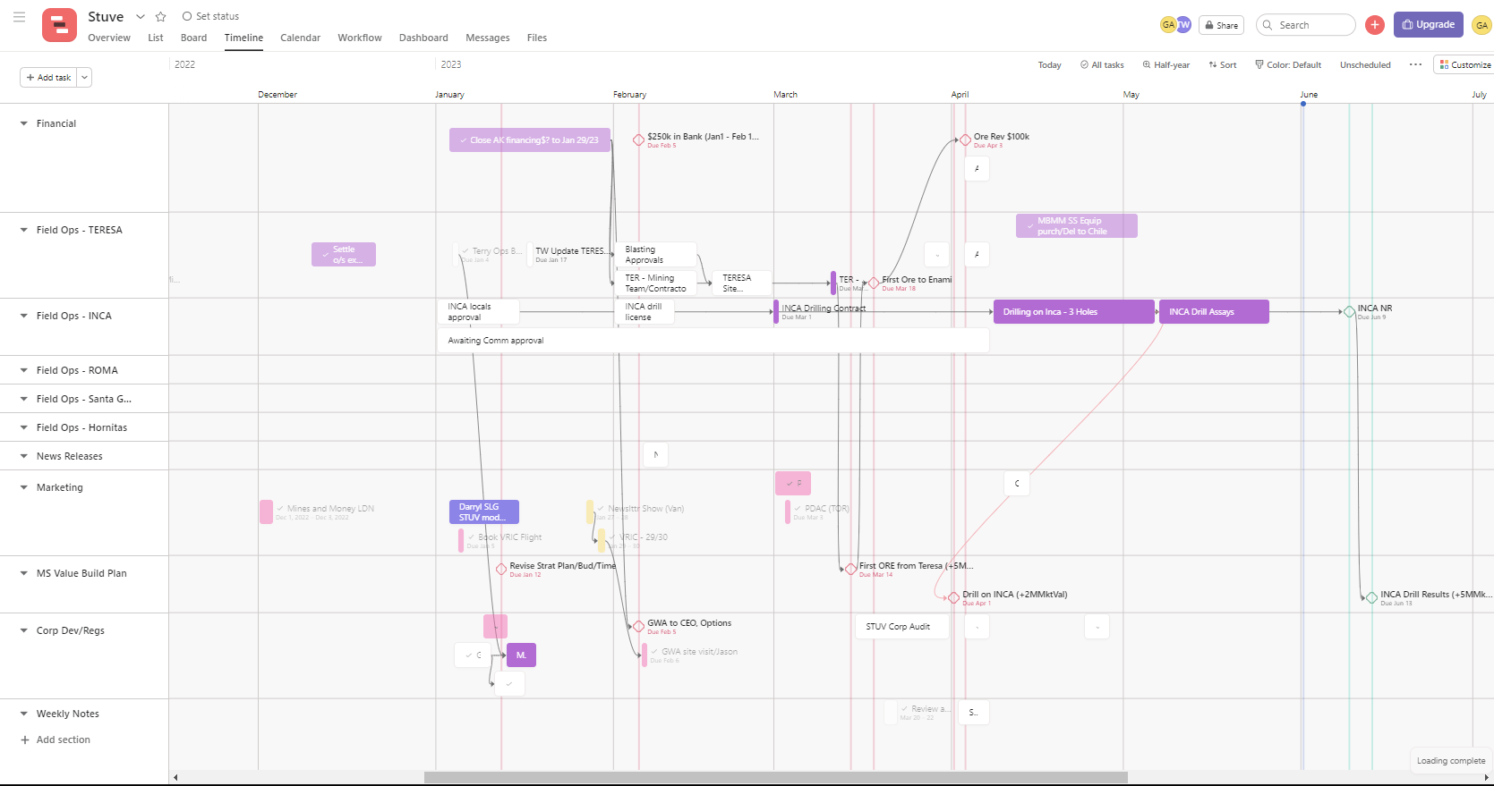

ACP Marketing Program

The Investment Marketing Program has a base communication element that is executed on a regular basis for consistency and presence while another level of activities is implemented to leverage corporate activities/results in real time.

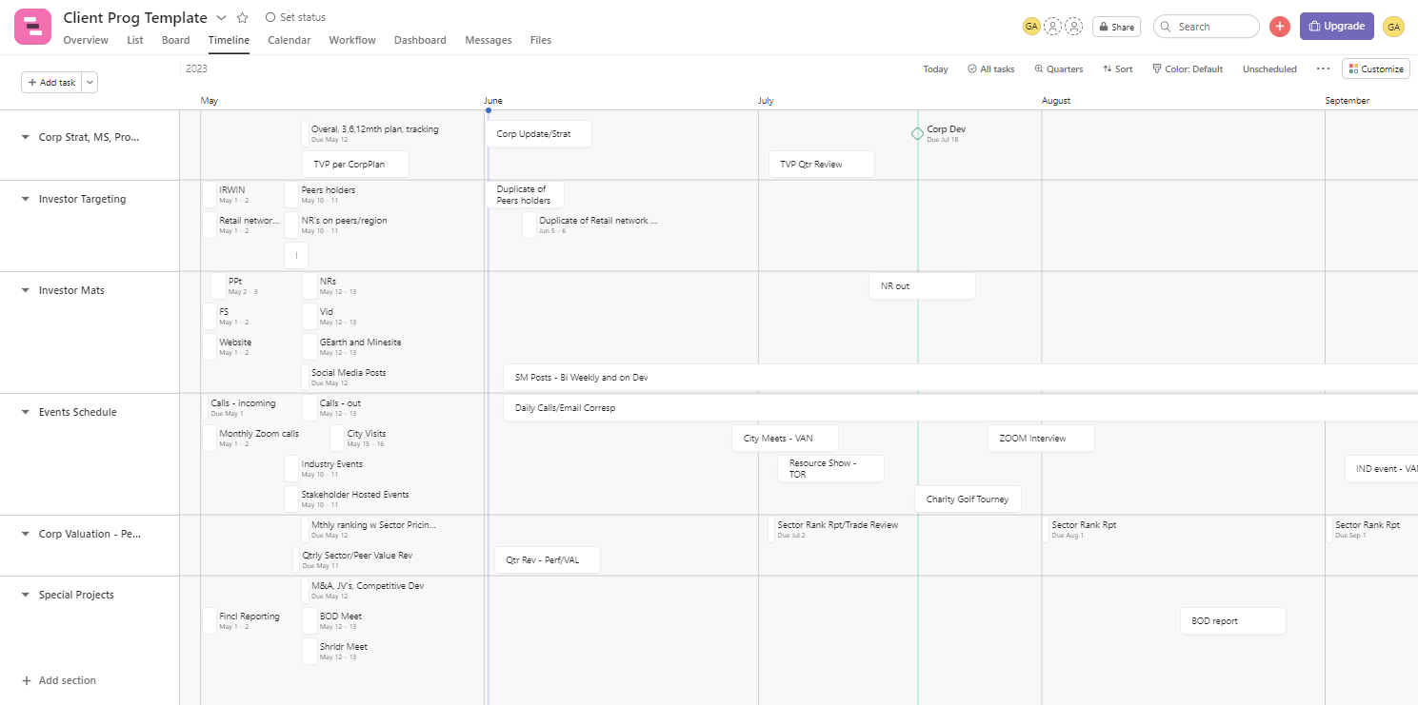

ACP Quarterly Reporting

Monthly and Quarterly Reporting on Program Initiatives and results are provided to the client. Assessment of sector activities as well as trading in the company’s stock and shareholder interaction is outlined.

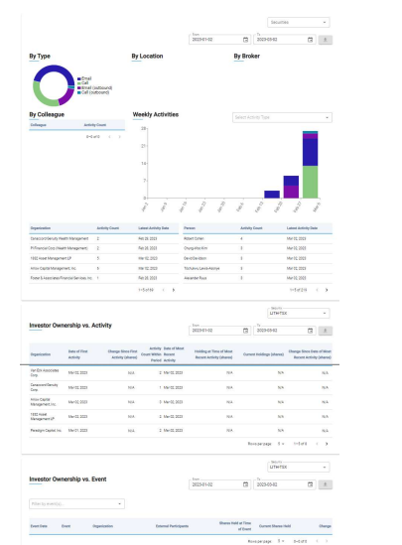

ACP Product Sheets:

