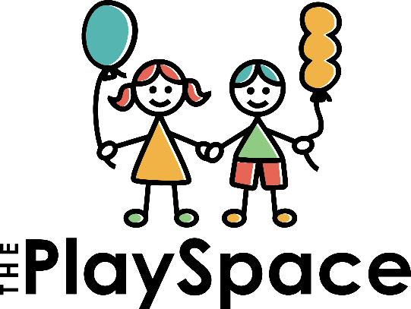

Application Process 2025

- Please fill in application forms that have been emailed to you.
- Submit forms together with the all the necessary extra documentation required. You may email to theplayspace.za@gmail.com or drop off at 43 Balmoral Drive, Cowies Hill.
- A credit check will be conducted if your child is currently attending another school.
- When your place has been confirmed, we request a non-refundable enrolment levy of R1500 which secures your place and is also used to develop and maintain the school facilities and equipment.
- Upon successful application, please be advised that both parents will need to sign a contract with the school. Your child may only commence their attendance when the signed contract has been received.
- We will have an info evening before school begins where you will find out all the info you need for school.

DOCUMENTS REQUIRED FOR ADMISSION
- Application form-both parents must please sign this form
- Serious medical conditions form if applicable
- Copy of your child’s birth certificate
- Copies of any assessments your child may have had (if applicable-educational, OT, Speech therapy etc)
- Copy of both parent’s identity documents
- Photo of your child (can be emailed-no need to print)
- Immunization card
- Proof of residence
- Proof of employment

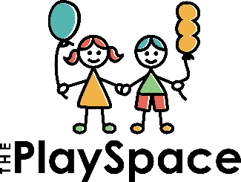
43 Balmoral Drive
Cowies Hill, 3610
Email: theplayspace.za@gmail.com
Phone: 0832547669
APPLICATION FOR ADMISSION
PROPOSED YEAR OF ADMISSION:
How many days per week? (2/3/4/5)
(R190 per day 7:15-12pm INCL SNACK)

Please tick days you would like them to  attend | MON | TUES | WED |  | THURS | FRI
Aftercare until 2:30pm  (R70 per day) | YES |  |  | NO
Pupil’s surname
Pupil’s first names
Sex | MALE | FEMALE |  | (PLEASE TICK)
Date of birth
Identity number
Citizenship
Religion
Home language
Father’s title and Surname |  | Mother’s title and Surname
Father’s first names |  | Mother’s first names
Father’s ID no |  | Mother’s ID no
Residential Address |  | Residential Address
Cell number |  | Cell number
Email address |  | Email address
Work Name |  | Work Name
Work phone number |  | Work phone number
Occupation |  | Occupation
Name of person responsible for payment of fees:
If parents are separated or divorced:
Legal Guardian: (please state if it is the father or mother)

With whom is the child currently living:

Where did you hear about The PlaySpace?

___________________________________________
I hereby apply for admission of the above-mentioned child as a pupil at The PlaySpace school. I agree to pay the fees I have committed to according to my preference for the days of attendance per week in advance each month.
I agree to giving a month’s notice should I wish to withdraw my child from the school.
I understand that if I should withdraw my child during a term, or if my child should leave the school for any reason whatsoever during a term, whether at my instance or that of the owner (Ariadni Hind), the current term’s fees shall be forfeited and I shall be liable for a month’s fees in lieu of notice.
I understand that if ____________________________ (child’s name) is accepted as a pupil at The PlaySpace School:
- The fact that my child may be absent and cannot attend school does not relieve me of my liability for payment of school fees in full. This includes taking your child out of school for holidays during term time. Missed days cannot be caught up.
- The PlaySpace School is not responsible for loss or damage to the clothing and other personal property of my child.
- The PlaySpace School has the right to terminate the contract with the parents if fees are not paid timeously. Your child will not be allowed to attend if more than a month’s fees are outstanding.
- The enrolment fee is a once off payment that secures my child’s spot and it is non-refundable.

Father’s Signature: Mother’s Signature:

Date Date:

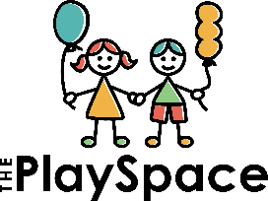
SERIOUS MEDICAL CONDITIONS:

1: Name of Child:

2: Age:

3: Medical Condition: (including allergies)

4: Symptoms of condition:

5. How long will it take for these symptoms to appear in the event of an ‘incident if applicable’:

6: Medication required:

7: Emergency Treatment:

8: Emergency Contacts:
- Parent:

- Doctor:

- Medical Aid:

- Medical Aid Number:
As per the Enrolment agreement, if the parents are unable to be contacted, the Parents’ consent to the administration of medical treatment to the child and the Parent undertakes to reimburse the costs of the whatever the treatment where costs have been incurred.

Parent’s Signature: Date:

