MASSAGE INTAKE FORM

 | PERSONAL INFORMATION
 | Your Name: |  |  |  |  |  |  |  |  |  |  | Gender: |  |  |  |  | Age:
 | Phone: |  |  |  |  |  |  |  |  | Email:
 | Address:
 | MASSAGE SERVICE DETAILS
 | Have you had a professional massage before?
 | ☐ | YES |  | ☐ | NO
 | Massage service you are here for: |  |  |  |  |  |  |  |  |  |  | 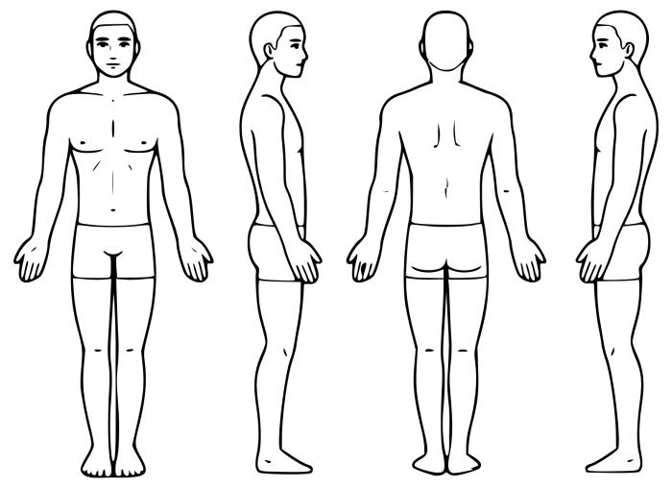
 | ☐ | RELAXING |  |  | ☐ | THERAPEUTIC
 | ☐ | OTHER
 | Type of pressure that you prefer:
 | ☐ | LIGHT |  | ☐ | MEDIUM |  | ☐ | DEEP
 | Which type of masseur do you prefer?
 | ☐ | MALE |  | ☐ | FEMALE |  |  |  |  | PLEASE MARK ANY AREAS OF DISCOMFORT
 | IMPORTANT HEALTH INFORMATION
 | Do you have high blood pressure? |  |  |  |  |  |  |  |  |  | Do you have Cardiac/Circulatory problems?
 | ☐ | YES |  | ☐ | NO |  |  |  |  |  | ☐ | YES |  | ☐ | NO
 | Do you suffer from Arthritis? |  |  |  |  |  |  |  |  |  | Do you have Osteoporosis?
 | ☐ | YES |  | ☐ | NO |  |  |  |  |  | ☐ | YES |  | ☐ | NO
 | Do You suffer from Epilepsy/Seizures? |  |  |  |  |  |  |  |  |  | Do you have frequent Headaches or Migraines?
 | ☐ | YES |  | ☐ | NO |  |  |  |  |  | ☐ | YES |  | ☐ | NO
 | Are you taking any medication? (Please list if yes)
 | ☐ | YES |  | ☐ | NO |  |  | Medication Listing:
 | Do you have any other important medical condition?
 | ☐ | YES |  | ☐ | NO |  |  | Condition Explained:
 | PLEASE READ THE FOLLOWING CAREFULLY AND SIGN BELOW
I acknowledge the benefits and risks of massage therapy provided by Natural Therapies with Soo.
I am aware that I am receiving services at my own risk.
I understand that my health and safety regarding the massage services are my sole responsibility, and I have consulted my medical provider about any concerns and have received clearance.
I confirm that I have provided accurate health information and understand the potential risks associated with massage therapy.
I confirm that I have read Soo Williams Massage terms and conditions, available as a printout and on the website.
 | Date: |  |  |  |  |  |  |  | Signature:
 | © Soo Williams, 2 Orpheus Close, Mt Sheridan, QLD 4868. Mobile: 0434908635, Email: support@soowilliams.com, Website: https://soowilliams.com

