
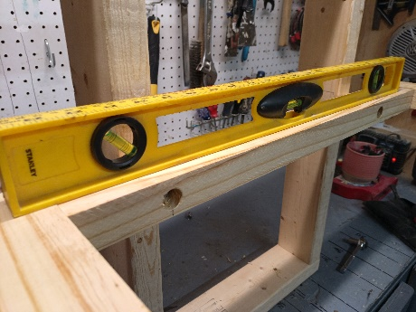
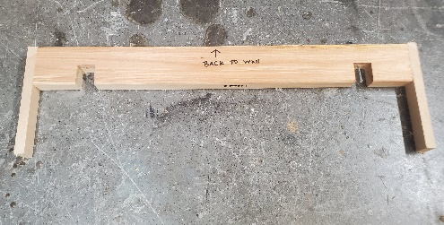
Directions for mounting your new floating shelf to a wall made of drywall material using ¼” lag screws. The first and best method is to use the 4-inch wood screws provided and drill a pilot hole directly into a stud. If possible, do this with at least one stud. The first thing to do is locate the studs with a stud finder. Mark the spots on the wall. Line up the mounting plate on your wall and use a level to make sure it’s straight.

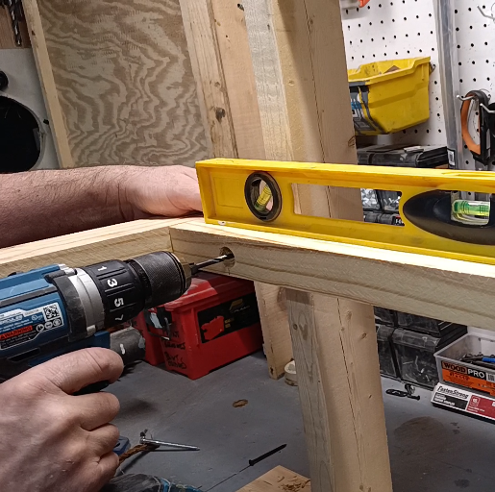
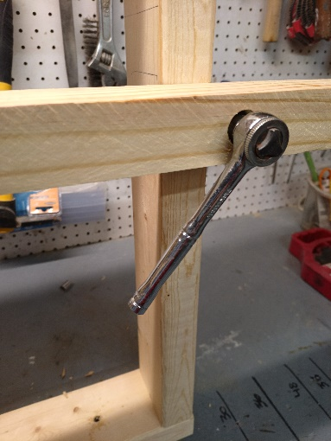
Without moving the mounting plate, 7/32” drill bit to drill through the bracket and into the wall hitting the 2 x 4 stud. plate. Do this for both stud locations. Tighten the lag screws through the holes on the plate and into the pilot hole on the drywall. Tighten just snug for now. Check levelness and wiggle as needed to be level then tighten down firmly. Tighten well to prevent the shelf from leaning down. If it leans down, it’s not tight enough against the wall. Use a socket wrench with a 7/16 socket to tighten firmly.

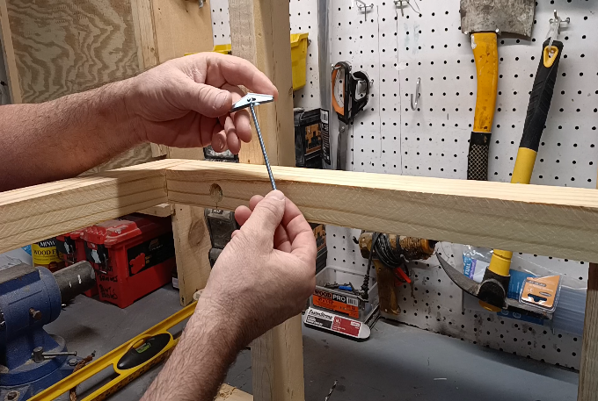
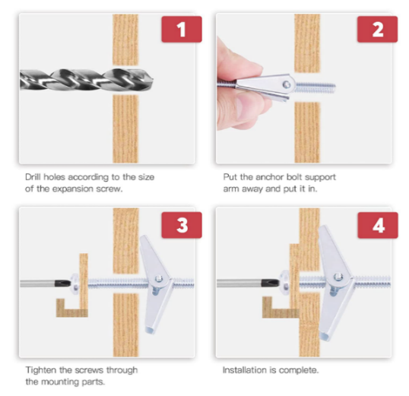
If you can’t hit a 2nd wall stud, then use a butterfly toggle bolt provided.

Now slide the shelf over the mounting plate. You can also add shim for small adjustments. That’s it.
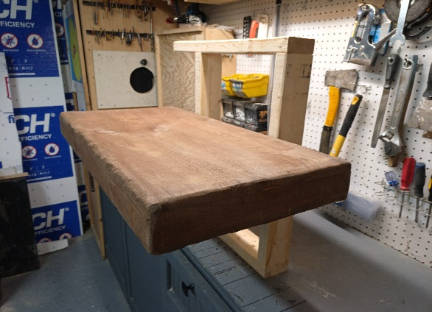
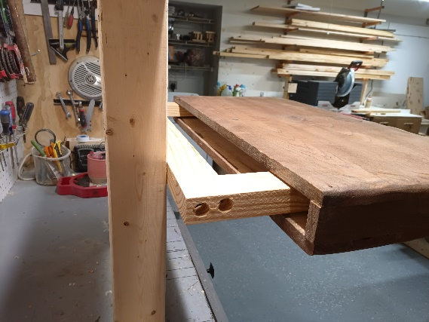

I also have a YouTube video showing how to install these shelves: https://youtu.be/2gKoOsjpDRI?si=7ZXXDrelLMtnOmhE

Thanks for your purchase and I hope you enjoy this handcrafted wall shelf! Check my other products on my website.

Website: www.rusticdesignsbyjeff.com n Email: handcraftedrustics@gmail.com n PH: 561-847-0077

