
Directions for Mounting Your New Fireplace Mantel
Be sure to check local codes and fireplace manufacturer specifications before installing to maintain safe and proper clearances to combustible material. The following is for mounting your new fireplace mantle to a wall. If you can secure directly into a wooden wall stud, then use the wood screws or the lag screws provided, lag screws being better. If not, you will need to use 3” toggle bolts. If securing to concrete or rock use concrete screws and sinkers. Now, the first thing to do is use a stud finder to locate the wall studs and mark them. Line up the mounting plate (with a mitered angle), on your wall and use a level to make sure it’s straight. Have the angled side facing the wall. Without moving the mounting plate, mark the plate with a pen where to drill through and into the studs. Move the plate away from the wall and drill holes where the marks are with a 1/8” drill bit. Screw the supplied 3.5” screws through the plate and into the studs. Use the level while doing this to be sure to maintain levelness.
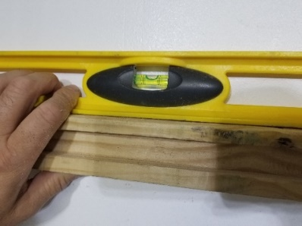
Slide the shelf over the mounting plate. Do this on an angle tilted up so that the mitered wall hanger seats together. I recommend using wood glue or liquid nails on the top of the bracket and on the mitered edge where they come together if you are not planning on removing it. Use some trim screws to secure the top of the mantel to the mounting bracket for added security if you like.
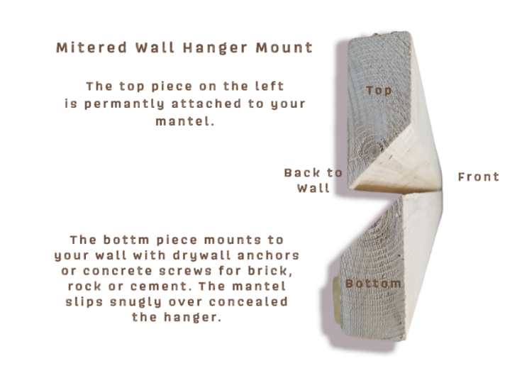

I also have a video on YouTube showing how to install this: https://youtu.be/di_4Tay03hw
Thanks for your purchase. Check my other handcrafted products on my website too:
Website: www.rusticdesignsbyjeff.com n Email: handcraftedrustics@gmail.com n PH: 561-847-0077

