Directions for mounting your towel or coat rack to a wall made of drywall material. If you can secure directly into a wooden wall stud, then use wood screws for this instead. Now, first thing to do is line up the rack on your wall and use a level to make sure it’s straight.

Without moving the rack, use a nail or a 1/8” drill bit to mark a pilot hole in the wall by poking it through the predrilled holes.

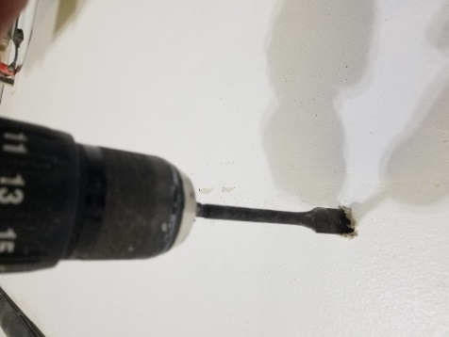Move the plate away from the wall and drill holes where the marks are with a ½”” drill bit.

Push the bolts through the holes on the rack front.

Screw on the butterfly toggles to the end of the bolts as shown.

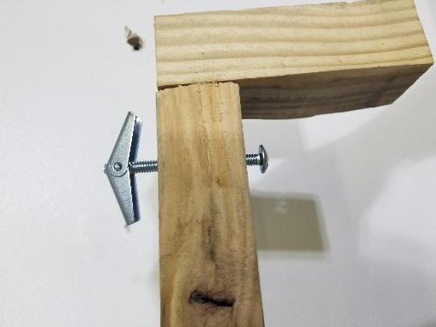

Push into the holes on the wall. Tighten down the bolts with a screwdriver while gently pulling outwards so the toggles catch on the inside of the drywall. Use the level while doing this to be sure to main levelness.

